Our Wildlife Fact Sheet
  - Australian Fur Seal

The Australian Fur Seal is the largest of all fur seals and the world’s fourth rarest seal species.
Scientific name
Arctocephalus pusillus doriferus
Did you know?
The Australian Fur Seal was hunted to the edge of extinction in the 19th century, but population sizes are now increasing.

They can dive up to 150 m in search of prey.

Although they can breathe on land Australian Fur Seals prefer to live in the water spending weeks feeding at sea.

The mother seal and pups can recognise each other by using a familiar call.

Australian Fur Seals, like all seals, can raise their body with their front flippers enabling them to move on land.
Description
The Australian Fur Seal can reach up to 2.5 m in length. Adult males are heavier than the females, weighing up to 100 kg.

The fur colour of Australian Fur Seals also varies between male and female, with the male being dark grey to brown with a paler underside. They have a dark mane of coarse hair over the neck and shoulders. Females can vary from pale fawn to greyish brown with a paler yellowish throat and underside.

The coat of the Australian Fur Seal is made of a woolly underfur with long coarse outer hairs to trap air. This provides waterproofing and insulation for the seal, along with a layer of fat. They moult each year which means they lose their fur, replacing the old fur with new.

Australian Fur Seals have large eyes with which they can see excellently in the dark. They have a pointed face, whiskers that help them find food and very sharp teeth similar to a bear.

Their flippers are forward facing, allowing them to walk on land. While they appear to mainly shuffle along, Australian Fur Seals can move very quickly if they feel threatened.
Diet
The Australian Fur Seal mainly feeds on a diet of bony fish species, squid and octopus.

They are very skilful hunters with keen senses and eyesight. They have been also known to take advantage of fishing nets, taking fish from the catch.
Habitat
The Australian Fur Seal can be found in coastal waters and oceans.

They prefer rocky islands, boulder and pebble beaches and rocky ledges for resting and breeding.
Distribution
The Australian Fur Seal can be found around the islands of the Bass Strait, southern Victoria and parts of Tasmania. They have also been seen on islands off South Australia and southern New South Wales. 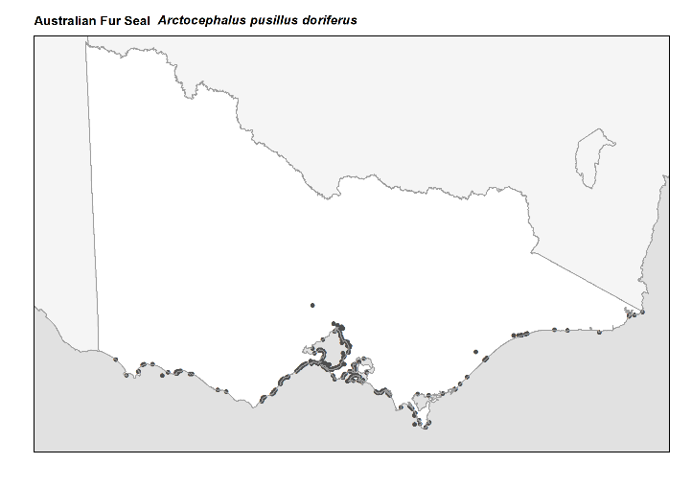
Figure 1. Recorded occurrences in Victoria
Source: Victorian Biodiversity Atlas (records post 1979, version 15/5/2017
Breeding
Australian Fur Seals breed between October to December.
During the breeding season, they come ashore and establish territories. Females are defended by the resident male in these territories.
During the gestation period females remain mostly at sea and only come ashore just before the birth of the single pup. Females will then mate again usually 6-10 days after birth.

The Australian Fur Seal has the ability to delay implantation of the egg. This means that the fertilised egg can remain dormant for some time, ensuring that the female will give birth in the summer months and in turn giving the pup a greater chance of survival.
Australian Fur Seal pups suffer a high mortality rate in the first few months after birth, especially when the mother is at sea feeding for days at a time before returning to her pup.
Pups are weaned at around 4-6 months old but still can remain with the mother until 12 months old.
What you can do to help
Australian Fur Seal populations have increased since the Australian and State Governments passed laws making it illegal to kill, hunt or harass Australian Fur Seals.
Australian Fur Seals are threatened by sharks, Killer Whales, commercial fishing, entanglement with fishing gear and swallowing of plastic bags.

You can help by ensuring your beaches are clean from plastic or any littler. If you see a plastic bag, pick it up and dispose of it. If a seal eats plastic, its gut cannot digest it which can result in a very slow and painful death for the animal. This can easily be avoided if people stop littering.

It is important that both people and dogs keep away from Australian Fur Seals. The law prescribes varying approach distances depending on where you are and how you are travelling (see www.wildlife.vic.gov.au for full list of approach distances).

You must not get closer than 30 metres to a seal on land, whether you also on land or in the water. If a seal is on a boat ramp, pier or other man-made structure, then you need to keep at least 5 metres away from the seal.

When taking your dog for a walk you need to make sure that you keep it at least 50 metres away from a seal on land. Dogs also must not enter the water within 50 metres of a seal.

If you are flying a drone, remember that you must not allow the drone to get closer than 500 metres above or around the Australian Fur Seal.

Report any suspected illegal activity in regard to seals to the DELWP Customer Contact Centre on 136 186.

All wildlife is protected in Victoria. Visit the DELWP website for more information regarding protected wildlife www.wildlife.vic.gov.au

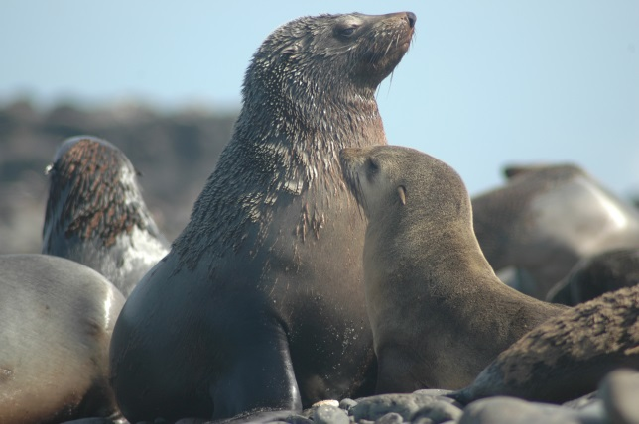
Figure 2. Australian Fur Seal © R. Kirkwood, Phillip Island National Park

Further reading
Menkhorst, P.W. (ed), (1995), Mammals of Victoria, Oxford University Press, Melbourne.
Strahan, R. (ed.), (1995), The mammals of Australia, Reed Books, Australia.

