|  |
| --- |
| Kangaroo Pet Food Trial |
| Overview |

Large kangaroos such as Eastern Grey Kangaroo (*Macropus giganteus*) and Western Grey Kangaroo (*Macropus fuliginosus*) are relatively abundant in Victoria. While they are a valuable part of our native wildlife, in some areas they may cause problems.

## Managing kangaroos

The Department of Environment, Land, Water and Planning (DELWP) issues Authorities to Control Wildlife (ATCWs) under section 28A of the *Wildlife Act 1975* for the control of kangaroos where they are damaging pasture, crops or other property or impacting on biodiversity values.

Wherever possible, DELWP advocates non-lethal management of problems with kangaroos. Some non-lethal methods must be authorised by DELWP before they can be carried out. Where non-lethal techniques are ineffective or impractical, lethal control may be necessary.

Appropriate non-lethal wildlife management options must be attempted before DELWP will issue an ATCW for lethal control.

ATCWs for lethal control are issued on a case by case basis for a specified period and for a maximum number of kangaroos. Kangaroos must be destroyed by shooting only, in accordance with the strict conditions of the ATCW, to ensure animals are destroyed in a humane manner.

Landholders who are issued with an ATCW may arrange for shooters to control wildlife on their behalf. Before now, landholders and shooters could retain the carcasses of kangaroos for personal use only.

## Kangaroo Pet Food Trial

The vast majority of kangaroo carcasses from kangaroos controlled under an ATCW are buried or left onsite to decompose.

The aim of the Kangaroo Pet Food Trial (KPFT) is to facilitate the use of kangaroo carcasses controlled in accordance with an approved KPFT ATCW.

The trial was initially a two-year trial. It has been extended twice to test its sustainability over a longer period and to see whether changes to compliance, monitoring and education would address issues that arose.

An evaluation of the KPFT has identified a number of positive outcomes, but it also highlighted some key risks associated with allowing commercial processing of kangaroos. The current system is not the appropriate mechanism for kangaroo processing in the long term. However, the Victorian Government recognises the benefits that kangaroo processing can provide to rural and regional communities.

The trial will be extended for a further six months, to 30 September 2019. This will provide continuity to current participants of the KPFT while a new, ongoing kangaroo pet food program is developed.

Participating in the trial does not change the requirement for a landholder applying for an ATCW to demonstrate that kangaroos are causing property damage*.*

Only the carcasses of kangaroos controlled under a KPFT ATCW within the trial area may be used for processing into pet food, and only by licensed pet meat processing facilities that hold wildlife processor licences.

The trial includes landholders in the following local government areas: Ararat, Benalla, Glenelg, Greater Bendigo, Horsham, Mansfield, Mitchell, Murrindindi, Loddon, Northern Grampians, Pyrenees, Southern Grampians, Strathbogie, Wangaratta, West Wimmera and Yarriambiack (Figure 1).

## Use of kangaroos for pet food

The trial focuses on the use of kangaroos controlled under a KPFT ATCW for pet food in the domestic market. The trial does not allow kangaroo meat to be used for human consumption. Kangaroo meat obtained under a KPFT ATCW can still be kept for personal consumption by landholders and shooters.

The production of pet food in Victoria is regulated under the *Meat Industry Act 1993* by PrimeSafe.

Pet meat processing facilities must meet the outcomes of the *Australian* *Standard for the Hygienic Production of Pet Meat* (‘the Standards’) and have a food safety plan (also known as a Quality Assurance Program).

The Standards apply to the processing of all animals used in the production of pet food, including wild animals. They contain minimum requirements for hygiene in harvesting, transportation, processing, identification, packaging and storage. The Standards require compliance with the *National Code of Practice for the Humane Shooting of Kangaroos and Wallabies for Commercial Purposes*, and federal and state wildlife protection legislation.

Landholders within the trial area will be required to have a Property Identification Code (PIC) to participate. The PIC is used to trace animals for pet food safety purposes and will identify which property the kangaroos came from.

Pet meat processing facilities must ensure that kangaroos are controlled by a person who has sufficient training in humane killing procedures and hygienic handling of pet food. Pet meat processing facilities must specify the professional shooters who will be supplying kangaroos (their ‘preferred suppliers’) in their food safety plan. Pet meat processing facilities are also required to obtain a wildlife processor licence issued by DELWP under the *Wildlife Act 1975*.

## Tagging and record keeping

Kangaroos controlled by a professional shooter under a KPFT ATCW must be tagged with an individually numbered plastic tag. These tags will be labelled ‘Vic KPFT’ and will be issued by DELWP to the landholder. Blue tags are issued for tagging Eastern Grey Kangaroos, and white tags are issued for tagging Western Grey Kangaroos. The landholder will provide tags to the professional shooters when making arrangements for control. This allows the carcasses to be traced back to the KPFT ATCW they were controlled under.

The shooter is also required to report back to the landholder on the control work undertaken, including the number and species of kangaroos controlled and the tag numbers used.

The tagging and record keeping process provides the landholder and DELWP with confirmation of the number and species of kangaroos controlled under the KPFT ATCW.

## Frequently Asked Questions

***When will the trial run?***

The trial is running from 31 March 2014 to 30 September 2019.

***As a landholder, can I control the kangaroos myself and take them to a pet meat processing facility?***

No. Kangaroos must be controlled by a shooter who is listed in the food safety plan of a licensed pet meat processing facility.

***What if a landholder does not have a Property Identification Code?***

All landholders will need to provide a PIC on the KPFT ATCW application form. If you don’t have one please contact DELWP Customer Service Centre on 136 186.

***What if a landholder wants to control kangaroos but does not want to participate in the trial?***

Landholders who live in the trial area and wish to control kangaroos that are causing damage on their property do not have to participate in the trial. Landholders may apply for an ATCW to control kangaroos using the standard form and follow the standard process.

***Can landholders outside the trial area participate?***

No. Only kangaroos controlled in the trial area may be used for pet food*.*

***Can a pet food processing facility accept kangaroos from people who are not listed in its food safety plan?***

No. A pet food processing facility can only receive kangaroos that have been controlled in the trial area by shooters listed as preferred suppliers in its food safety plan.

***Can a pet food processing facility accept kangaroos that have been controlled on land where there is no ATCW?***

No. Only kangaroos that have been controlled under a KPFT ATCW can be processed. It is an offence against the *Wildlife Act 1975* to destroy kangaroos without an ATCW.

***How many pet meat processing facilities are participating in the trial?***

Licensed pet meat processing facilities must have a food safety plan and obtain a wildlife processor licence from DELWP before they can receive kangaroos.

Three pet meat processing facilities have the relevant approvals and are processing kangaroo carcasses from the trial.

***How will the new kangaroo pet food program be different from the trial?***

Unlike the KPFT, the new framework will operate independently of the ATCW system. Landholders will still be able to apply for ATCWs to control kangaroos on their own property, however these carcasses will not be processed under the new system.

The new regulatory framework and Kangaroo Management Plan will establish kangaroo harvesting zones and set appropriate annual quotas for each zone, based on information gained from recent statewide kangaroo population surveys, to ensure Victoria’s kangaroo population is managed sustainably under the pet food program.

The new framework will include safe guards to ensure that harvesting is sustainable, animal welfare requirements are met and stronger compliance and enforcement requirements are in place.

For more information see the, *“Information for landholders”*, *“Information for shooters”* and *“Information for pet meat processing facilities”* factsheets on the DELWP website.

Figure 1 Map of existing and extended trial area. From 19 September 2016, four additional local government areas have been added to the trial after local government and key stakeholder consultation.

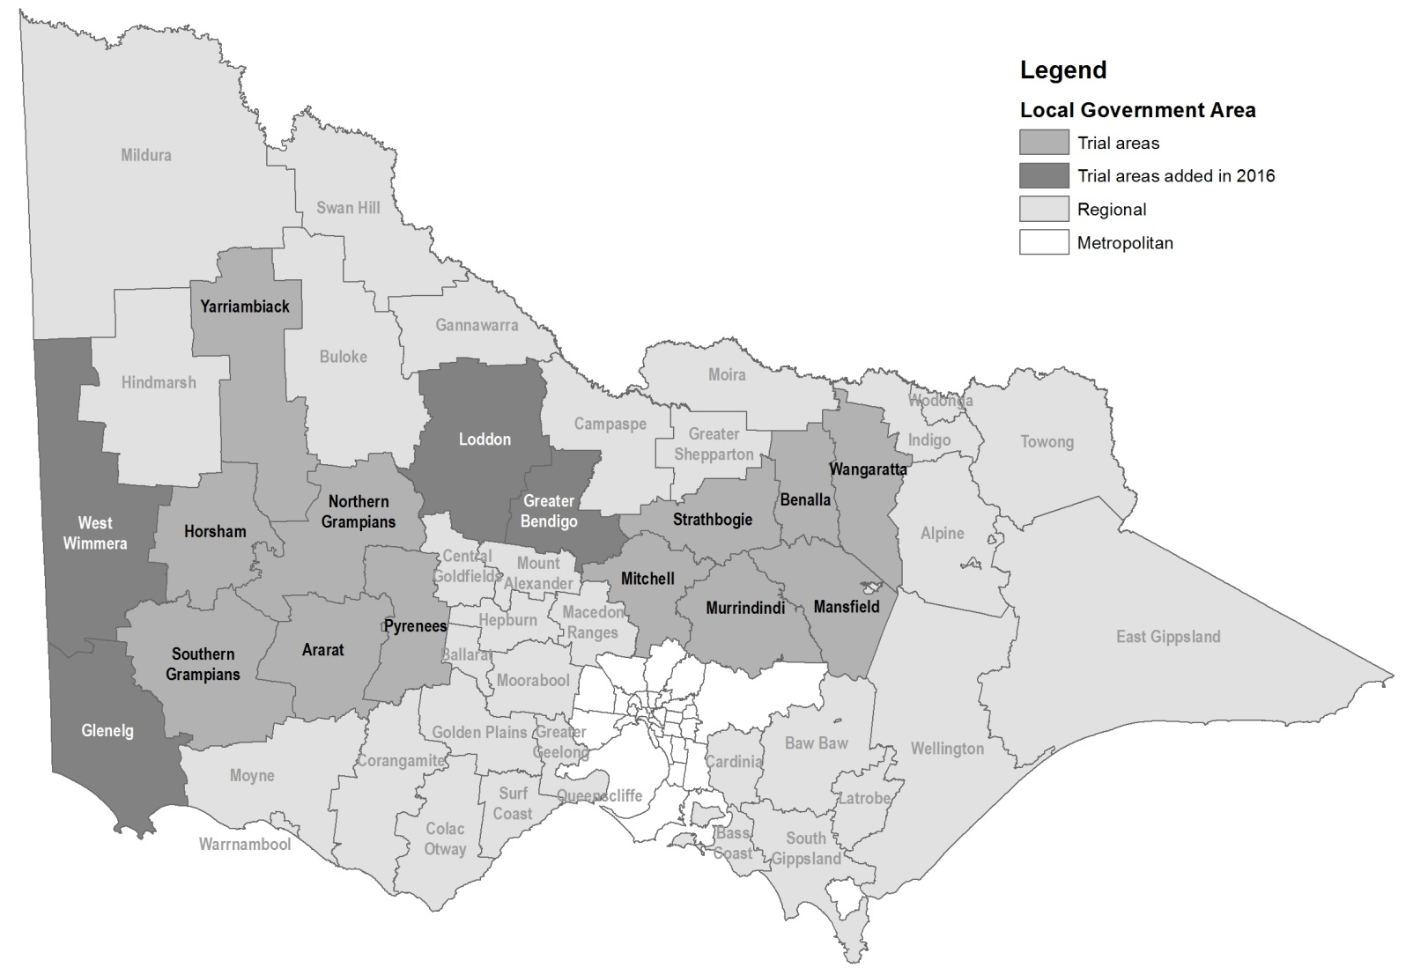

|  |  |
| --- | --- |
| © The State of Victoria Department of Environment, Land, Water and Planning 2019  LogoThis work is licensed under a Creative Commons Attribution 4.0 International licence. You are free to re-use the work under that licence, on the condition that you credit the State of Victoria as author. The licence does not apply to any images, photographs or branding, including the Victorian Coat of Arms, the Victorian Government logo and the Department of Environment, Land, Water and Planning (DELWP) logo. To view a copy of this licence, visit http://creativecommons.org/licenses/by/4.0/  ISBN 978-1-74326-817-9 (Online)  Disclaimer  This publication may be of assistance to you but the State of Victoria and its employees do not guarantee that the publication is without flaw of any kind or is wholly appropriate for your particular purposes and therefore disclaims all liability for any error, loss or other consequence which may arise from you relying on any information in this publication. | Accessibility  If you would like to receive this publication in an alternative format, please telephone the DELWP Customer Service Centre on 136186, email [customer.service@delwp.vic.gov.au](mailto:customer.service@delwp.vic.gov.au), or via the National Relay Service on 133 677 [www.relayservice.com.au](http://www.relayservice.com.au). This document is also available on the internet at [www.delwp.vic.gov.au](http://www.delwp.vic.gov.au). |