Our Wildlife Fact Sheet
  - Eastern Grey Kangaroo

One of the most recognisable and well-known animals in Australia is the Kangaroo. The Eastern Grey Kangaroo, a large grass eating marsupial, is a familiar sight in Victoria and is one of eight members of the kangaroo family found in Victoria.
Scientific name
Macropus giganteus
Did you know?
Kangaroos can cover up to 6 m in one bound.
As a Kangaroo’s speed increases, so does the distance of each hop!
Kangaroos can maintain a speed of 20 km per hour for long periods of time. For short periods, they can hop at speeds of up to 65 km per hour.
Most kangaroos can only move their back legs at the same time.
“Skippy” the bush kangaroo was an Eastern Grey Kangaroo.’
The kangaroo and Emu are on Australia’s Coat of Arms. It is thought they were chosen as they are the only two Australian animals that can’t move backwards. The Coat of Arms therefore symbolises a nation moving forward.
Kangaroos give birth to under-developed young that are suckled in a pouch on the mother’s belly.
Kangaroos belong to a group of marsupials called macropods, which means ‘big foot’. This group was named because of their large rear feet.
Description
Eastern Grey Kangaroos can be up to 1.5 m tall and weigh almost 60 kg.
Their fur is grey brown in colour. Their underparts are pale grey or whitish.
They have long ears with a whitish inner fringe and dark eyes.
Males can weigh twice as much as females and have more developed chests and forearms.

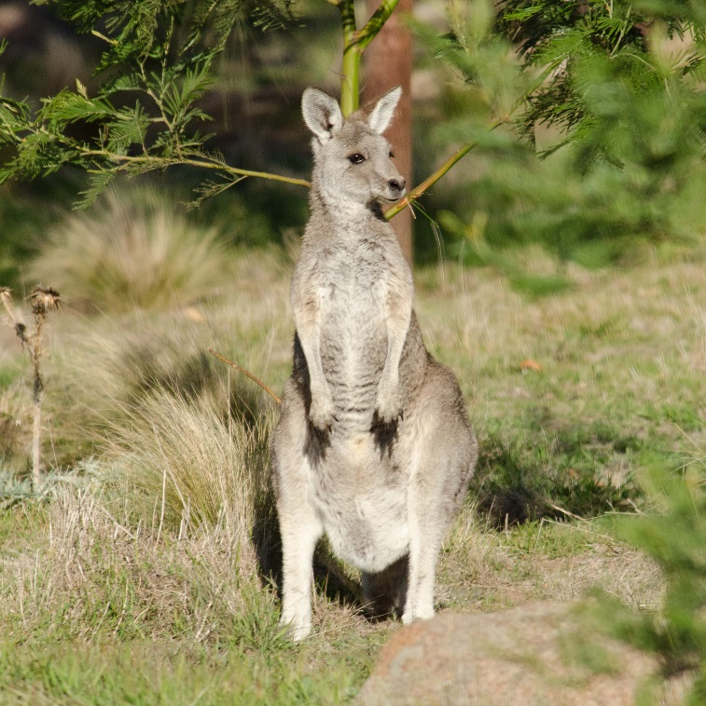
Figure 1. Eastern Grey Kangaroo © N. Talbot DELWP 2013
Diet
Eastern Grey Kangaroos eat grasses, herbs and occasionally shrubs. Their food is well chewed before it is swallowed and digested.
They mainly feed in areas where grasses are most plentiful.
Habitat
Areas with patches of trees for cover near open grassland provide perfect habitat for Eastern Grey Kangaroos.
During the day, they generally rest in the shade and sheltered areas. In the evenings and early morning, they move out into open areas to graze.

Distribution
The Eastern Grey Kangaroo is found in eastern Australia from Tasmania to Cape York Peninsula.
In Victoria, they are widespread in the southern and eastern regions. However, they are not found in north-western Victoria, where they are replaced by Western Grey Kangaroos.
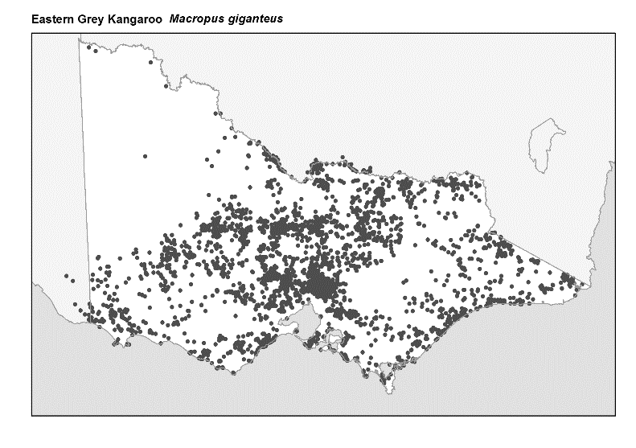
Figure 2. Recorded occurrences in Victoria
Source: Victorian Biodiversity Atlas (records post 1979), version 15/5/2017
Breeding
Eastern Grey Kangaroos can breed throughout the year. However, most births occur during summer or in response to favourable conditions.
Joeys are born 36 days after conception and are about the length of a jelly bean. They crawl into their mother’s pouch where they suckle until around nine months of age.
Joeys remain with their mother for approximately 18 months after leaving the pouch.
Females may have a second joey in their pouch while still tending young at foot.
Kangaroos live in groups called mobs. These groups have a dominant male that attempts to prevent other males from mating with receptive females.
Females often stay with other females in groups. Competition between males can occasionally lead to fights.
What you can do to help!
To protect kangaroo habitat, you can help by improving native vegetation on your property. Kangaroos need trees for shelter and resting.
Be aware of road signs indicating kangaroos are in the area and slow down. Kangaroos may be feeding along the road. Be especially careful at dawn and dusk.
If you do see kangaroos or other wildlife when driving, be careful and give them plenty of time and space to move off the road.
Control your dog: dogs can harass and injure kangaroos and other wildlife.
Eastern Grey Kangaroos are one of the most abundant macropods in Australia. In some areas, they can become overabundant because of access to food, permanent water sources and a lack of predators.
In over-populated areas, kangaroos can cause damage to farmland, property and habitat, show aggression towards people, and they can suffer starvation from over-grazing.
There are a number of ways humans and kangaroos can live together. For more information on living with kangaroos, please visit the DELWP website at www.wildlife.vic.gov.au.
Further reading
Menkhorst, P.W. (ed.), (1995), Mammals of Victoria, Oxford University Press, Melbourne.
Strahan, R. (ed.), (1995), The mammals of Australia, Reed Books, Australia.

