|  |
| --- |
| Victorian kangaroo population survey |

During September and October 2018, the Department of Environment, Land, Water and Planning (DELWP) conducted a population survey of Victoria’s three kangaroo species.

## The purpose of the survey

The survey was undertaken to estimate the abundance of Victoria’s three kangaroo species, the Eastern Grey Kangaroo (*Macropus giganteus*), the Western Grey Kangaroo (*Macropus fuliginosus*) and the Red Kangaroo (*Osphranter rufus*).

The results of the survey are important in providing a baseline against which DELWP can assess the sustainability of authorised kangaroo management activities in Victoria.

The 2018 survey results build on those from the 2017 survey and provide us with a greater understanding of the kangaroo population size and species distribution across Victoria.

## Why did DELWP undertake another kangaroo survey?

As the survey conducted in 2017 was the first of its kind, the survey design required some refinement to improve the precision of the results.

DELWP therefore engaged scientists from the Arthur Rylah Institute for Environmental Research to review and revise the survey design for the 2018 survey.

## How was the survey conducted?

As per the 2017 survey, the survey consisted of two methods, an aerial survey using distance sampling along transects combined with ground transect surveys.

The aerial survey was undertaken from helicopter, flying at approximately 200ft above ground level at a speed of 50 knots. It covered 3182km of transect lines across the non-forested, non-urban parts of Victoria (e.g. Metropolitan Melbourne and parts of Gippsland were excluded from the survey).

As Eastern Grey and Western Grey Kangaroos cannot be reliably distinguished from the air, ground transect surveys from a road vehicle were also carried out to determine the relative proportions of the two species in the parts of the state where their distributions overlap. Approximately 1850 km of transects were driven during the ground survey.

## How was the 2018 survey design different to the 2017 survey?

The main difference between the 2017 and 2018 surveys was the level of survey effort undertaken. In order to increase the precision of the results, additional transects were included in the 2018 survey.

The 2018 survey covered 3182km of aerial transects compared to 1600km in 2017 and 1850km of driven transects compared to 1587km in 2017.

## Who undertook the survey?

DELWP engaged external contractors experienced in kangaroo monitoring and surveying, to undertake the surveys. EcoKnowledge undertook the aerial surveys and Macropus Consultants undertook the ground surveys.

## What were the results of the survey?

The overall kangaroo population in Victoria was estimated to be 1,425,000 (95% confidence interval*; a range of 1,045,000 – 1,942,000) at the time of the survey.

As the survey excluded heavily forested areas of the state, this is a conservative estimate of the kangaroo abundance in Victoria.

Table 1 shows the estimated population for each species.

Table 1: Estimated populations of Victoria’s three kangaroo species (rounded to the nearest 1000).

|  |  |  |
| --- | --- | --- |
| Species | Estimated population | 95% confidence interval* |
| Eastern Grey Kangaroo | 1,251,000 | 889,000 – 1,762,000 |
| Western Grey Kangaroo | 130,000 | 91,000 – 185,000 |
| Red Kangaroo | 44,000 | 25,000 – 77,000 |

* The 95% confidence interval means that, while an estimated population number is provided, the actual number could be between the range specified.

## How do these results compare to the results from the 2017 survey?

The overall kangaroo population estimate is similar between the two years. In 2017 the overall kangaroo population was estimated to be 1,442,000 kangaroos at the time of the survey.

While this is higher than the estimate for 2018, the difference between the estimates is less than the statistical margin of error. Any change in the total population between the two years is relatively small.

The estimated populations for each species in 2017 were 1,359,000 Eastern Grey Kangaroos, 70,000 Western Grey Kangaroos and 13,000 Red Kangaroos.

The Eastern Grey Kangaroo estimates are similar between the two years, however, the estimates for the Western Grey Kangaroo and Red Kangaroo were much higher in 2018. This is due to the unreliability of the 2017 survey results for these species. The revised survey design used for the 2018 survey improved the precision of the population estimates for these species.

## Which areas of Victoria had the most kangaroos?

Consistent with the 2017 results, the 2018 survey results indicate a large variation in kangaroo numbers across the state. For example, central Victoria had the highest density of kangaroos with 22.7 kangaroos per km2, and north west Victoria had the lowest density of kangaroos with 2.3 kangaroos per km2.

## How many kangaroos were found in my local area?

Population abundance estimates were calculated for 58 Local Government Area (LGAs). Some LGAs were excluded from the survey area as they were either highly urbanised or heavily forested.

The LGAs with the highest estimated kangaroo abundances in 2018 were Mildura (91,100 kangaroos), Loddon (78,800 kangaroos), Southern Grampians (71,500 kangaroos), Northern Grampians (58,800 kangaroos) and Moyne (58,000 kangaroos).

Abundance estimates for each LGA surveyed are provided in the appendix of the survey report, which is available on the DELWP [website](https://www.wildlife.vic.gov.au/our-wildlife/kangaroos).

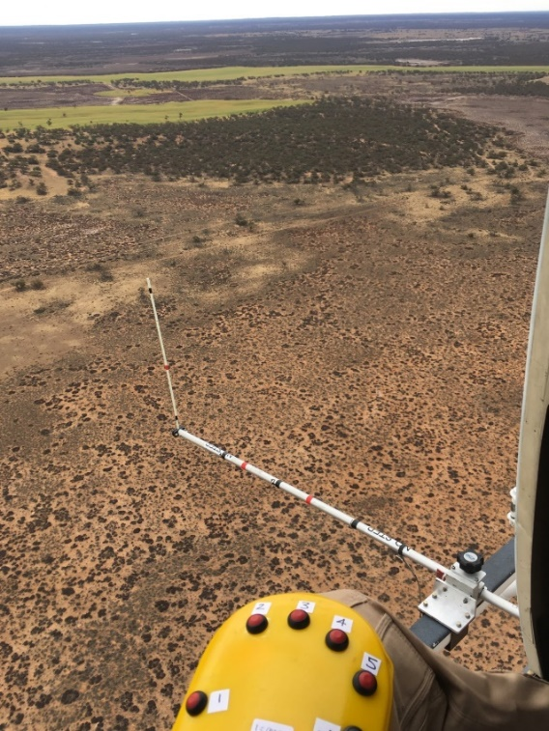

Figure 1: View from the helicopter conducting the aerial surveys

Credit: Michael Stead, EcoKnowledge

|  |  |
| --- | --- |
| © The State of Victoria Department of Environment, Land, Water and Planning 2019  LogoThis work is licensed under a Creative Commons Attribution 4.0 International licence. You are free to re-use the work under that licence, on the condition that you credit the State of Victoria as author. The licence does not apply to any images, photographs or branding, including the Victorian Coat of Arms, the Victorian Government logo and the Department of Environment, Land, Water and Planning (DELWP) logo. To view a copy of this licence, visit http://creativecommons.org/licenses/by/4.0/  ISBN 978-1-76077-029-7 (Online)  Disclaimer  This publication may be of assistance to you but the State of Victoria and its employees do not guarantee that the publication is without flaw of any kind or is wholly appropriate for your particular purposes and therefore disclaims all liability for any error, loss or other consequence which may arise from you relying on any information in this publication. | Accessibility  If you would like to receive this publication in an alternative format, please telephone the DELWP Customer Service Centre on 136186, email [customer.service@delwp.vic.gov.au](mailto:customer.service@delwp.vic.gov.au), or via the National Relay Service on 133 677 [www.relayservice.com.au](http://www.relayservice.com.au). This document is also available on the internet at [www.delwp.vic.gov.au](http://www.delwp.vic.gov.au). |