Our Wildlife Fact Sheet
  - Common Ringtail Possum

The Common Ringtail Possum is much smaller than the Common Brushtail Possum. It has a white tipped tail which acts like a fifth limb.

Scientific name
Pseudocheirus peregrinus
Did you know?
The Common Ringtail Possum has very good night vision.
The Common Ringtail Possum will eat its own faeces in order to get the maximum amount of nutrients available in eucalyptus leaves.
Description
The Common Ringtail Possum is smaller than the Common Brushtail Possum with a size ranging from 30-35 cm from the tip of the nose to the base of the tail. The tail itself is generally about the same length. They can weigh up to 1 kg.

Common Ringtail Possums are grey-brown to red-brown in colour, with a pale cream-white underbelly. Their ears are short and rounded with often a patch of white behind them.

Common Ringtail Possums’ eyes are brown. They have very long and sensitive whiskers and they have five clawed toes on each foot. The front feet have two “thumbs” to help with climbing.

The tail of the Common Ringtail Possum is prehensile meaning that it can grasp objects and act as another limb. The last third of the tail is always white and the underside of the tip is hairless. This tail is often used to carry nesting materials and to aid in balance.

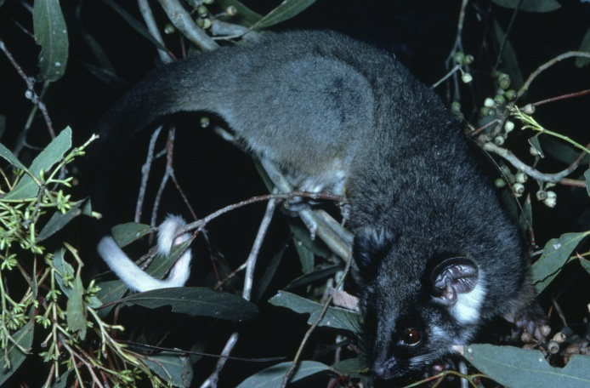Figure 1. Common Ringtail Possum © A. Houston DSE 2008
Diet
The main diet of the Common Ringtail Possum is eucalyptus leaves although they will eat other foods such as fruits, flowers and leaves of other native trees. They are also known to eat rose buds in suburban areas.

The Common Ringtail Possum is nocturnal and feeds exclusively at night.
Habitat
The Common Ringtail Possum can be found in rainforests, woodlands, eucalypt forests and suburban gardens.

They spend a great deal of their time in trees and have adapted well to living in suburban areas.

During the day, the Common Ringtail Possum will sleep in its soccer-ball-sized nest, called a drey, which will be located several meters high in dense foliage, sometimes with several other individuals.

They have been known to live in roofs of houses and sheds.

Distribution
The Common Ringtail Possum is found along the entire eastern part of Australia and south west Western Australia. They are also found throughout Tasmania.
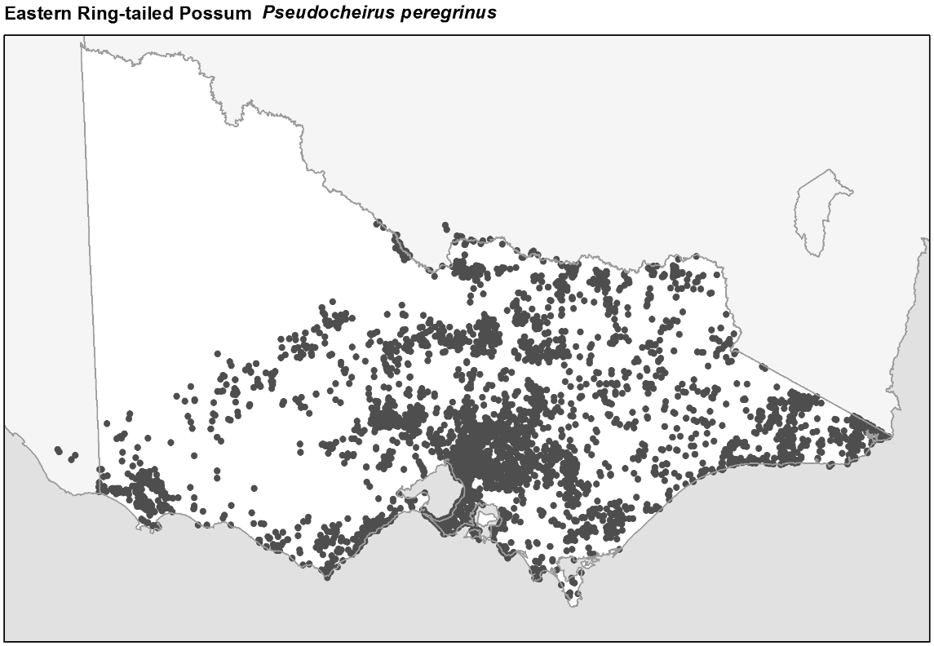

Figure 2. Recorded occurrences in Victoria
Source: Victorian Biodiversity Atlas (records post 1979) version 15/5/2017
Breeding
The breeding season for the Common Ringtail Possum is from April to November.

The male and the female both build the nest together. The nests are shaped similar to a soccer ball and are built in dense foliage of shrubs or in clumps of mistletoe. Common Ringtail Possums sometimes nest in tree hollows.

From 13 months of age the Common Ringtail Possum is sexually active. Gestation is 20-26 days, and one to two (sometimes three) babies are born. The young are born hairless and about the size of a jellybean. They usually have one litter per year in Victoria.

After the birth the young will crawl to the pouch of the mother. The young will leave the pouch after 7 weeks, and will instead ride on their mother’s back until they are weaned at about 6 months. Both parents take turns in caring for the young. The father will carry the young on his back while the mother is feeding.

The Common Ringtail Possum has large family groups of one male and one or two females from the previous breeding season that will forage and nest together
What you can do to help!
Common Ringtail Possums are prey for Powerful Owls when they are in trees, and on the ground they are vulnerable to attack by foxes, feral or unconfined domestic cats and dogs. They also suffer from urban development with many deaths from power lines.
Common Ringail Possums rarely enter roof space, but will sometimes gain access through loose tiles, loose roofing iron, broken eaves and holes in timber or brickwork. To avoid possums living in your roof, make sure these are covered up and there are no branches leading to your roof. Leave a gap between tree branches and the roof of a least 1.5 m.
Buy or make a nest box and install it in your garden as an alternative den site. Possums are territorial, so if one adopts the nest box it is likely to keep others away from your roof and garden area.
It is illegal to trap the Common Ringtail Possum without a permit. Report any illegal activity in regard to the Common Ringtail Possum to the DELWP Customer Contact Centre on 136 186.

All wildlife is protected in Victoria. Visit the DELWP website for more information regarding protected wildlife www.wildlife.vic.gov.au.
Further reading
Menkhorst, P.W. (ed), (1995), Mammals of Victoria, Oxford University Press, Melbourne.
Strahan, R. (ed.), (1995), The mammals of Australia, Reed Books, Australia.

