Help for Injured Wildlife Tool
Information for registered contacts
deeca.vic.gov.au

The Help for Injured Wildlife Tool is an online tool that provides the public with information and contacts who can help if they encounter sick, injured or orphaned wildlife in Victoria.
Eligible contacts can register on the Help for Injured Wildlife tool so that their contact details appear in relevant searches made by the public. Contacts must create an account on the tool and manage their listing to ensure their details are up to date.

Eligibility and contact types
Groups eligible to register as contacts are:
- Wildlife shelters and foster carers who hold a valid authorisation issued by the Department of Energy, Environment and Climate Action (DEECA)
- Registered veterinarians
- Rehabilitation and rescue organisations that can demonstrate:
- they are registered with the Australian Charities and Not-for-profits Commission, or
- they are an organisation that is not-for-profit, involved in wildlife rescue and/or rehabilitation and is not promoting unlawful activities.

Registration
To register as a contact, visit https://www.wildlife.vic.gov.au/injured-native-wildlife/help-for-injured-wildlife to submit a registration form. Your registration will be reviewed and verified in about five business days, and you will be notified of the outcome of your application via email.

Username and password
The email address you use during registration is your username, and you’ll need to create a password.
If you forget your password or want to update it, you can reset it via the forgotten password link on the account login screen.
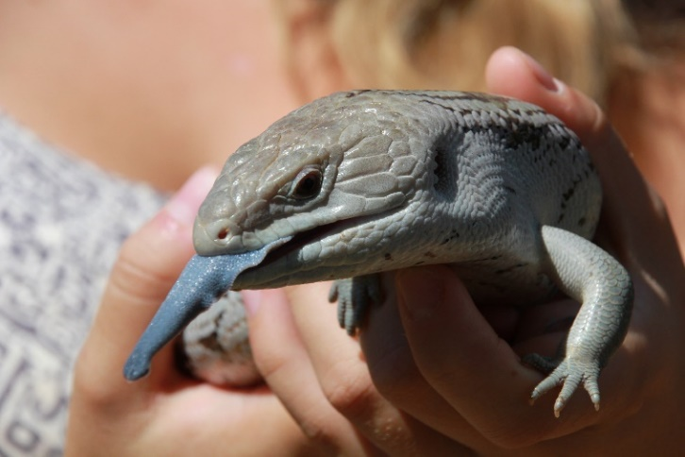

Required information
Your name, phone number, physical address (the specified premises that the relevant wildlife activity relates to), contact type and verification details are required to register on the tool.
You also need to specify the wildlife types you care for, your coverage area (by suburb) and hours of operation.

Optional information
You can choose whether you want your full address displayed to the public or just your suburb.
If you choose to display your full address it will be displayed on a map when you register, please ensure that the pin location shown for your address is correct.
If you are registering on behalf of your organisation, you may also enter your organisation’s name. Providing your website details is also optional.

Logging into your account and editing your details
Once you receive email notification that your account has been approved, use the link provided above to log in to your account with your username (email address) and password. From there, you can edit your contact details and other information, and view how your information will appear to the public. Updates to your account can take up to 24 hours to be processed.
You are responsible for making sure your details are kept up to date.
If you are taking holidays or would not like to be contacted for a period of time, you can update your hours of operation to reflect these changes. This allows you to remain in control of when your contact listing appears in a search. Don’t forget to update these details when you return.

Deleting your account
You need to be logged in to delete your account. After you delete your account, your information will no longer appear on the tool or return in a search result.
If you want to sign up again after deleting your account, you will need to re-register on the tool as deleted details cannot be retrieved.

How your listing will appear to the public
The public will search for help by entering the wildlife type and location, whether or not the animal is alive, and by selecting the scenario in which the animal has been found. The user will be presented with a list of the closest registered contacts who care for the type of wildlife requiring help.
The list will indicate the contact’s opening hours, the approximate distance from the user’s location and whether they operate state-wide.

Mapping feature
The tool also has a mapping feature that allows the user to view their closest contacts on a map. If you choose to display your full address, members of the public will be able to view your address as a pin on the map and get driving directions to your location.
If you choose not to display your full address, only your suburb will be visible, and the map will show the centre of your postcode area as your location.

I’m eligible for multiple registration types, which one should I choose?
Please choose one of the three registration types that is most relevant to you. Signing up to the tool with multiple accounts and user types is discouraged if the contact details (phone number and person answering the phone) are the same. This is so that the public are provided with a concise list of contacts and to minimise duplication of available help and services.
If you are a member of an organisation and prefer to get calls through the main phone number of that organisation and that organisation is registered already on the tool, then it is not necessary to register your individual shelter. However, if you are not affiliated with a wildlife rescue or rehabilitation organisation, you can register yourself individually as a shelter or foster carer (provided you have a valid authorisation from DEECA).

Help with the tool
If you experience issues accessing the registration form, editing your details, or have any general enquiries, please contact the Customer Contact Centre on 136 186 or email wildlife.policy@delwp.vic.gov.au.

Credit: Marcia Riederer.

We acknowledge Victorian Traditional Owners and their Elders past and present as the original custodians of Victoria’s land and waters and commit to genuinely partnering with them and Victoria’s Aboriginal community to progress their aspirations.
© The State of Victoria Department of Energy, Environment and Climate Action September 2023.
Creative Commons
This work is licensed under a Creative Commons Attribution 4.0 International licence, visit the Creative Commons website (http://creativecommons.org/licenses/by/4.0/).
You are free to re-use the work under that licence, on the condition that you credit the State of Victoria as author. The licence does not apply to any images, photographs or branding, including the Victorian Coat of Arms, and the Victorian Government and Department logos.
ISBN 978-1-76077-210-9 (print)
ISBN 978-1-76077-211-6 (pdf/online/MS word)
Disclaimer
This publication may be of assistance to you but the State of Victoria and its employees do not guarantee that the publication is without flaw of any kind or is wholly appropriate for your particular purposes and therefore disclaims all liability for any error, loss or other consequence which may arise from you relying on any information in this publication.
Accessibility
To receive this document in an alternative format, phone the Customer Service Centre on 136 186, email customer.service@delwp.vic.gov.au, or contact National Relay Service on 133 677. Available at DEECA website (www.deeca.vic.gov.au).

