|  |
| --- |
| Kurtonitj Koala Management Program November 2017 |

The Departmentof Environment, Land, Water and Planning (DELWP), in collaboration with Gunditj Mirring Traditional Owners Aboriginal Corporation, will deliver a two-week koala management program at Kurtonitj Indigenous Protected Area (IPA) from 13 to 24 November.

In parts of far south west Victoria, koala densities are high in Manna Gum areas. Koalas appear to be healthy and there are currently no known animal welfare issues, however over-browsing diminishes tree condition through defoliation.

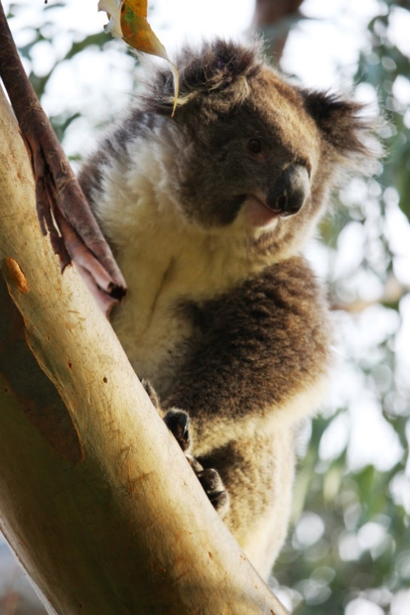

**A koala in a Manna Gum woodland**

## Koalas at Kurtonitj IPA

Kurtonitj is an Indigenous Protected Area within the Budj Bim Landscape; a significant heritage site in far south west Victoria.

Monitoring since 2013 has indicated that koala densities have been high and Manna Gum habitat health is declining on the IPAs across the Budj Bim Landscape.

The most recent population and habitat health monitoring in March 2017 found that there are 2.89 koalas per hectare at Kurtonitj and there has been a decline in habitat health.

Areas of Kurtonitj with the highest koala densities and declining habitat health will be the focus of the management program.

## Koala Management November 2017

DELWP Wildlife officers and crew, Winda-Mara rangers and vets will be involved in the November koala management program.

The aim of the management program is to conduct health checks and fertility control of as many koalas as possible, including translocation of 100 koalas to Mt Napier State Park. This is a small-scale management program designed to proactively alleviate some of the koala browsing pressure of areas with significant over browsing, as much as possible, in the short-term.

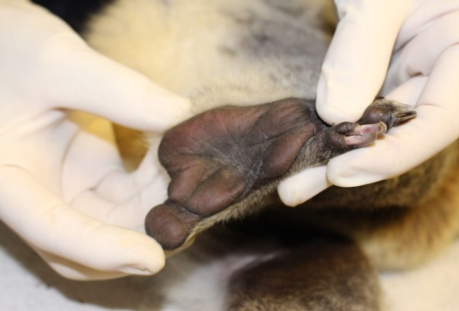

**Vets assess the body condition and health of individual koalas**

All captured koalas will have a health assessment by a qualified veterinarian team experienced in koala management. Female koalas that weigh over two kilograms will be fertility controlled. Any koalas assessed by the veterinarians as having a body condition score < 3 (i.e. poor health) or significant health issues including genetic abnormalities will be humanely euthanised.

During the management program, up to 100 koalas will be translocated to Mt Napier State Park - 2,800 ha of public land approximately 50km north-east of Kurtonitj. This site has been identified as a suitable location for translocation of koalas from Kurtonitj as it has similar vegetation, topography, soil type and aspect, and lower koala densities (approximately 1 koala per hectare). Parks Victoria monitors the area, koala population and impacts.

DELWP would like to extend our sincere thanks to the Gunditj Mirring Traditional Owners, Parks Victoria and for their cooperation and contribution this management program at Kurtonitj.

## Next steps – koalas in the landscape

DELWP has been engaging with local landholders, carers, blue-gum plantation industry, Parks Victoria, Glenelg Shire, Glenelg Hopkins Catchment Management Authority, Portland Field Naturalists Club, Greening Australia and Gunditj Mirring Traditional Owners Aboriginal Corporation through the Far South West Stakeholder Group on koala management issues including Kurtonitj.

The department has developed strategic long-term approaches for the management of koalas in the BSW region including the Far South West. Any future koala management in the region will be guided by these approaches, which are informed by the learnings of the previous programs (e.g. DELWP’s Cape Otway koala management program), monitoring and research into koala populations and habitat health, and engagement with our stakeholders.

Additionally, data from the Kurtonitj IPA management program will be an input into longer term management approaches for koala over abundance and over browsing in the far south west.

The ongoing management of koala populations and their habitat will require the continued collaboration between key stakeholders, including land owners, across private and public land.

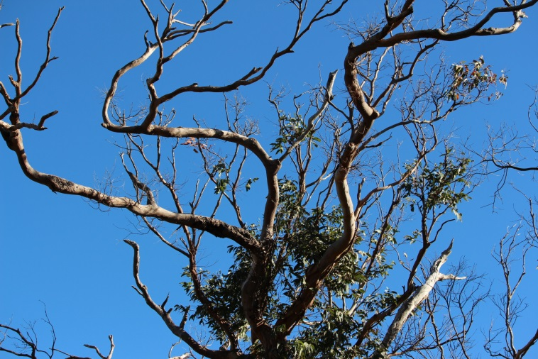

**Over-browsing by koalas defoliates Manna Gum woodlands**

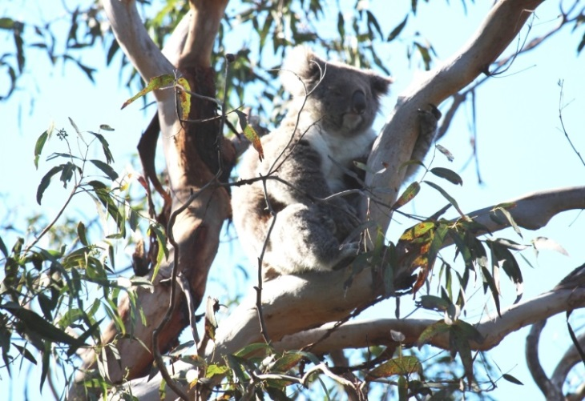

Victorian koalas are reluctant to move from a favourite food source - Manna Gums

|  |  |
| --- | --- |
| © The State of Victoria Department of Environment, Land, Water and Planning 2017  LogoThis work is licensed under a Creative Commons Attribution 4.0 International licence. You are free to re-use the work under that licence, on the condition that you credit the State of Victoria as author. The licence does not apply to any images, photographs or branding, including the Victorian Coat of Arms, the Victorian Government logo and the Department of Environment, Land, Water and Planning (DELWP) logo. To view a copy of this licence, visit http://creativecommons.org/licenses/by/4.0/  Disclaimer  This publication may be of assistance to you but the State of Victoria and its employees do not guarantee that the publication is without flaw of any kind or is wholly appropriate for your particular purposes and therefore disclaims all liability for any error, loss or other consequence which may arise from you relying on any information in this publication. | Accessibility  If you would like to receive this publication in an alternative format, please telephone the DELWP Customer Service Centre on 136186, email [customer.service@delwp.vic.gov.au](mailto:customer.service@delwp.vic.gov.au), or via the National Relay Service on 133 677 [www.relayservice.com.au](http://www.relayservice.com.au). This document is also available on the internet at [www.wildlife.vic.gov.au](http://www.wildlife.vic.gov.au). |