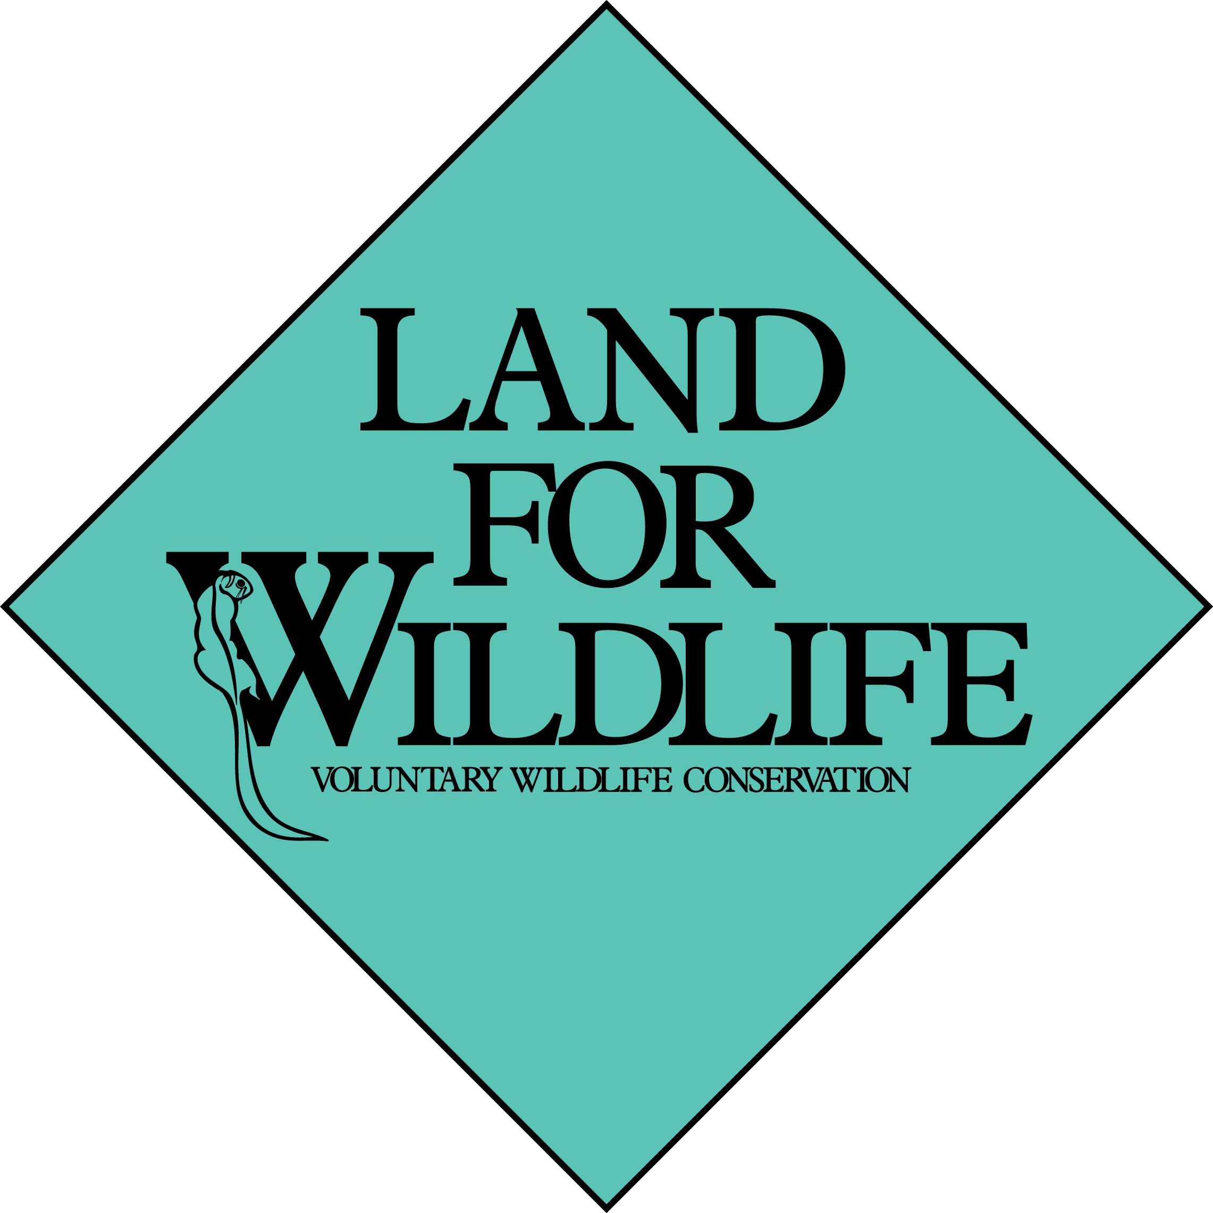

Land for Wildlife Application Form

Applying for Land for Wildlife is easy.
Simply follow these 3 steps:

- Save a copy of this application form to your computer
- Complete the form with your details
- Email it to LFW@delwp.vic.gov.au .

A Land for Wildlife officer will contact you as soon as possible
to discuss your application with you.

Name:

Postal Address:

Daytime Telephone & Mobile (if applicable):
Email (if applicable):

Organisation (if applicable):

Date of application:

I/we wish to apply for Land for Wildlife registration for the property at:
Property name:

Property Location:

Size of whole property:

First application? | Yes / No ?
(Optional) How much and what type of remnant vegetation do you have? Do you have any threatened species?
It would assist us if you briefly note in the space opposite how you heard about Land for Wildlife? (e.g. Friend, neighbour, saw the sign, etc ….)

© The State of Victoria, 2023

wildlife.vic.gov.au/land-for-wildlife

