Our Wildlife Fact Sheet
  - Platypus

The Platypus is one of Australia’s most extraordinary looking animals. It has a bill and webbed feet like a duck, but is covered in thick fur and has a flattened tail like a beaver.
Scientific name
Ornithorhynchus anatinus
Did you know?
Platypus have eyes above their bill so they are not able see things directly below them.
Skin flaps cover the Platypus’ eyes and ears underwater which means it is temporarily blind when swimming. Instead, the Platypus uses its bill to feel its way and find food under water.
Platypuses’ back legs act as a rudder when swimming to help steer and change direction. The front feet have enlarged webbing that extends beyond the claws to provide power while swimming.
Male platypuses have venomous spurs on their back legs.
Platypuses have no teeth. Instead, they grind their food with hard plates on the upper and lower surfaces of the jaw.
Platypuses eat between 20 % and 50 % of their body weight each day in food. That is the equivalent of an adult human of 80 kg eating between 16 kg and 40 kg of food a day!
Description
The Platypus lives both on land and in water. It is approximately 50 cm in length and is covered in waterproof fur except on its feet and bill. The Platypus has dark brown fur on its back with light brown fur underneath.
Its body is streamlined, and along with short limbs and broad webbed feet, it is perfectly built for swimming. Each of its feet has five clawed digits. When swimming, it uses its front feet to paddle and its back legs to steer and change direction.
Figure 1. Platypus © I. Temby
Diet
The Platypus’ diet consists of a variety of insect larvae, yabbies, small fish and worms. Platypuses find their food amongst the rocks, leaf litter and other material on the bottom of the water body with their bill. They then store the food collected in large cheek pouches, and chew it when they reach the surface. Each dive usually lasts between 30 and 60 seconds.
Habitat
Platypuses can live in a range of freshwater bodies. They are mostly found where the banks are suitable for building stable burrows and where the water is shallow enough for them to dive down and feed on bottom-dwelling creatures. They also prefer areas where there are trees, shrubs and grassy banks. Occasionally, platypuses venture into saltwater near the mouths of rivers but they do not live in such areas.

The water temperature does not limit the distribution of Platypuses. They are able to regulate their own body temperature to cope with hot or cold environments. A Platypuses’ normal body temperature is 32 degrees, several degrees lower than ours.

Platypuses also spend time out of the water in burrows, or on rocks or logs. They use a number of different burrows for resting and breeding. The entrances to these burrows may be above or below the water level.

Platypuses are most active at night but may also feed in the early morning or late afternoon.
Distribution
Platypuses are widespread in Victoria, and are found in all areas except the Mallee where there are no permanent streams. Platypuses are still present in the Yarra River close to Melbourne

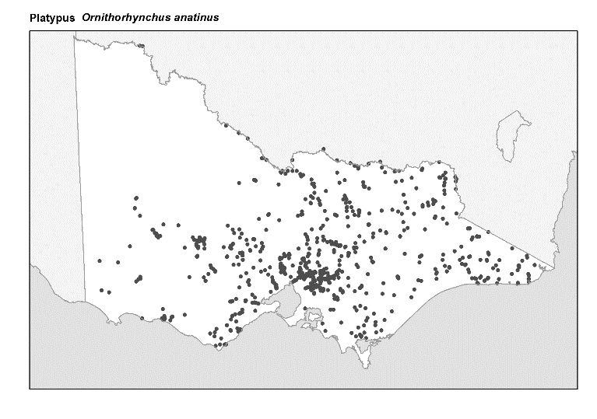
Figure 2. Recorded occurrences in Victoria
Source: Victorian Biodiversity Atlas (records post 1979), version 15/5/2017
Breeding
Platypuses breed between August and September. The female lays 2 – 3 eggs around September or October.

The eggs are laid in a deep burrow over 10 m in length. The eggs are incubated in this burrow for at least 10 days before hatching. The young are then suckled for 3 - 4 months. The young leave the nest around June/July.
Young Platypuses are known as puggles.
What you can do to help!
Don’t drop litter. Litter dropped on the ground can end up in the waterways that the Platypus depends on. Platypuses are often found injured by rubber, plastic or metal rings around their necks, or with wounds on their bills possibly from broken glass on the riverbed.

Always put your rubbish in a bin and make sure the bin lid is on tight, so rubbish doesn’t fall out and blow away.

Always pick up after your dog! Dog droppings can pollute waterways.

Check your car for leaking oil. One litre of oil on the ground can contaminate millions of litres of water.

Participate in ‘Clean up Australia Day’ and help to pick up rubbish in your area.

If you go yabbying, remember that the use of opera house nets is prohibited in public waters in Victoria. Opera house nets become a death trap to many animals, including Platypus, turtles and water-rats. Use a hoop net instead, it is much safer for our native amphibious mammals.

Further reading
Menkhorst, P.W. (ed), (1995), Mammals of Victoria, Oxford University Press, Melbourne.

