Our Wildlife Fact Sheet
  - Wedge-tailed Eagle

Australia’s largest raptor is the Wedge-tailed Eagle, which is truly a magnificent bird.

Scientific name
Aquila audax
Did you know?
The Wedge-tailed Eagle can carry up to 5 kg of prey through the air.
They can see in a larger range of colours than humans.
They prey on ground dwelling animals and will attack with a fast swooping motion usually killing their prey instantly.
The Wedge-tailed Eagle can reach altitudes higher than 2 km and soar in the air for up to 90 minutes at a time.
The call of the Wedge-tailed Eagle, a ‘pee-yaa’, is rarely heard.
Description
The Wedge-tailed Eagle has a wing span that can reach up to 2.8 m and will stand up to 1 m tall. They can weigh up to 5 kg. Females are generally larger than males.
Adults are a dark brown-black colour. Juveniles are a lighter brown with reddish brown heads and wings.
They have wedge-shaped tail feathers with feathered legs that run all the way to the base of the legs. The beak of the Wedge-tailed Eagle is pale pink to cream. Their eyes are dark brown to black.
The Wedge-tailed Eagle can live up to 20 years.
They have binocular vision in which they can pin point their prey from great distances. They can see 8 times more detail than humans can. In fact, their eyes have adapted to be able to squeeze and elongate their eyeball so that they can use their eyes similar to a zoom lens on a camera!
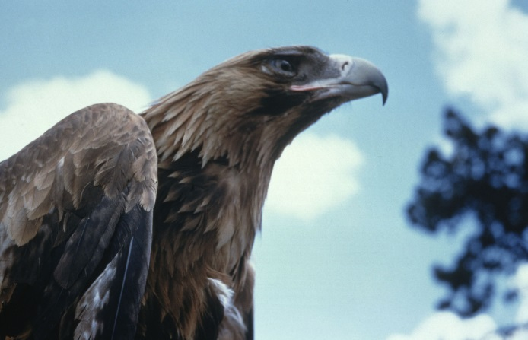
Figure 1. Wedge-tailed Eagle © I. McCann DSE 2009
Diet
The Wedge-tailed Eagle feeds on live prey that consists of rabbits, mammals, lizards, possums, foxes and feral cats.

Carrion (dead and decaying animals) is another major food source, such as road kill or dead stock.

Up to 40 birds have been recorded at a carcass, yet only 2 or 3 will feed at one time.

Wedge-tailed Eagles hunt alone or in groups. If hunting in groups, they have a greater chance of killing larger prey such as a kangaroo.

Wedge-tailed Eagles have been known to store food items near their nesting site.
Habitat
The Wedge-tailed Eagle prefers wooded, forested land and open county. They can also be found in mountains and near the sea.

They can be seen soaring in the air or perched high in trees or poles surveying their territory.
Distribution
The Wedge-tailed Eagle is found in mainland Australia including Tasmania, and New Guinea.

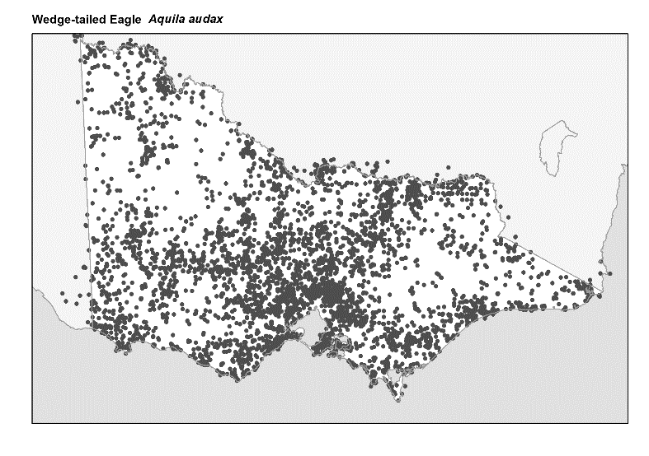
Figure 2. Recorded occurrences in Victoria
Source: Victorian Biodiversity Atlas (records post 1979), version 15/5/2017
Breeding
The Wedge-tailed Eagle’s breeding takes place from June to October depending on conditions.

They are monogamous meaning that they pair for life. During the breeding season, both the male and female groom each other and build the nest together.

The nests are constructed from sticks and leaves, often in the tallest tree in their breeding area. They will often use the same nest for years. The nest can be quite large; up to 2 m wide and 3 m deep.

The female lays between 1-3 eggs over several days. The female will incubate the eggs while the male lines the nest daily with fresh leaves. Sometimes the male will take over and incubate the eggs.

The eggs hatch within 45 days. Chicks emerge covered with a white down. The eggs can hatch at different times, so the first chick to hatch will be the biggest. This chick is usually the only one that survives, and sometimes even kills the other chicks! The parents feed the chicks for 5 weeks with the male hunting and the female shredding the food for the chicks.

Young leave the nest after 12 weeks, but don’t fully mature into an adult until 6-8 years.
What you can do to help!
Wedge-tailed Eagles are very common in Victoria. It has previously been believed that Wedge-tailed Eagles were responsible for killing livestock, as a result, they were once legally killed in large numbers. Research has since established that Wedge-tailed Eagles hardly ever attack healthy lambs and never fully-grown sheep.

Threats known to the Wedge-tailed Eagle are lack of nesting sites due to clearing of land, poisoning by eating animals that have died from pesticides and baits, as well as road vehicle accidents while they are eating carcasses on the road.

Report any suspected illegal activity regarding Wedge-tailed Eagles to the DELWP Customer Contact Centre on 136 186.

All wildlife is protected in Victoria. Visit the DELWP website for more information regarding protected wildlife www.wildlife.vic.gov.au
Further reading
Simpson, K. and Day, N., (2010), Field guide to the birds of Australia, (8th ed), Penguin Books, Australia.
Morcombe, M., (2004), Field guide to Australian birds, Steve Parish Publishing, Australia.

