Our Wildlife Fact Sheet
  - Bearded Dragon

Bearded Dragons are known for their distinctive flap of spiky skin under the jaw. When threatened, they open their mouths and push the flap forward to make a ‘beard’ to deter potential predators.

Scientific name
Pogona barbata

Did you know?
Bearded Dragons are a popular pet in Victoria. They are relatively easy to keep, quiet and don’t need much space. However, in order to keep one in captivity you will need a licence from DELWP.

Bearded Dragons use a variety of behavioural displays for courtship or defence. These include head bobbing, arm waving, head licking, pawing, biting and showing their beard. They can also change colour and puff up their bodies to appear larger in size.

Young Bearded Dragons spend most of their time in trees while the adults stay on the ground.

Like all reptiles, Bearded Dragons rely on the warmth from the sun to regulate their body temperature. They can often be found basking on rocks and logs or on roadsides and fence posts.

Males are territorial and permit only females and juveniles into their territory.

Bearded Dragons can be mistaken for the Frilled-neck Lizard but if you look closely you will see the frill is much shorter and spikier on the Bearded Dragon. Frilled-neck Lizards are only found in tropical northern Australia.

Description

Bearded Dragons are a large and robust lizard growing to about 45 – 60 cm from head to tail.

Their colour can vary from grey to brown although they can occasionally be yellowish brown. They’re pale underneath, and when puffed up will show a yellow mouth lining.

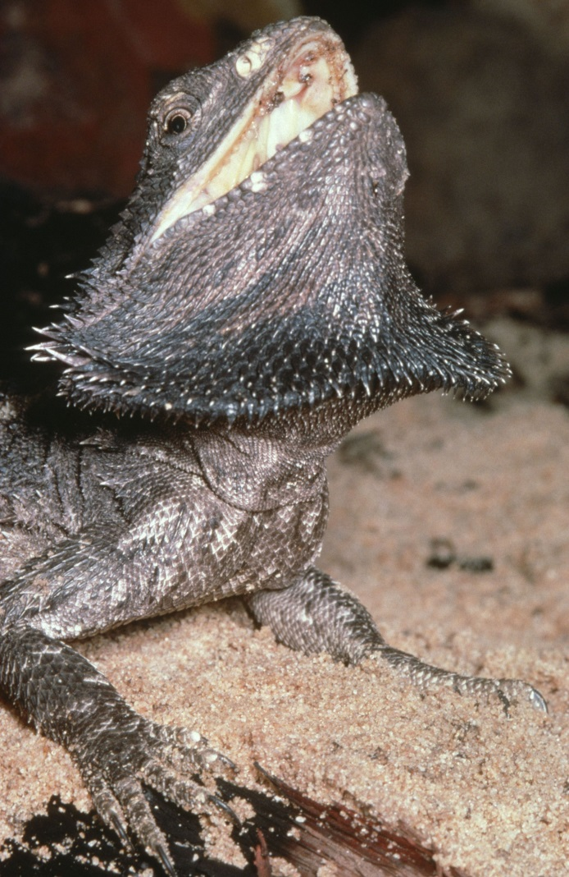 Figure 1. Bearded Dragon © I. McCann DSE 2008

Their skin is covered in scales with spiky spines from the head to tail. These spines can change colour to match the colour of the soil or their mood.

Patterns are visible on the young but fade as they mature. You can distinguish a mature male by a dark grey to black beard.

The head is roughly triangular in shape.

Diet

Bearded Dragons are omnivorous, meaning they eat a wide variety of food from leaves, fruits, berries and flowers to insects, small lizards and snakes.
Habitat

The preferred habitat of Bearded Dragons are trees in woodlands and dry sclerophyll (Eucalyptus) forests where they can observe their territory, catch prey, bask in the sun and sleep.

They can occasionally be found in suburban gardens but these are usually pets that have escaped from their owners.
Distribution

Bearded Dragons are generally found in the warmer parts of Victoria, north of Melbourne.
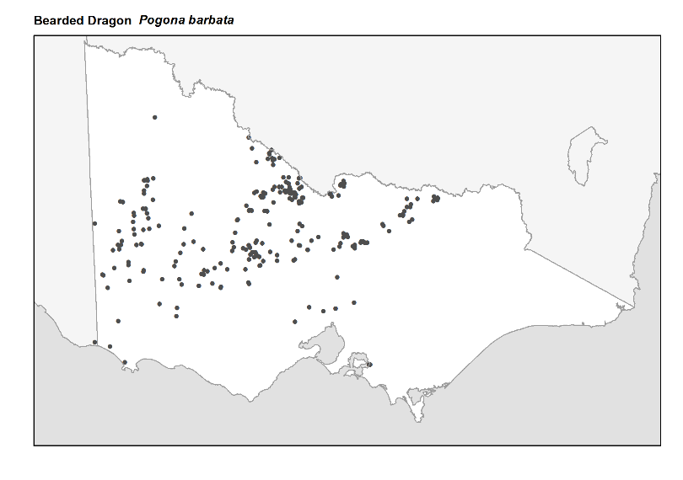Figure 2: Recorded occurrences in Victoria
Source: Victorian Biodiversity Atlas (records post 1979), version 15/5/2017
Breeding
Breeding begins with the onset of warmer weather each year, usually around late August to September.

Males compete for female attention using various forms of display such as head bobbing and showing the beard.

Females lay about 20 eggs. To do this, she will bury herself in a hole and resurface once the eggs are laid. The eggs incubate for 45 - 70 days before they hatch.

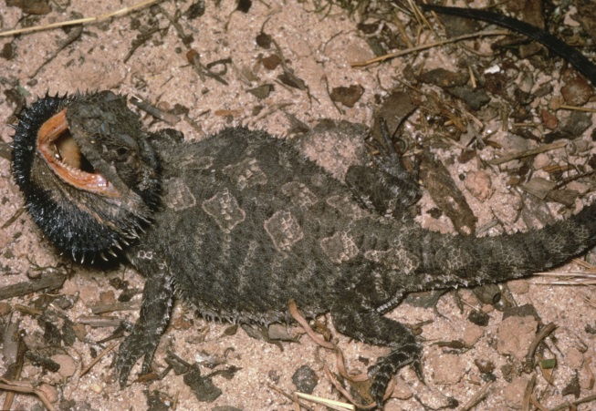
Figure 3. Bearded Dragon © I. McCann DSE 2008

What you can do to help!
Bearded Dragons make great pets, however as they are protected by law, you will need a licence to buy one from a pet shop or wildlife dealer. To find out more about keeping reptiles in Victoria, please visit the DELWP website at: www.wildlife.vic.gov.au.

Be careful when on the road as Bearded Dragons like to bask on warm surfaces and can’t move quickly to avoid you.

If you see a Bearded Dragon in your yard, reduce the amount of garden chemicals used as they may eat sprayed vegetation or snail bait and become sick.

Further reading
Cogger, H.G., (2000), Reptiles and amphibians of Australia (6th ed.), Reed New Holland, Sydney.
Wilson, S.K. and Knowles, D.G., (1988), Australia’s reptiles, Collins, Sydney.

