Our Wildlife Fact Sheet
  - Tiger Snake

Victoria is home to some of the most venomous snakes in the world and the Tiger Snake is no exception.
While we need to be careful around these animals, they are an important part of our environment and need to be respected and conserved.
Scientific name
Notechis scutatus
Did you know?
Tiger Snakes are named after their tiger like stripes. However, some Tiger Snakes do not have any stripes at all.
Tiger Snakes are one of the most venomous snakes in the world.
Their fangs are usually 3.5 – 5 mm in length.
They can move through water with ease.
When they feel threatened, they raise themselves off the ground and flatten their heads and neck, almost like a cobra.
Description
Tiger Snakes are thick-bodied solid snakes; they are usually around 1 m long but may grow up to 1.5 m. Their head is slightly wider and distinct from their neck.
Tiger Snakes main body colour ranges from grey-brown to black. However, their body colouration cannot be used as a sole method of identification, as there are many variations.
Tiger Snakes are often marked by a series of dark brown and yellow-brown bands, but they may or may not be present. Their underbelly is generally lighter than the main body and un-banded.
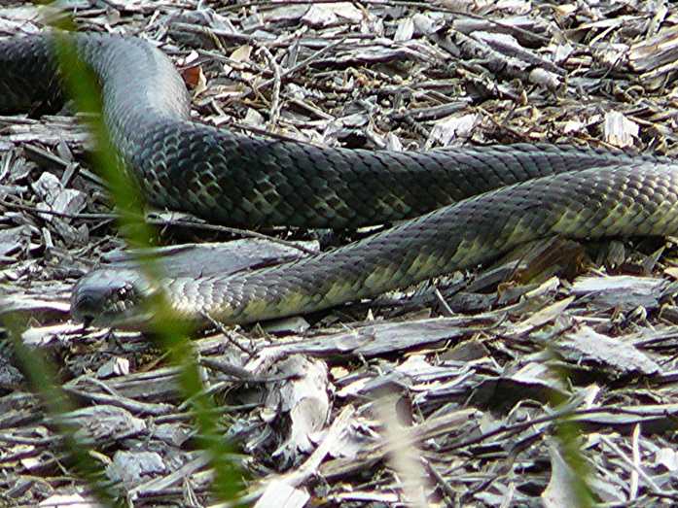
Figure 1. Tiger Snake © A. Houston DSE 2008
Diet
A Tiger Snake’s diet comprises of a wide range of food sources. They primarily eat frogs, but they also consume other reptiles, birds, small mammals and fish.
Powerful chemicals in their venom help break down prey in their stomach. Warmth from the sun also aids in digestion of food.
Habitat
Tiger Snakes can be found in a range of habitats. They are most often seen near creeks, rivers or swamps.
Tiger Snakes are normally a ground-dwelling snake, but they have been recorded climbing small trees and shrubs.
Tiger Snakes cannot maintain a constant body temperature without help from their environment. This means that they use the sun’s warmth to raise their body temperature.
Tiger Snakes are active during the day and also during the night in warmer weather.
Tiger Snakes spend the cooler months sheltering in hollow logs, rodent burrows or other suitable sites.

Distribution
The Tiger Snake is distributed across the south-eastern coast of Australia, including southern Queensland, eastern and southern New South Wales, Victoria and south-eastern Australia.
In Victoria, Tiger Snakes can be found across a large area of the state. They are generally absent from the lower rainfall parts of the state and are frequently found in the suburbs around Melbourne, particularly in the western suburbs.
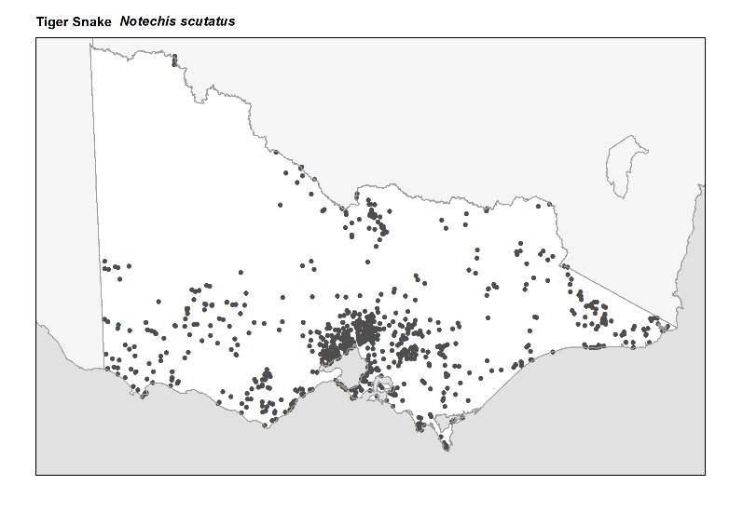
Figure 2. Recorded occurrences in Victoria
Source: Victorian Biodiversity Atlas (records post 1979), version 15/5/2017.
Breeding
Tiger Snake mating occurs throughout the summer and reaches a peak in late January and February. Females give birth to live young.
Females give birth to a litter of between 15-20 snakes, usually in late summer or early autumn. Tiger Snakes are around 10 cm long when born.
Female Tiger Snakes provide no maternal care to their young once they are born. In ideal conditions, females reproduce every second year.
What you can do to help!
Remember that snakes are an important part of the ecosystem; they act as predators, reducing populations of overabundant pest species such as rats and mice.
Snakes normally avoid people, but if they feel threatened, disturbed or surprised, they may attack. If provoked or cornered, Tiger Snakes may bite.
All Tiger Snakes should be regarded as highly venomous and dangerous to humans.
To reduce the chance of encountering a snake around your home, keep grass very short and remove piles of rubbish and wood.
Never attempt to move a snake yourself. If there are unwanted snakes around your home, call DELWP’s Customer Service Centre on 136 186 and ask for a list of snake controllers in your area. These people are licensed to safely remove the reptile from the area.
Snakes are protected under the Wildlife Act 1975. Do not attempt to kill a snake; it is illegal and you are more likely to get hurt.

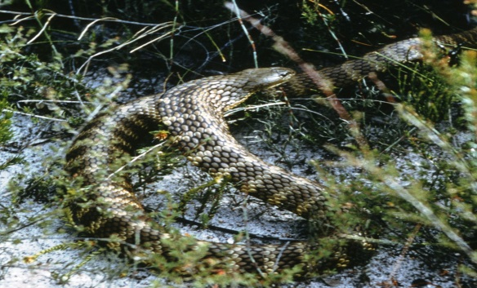 Figure 3. Tiger Snake © I. McCann DSE 2008
Further reading
Cogger, H.G., (2000), Reptiles and amphibians of Australia (6th ed.), Reed New Holland, Sydney.
Wilson, S.K. and Knowles, D.G., (1988), Australia’s reptiles, Collins, Sydney.

Never attempt to approach or handle a snake.
All snakes should be considered venomous and highly dangerous.
If bitten by a snake dial 000 immediately.

