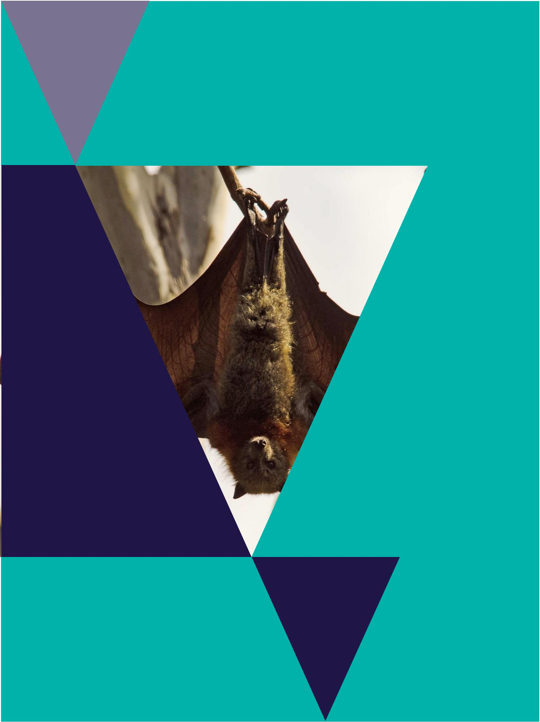
Wildlife Rehabilitator Grants 2017/18

Funding Guidelines

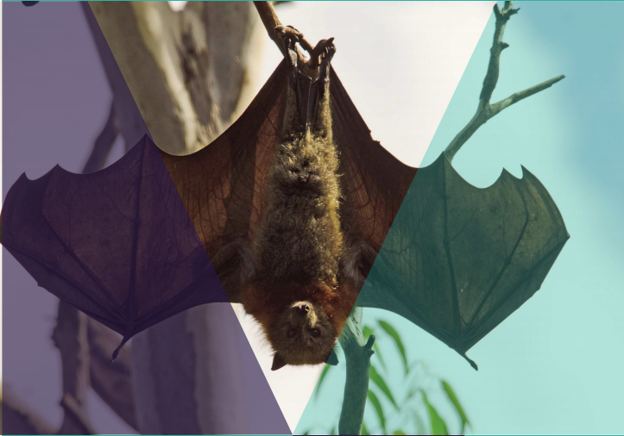

Photo credit

Cover: Nick Talbot

© The State of Victoria Department of Environment, Land, Water and Planning 2017


This work is licensed under a Creative Commons Attribution 4.0 International licence. You are free to re-use the work

under that licence, on the condition that you credit the State of Victoria as author. The licence does not apply to any images, photographs or branding, including the Victorian Coat of Arms, the Victorian Government logo and the

Department of Environment, Land, Water and Planning (DELWP) logo. To view a copy of this licence, visit http://creativecommons.org/licenses/by/4.0/

ISBN 978-1-76047-916-9 (pdf)

Disclaimer

This publication may be of assistance to you but the State of Victoria and its employees do not guarantee that the publication is without flaw of any kind or is wholly appropriate for your particular purposes and therefore disclaims all liability for any error, loss or other consequence which may arise from you relying on any information in this publication.

Accessibility

If you would like to receive this publication in an alternative format, please telephone the DELWP Customer Service Centre on 136186, email customer.service@delwp.vic.gov.au or via the National Relay Service on 133 677 www.relayservice.com.au. This document is also available on the internet at www.wildlife.vic.gov.au.

Minister’s Foreword


Victoria is home to a variety of beautiful and unique wildlife, and throughout the last nine years the Wildlife Rehabilitator Grants program has supported wildlife shelter operators and foster carers in protecting and rehabilitating our native fauna.

Environmental impacts such as bushfires, flooding and ecosystem imbalance can endanger our native wildlife – so the care and expertise of rehabilitators is imperative.

This year, as a result of feedback from consultation between the Department of Environment, Water and Planning and the community,

I am very pleased to announce that the funding limit for consumable items has been increased to $1000 per applicant.

The total allocation for the 2017/18 grants is $170,000 and individual applicants can access up to $2000 each with the funding amount to be based on applicants’ needs, experience, performance and past funding allocation.

This year, the Guidelines have been updated and a series of Frequently Asked Questions made available to add further clarity and transparency to the application process.

The Victorian Government values the important contribution of shelter operator and rehabilitators to our natural environment and biodiversity. These grants are designed to assist rehabilitators with training – and the purchase of equipment, infrastructure and consumable items.

Keep up the good work in protecting and rehabilitating our precious Victorian wildlife.


Hon Lily D’Ambrosio MP

Minister for Energy, Environment

and Climate Change

Wildlife Rehabilitator Grants 2017/18 | 3
Funding Guidelines

What is the Wildlife Rehabilitator Grants Program?

The Victorian Government’s Wildlife Rehabilitator Grants Program provides funding to support wildlife rehabilitators including shelter operators and foster carers, to purchase a range of equipment and infrastructure to assist with the operation of their facilities and to attend appropriate training.

The program aims to help wildlife rehabilitators:

- increase their knowledge/skills in the care of wildlife

- improve their facilities to treat, house and rehabilitate wildlife for release

- improve the standard of wildlife care they provide for specialist species (e.g. raptors) or threatened species (e.g. brush tailed phascogales).

Who can apply?

Wildlife rehabilitators in Victoria who:

- hold a current permit as a shelter operator or foster carer for at least two (2) years

- have no convictions for fraud or convictions under the Wildlife Act 1975 or the Prevention of Cruelty to Animals Act 1986 during the past ten years

- have submitted all Completion Statements for previous funding under this program and have no outstanding compliance requirements

- have the consent of the property owner.

How much can I apply for?

The 2017/18 grants are capped at $2,000 per applicant.

The amount granted may be less than this depending on the purpose for which it is to be used, the amount sought, the number of applications received and how well the application meets the assessment criteria.

Tips on applying for grants


1. Read the guidelines carefully.

This document is updated each year and items that were eligible last year, may not be eligible this year. Be clear on how your project aligns with the guidelines.

If you are unsure about anything in this document, please contact either the Victorian Grants Information Line 1300 366 356 or DELWP by emailing: enviro.grants@delwp.vic.gov.au.

2. Find out the limit of the grants.

Applicants that apply for more than the available funding limit may not be successful.

3. Start early!

A well thought out, well written application will give your project proposal the best chance of success.

4. Put yourself in the assessors’ shoes.

Be clear about the who, what, where, when, why and how of the proposal. It might be worthwhile getting an external person to read over the application to see if it clearly describes your proposed project.

Do not put acronyms into a funding application. The use of acronyms may confuse readers particularly if they know nothing about your project.

5. Be thorough with the budget.

Assessors will usually have a good idea of what training and equipment are worth. If an item is unusually expensive, explain why (e.g. fencing costs more due to wombat enclosure that requires additional materials).

6. Competitive grants

The Wildlife Rehabilitator Grants are competitive grants and are scored in accordance with specific assessment criteria. Not all applications that meet the minimum criteria will be funded.

7. Frequently Asked Questions

Please read the Frequently Asked Questions document prior to applying which can be found at www.wildlife.vic.gov.au/grants/wildlife-rehabilitator-grants

- Wildlife Rehabilitator Grants 2017/18 Funding Guidelines

What will be funded? What will not be funded?

If eligible, you can receive funding for:

- Education and training which may be competency based training delivered by a registered training organisation or any other approved training. N.B. these must be held within the grant period.

- General infrastructure and equipment to assist with the operation of wildlife facilities, e.g. build a wombat enclosure, buy an aviary; buy portable cages. It is a requirement that you provide a quote and design dimensions for any proposed enclosures to be constructed, to assist the Advisory Panel in determining the outcome of the application.

- Other equipment relevant to wildlife rehabilitation including non-fire Personal Protective Equipment (PPE) (not consumable items).

- Consumable items (capped at $1,000 as part of the maximum grant allocation), e.g. feed, petrol, veterinary fees and veterinary supplies.

Funding for other items (other than those excluded) will also be considered by DELWP on merit providing there is enough information to justify the purchase.

Please note that Personal Protective Equipment (PPE) for use while handling wildlife is allowed, however PPE for fire response activities will not be funded this round.

Tax Implications

Please note that there may be tax implications resulting from the receipt of grant funds.

It is strongly recommended that Applicants consult the Australia Taxation Office or seek professional advice on any taxation implications that may arise from participation in this grant funding.

If your application is successful and you are applying as an individual and don’t have an ABN, you will need to provide the Australian Taxation Office form called ‘Statement by Supplier: (Reason for not quoting an ABN)’ as part of your funding requirements.

- Utility costs such as rates, electricity, water, gas and sewerage bills or insurance.

- Vehicles including trailers, boats, computers, laptops, tablets and mobile phones.

- Surgical equipment, microscopes, darting equipment, chainsaws, mulchers and freezers and PPE for fire related purposes.

- Infrared and motion-sensing surveillance cameras, radio telemetry, scheduled capture chemicals, firearms including captive-bolt guns and darting related equipment and training courses.


Important dates

The grants are open from Wednesday 20th December to Wednesday 7th February

2018. For more information visit the Department of Environment, Land, Water

and Planning (DELWP) website:

www.wildlife.vic.gov.au/grants/wildlife-rehabilitator-grants

Please note that annual shelter operator and foster carer permits recently expired on 30 June 2017 and you must renew your authorisation if you wish to remain eligible for a grant. Please provide your permit number when applying so we can confirm you are still an authorised carer until 30 June 2018.
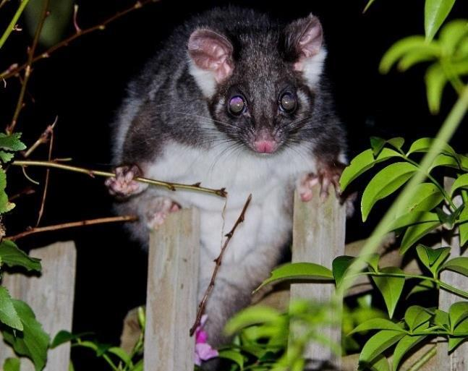

Credit: Nick Talbot

Wildlife Rehabilitator Grants 2017/18 | 5
Funding Guidelines



How can I apply?

Current authorised wildlife shelter operators and foster carers will receive a letter inviting them to apply.

The letter has details of the Department of Environment, Land, Water and Planning website where you can apply.

To apply, go to:

www.wildlife.vic.gov.au/grants/wildlife-rehabilitator-grants

Make sure you have responded to all application information requirements and provided all the necessary documents. Late applications will not be accepted.

What happens next?

Submit your application by the closing date.

Your application will be assessed for eligibility and recommendations will be forwarded to the Minister for Energy, Environment and Climate Change for approval. You will be advised in writing if your application is successful or not.

Note: eligibility does not guarantee that you will be funded. The Wildlife Rehabilitator Grants Program aims to support a range of different applications and this will be considered in the assessment process.

See page 7 for more information on items that may be funded and items that will not be funded.
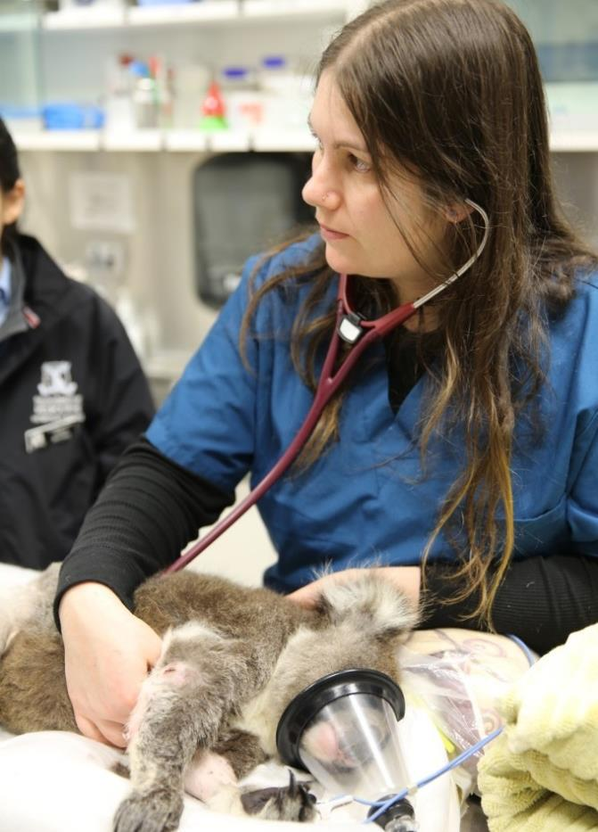

How will applications be assessed?

Applications will be considered against the following criteria as well as value for money:

- How well your project meets one or more of the program’s aims.

- Your level of need for funding.

- How many and what type of animals you treat.

- Your wildlife rehabilitation experience and knowledge.

- Whether you have received funding from us in the past 3 years.

- Previous performance and whether you have met all your previous funding agreement requirements or have any outstanding regional compliance issues.

Please note that the Wildlife Rehabilitator Grants are competitive grants and are scored according to specific assessment criteria. Not all applications that meet the minimum criteria will be funded.

Credit: Zoos Victoria


For more information

Contact DELWP by emailing:

enviro.grants@delwp.vic.gov.au, by phoning the Victorian Grants Information Line 1300 366 356 or visiting the DELWP website: www.wildlife.vic.gov.au/grants /wildlife-rehabilitator-grants

- Wildlife Rehabilitator Grants 2017/18 Funding Guidelines

Table 1: Eligible items

What items may be funded?

Training/Education | General Infrastructure | Other items | Consumables

- first aid training

- conferences

- workshops

- reference manuals

- 4WD training (must be accredited)

- TAFE courses (must relate to wildlife rehabilitation)

- Books (you must list the name/s of the books to help assessors)

- enclosures

- fencing

- aviaries

- incubators

- portable cages

- plumbing of water to pens

- rescue equipment

- shelters

- water enclosure or pond

- heat boxes

- climbing equipment & ladders

- binoculars

- spotlights

- GPS (up to $300)

- shelter signage

- first aid kits

- other items deemed appropriate and not listed on the ineligible items list below.

- personal protective equipment for animal handling (eg gauntlets, eye protection, etc)

- veterinary fees

- veterinary supplies

- milk formula

- petrol

- food

- nursing pads

- cleaning products (disinfectant, hand wash, hand sanitiser, tissues, etc)

- medications such as cydectin

- vaccinations or booster costs for lyssavirus

Table 2: Ineligible items

What items will NOT be funded?

Training/Education | General Infrastructure | Other items | Consumables

• firearms purchase | • trailers | • computers & laptops
• firearms licence | • 4wd purchase | • registrations
• firearms training | • vehicle servicing | • vehicle servicing and
• captive bolt or any | • motorbike purchase | maintenance
darting purchase, | • purchasing of land | • chainsaws including pole
training or equipment | • purchasing of land | chainsaws
 |  | • mulchers
 |  | • infrared and motion-
 |  | sensing surveillance
 |  | cameras
 |  | • radio telemetry
 |  | • personal protective
 |  | equipment for fire related
 |  | activities

- utility costs including rates, electricity, water, gas and sewerage bills

- vouchers (petrol, food, etc)

- insurance

- scheduled chemical capture drugs listed in Schedule 4 and 8 in the Drugs, Poisons and Controlled Substances Regulations 2006.

Please note that receipts for all purchases will need to be kept this year.

Wildlife Rehabilitator Grants 2017/18 | 7
Funding Guidelines



wildlife.vic.gov.au

