Koalas at Cape Otway

Cape Otway Koala Management Actions – Spring Program, 2016

DEWLP recently carried out another koala management program at Cape Otway.

In line with the Cape Otway Koala Management Actions, 2015 DELWP has implemented a range of measures aimed to achieve a vision of healthy habitats and a population of healthy koalas at Cape Otway.
Since May 2015 DELWP has undertaken the following;
- Koala health assessment in May, 2015,
- Koala welfare intervention and trial translocation in September, 2015,
- Large scale translocation and fertility control program in November and December 2015,
- Fertility control and health check program May 2016,
- Monitoring of trial translocated koalas, and
- Habitat mapping and species distribution modelling.
- Fertility control, health check and translocation November/December, 2016
As a result of these programs, overall koala health and conditions at Cape Otway have improved, however, some areas of high koala densities still remain. This highlights the need for further programs.

The recent Cape Otway Spring koala management program
The aim of the recent Spring management program was to conduct a fertility control, health check and translocation of koalas from Cape Otway to north of Lorne within the Great Otway National Park. The Spring program aimed to reduce the koala population at areas of high densities and declining canopy cover to assist the Manna Gum woodland to recover.
A total of 344 koalas were captured and assessed. Of those checked, 100 healthy females were fertility controlled and 236 koalas were translocated to suitable habitat in the Great Otway National Park. All captured animals were in good condition. There were 29 koalas which our veterinarian determined to have significant health issues and genetic abnormalities. These animals were humanely euthanased to prevent further suffering. There were no orphaned back young during the delivery of the program.
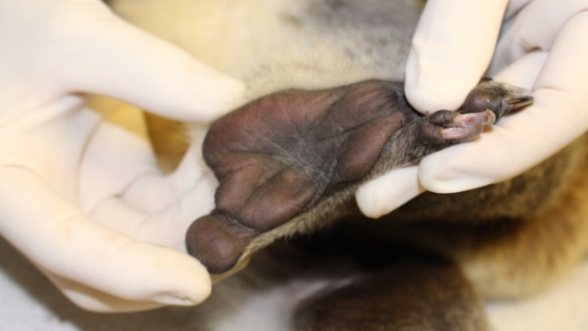
Vets assess the body condition and health of individual koalas.

All efforts were made to ensure female koalas were not translocated if they were pregnant, or carrying female pouch or back young under two kilograms. All translocated females and female back young over two kilograms were fertility controlled prior to translocation.
The program aimed to maximise the percentage of fertility controlled female koalas within the population and minimise the percentage of the population that can breed over the summer.
What further programs are planned at Cape Otway?
Results from past programs, along with further monitoring of koala densities and habitat health assessments will be used to inform future koala management programs at Cape Otway.
Thank you
DELWP would like to extend our sincere thanks to the Cape Otway community especially local landowners, businesses, the Conservation Ecology Centre and other research partners, for their cooperation during the fertility control, health check and translocation programs at Cape Otway.

