Threatened species/breeding waterbird colonies third party report

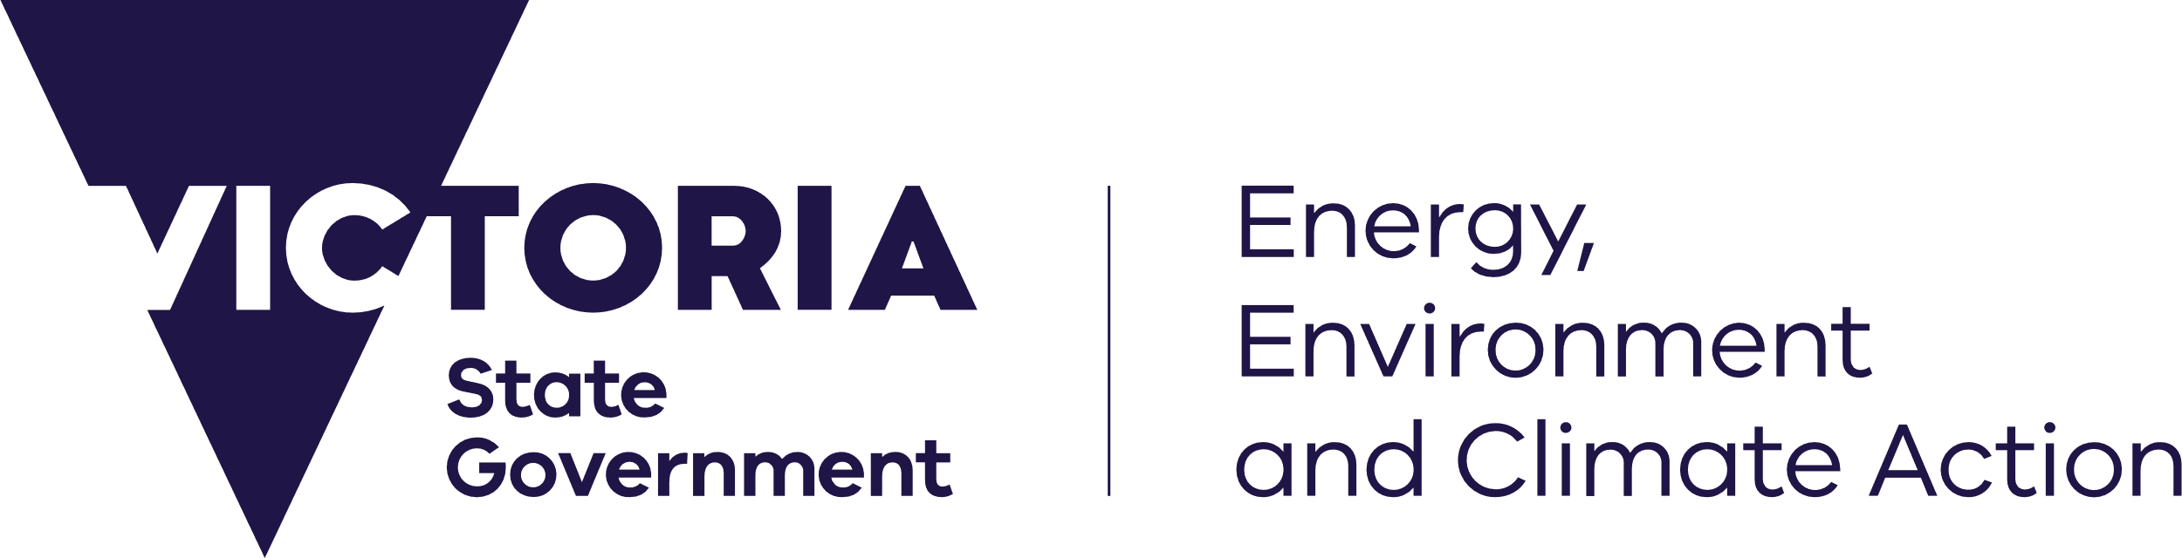
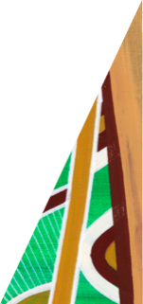
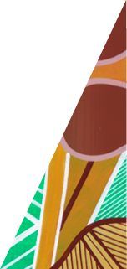
deeca.vic.gov.au

Instructions
Please complete this form if you have observed significant numbers of threatened species or breeding waterbird colonies at a wetland open to duck hunting and wish to make a third party report to the Department of Energy, Environment and Climate Action and the Game Management Authority.
Please ensure all details are completed so that your report can be investigated. Please provide a contact phone number or email address so that we can get in touch with you if we need more information to verify your report.
Completed forms can be emailed to: wildlife.policy@delwp.vic.gov.au. Please ensure you include ‘third party report’ in the subject line so that your report can be considered promptly.

Reporter details
Name of person making report: | Click or tap here to enter text.
Organisation name (if applicable): | Click or tap here to enter text.
Contact number: | Click or tap here to enter text.
Email address: | Click or tap here to enter text.

Observation details
Date observed: | Click or tap to enter a date.
Time observed: | Click or tap here to enter text.
Wetland name: | Click or tap here to enter text.
Wetland location (address or GPS coordinates): | Click or tap here to enter text.
Species observed: | Click or tap here to enter text.
Number of each species observed: | Click or tap here to enter text.
Other observation details (e.g. colonial breeding waterbirds, specific location of birds in wetland etc.): | Click or tap here to enter text.

