Our Wildlife Fact Sheet
  - Common Blue-tongued Lizard

Have you ever wondered why a Common Blue-tongued Lizard has such a bright blue tongue? Read on to find out why.
Scientific name
Tiliqua scincoides scincoides
Did you know?
Common Blue-tongued Lizards (“Blue-tongues”) are named after their bright blue fleshy tongue, which contrasts with their pink mouths.
They use their tongue as a defence tool to scare off predators. When Blue-tongues feel threatened they stick out their tongue to frighten predators. They are also known to hiss when threatened.
Blue-tongues are not venomous, but may try to bite if handled.
If you come across one around your home, it’s best to leave it alone. It won’t harm you or any of your pets.
Description
Blue-tongues can grow up to 60 cm in length.
They have silvery grey to brown smooth scales, with distinct dark stripes running across their body and tail. Their underbelly is usually a light grey colour.
Blue-tongues have a broad triangular head that is wider than the neck.
Their eyes are reddish-brown to grey and there is a broad black strip that runs from the eye to their neck.
Diet
Blue-tongues search for food during the warmer parts of the day. They feed on a variety of insects, beetles, snails, wildflowers, native fruits and berries.

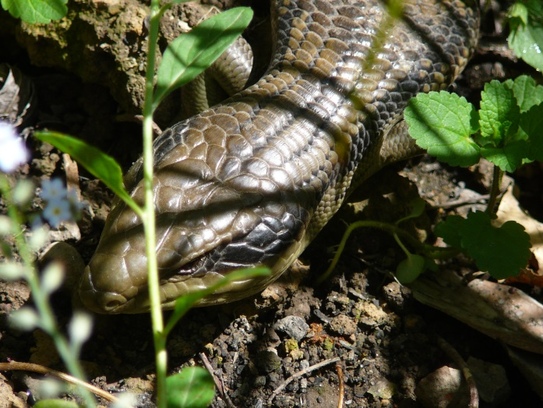
Figure 1. Common Blue-tongue Lizard © A. Houston DSE 2008
Blue-tongues don’t just smell by using their nose. They also have an organ, called a ‘Jacobson’s Organ’, on the roof of their mouth, which they use to sense chemicals that are emitted by their prey (e.g. insects). Blue-tongues use this to detect their prey.
Blue-tongues have strong teeth and jaw muscles to crush their food – they can even crush the shell of a snail.
Habitat
Blue-tongues can be found in virtually all habitats across Australia. In Victoria, they inhabit a wide variety of ecosystems from coastal heathland, lowlands and mountain forests to interior plains.
They are also common in urban areas, and unfortunately are often injured by people using shovels to dig in their garden.
Like all lizards, Blue-tongues cannot maintain a constant body temperature without help from the sun. This means that they use the sun’s heat to maintain their body temperature.
Blue-tongues are active during the daytime and shelter at night under large objects such as logs or leaf litter and debris. They can often be seen warming themselves in sunny areas.
During the colder months, Blue-tongues are mostly inactive, often taking shelter until the warmer weather arrives.
They may spend many years living in the same area.
Distribution
Common Blue-tongued Lizards are found right across Victoria.
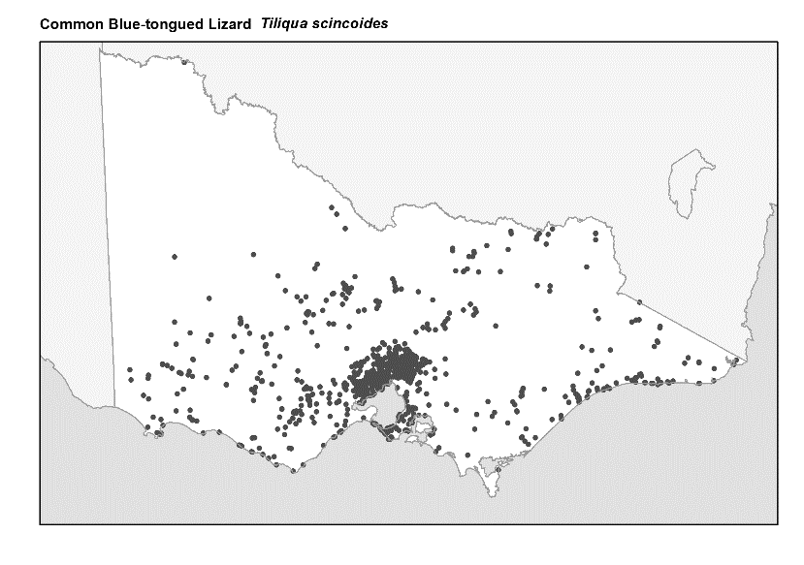
Figure 2. Recorded occurrences in Victoria
Source: Victorian Biodiversity Atlas (records post 1979), version 15/5/2017
Breeding
Blue-tongues live alone for most of the year, but between September and November, males leave their territory in search of a mate.
Males can travel up to 15 city blocks in their search and may have several families.
Females give birth to as many as 25 live young (but usually 10) in a litter, which are born between December and January.
The young are born self-sufficient and disperse a few days after birth. Blue-tongues are sexually mature when they are four years old.
What you can do to help!
Blue-tongues are beneficial to your garden, as they reduce the number of plant eating insects such as snails and slugs.
To help protect Blue-tongue habitat, you can maintain a lizard friendly garden by leaving logs and rocks on the ground to provide shelter.
You can also reduce or eliminate the use of snail bait. Blue-tongues eat the snails and slugs that are killed by the bait, which in turn poisons the Blue-tongues.
On warm days, Blue-tongues lie on hot surfaces such as roads. As they are easily camouflaged and slow to move, please be alert and careful when driving.
All cats are natural hunters and Blue-tongues are common prey. If you own a cat keep it indoors at night. Never dump cats or kittens in the bush. Take them to an animal shelter or have them humanely put down.
Never try to feed Blue-tongues as they have specific diets.
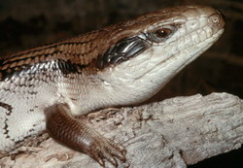
Figure 3. Blue-tongue Lizard © I. McCann DSE 2008
Further reading
Cogger, H.G., (2000), Reptiles and amphibians of Australia (6th ed.), Reed New Holland, Sydney.
Wilson, S.K. and Knowles, D.G., (1988), Australia’s reptiles, Collins, Sydney.

