Our Wildlife Fact Sheet
  - Short-beaked Echidna

There are only three known egg laying mammals (monotremes) in the world. These are two species of Echidna (one is only found in New Guinea) and the other is the Platypus.
Scientific name
Tachyglossus aculeatus
Did you know?
Each spine of the Echidna is formed from a single hair.

The Echidna uses all four feet to dig.

When the Echidna is disturbed or threatened, it will roll into a ball or burrow into the ground so that only its spines are exposed.

A baby Echidna is called a ‘puggle’.

The Short-beaked Echidna is featured on the Australian 5c piece.
Description
The Echidna ranges from 35-52 cm in length. It can weigh up to 6 kg, but the females are usually smaller than the males.

Echidnas are covered with a fur that can range from reddish to dark brown colour. The spines on the backs of Echidnas are modified hairs that vary in colour from cream to black. Their spines can reach up to 50 mm in length. The proportion of hair to spines varies according to climate, so Echidnas from cold areas have more dense hair than Echidnas from the warmer north-west of Victoria.

The Echidna’s snout is 7-8 cm long and used to poke into rotten logs and termite mounds that have been broken into with the Echidna’s feet. The mouth is positioned right at the end of the snout. The Echidna’s tongue is very long and sticky enabling it to collect large quantities of ants and termites when feeding.

The front feet of the Echidna have five flattened claws, designed to dig burrows and tear open logs and termite
mounds. Their hind feet point backwards enabling the soil to be pushed away when burrowing. They commonly use their back claws for grooming. The tail of the Echidna is very short and hairless underneath.

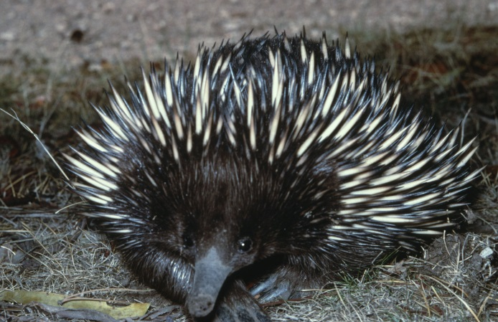
Figure 1. Short-beaked Echidna © I. McCann DSE 2009
Diet
Echidnas feed mainly on ants and termites though they have been known to eat other invertebrates. They generally feed during early morning and late evenings – the cooler periods of the day.

They have an acute sense of smell which they rely on to detect food. Once the food is located they use their long sticky tongue to catch their prey. Echidnas have no teeth, so instead grind their food between the tongue and roof of their mouth.
Habitat
The Echidna is usually found in open heathland, forests, woodlands, scrublands and grasslands, among vegetation or in hollow logs. In poor weather, they will often shelter under bushes or burrow into the soil.

You will most likely see an Echidna during early morning or late evening as they avoid extreme temperatures.

The Echidna does not defend a territory, but will instead wander over its large home range.

Distribution
The Short-beaked Echidna can be found throughout Victoria.
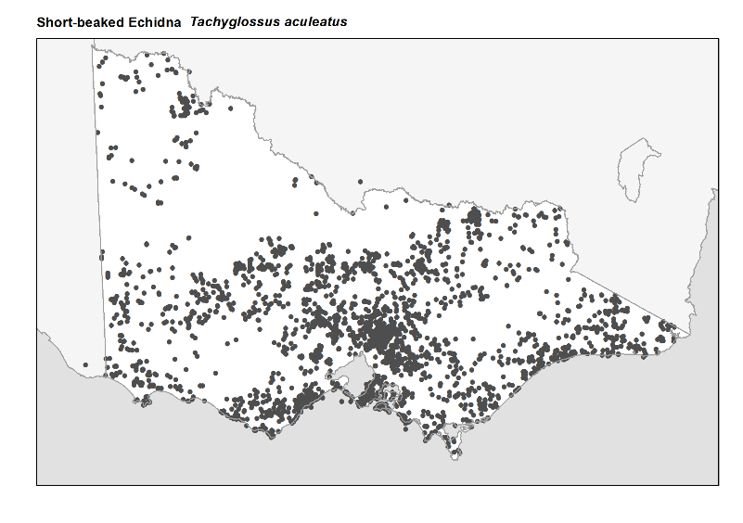
Figure 2. Recorded occurrences in Victoria
Source: Victorian Biodiversity Atlas (records post 1979), version 15/5/2017
Breeding
The breeding season is from June to September. During this season both the males and females will emit a strong odour, which allows males to locate the females.

During courtship, many males may follow one female for up to four weeks in an effort to mate with her.

Two weeks after successful mating the female will lay a single rubbery egg directly into her small backward facing pouch. After 10 days, the egg will hatch producing a jellybean sized young known as a puggle.

The puggle is carried around in the mother’s pouch for around three months. On occasion, the mother will leave the young in a burrow covered in leaf litter or soil to go foraging.

The puggle suckles from specialised pores inside the mother’s pouch as she does not have nipples.

When the puggle leaves the pouch, it will have already started to develop spines, yet will not be fully weaned until it is 12 months old.

The Echidna’s life span can range from 15-40 years yet usually averages around 10 years in the wild.
What you can do to help!
The main threats to an Echidna are feral dogs and foxes. They are also vulnerable to habitat loss from land clearing and development.

The Echidna is a frequent casualty on roads. Please take care when driving in bush areas and keep an eye out for Echidnas and other wildlife.

It is illegal to pick up or move an Echidna from its natural surroundings. Sometimes Echidnas can make their way into backyards. If this is the case, please keep all pets away and allow the Echidna to find its own way out again. It is likely that the backyard is next to habitat where the Echidna belongs.

Report any suspected illegal activity relating to Echidnas to the DELWP Customer Contact Centre on 136 186.

All wildlife is protected in Victoria. Visit the DELWP website for more information regarding protected wildlife www.wildlife.vic.gov.au

Further reading
Menkhorst, P.W. (ed.), (1995), Mammals of Victoria, Oxford University Press, Melbourne.
Strahan, R. (ed.), (1995), The mammals of Australia, Reed Books, Australia.

