Our Wildlife Fact Sheet
  - Common Long-necked Turtle

The Common Long-necked Turtle sure is true to its name, with a neck that is sometimes longer than the full length of its shell.

Scientific name
Chelodina longicollis

Did you know?
The Common Long-necked Turtle can live up to 50 years and is also known as the Eastern Snake-necked Turtle.

They have a great defence mechanism for predators with the ability to omit a foul smell from their glands that they can spray more than 3 feet.

During the dry months, Common Long-necked Turtles bury themselves in mud or soil in dried up water bodies, protecting them from the drought.

These turtles are known to travel very long distances in search of a new home.

Description
The Common Long-necked Turtle’s shell can grow up to 25 cm with its neck sometimes as long as the body.

The shell is known as a ‘carapace,’ which can vary from a light brown to a dark brown. In the lighter coloured turtles, you can clearly see the black outlines across the shell. On the lower part of the shell (plastron) yellow markings can be seen with the black outlines.

Their feet and claws are very strong and are webbed for swimming and tearing apart large food items. With strong jaws, they can have quite a nasty bite so be sure not to touch or aggravate them.
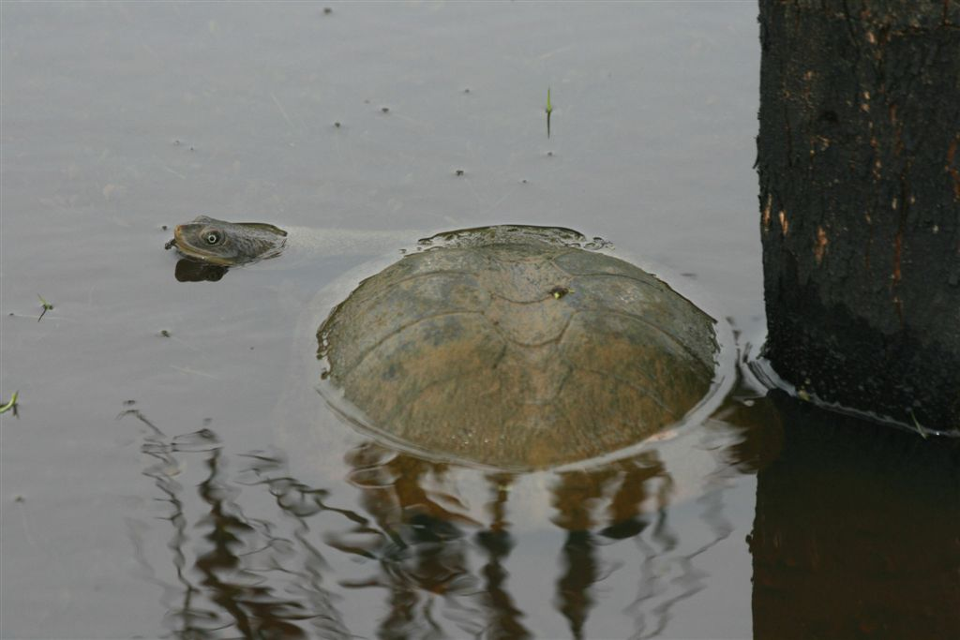Figure 1. Common Long-Necked Turtle © I. McCann DSE 2008
Diet
The Common Long-necked Turtle is carnivorous and commonly feeds on fish, insects, tadpoles, frogs, yabbies and other crustaceans.

They have a unique hunting mechanism. By bending its neck under its shell, it will get close enough to the pray and then strike out as they extend its neck, similar to the action of a snake.
Habitat
The Common Long-necked Turtle is very common and can be found in many slow-moving water bodies such as swamps, dams and lakes. They like a soft sandy area with nearby logs or rocks to bask on.

Summer months are the most active for this turtle. During winter they become dormant residing under leaves or logs.

Sometimes during a dry season the Common Long-necked Turtle will go on long journeys to find new and improved water bodies.
Distribution
The Common Long-necked Turtle is found throughout costal and inland waterways from south eastern Australia to eastern Queensland.

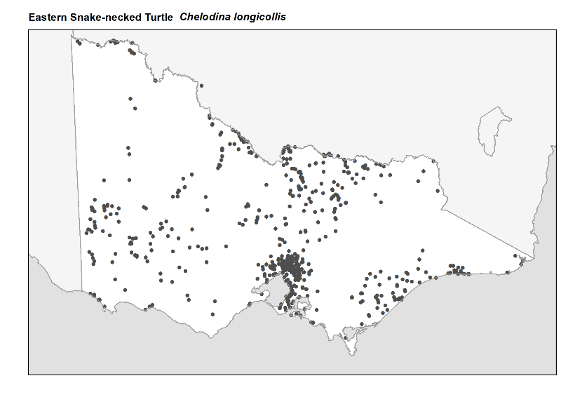
Figure 2. Recorded occurences in Victoria
Source: Victorian Biodiversity Atlas (records post 1979), version 15/5/2017
Breeding
The Common Long-necked Turtle will breed during December to February when they are most active. The males and females will engage in head bobbing as they prepare to mate.

The female will create her nest by digging the earth to form a circular hole with her hind feet in the bank within close proximity to their habitat. The female will then lay approximately 4-20 eggs in the nest. Eggs are laid each year.

The eggs will incubate up to 4 months and hatchlings will emerge to take shelter under nearby water. The colour of the hatchlings can be quite bright and they can have an orange to red underbelly.
What you can do to help!
The biggest threat for the Common Long-necked Turtle is crossing roads. As they migrate during summer months they can be found near or on roads and footpaths. Be on the lookout for any wildlife on the roads in your area, but remember not to swerve if you see wildlife on the road. Swerving to avoid wildlife may cause more danger to the driver and passengers.

As our natural wetland habitat is decreasing, so is the Common Long-necked Turtle’s population. You can help keep creeks and rivers pollution free by not dumping waste and litter into water bodies. See if your school or institution is running any programs targeted at revegetation of wetlands around your area.

Common Long-necked Turtles make great pets, however as they are protected by law, you will need a licence to buy one from a pet shop or wildlife dealer. To find out more about keeping reptiles in Victoria, please visit the DELWP website at: www.wildlife.vic.gov.au.

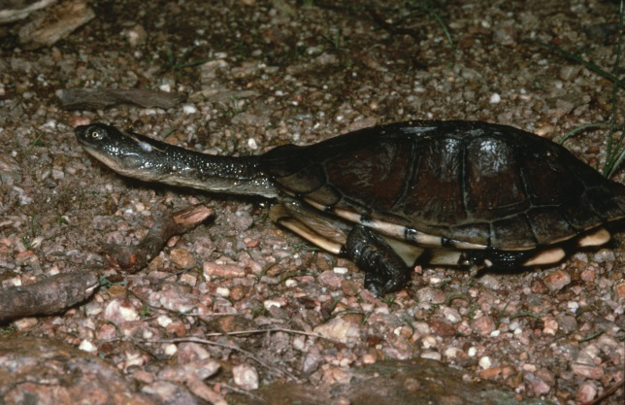 Figure 3. Common Long-Necked Turtle © I. McCann DSE 2008
Further reading
Cogger, H.G., (2000), Reptiles and amphibians of Australia (6th ed.), Reed New Holland, Sydney.
Wilson, S.K. and Knowles, D.G., (1988), Australia’s reptiles, Collins, Sydney.

