Our Wildlife Fact Sheet
  - Common Froglet

The Common Froglet is a small, ground dwelling-frog, and is one of eastern Australia’s most common and widespread species. Go looking for this frog and you could find dozens of them under one log or rock.

Scientific name

Crinia signifera

Did you know?

Unlike some other frogs, this one calls all year round, making a continual “crick, crick, crick” sound, similar to the sound of a cricket.
They breed in a variety of still water bodies, with females laying up to 150 eggs.
They feed entirely on small insects, helping keep the numbers of these insects in check. If you see or hear them in your garden, be sure to not disturb or damage their habitat.

Description

Common Froglets can grow up to 3 cm long and vary in colour.
The most common colour of this species is grey, brown or black with some displaying dark bands and irregular patches of colours over their body. Their belly can also be grey or white with darker flecks.
There is also a slight variation of skin textures, with some having smooth and others having warty or ridged skin.
Males can be distinguished by their dark brown or white throat.
The fingers and toes of the Common Froglet are not webbed.

Diet

These frogs feed on a diet of small insects, including mosquitoes, moths, caterpillars, cockroaches and flies.

Habitat

Common Froglets can be found in streams, ponds, dams and flooded ditches.
They generally shelter under logs and leaf litter (where they are well camouflaged), and in debris around the edges of swamps and ponds.
They are found in almost all habitats from mountains to the coast, covering flood plains, forest, grasslands, open and disturbed areas.
Distribution

The Common Froglet is found across most of Victoria. 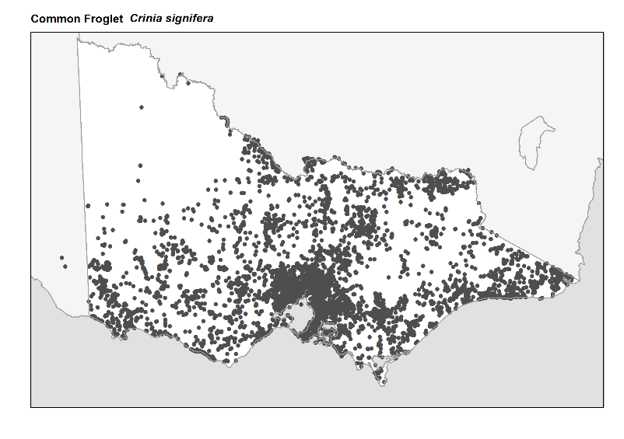
Figure 1 Recorded occurences in Victoria
Source: Victorian Biodiversity Atlas (records post 1979), version 15/05/2017

Breeding

The Common Froglet breeds throughout the year, except during mid summer.
The male frog calls for a mate from cover at the edge of the water body. When mating, the male clasps onto the back of the female and fertilises the eggs as she lays them.
Up to 150 small eggs are laid in separate bunches on submerged plants in still or slow moving water.
Development from egg to frog can take place in as little as 7 weeks.

What you can do to help!

Sometimes humans can be a frog’s worst enemy!
Although the Common Froglet remains abundant and widespread, loss of habitat due to clearing of land and development threatens some species of frogs. These species need your help.
Frogs are susceptible to pollution, so keep waterways clean by not dumping waste or toxic liquids into your drains and creeks.
Frogs are also vulnerable to an infectious disease caused by the chytrid fungus, which can make them sick or kill them. Help protect Common Froglets by not touching or moving them from one area to another.
Create a frog-friendly backyard by composting and avoid using chemicals like herbicides.
Providing rocks, logs, leaf litter and appropriate shrubs around your home will keep the frogs happy. In return, you’ll be delighted with the sound of their calls.

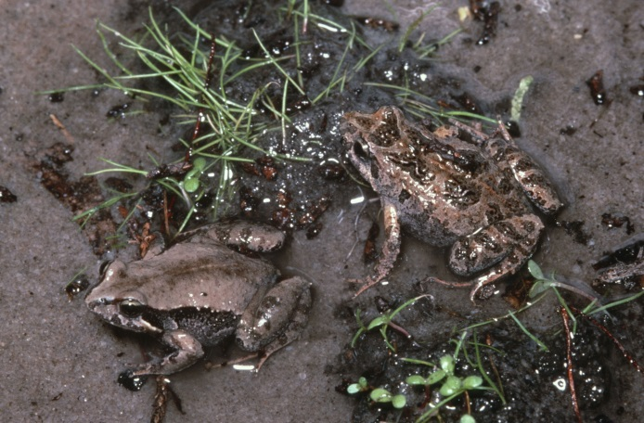Figure 2. Common Froglet © I. McCann DSE 2008

Further reading

Barker, J., Grigg, G. and Tyler, M. J. 1995. A Field Guide to Australian Frogs. Surrey Beatty & Sons, Sydney.

Cogger, H.G., (2000), Reptiles and amphibians of Australia (6th ed.), Reed New Holland, Sydney.

Hero, J-M., Littlejohn, M. and Marantelli, G. (1991). Frogwatch Field Guide to Victorian Frogs. Department of Conservation and Environment, Victoria.

Robinson, M. 2002. A Field Guide to Frogs of Australia. Australian Museum/Reed New Holland: Sydney.

Swan, G. 2001. Green Guide to Frogs of Australia. New Holland: Sydney.

Tyler, M. J. and Knight, F. (2009). Field Guide to the Frogs of Australia. CSIRO Publishing, Collingwood.
Frogs of Australia Website: www.frogs.org.au

