Our Wildlife Fact Sheet
  - Common Wombat

The Common Wombat is predominantly found in eastern Victoria, with numbers severely declining in western Victoria. The 2019/20 bushfires have also had a significant impact on their habitat.
Scientific name
Vombatus ursinus
Did you know?
Wombats are more closely related to Koalas than any other living marsupial.
Early settlers often called the Common Wombat a Badger because of its burrowing behaviour.
Wombats often sleep with their four feet sticking up in the air!
Description
Common Wombats grow up to 40 kg in weight and can reach about 115 cm head to tail. Males tend to be slightly larger and heavier than females.
The Common Wombat has a large nose which is shiny black, much like that of a dog. The ears are relatively small, triangular, and slightly rounded.
Their thick paws are designed for digging burrows. They also have a pouch which faces backwards to protect their young from flying dirt whilst the mother is digging the burrow. The rump is protected by thickened skin that acts as a defensive shield if the wombat is chased down its burrow by a predator.
The Common Wombat's fur is coarse, thick and bristle-like with little or no underfur. Their fur colour varies from sandy to brown or black, to grey.
The Southern and Northern Hairy-nosed Wombats have longer, pointed, almost naked ears, a longer square cut muzzle and fine white hairs over their nose. They also have a short tail, a little longer than that of the Common Wombat.
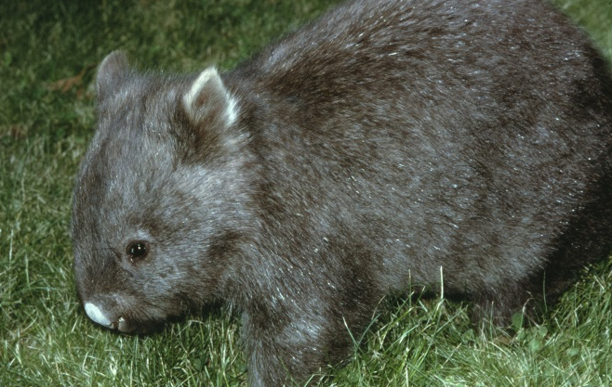 Figure 1. Common Wombat © I. McCann DSE 2008
Diet
A wombat's diet can consist of coarse native grasses, sedges, rushes, succulent plant roots and tubers, and pasture grasses.
Wombats are mostly nocturnal, usually coming out at night to graze when the temperature is lower. However, in cold periods they may be seen out during the day either grazing or basking in the sun.
Habitat
Common Wombats inhabit sub-alpine heath at altitudes of up to 1800 m, sub-alpine woodland, wet forest, dry forest, woodland, coast scrub and wet heath.
The distribution of the Common Wombat mainly depends on the availability of suitable burrow sites that are near their food sites.
Although they are not territorial in their sleeping arrangements, they are territorial about feeding areas and will scent mark their territory and defend it aggressively using vocalization and aggressive behaviour.
They graze between 3 and 8 hours a night, during which time they may travel many kilometres and visit up to 4 burrows. Over several weeks they have been found visit up to 13 burrows in their home territory.
Distribution
The Common Wombat occupies Tasmania, eastern New South Wales and eastern Victoria with scattered populations in south-eastern South Australia and south-western Victoria.
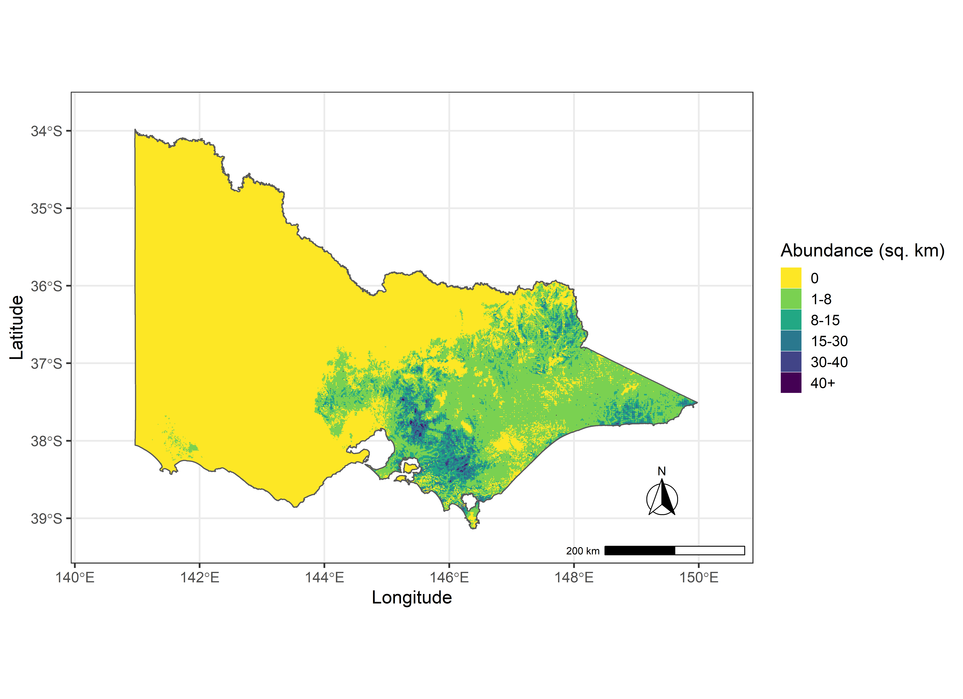
Figure 2. Predicted distribution and abundance of the Common Wombat (per square kilometre) across Victoria prior to 2019/20 bushfires (Dec 2019).
Source: Heard, G.W. and Ramsey, D.S.L. (2020).

It is estimated that 21% of the suitable habitat for the Common Wombat in Victoria has been affected by the 2019/20 bushfires in East Gippsland and the alpine regions.
Breeding
When food is plentiful the Common Wombat will breed throughout the year. Gestation lasts for one month, after which a jelly-bean sized joey is born which attaches to a teat in its mother's pouch.
The joey will leave the pouch at 10 months but will stay with the mother for another 8 to 10 months. From the time the juvenile leaves the pouch it begins to supplement its mother’s milk with increasing amounts of plant material.
Between 12-15 months of age it stops suckling altogether.
Common Wombats reach breeding maturity at two years and can live for 15 years in the wild or up to 20 years in captivity.
What you can do to help?
Some of Victoria’s Common Wombat population suffers from sarcoptic mange. Mange is an infectious disease caused by mange mite (Sarcoptes scabei). This mite can infect over 100 mammal species (including humans) and is believed to have been introduced to Victoria by early European settlers and their dogs.
Mange mites burrow under the skin and cause extreme discomfort and wounds that can result in infection and eventual death.
Mange infection in wombats causes skin redness, inflammation and thickening, and loss of fur. The thickening of the skin around the eyes and ears can result in the wombat becoming blind and deaf. When the wombat scratches due to the irritation caused by the mite, fissures can develop in the skin, which leaves the wombat susceptible to secondary skin infections.
Affected Common Wombats will quickly lose condition and display unusual behaviour, such as feeding throughout the day.
If you are concerned about a particular wombat that appears to be affected by mange, you can contact a wildlife rehabilitation organisation. See the following link: https://www.wildlife.vic.gov.au/sick-injured-or-orphaned-wildlife/sick-injured-or-orphaned-wildlife.
Alternatively, call the DELWP Customer Contact Centre on 136 186, who can also provide you with contact details for wildlife rehabilitation organisations.
Further reading
Heard, G.W. and Ramsey, D.S.L. (2020). Modelling the abundance of the Common Wombat across Victoria. Arthur Rylah Institute for Environmental Research, Heidelberg, Victoria.
Menkhorst, P.W. (ed), (1995), Mammals of Victoria, Oxford University Press, Melbourne.

