

Authority to Control Wildlife Application Form - Kangaroo Pet Food Trial

Landholders seeking to control Eastern and Western Grey Kangaroos in the below shires are eligible to participate in the Kangaroo Pet Food Trial. For further information please see the DELWP factsheet *Kangaroo Pet Food Trial: information for landholders.*

|  |  |  |  |
| --- | --- | --- | --- |
| Ararat (Rural City of) | Benalla (Rural City of) | Glenelg | Greater Bendigo |
| Horsham | Loddon | Mansfield | Mitchell |
| Murrindindi | Northern Grampians | Pyrenees | Southern Grampians |
| Strathbogie | Wangaratta | West Wimmera | Yarriambiack |

**1. Do you hold a current ATCW for Eastern or Western Grey Kangaroos for a property located within the trial area and wish to transfer to a KPFT ATCW?**

No (proceed to Q. 4) Yes Current ATCW number

**2. How many kangaroos have been controlled under this authority?**

Species No. already controlled

Eastern Grey Kangaroos

Western Grey Kangaroos

**3. Does this authority include other wildlife?**

No (Please sign below) Yes Species of wildlife No. already controlled

By signing below, your current ATCW will be cancelled and a new KPFT ATCW will be issued. You must supply a Property Identification Code (PIC) for the KPFT ATCW to be issued. If your current ATCW also includes other species, then a new ATCW for those species will also be issued.

National Property Identification Code (PIC)

***Acknowledgment by Authority Holder***

I, *(name of applicant)* ……………………………………………………………………..………………… being the holder of the specified Authority to Control Wildlife noted in Question 2, request that this Authority be cancelled for the balance of kangaroos remaining for the purposes of participating in the DELWP Kangaroo Pet Food Trial.

SIGNATURE of Authority Holder ………………………………………………… DATE signed ………………………………

**Please complete the details below and submit the form to your local DELWP Office. See page 4 for details. Note: If you answered ‘yes’ to question 1 above, you are only required to complete sections 4 – 10 and sign the declaration in section 14.**

**4. Applicant’s personal details**

# Mr/Mrs/Ms First Name Other Given Names Family Name

Date of Birth Sex (M/F) DELWP Customer Number (if known)

**5. Applicant’s residential address**

Property Name *(Name of house, farm or building if applicable).* Flat/Unit No. House/Lot No.

Street Name City/Suburb/Town Postcode

**6. Applicant’s postal address** *(if same as above, please write “as above”)*

Property Name *(Name of house, farm or building if applicable).* Flat/Unit No. House/Lot No.

Street Name City/Suburb/Town Postcode

**7. Applicant’s contact details** *(Please circle your preferred contact)*

Telephone – Mobile Telephone – Private Telephone – Business Email address

**8. Applicant’s relationship to the land with the wildlife problem:** (*Tick ONE box which best describes this)*

Land Land Lessee Business

owner manager Owner/Director

**9. Business name** *(ONLY complete if the land is owned under the name of a business)*

**10. Description and location of land where you plan to control wildlife**

Crown Allotment Number(s)*. (This**must be supplied – see your Rates Notice or Shire Office). Include Square No. & House No, if applicable.*

*A copy of the rates notice for the property may be attached.)*

Road Location (*e.g. No. 2010 Plenty Rd, 2km west of intersection with Centre Rd)*

City / Town Postcode Municipality (Shire or Borough) National Property Identification Code (PIC)

Approximate area in hectares Land Use Zone Current land use (*e.g. Cropping wheat, cattle grazing, apple orchard, etc)*

**11. Species and number of kangaroos causing property damage or health and safety risks**

Please provide an estimate of the total number of kangaroos on the property in section 11.1 below and

an estimate of the number of kangaroos that are causing property damage or health and safety risks in section 11.2 below.

To estimate kangaroo numbers the kangaroos should be counted when they are most active (dawn or dusk). The count should be repeated over a number of days to get an accurate estimate.

Western Grey Kangaroos can be distinguished by their more brown and slender appearance compared to Eastern Grey Kangaroos. See below for distribution maps of the species.

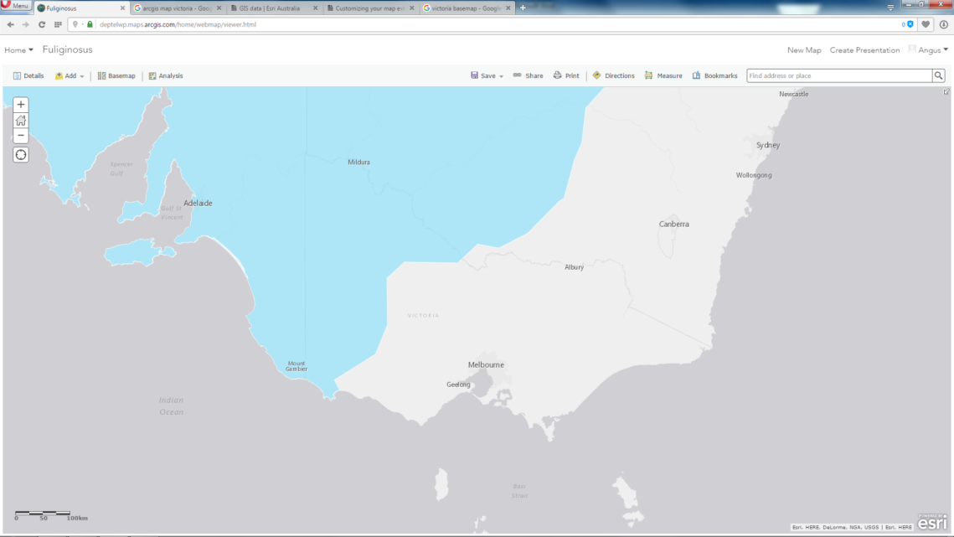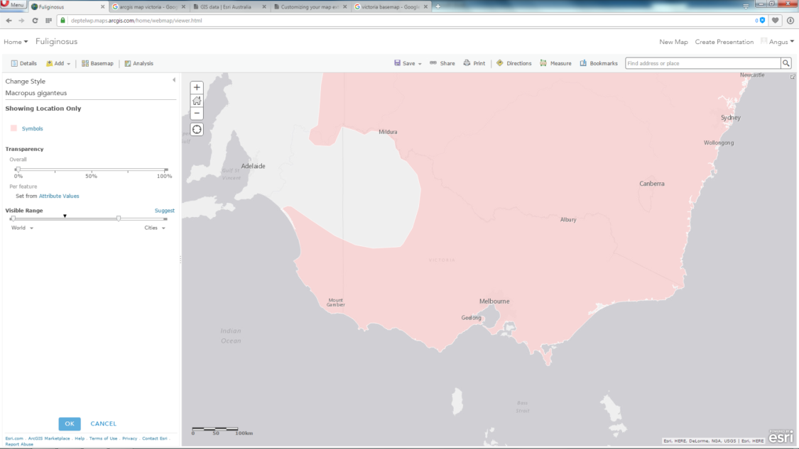

Western Grey Kangaroo distribution in Victoria (shown in dark grey)

Eastern Grey Kangaroo distribution in Victoria (shown in dark grey)

**11.1 The total number of kangaroos on the property**

Eastern Grey Kangaroos: Western Grey Kangaroos:

Dates counted:

**11.2 The number of kangaroos causing property damage or health and safety risks**

Eastern Grey Kangaroos: Western Grey Kangaroos:

Dates counted:

**12. Description of damage or health and safety risks resulting from wildlife**

*The description should outline the type and extent of damage to property including buildings, fences, pasture, crops or livestock. Any issues related to human health and safety should also be included (for example, hazards to aircraft safety, fouling of produce or property or aggressive behaviour). Attach a separate sheet if required.*

**13.What actions are you currently taking to manage the issues identified in section 12?**

*Include any measures you have taken, such as fencing or restricting wildlife access to property or crops. Attach a separate sheet if required.*

**14. Acknowledgment by applicant**

I, *(name of applicant)* …………………………………………………… being the applicant for this Authority to Control Wildlife, acknowledge that it is an offence under Section 58B of the *Wildlife Act 1975*  to provide false or misleading information in, or in connection with the application for an Authority to Control Wildlife and I state that the information that I have provided is true and correct.

SIGNATURE of Applicant …………………………………………………………… DATE signed ………………………………

|  |
| --- |
| **Collection, use and disclosure of personal information - *Privacy and Data Protection Act 2014*** |
| The Department of Environment, Land, Water and Planning (DELWP) is committed to protecting personal information provided by you in accordance with the principles set out in the Victorian privacy laws. This privacy statement applies to the collection and use of personal information, voluntarily provided by you, in relation to administration of licences and authorisations administered under the *Wildlife Act 1975*.  The information you provide will be used to assess your application, administer any relevant licences or authorisations and carry out compliance relating to those licences or authorisations.  You may apply for access to your personal information at any time to confirm that it is accurate and up to date, upon payment of a prescribed fee (if any). Enquires should be directed to the DELWP Customer Service Centre on 136 186.  An authorisation may not be issued if the information required is not provided. |

**Where to send your completed application form**

Please submit your **completed** and **signed** application to the office closest to where the property concerned is located.

|  |  |
| --- | --- |
| For properties in the LGAs of **Yarriambiack, Horsham, Pyrenees, Northern Grampians** and **Ararat**:  ATCW Coordinator  DELWP  402-406 Mair St  Ballarat VIC 3350 | For properties in the LGAs of **Mitchell, Mansfield, Murrindindi, Strathbogie, Benalla** and **Wangaratta**:  Kangaroo Pet Food Trial ATCW Coordinator  Department of Environment Land, Water & Planning  PO Box 124  BENALLA Victoria 3672  Fax: 5962 0244 |
| For properties in the LGAs of **Loddon** and **Greater Bendigo**:  ATCW Coordinator  DELWP  Box 3100  Bendigo Delivery Centre  Bendigo VIC 3551  Fax: 5448-4982 | For properties in the LGAs of **Glenelg, West Wimmera** and **Southern Grampians**:  ATCW Coordinator  DELWP  PO Box 105  Warnambool VIC 3280  Fax: 5561-9988 |

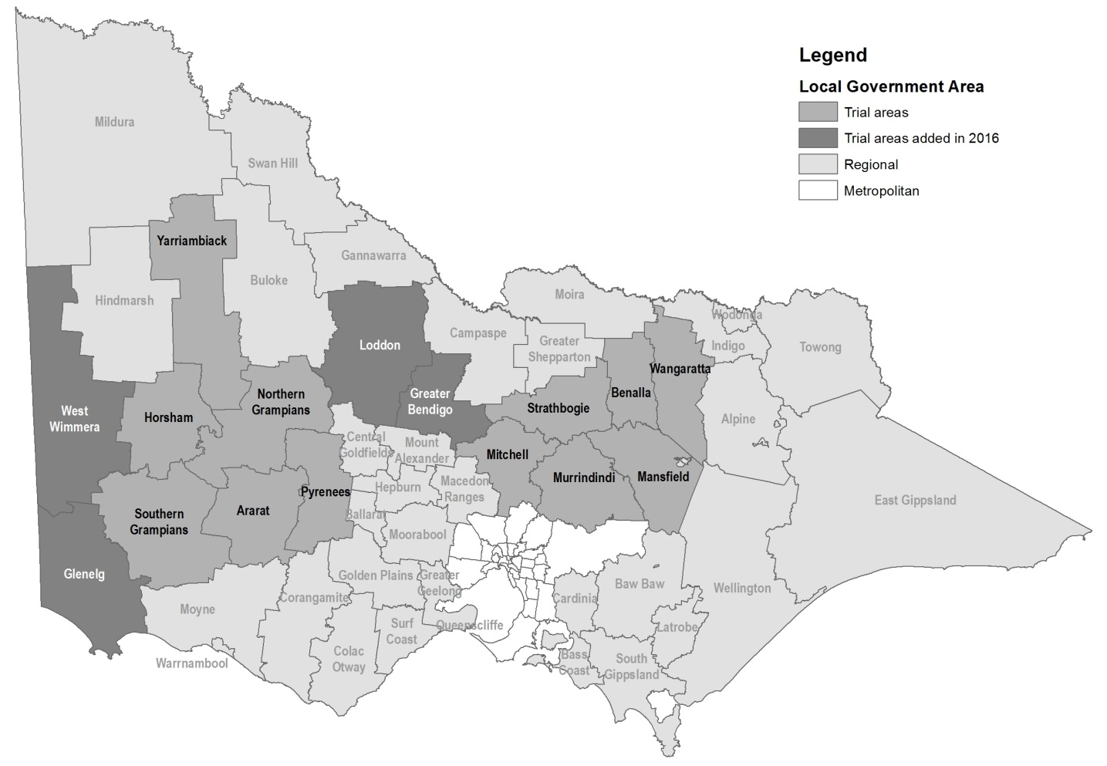**Map of KPFT trial areas**