www.delwp.vic.gov.au

2018/19

|  |
| --- |
| **Wildlife Rehabilitator Grants**  **2018/19**  Funding Guidelines |

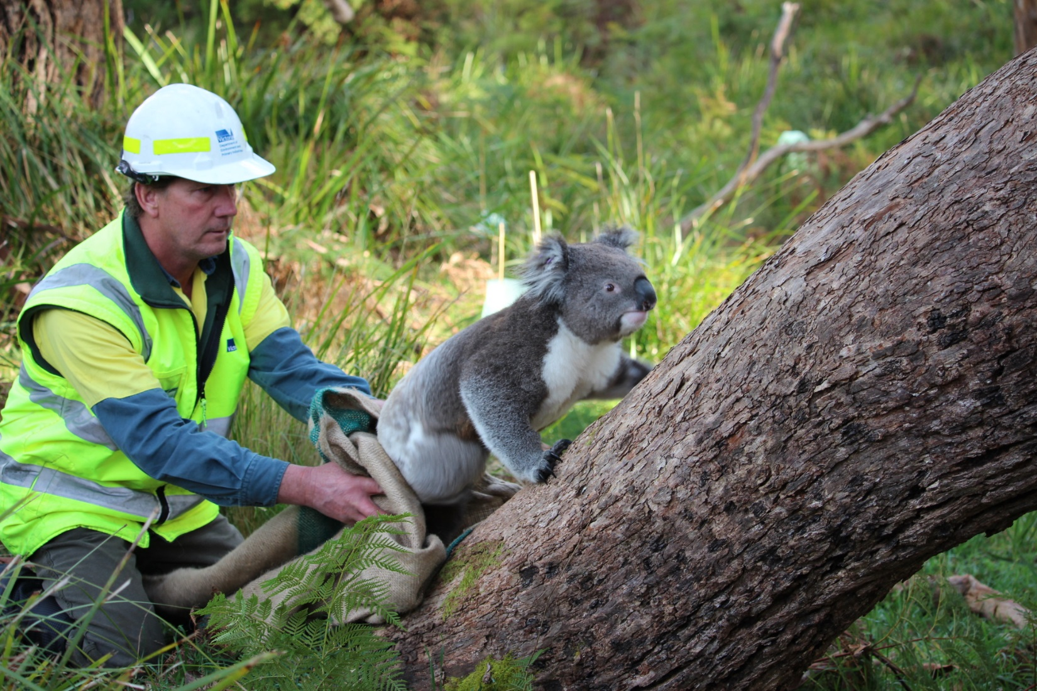

|  |  |
| --- | --- |
|  |  |

|  |
| --- |
| © The State of Victoria Department of Environment, Land, Water and Planning 2018  Logo  This work is licensed under a Creative Commons Attribution 4.0 International licence. You are free to re-use the work under that licence, on the condition that you credit the State of Victoria as author. The licence does not apply to any images, photographs or branding, including the Victorian Coat of Arms, the Victorian Government logo and the Department of Environment, Land, Water and Planning (DELWP) logo. To view a copy of this licence, visit <http://creativecommons.org/licenses/by/4.0/>  ISBN 978-1-76077-116-4 (pdf/online/MS word)  Disclaimer  This publication may be of assistance to you but the State of Victoria and its employees do not guarantee that the publication is without flaw of any kind or is wholly appropriate for your particular purposes and therefore disclaims all liability for any error, loss or other consequence which may arise from you relying on any information in this publication.  Accessibility  If you would like to receive this publication in an alternative format, please telephone the DELWP Customer Service Centre on 136186, email [customer.service@delwp.vic.gov.au](mailto:customer.service@delwp.vic.gov.au), or via the National Relay Service on 133 677 [www.relayservice.com.au](http://www.relayservice.com.au). This document is also available on the internet at [www.delwp.vic.gov.au](http://www.delwp.vic.gov.au). |

Contents

Minister’s Foreword 2

Wildlife Rehabilitator Grants 2018/19 3

About the Wildlife Rehabilitator Grants program 3

Available funding 3

Additional $500 funding for 2018/19 3

Submission period 3

Who can apply? 3

Ineligible applicants 3

Assessment criteria 4

Eligible activities 4

Eligible Personal Protection Equipment budget items 5

Ineligible activities / costs 5

How do I apply? 5

What happens after applications close? 5

When will I be notified? 5

If our project is successful, when will we be paid? 5

GST advice 6

Tax implications 6

Project reporting 6

Funding conditions 6

Privacy 6

More information 6

**Minister’s Foreword**



This year marks the 10-year anniversary of the Victorian Government’s funding commitment to wildlife shelter operators and foster carers. Over this time, over $1.3 million has been paid directly to rehabilitators to provide equipment and resources to assist in the rehabilitation of our native fauna.

I am very proud of the work that has been undertaken and achieved in the last 10 years. For example, Ian from near Bairnsdale has used the grant funding to upgrade wombat enclosures that transition injured wombats through different stages of recovery.

And Denise, from the Mornington Peninsula, who has used funding to purchase textbooks on rehabilitation techniques as well as purchasing transport carriers to ensure safe recovery and transport of injured animals.

Last year, as a result of feedback from consultation between the Department of Environment, Land, Water and Planning (DELWP) and the community, the funding limit for consumable items was increased to $1,000 per applicant. After positive feedback from rehabilitators about the increased limit, I am happy to announce that the $1,000 consumable limit will continue again this year.

In 2018/19, $170,000 has been allocated to individual grant applicants with the final funding amount to be based on applicants’ needs, experience, performance and past funding allocation. In addition, rehabilitators who have successfully completed one of the ‘*Support wildlife response activities (fire)’* courses conducted by DELWP, can access up to an additional $500 for personal protective equipment. We recognise and acknowledge that the safety of rehabilitators is important for long term success.

The Victorian Government values the important contribution that shelter operator and rehabilitators undertake within our natural environment. These grants are designed to assist rehabilitators with training, the purchase of equipment, infrastructure and consumable items.

Thank you for the good work in protecting and rehabilitating our wildlife.



**The Hon. Lily D’Ambrosio MP**

**Minister for Energy, Environment and Climate Change**

|  |  |
| --- | --- |
| Wildlife Rehabilitator Grants 2018/19 | |
| About the Wildlife Rehabilitator Grants program | The Victorian Government’s Wildlife Rehabilitator Grants Program provides funding to support wildlife rehabilitators including shelter operators and foster carers, to purchase a range of equipment and infrastructure to assist with the operation of their facilities and to attend appropriate training.  The program aims to help wildlife rehabilitators to:   * increase their knowledge/skills in the care of wildlife * improve their facilities to treat, house and rehabilitate wildlife for release * improve the standard of wildlife care they provide for specialist species (e.g. raptors) or threatened species (e.g. brush tailed phascogales). |
| Available funding | The 2018/19 grants are capped at $2,000 (ex GST) per applicant.  The amount granted may be less than this depending on the purpose for which it is to be used, the amount sought, the number of applications received and how well the application meets the assessment criteria. |
| Additional $500 funding for 2018/19 | For rehabilitators that have successfully completed one of the ‘*Support wildlife response activities (fire)*’ courses conducted by DELWP, an additional $500 will be available for approved fire Personal Protective Equipment (PPE). This PPE must meet approved standards and must be purchased from DELWP.  To be eligible, you must have attended and successfully completed the ‘*Support wildlife response activities (fire)*’ course held at one of the following locations:  Ballarat 8 January 2018  Benalla 22 February 2018  Bendigo 23 February 2018  Knoxfield 28 February 2018 |
| Submission period | **Sunday 1 July to Tuesday 31 July 2018**  **Applications must be submitted by 5.00 pm on Tuesday 31 July 2018** |
| Who can apply? | Wildlife rehabilitators in Victoria who are eligible to apply must have:   * held a current permit as a shelter operator or foster carer for at least two (2) years * no convictions for fraud or convictions under the Wildlife Act 1975 or the Prevention of Cruelty to Animals Act 1986 during the past ten years * submitted all Completion Statements for previous funding under this program * no outstanding compliance requirements and * the consent of the property owner. |
| Ineligible applicants | The following are NOT eligible to apply:   * any rehabilitator who is not registered as a shelter operator or foster carer with DELWP * multiple applicants residing at the same address (ie. only one applicant can be nominated for a given residential address) * any applicant that does not provide clear and readable shelter records * any applicant that does not have consent of the property owner. |

|  |  |
| --- | --- |
| Assessment criteria | A Panel will use the assessment criteria detailed below to assess each application. Applications must meet a passable standard in each criterion to be considered for funding.  In addition to these questions, previous history, such as non-completion of projects and overdue reports, may be taken into account as part of the assessment.  **Assessment criteria:**  **35%** **PROJECT ALIGNMENT WITH THE GRANTS PROGRAM**  You will be asked in question 3.1 in the application form to describe how your project will benefit wildlife welfare through:   * increased knowledge of and/or skills in the care of wildlife * improved facilities to treat, house and rehabilitate wildlife for release * improved standard of wildlife care you provide for specialist species or threatened species.   **40% PROJECT NEED**  You will be assessed on the nature of items asked for, what wildlife rehabilitation issue will this project support and whether you have received grant funding under this program in the past two years. Preference will be given to those rehabilitators that have not received funding in the last two years.  Applications that provide quotes, drawings and evidence to support their requested items, will be scored higher than those applications that do not supply this supporting information.  **25% EXPERIENCE/KNOWLEDGE OF REHABILITATOR**  You will be assessed on the number of years’ experience as a DELWP authorised rehabilitator, whether you have handled threatened species in the past, the number of wildlife you handled between 1 July 2017 and 30 June 2018 and how many wildlife courses have you undertaken previously.  **Please note** that the Wildlife Rehabilitator Grants are competitive grants and are scored according to the above assessment criteria. Not all applications that meet the minimum criteria will be funded. |
| Eligible activities | **Education and Training**   * + Education and training which may be competency based training delivered by a registered training organisation or any other approved training to be held in 2018/19.   **General infrastructure and equipment**   * + General infrastructure and equipment to assist with the operation of wildlife facilities, e.g. build a wombat enclosure, buy an aviary, buy portable cages. It is a requirement that you provide a quote and design dimensions for any proposed enclosures to be constructed, to assist the Assessment Panel in determining the outcome of your application.   **Other equipment**   * + Other equipment relevant to wildlife rehabilitation including non-fire Personal Protective Equipment (PPE) (not consumable items).   **Consumable items**   * + Consumable items (capped at $1,000 as part of the maximum grant allocation), e.g. feed, petrol, veterinary fees and veterinary supplies.   Funding for other items (other than those excluded) will also be considered by DELWP on merit providing there is enough information to justify the purchase.  **Please see Table 1 for additional information on eligible activities.** |
| Personal Protection Equipment | **Please see Table 3 for information on approved fire PPE budget items.** |
| Ineligible activities / costs | Funding will not be provided for:   * costs and activities that are already funded in the 2017/18 program * utility costs such as rates, electricity, water, gas and sewerage bills * vehicles including all types of trailers, boats, ride on mowers, etc. * surgical equipment, microscopes, IV equipment * chainsaws, mulchers, freezers, generators * infrared and motion-sensing surveillance cameras, radio telemetry, schedule 4 and 8 capture chemicals * firearms including captive-bolt guns and darting related equipment, purchase, hiring and training courses. Guns safes, bullets and darts are not permitted * any illegal activity * purchase of goods for competitions, prizes, giveaways, vouchers or alcohol * promotional or marketing material (eg stickers, magnets, flyers, etc) * computers, laptops, tablets and mobile phones/smartphones * insurance (vehicles, memberships, house and property, etc) * registrations for all types of vehicles and equipment (excludes training and course registration) * flights and accommodation to attend training * Any other action or activity determined by the Panel through the assessment process to be an inappropriate or unsuitable use of the funds.   **Please see Table 2 for additional information on ineligible activities.** |
| How do I apply? | Our preferred way for you to apply, is to:   * submit your application online via SmartyGrants.   To apply, click on the application link and create a login address (or use your last login):  **https://delwp.smartygrants.com.au/WRG2018-19**  We encourage you to start your application as early as possible.  Remember to save your draft application as you work on it, until you are ready to submit it. |
| What happens after applications close? | Projects will be assessed by an independent panel and you will be advised of the outcome of your application by letter after the assessment process is complete. All decisions are final and are not subject to further review. However, applicants who are not granted funding are welcome to ask for feedback on their application.  If successful, you will have **2 weeks** from the date of notification of success to submit the signed funding agreement, and any other documentation outlined in the letter of offer. If the documentation is not submitted within this timeframe, DELWP reserves the right to reallocate the funding. |
| When will I be notified? | All applicants will be notified of the result following the completion of the assessment process. Please be patient as it can take some time to assess and seek funding approval before groups can be notified. We anticipate an announcement of successful recipients in the coming months. |
| If our project is successful, when will we be paid? | Successful recipients will need to enter into a contract (Victorian Common Funding Agreement) with DELWP. A single upfront payment will be made when all paperwork has been completed and submitted to DELWP. There are no further payments.  Payments will generally be paid into your nominated bank account 2-3 weeks after the Victorian Common Funding Agreement is counter signed by the department. |
| GST advice | The maximum grant amount available for a project is $2,000 ($2,500 with fire Personal Protective Equipment) and is GST free.  As the grant is not a taxable supply, the payment of the grant by DELWP does not incur GST on top of the grant (i.e. it is GST free), regardless of the GST status of the recipient. |
| Tax implications | Please note that there may be tax implications resulting from the receipt of grant funds.  It is strongly recommended that applicants consult the Australia Taxation Office or seek professional advice on any taxation implications that may arise from participation in this grant funding.  If your application is successful and you are applying as an individual and don’t have an ABN, you will need to provide the Australian Taxation Office form called *‘Statement by Supplier: (Reason for not quoting an ABN)’* as part of your funding requirements. |
| Project reporting | On completion of a project, you will need to submit a final report to acquit the funds and demonstrate the outcomes of the project. Recipients will have four weeks from their project end date to submit their final report.  **Please note that you will be required to submit your receipts in your final report.** |
| Funding conditions | Successful applicants are required to:   * enter into a funding agreement with DELWP. Information about the Victorian Common Funding Agreement can be found at <https://providers.dhhs.vic.gov.au/victorian-common-funding-agreement> * have appropriate land owner approvals and relevant permits * be responsible for meeting contractual obligations to deliver the project and report on its success by the due date * adhere to all relevant legislation including Occupational Health and Safety requirements, and child safe standards and * acknowledge the Victorian Government funding in publications, promotions and interviews. |
| Privacy | **Privacy Collection Statement**  DELWP is committed to protecting personal information provided by you in accordance with the principles of the Victorian privacy laws.  The information you provide will be used to:   * assess your application for grant funding in 2018/19 including to check for previous funding compliance issues * announce successful applicants in media releases by describing the work you will undertake as part of your grant from the department * publish a list of successful applicants including local government area and amount funded on the DELWP website and/or social media pages and * contact you regarding program updates and to notify you of future funding.   The information you provide will be made available to the Minister for Energy, Environment and Climate Change delegates including ministerial office staff and DELWP employees in the assessment and compliance stages as well as internal communications staff for publishing on the DELWP website and social media pages.  If you need to request confidentiality, please contact enviro.grants@delwp.vic.gov.au quoting your application number and reason for requesting confidentiality. |
| More information | Contact the Grants Information Line on 1300 366 356 or visit the website: **www.wildlife.vic.gov.au/grants/wildlife-rehabilitator-grants** |

**Table 1: Eligible items**



**What items may be funded?**

|  |  |  |  |
| --- | --- | --- | --- |
| **Training/Education** | **General Infrastructure** | **Other items** | **Consumables** |
| first aid training | enclosures | heat boxes | veterinary fees |
| reference manuals | fencing | first aid kits | veterinary supplies |
| workshop registrations | aviaries | binoculars | milk formula |
| conference registrations including field visits | incubators | spotlights | petrol |
| 4WD training (must be accredited) | plumbing of water to pens | climbing equipment & ladders | medications such as cydectin |
| 2018 AWRC – Sydney registration up to $300 | portable cages | GPS (up to $300) | food |
| TAFE courses (must relate to wildlife rehabilitation) | shelters | shelter signage | vaccinations or booster costs for lyssavirus |
| Books (you must list the name/s of the books to help assessors) | water enclosure, pond or other facilities to assist in the rehabilitation of animals | other items deemed appropriate and not listed on the ineligible items list below | cleaning products (disinfectant, hand wash, hand sanitiser, tissues, etc) |
|  |  | personal protective equipment for animal handling (eg gauntlets, eye protection, etc) | nursing pads |
|  |
|  |  |  |  |

**Table 2: Ineligible items**



**What items will NOT be funded?**

|  |  |  |  |
| --- | --- | --- | --- |
| **Training/Education** | **General Infrastructure** | **Other items** | **Consumables** |
| firearms & darting purchase | motorbike & 4wd purchase | promotional materials | vouchers (petrol, food, etc) |
| firearms & darting licence | vehicle registrations of any type (excluding training or course registration) | donation boxes | insurance (all types) |
| firearms & darting training | mulchers, freezers | medical supplies including needles and syringes |
| gun safes and equipment | generators, dishwashers | radio telemetry |
| captive bolt or any darting purchase, training or equipment | equipment for the rehabilitation of unfurred animals | computers, laptops, tablets, mobile phone, smartphones | utility costs including rates, electricity, water, gas and sewerage bills |
| flights and accommodation to attend training | trailers – all types including car, boat, ride on mower, etc | vehicle servicing, maintenance, registration | scheduled chemical capture drugs listed in Schedule 4 and 8 in the Drugs, Poisons and Controlled Substances Regulations 2006. |
| **Any activities already funded in the 2017/18 program** | vehicle mounted spotlights (hand held spotlights are acceptable) | chainsaws including pole chainsaws |
| purchasing of land | infrared and motion sensing surveillance cameras |
| trees for rehabilitation | Lethabarb for euthanasia |
|  | IV drips or medical equipment |  |
|  |  |  |  |

**Table 3: Fire related Personal Protective Equipment (PPE)**



**What fire PPE will be funded?**

*Please note that only approved fire PPE purchased from DELWP at Altona will be considered.*

*Details on how to order will be provided to successful applicants.*

|  |  |
| --- | --- |
| **Item** | **Maximum amount $** |
| Boots | $230 |
| Overalls | $180 |
| Helmet | $50 |
| Socks | $15 |
| Goggles | $15 |
|  |  |
|  |  |
| Mask | $10 |
|  | |

delwp.vic.gov.au