DELWP Grants Online Information Sheet
for Community Users

Wildlife Rehabilitator Grants 2019/20 program will start using the DELWP Grants Online Portal to accept new applications. This Portal is used across all DELWP grants programs.

Registration & login
If you will be creating/submitting grant applications, it is highly recommended that you register an account with an email address that won’t change over time. Note your account details. This account will help you build your DELWP grant history over time.

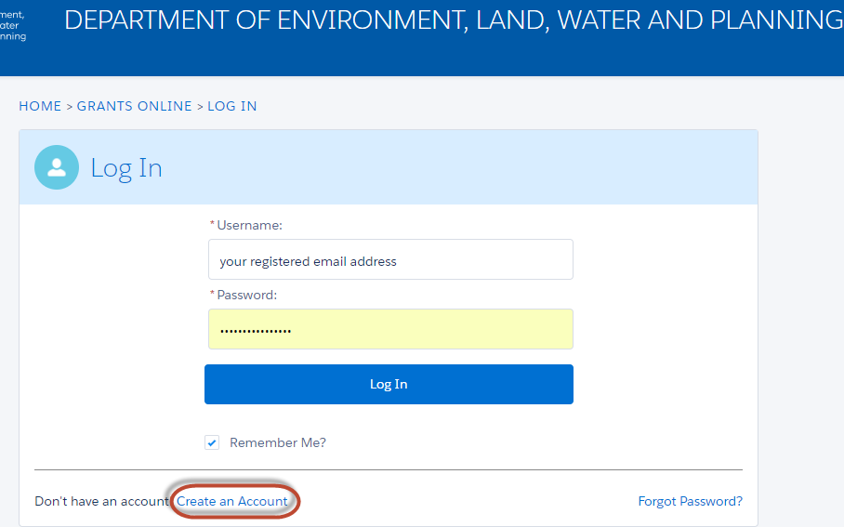

Starting a new application
The ‘Create new application’ link will be available from relevant DELWP website, as well as Grants Victoria website, for example:
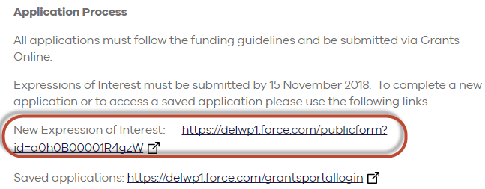

Accessing existing draft & submitted applications
A unique application reference number is generated by the system when your application is saved as draft, the application number starts with “GA-F” and looks like “GA-F12345-1234”. It is important that you include your application reference number in any communication with this grant program.

There are three ways to access existing draft and submitted applications:
- Login to https://delwp1.force.com/GrantsPortalLogin to access all your draft and submitted applications.
- Using the link provided on the program page under “How to apply” section
- Using the link provided in notification email you received after creating a new draft.

Site navigation
- The side navigation bar helps you to quickly navigate to the page you have worked on. The navigation bar colour changes from grey to green once the page is completed. And you can only jump to a page that is in green colour.
- When you click on Save as Draft button, your application form is saved.
- When you click on View as PDF button, you can view the entire application form.
- When you click on Next Page button, the previous page content is saved automatically.
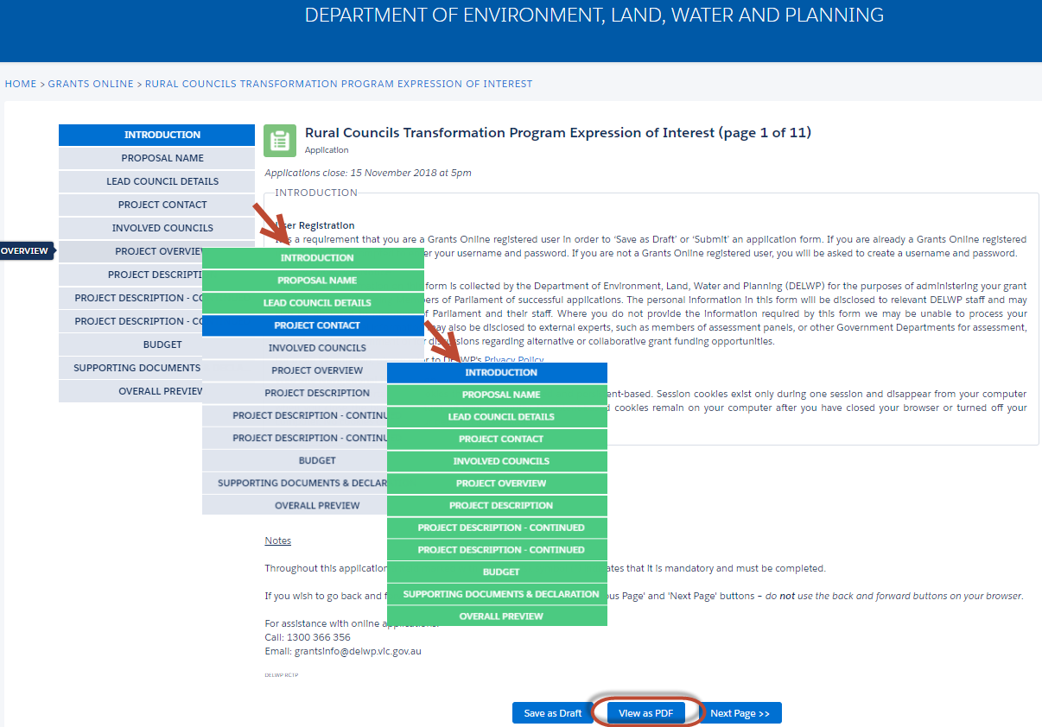

Communicate with Program representatives
When communicating with program representatives, for example, emailing to enviro.grants@delwp.vic.gov.au, please include the program name abbreviation (e.g. WRG), your application reference number, and program staff name if known in the subject line.

Note about SmartyGrants
If you have received Wildlife Rehabilitator Grants in previous years - DELWP will keep using SmartyGrants to complete their administration, and then stop using SmartyGrants. If you have an outstanding final report, please use SmartyGrants to submit it. We highly recommend you save all your previous grant documents (e.g. applications, variation requests and reports) into your own computer for future reference.

For further information & program related queries, please contact enviro.grants@delwp.vic.gov.au

