# DEECA Grants Online Portal

Information Sheet for Community Users



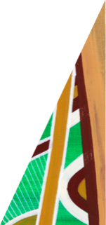The Department of Energy, Environment and Climate Action (DEECA) uses the DEECA Grants Online Portal for the management of grant applications.

[deeca.vic.gov.au](https://delwpvicgovau.sharepoint.com/Users/fionadurante/Downloads/deeca.vic.gov.au)

## Starting a new application

To start a new application, select the ‘Start a new application’ button available at [wildlife.vic.gov.au/grants/wildlife-rehabilitator-grants under the heading ‘Apply’.](https://www.wildlife.vic.gov.au/grants/wildlife-rehabilitator-grants)

To return to a previous application click the ‘Return to a saved application button’.

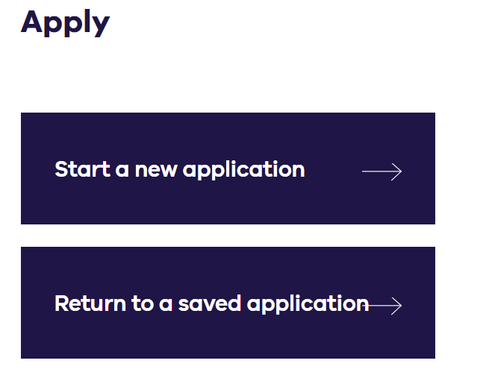

## Registration and login

If you are a new user, you will need to create an account.



If you have an existing account, you can login to the Grants Online Portal.

If you don’t remember your password, you can click on the “Forgot Password” link on the sign-in screen. A new code will be sent to your nominated email to reset your password.

It is highly recommended you write down your password and keep it safe.

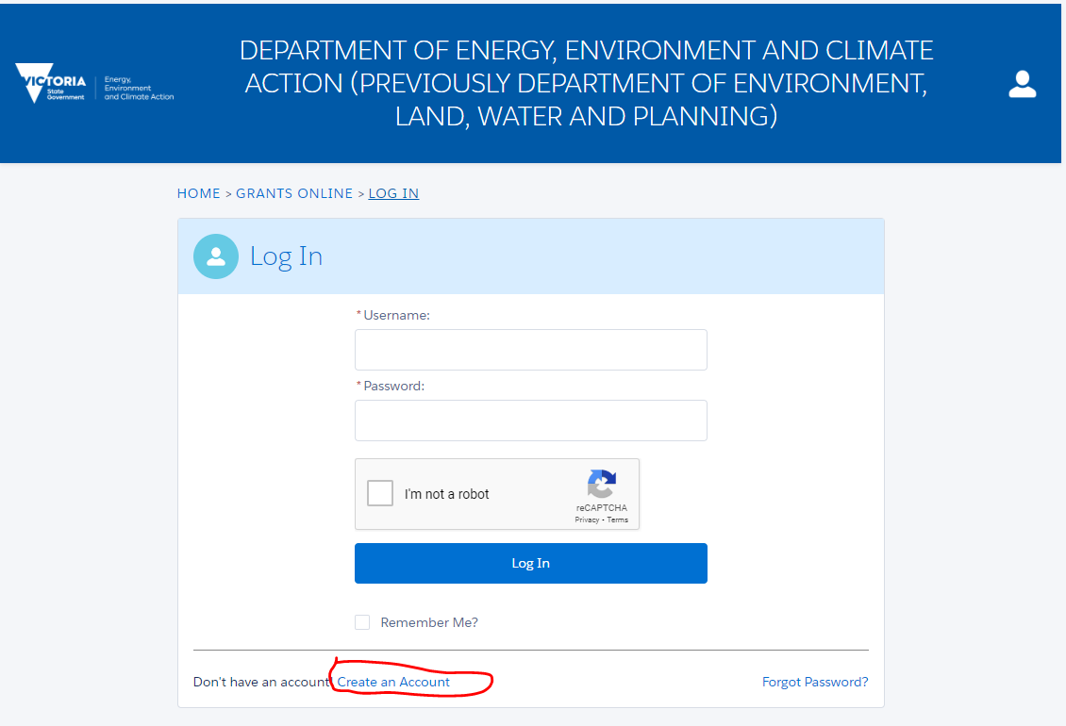

## Start your application

When you open the application form you will see a unique Application Number (yellow highlight below).

It is important that you include your Application Number in any communication with grant program staff.

Please note the **closing date and time of the application,** also highlighted in yellow.

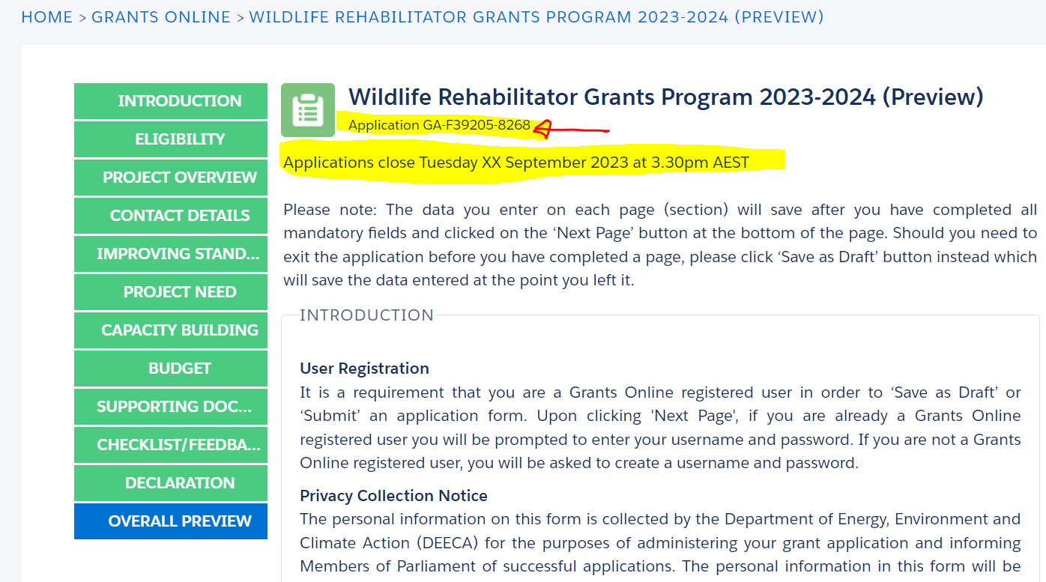

**Sample Only**

## Site Navigation

1. The side navigation bar helps you to quickly navigate to the page you have worked on. The navigation bar colour changes from grey to green once the page is completed. You can only move to a page that is in green colour.



1. When you click on the ‘Save as Draft’ button, your application form is saved.



1. To access your existing draft or submitted application, you can login into <https://delwp1.force.com/GrantsPortalLogin> **OR** use the link provided in the notification email you received after creating a new draft.
2. When you click on the ‘View as PDF button’, you can view the entire application form before filling it out.
3. When you click on the ‘Next Page’ button, the previous page content is saved automatically.



1. If you have completed the application form, click on the ‘Save and Preview’ button to save and preview your responses.



## Submit Your application

Before you submit your application, make sure you review all sections of your application form and attach all the supporting documents.

Supporting documents must be in an acceptable file type, such as Word, Excel, PDF, or JPEG. The maximum file size for each file is 10MB. If you cannot attach a document, you can email it to [grantsinfo@delwp.vic.gov.au](mailto:grantsinfo@delwp.vic.gov.au)

Note that your support documents will help with the assessment process and scores.

## Additional Information

If you require technical assistance with submitting your online application, email [grantsinfo@delwp.vic.gov.au](mailto:grantsinfo@delwp.vic.gov.au)

If you have any general questions about this grant program, email [enviro.grants@delwp.vic.gov.au](mailto:enviro.grants@delwp.vic.gov.au) quoting your application number.



We acknowledge Victorian Traditional Owners and their Elders past and present as the original custodians of Victoria’s land and waters and commit to genuinely partnering with them and Victoria’s Aboriginal community to progress their aspirations.

© The State of Victoria Department of Energy, Environment and Climate Action August 2023.

Creative Commons

This work is licensed under a Creative Commons Attribution 4.0 International licence, visit the [Creative Commons website](http://creativecommons.org/licenses/by/4.0/) (<http://creativecommons.org/licenses/by/4.0/>).

You are free to re-use the work under that licence, on the condition that you credit the State of Victoria as author. The licence does not apply to any images, photographs or branding, including the Victorian Coat of Arms, and the Victorian Government and Department logos.

Disclaimer

This publication may be of assistance to you but the State of Victoria and its employees do not guarantee that the publication is without flaw of any kind or is wholly appropriate for your particular purposes and therefore disclaims all liability for any error, loss or other consequence which may arise from you relying on any information in this publication.

Accessibility

To receive this document in an alternative format, phone the Customer Service Centre on 136 186, email [customer.service@delwp.vic.gov.au](mailto:customer.service@delwp.vic.gov.au), or contact National Relay Service on 133 677. Available at [DEECA website](http://www.deeca.vic.gov.au/) (www.deeca.vic.gov.au).