|  |
| --- |
| Our Wildlife Fact Sheet |
| Australian Magpie |

The song of the Australian Magpie is a common one that Victorians wake up to in the morning.

Scientific name

Craticus tibicen

Did you know?

Australian Magpies live in very strict groups of up to 25 birds. Females make up most of the group with usually one or two males being the dominant individuals.

Australian Magpies have one of the most complex bird songs.

Australian Magpies are related to butcherbirds, currawongs and woodswallows.

Description

The size of the Australian Magpie can vary from 38-44 cm with a wing span of 76 cm.

Mostly black and white in colouring, males are distinguished by white on the back of its neck, upper tail and shoulders, while females are often grey in these parts.

The beak is blue-grey in colour, with black legs and rusty coloured eyes.

They have four toes, three facing forward and one backwards.

Diet

The Australian Magpie forages on the ground with their strong beaks feeding on insects, worms, small lizards, frogs and beetles.

Being used to humans, they take handouts of food and will often head into open houses to beg for food.

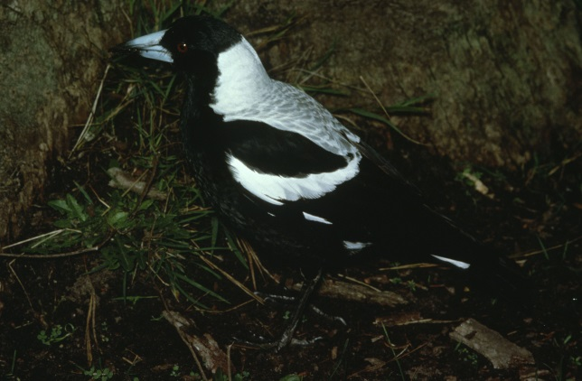

**Figure 1. Australian Magpie © I. McCann DSE 2009**

Habitat

The Australian Magpie has adapted well to urban life, inhabiting open areas with a suitable tree canopy, such as parks, sports playing fields, agricultural areas and bush landscapes.

During the breeding season, some male Magpies are territorial and aggressive towards intruders including humans, and may swoop to deter perceived predators.

Distribution

The Australian Magpie is very common, found right across Australia except for arid deserts and dense forests.

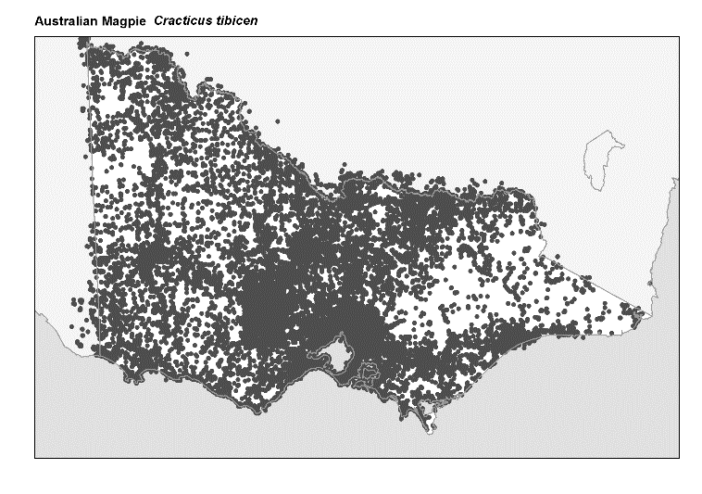

Figure 2. Recorded occurrences in Victoria

*Source: Victorian Biodiversity Atlas (records post 1979), version 15/5/2017*

Breeding

Australian Magpies breed from June to December.

They generally breed in their own social group which they defend against predators and other Magpies.

The female is in charge of selecting the nesting site and incubating the eggs.

The nest consists of sticks and twigs in a bowl shape, which the female lines with softer materials such as hair, feathers, wool and shredded bark.

The female Australian Magpie lays between 1 - 5 eggs, which she incubates (keeps warm) for around 3 weeks. Once the eggs hatch the young remain in the nest for about 4 weeks whilst being fed by the mother. During this time the nest is defended by the male.

The family group will help protect and educate the young with the father teaching them foraging skills. Many young die in the first few months due to road hazards, natural predators and lack of sufficient food.

Within two years the young are forced by their parents to leave the group and may join another group or create their own territory.

What you can do protect yourself from swooping Magpies!

Here are some things you can do to protect yourself from being swooped by Magpies.

Wear a hat and sunglasses at the back of your head if you are walking in their path. They will always swoop from behind but won’t if they think you are looking at them.

Avoid riding a bike through a known magpie area during breeding season. Instead hop off and walk.

|  |  |
| --- | --- |
| © The State of Victoria Department of Environment, Land, Water and Planning 2017  LogoThis work is licensed under a Creative Commons Attribution 4.0  International licence. You are free to re-use the work under that licence,  on the condition that you credit the State of Victoria as author. The licence does not apply to any images, photographs or branding, including the Victorian Coat of Arms, the Victorian Government logo and the Department of Environment, Land, Water and Planning (DELWP) logo. To view a copy of this licence, visit http://creativecommons.org/licenses/by/4.0/  Disclaimer  This publication may be of assistance to you but the State of Victoria and its employees do not guarantee that the publication is without flaw of any kind or is wholly appropriate for your particular purposes and therefore disclaims all liability for any error, loss or other consequence which may arise from you relying on any information in this publication. | Accessibility  If you would like to receive this publication in an alternative format, please telephone the DELWP Customer Service Centre on 136186, email [customer.service@delwp.vic.gov.au](mailto:customer.service@delwp.vic.gov.au), or via the National Relay Service on 133 677 [www.relayservice.com.au](http://www.relayservice.com.au). This document is also available on the internet at [www.wildlife.vic.gov.au](http://www.wildlife.vic.gov.au). |

Carry an open umbrella low over your head as you enter a swoop zone. Using a large clear umbrella would be ideal, as you can then see where you are going and avoid tripping.

Use a leafy branch and wave it around to deter them from swooping.

Remember that Australian Magpies, like all native Victorian wildlife, are protected and must not be harmed or harassed.

Report any suspected illegal activity in regard to Magpies to the DELWP Customer Contact Centre on 136 186.

You can find more information regarding protected wildlife on the DELWP website [www.wildlife.vic.gov.au](http://www.wildlife.vic.gov.au)

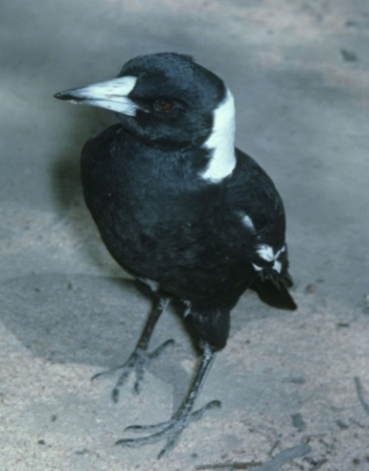

**Figure 3. Australian Magpie © I. McCann DSE**

Further reading

Simpson, K. and Day, N., (2010), *Field guide to the birds of Australia*, (8th ed), Penguin Books, Australia.

Morcombe, M., (2004), *Field guide to Australian birds*, Steve Parish Publishing, Australia.