Koalas at Cape Otway
Managing koalas at Cape Otway
Victoria and South Australia have large and thriving koala populations, especially around coastal areas. A prime example of this is Cape Otway, which contains stands of Manna Gum woodland, one of the most favoured koala habitats.

In contrast to Victoria and South Australia’s secure koala populations, koala populations in Queensland, New South Wales and the Australia Capital Territory are in decline and have been listed as Vulnerable under the Environment Protection and Biodiversity Conservation Act 1999.
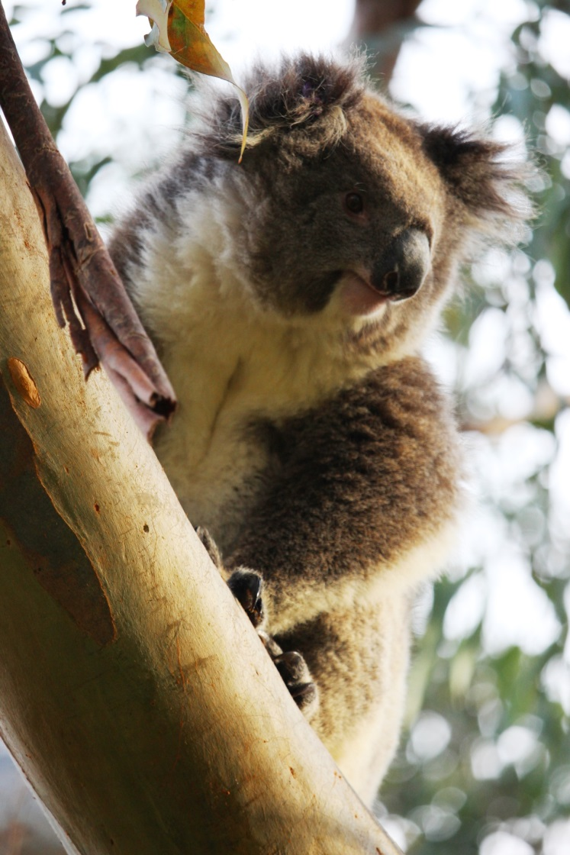
A koala in a Manna Gum at Cape Otway.

Cape Otway koala population
Due to hunting, land clearance, wildfires and disease pressure, koala populations declined significantly in the late 1800s, leaving only a few remnant populations on the mainland and some translocated populations on French and Phillip Island.
From the 1920s to 1980s, translocation programs successfully reintroduced koalas back to what is thought to be their natural range in Victoria.
In 1981, 75 koalas were reintroduced to Cape Otway from French Island. These animals were the founding individuals of the current Cape Otway koala population.
The favourable diet and climatic conditions at Cape Otway, along with the absence of predators, disease and wildfires, and a high koala fertility rate, has enabled the Cape Otway koala population to grow rapidly.
The population inhabits the favoured Manna Gum woodland, which occurs predominantly on private land.

Koala over-abundance
At the time of the translocation to Cape Otway the Manna Gum woodlands covered approximately 450 hectares. No significant land clearing has occurred since the introduction, but over-browsing by the rapidly increasing koala population has significantly reduced the condition and amount of habitat.
A sustainable koala density is believed to be approximately one koala per hectare (Victorian Koala Management Strategy 2004).
By 2013 and 2014, koala population densities were reaching up to 20 koalas per hectare at Cape Otway.
Over-abundance of koalas at Cape Otway is a difficult long-term issue brought about by their love of Manna Gums, their reluctance to change food source, favourable climatic conditions and an absence of predators.
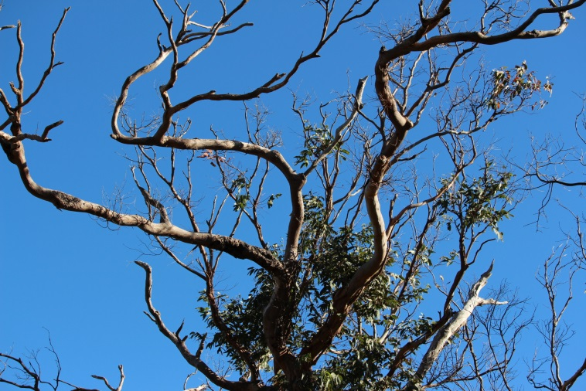
Over-browsing by koalas defoliates their Cape Otway habitat.

Unsustainable koala densities and subsequent over-browsing of the habitat has resulted in the koalas’ preferred food trees dying. Without a sufficient food source to sustain them, the health of the koala population can quickly decline, resulting in koala welfare impacts.
What actions has DELWP undertaken so far?
Emergency welfare intervention – 2013/2014
When the Cape Otway koala population density reached an unsustainable peak in 2013, an emergency welfare intervention program was initiated by the Department. During the interventions, captured koalas were assessed by veterinarians based on Koala Welfare Assessment Guidelines, developed by Zoos Victoria veterinarians and the Department.
After the intervention koala population density at Cape Otway was still high.

Cape Otway Koala Management Actions
In early 2015, DELWP established and consulted an expert panel of animal welfare and ecological experts on how to proactively manage the koala over-abundance at Cape Otway. This resulted in the development of the Cape Otway Koala Management Actions.
Since then, DELWP has been delivering management programs identified in the Management Actions to improve the health of the koala population and their habitat.
These actions aim to achieve healthy habitat and a population of healthy koalas at Cape Otway.
Since May 2015 five management programs have been delivered within the framework of the Cape Otway Koala Management Actions. These include:
- Koala health assessment in May 2015,
- Koala welfare intervention and trial translocation in September 2015,
- Large scale translocation in November and December in 2015 and
- Fertility control and health check program in May 2016, and
- Fertility control, health check and translocation program in November/December 2016.
Koala health assessment - May 2015
The first recommended action by the newly convened expert panel was to conduct a koala health assessment to gain information about the health status of the population and how that relates to the condition of habitat.
Results from the health and habitat assessment confirmed that further actions were needed to manage the welfare of the koalas at Cape Otway.

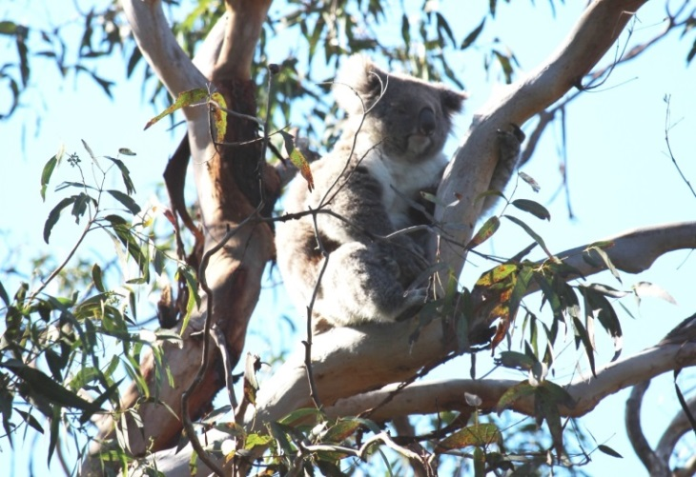
Koalas are reluctant to move from a favourite food source - Manna Gums.

Koala welfare intervention – September 2015
In September 2015 DELWP completed a two-week program, capturing and assessing a total of 395 koalas.
Of these, 166 females were treated with fertility control hormone implants. During the operation 69 dependent back young were captured and released with their mothers.
Four back young were rehomed to a Victorian wildlife park after their mothers were euthanized due to poor health.

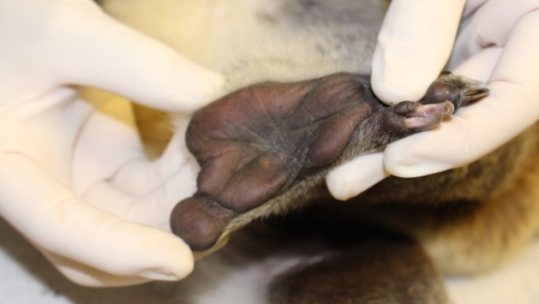
Vets assess the body condition and health of individual koalas.

Trial translocation – September/October 2015
Thirty seven healthy koalas were fitted with radio collars and moved from the Manna Gum woodland to a habitat of mixed Eucalyptus tree species in the Great Otway National Park as part of a trial translocation.
Initial monitoring of the trial translocated koalas has shown positive results after 137 days with minimal adverse health impacts on most of the koalas. The last comprehensive monitoring of the trial translocated koalas is currently being delivered and will include condition assessment and removal of collars.

This trial helped to test the viability of translocating koalas to a habitat of mixed Eucalyptus forest.

Large-scale translocation and fertility control – November/December 2015
Due to the positive outcomes of the previous trial translocation, a large-scale translocation of 374 adults koalas and 74 dependent back-young from Cape Otway to Great Otway National Park, near Lorne, was carried out in late 2015.
The large-scale translocation was designed to manage the immediate welfare needs of the Cape Otway koalas and reduce browsing pressure on their preferred Manna Gum habitat.

The translocation provided short and medium term relief for the forest and koalas at Cape Otway over summer.

Fertility control and health check program – May 2016
In May 2016 DELWP delivered a two week fertility control and health check program. The program focused on catching female koalas previously not caught before and any male koalas which appeared to be in poor condition. The program targeted private properties with high koala densities.
A total of 259 koalas were captured and assessed at the vet station. Of those, 246 were female and 13 male, with 184 healthy females fertility controlled.
Unfortunately vets considered 10 koalas to be in poor health and these were humanely euthanized to prevent further suffering.
A total of 249 healthy koalas were released back to their site of capture at Cape Otway. No dependent back-young were encountered.

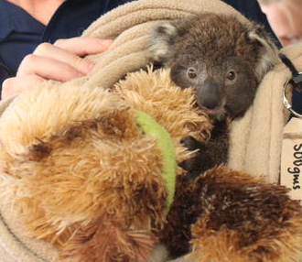
Back young koala being cared for while its mother is being assessed.

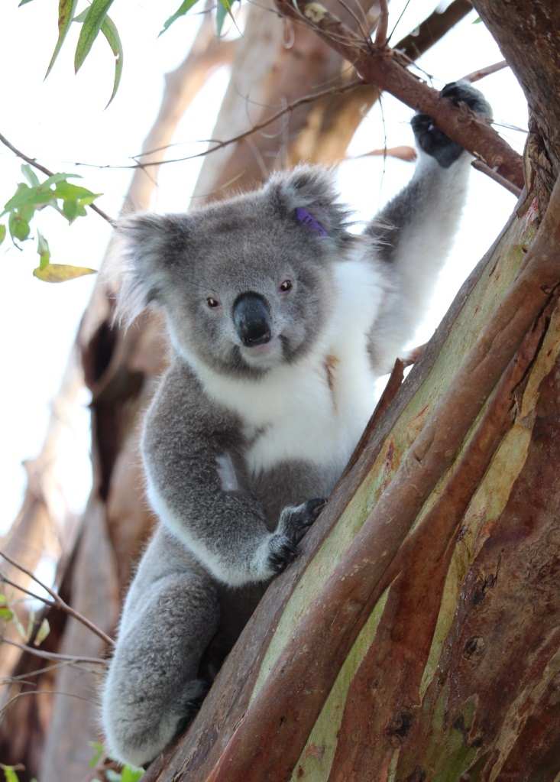
An ear-tagged male koala after release.

Fertility control, health check and translocation program - November/December 2016
In November, 2016 DELWP delivered a two week fertility control, health check and translocation program. The aim of the Spring program was to reduce the koala population at areas of high densities and declining canopy cover to help the Manna Gum woodland to recover.
A total of 343 koalas were captured and assessed at the vet station. Of these, 236 mature koalas and 54 back young were translocated to suitable habitat in the Great Otway National Park, with 95 healthy females fertility controlled before translocation. All captured animals were in good condition.
Unfortunately, the veterinarians identified 28 koalas with significant health issues and genetic abnormalities. These were humanely euthanised to prevent further suffering. There were no orphaned back young during the delivery of the program.
Although the overall health and body condition of koalas at Cape Otway have improved, areas of high koala densities still remain. Results from recent koala density surveys confirmed that further actions are required to continue managing the Cape Otway koala population in the future.
Next Program Autumn 2017
DELWP will be delivering another fertility control, health check and translocation program in Autumn 2017. The program will commence on 8 May 2017 for a two week period. The Autumn 2017 program aims to help the Manna Gum woodland continue to recover by reducing koala populations in high koala density areas.
We thank the Cape Otway community
DELWP would like to extend our sincere thanks to the Cape Otway community especially local landowners, businesses, the Conservation Ecology Centre and other research partners, for their cooperation during the recent fertility control and health check programs at Cape Otway.

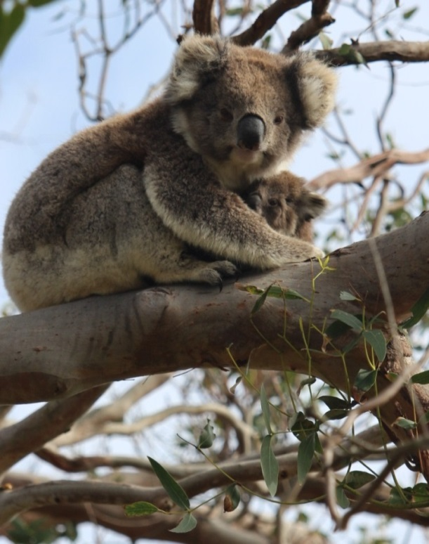
Koalas translocated in late 2015 have settled into their new home.

