Our Wildlife Fact Sheet
  - Southern Right Whale

The majestic Southern Right Whale is one of Victoria’s most loved species and is the only large whale to spend long periods of time close to shore. From Nelson to Mallacoota, there’s a good chance you’ll see one of these special creatures during winter.

Species name
Eubalaena australis
Did you know?
Southern Right Whales can be identified by the lack of a dorsal fin and distinctive skin growths called callosities on their heads. These look like barnacles and occur on top of the head, chin and lower jaw.
Callosities are as unique as a human’s fingerprint. This is how individual whales can be identified.
Southern Right Whales have two blow holes, which result in a bushy “V” shaped blow that can reach up to 5 m high.
Description
Southern Right Whales are large and stocky whales. Their body colour is usually black with white patches on the belly. They have a narrow head with a strongly arched mouth.
Southern Right Whales do not have a dorsal fin. Their pectoral fins are broad and rectangular in shape.
Adult Whales weigh about 80 tonnes and can grow to over 18 m in length.
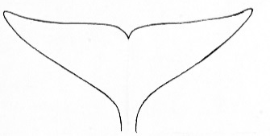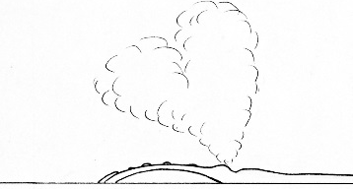

Figure 1. Southern Right Whale tail fluke and blow pattern
© B. Jarrett 2010
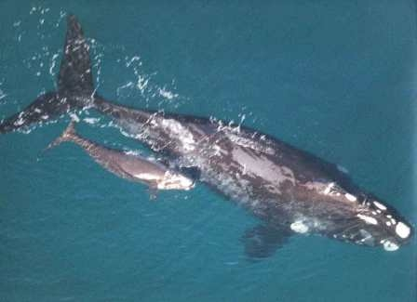
Figure 2. Southern Right Whale © DSE 2007
Diet
Southern Right Whales are one of the largest animals on earth, yet they eat some of the smallest creatures in the ocean, feeding on tiny plankton and crustaceans.
They are part of a group known as baleen whales. These whales have no teeth. Instead they have a series of filters in their mouths called baleen plates.
Baleen plates can be over 2.5 m long and are suspended from each side of the whale’s upper jaw.
To feed, Southern Right Whales skim along the surface of the water with their mouths open. When they close their mouths, the baleen plates trap food and push the water out.
Habitat
Southern Right Whales live in cool seas in the Southern Hemisphere. They migrate each year traveling between different areas at different times.
During summer, they feed in sub-Antarctic waters of the Southern Ocean.
During winter and spring, they move to warmer waters off the southern coast of Australia, South America, South Africa and New Zealand.
Distribution
During winter, Southern Right Whales can be found along most of Victoria’s coastline – most commonly in the south western Victorian region.
They usually travel close to the surface in pairs or groups of three, with larger numbers coming together at important calving areas.
Logan's Beach at Warrnambool has been a favoured area for Southern Right Whales in Victoria for many years. Nobody is quite sure why, but Logan’s Beach is the only place where females return regularly from Antarctic waters to nurse and feed their young every year.
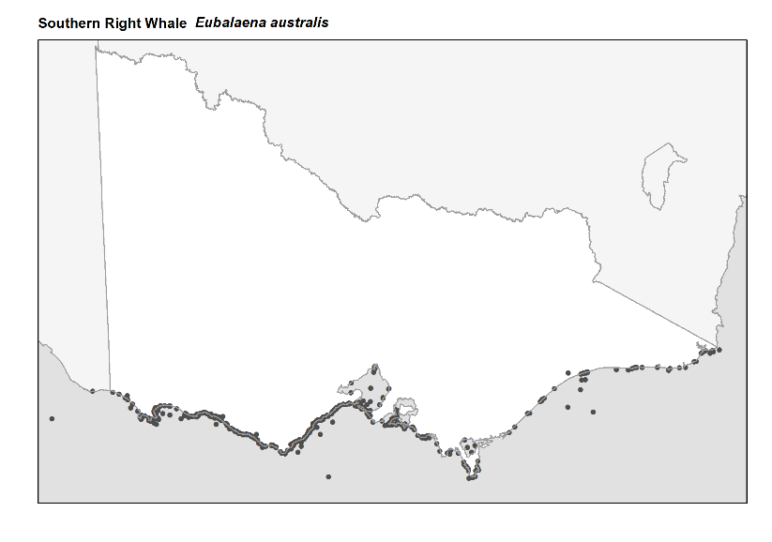
Figure 3. Recorded occurrences in Victoria
Source: Victorian Biodiversity Atlas (records post 1979), version 15/5/2017
Breeding
The Southern Right Whale is a long-lived species with an estimated life span of up to 80 years.
Females reach sexual maturity at 5-6 years old and breed every 3 years. Pregnancy lasts 11-12 months.
Reproduction and calving takes place during the winter months.
Calves weigh approximately 1 tonne at birth and grow very quickly during early development. Calves are weaned at 11-12 months.
Conservation
The numbers of Southern Right Whales dropped dramatically when whaling was allowed in the 1800s. They were nearly hunted to extinction.
The species has slowly recovered in Australia however is still extremely vulnerable and listed as a threatened species in Victoria.
Southern Right Whales are fully protected within Australian waters.
What you can do to help!
It’s important not to get too close to whales. They need space to move, feed and take care of their young.

Boating can disturb these behaviours and threaten their well being. If you are out on the ocean and see a whale, make sure you stay at least 200 metres away! When riding a jetski then you need to stay at least 300 metres away.

If you are flying a drone, remember that you must not allow the drone to get closer than 500 m above or around the whale.
Don’t drop litter! The litter you drop on the street ends up in the oceans and can be very harmful to all marine life.
Don’t discard fishing line into the ocean. It can harm marine life, including whales formany years to comer.
If you see a whale entangled in fishing line or stranded on a beach, call the Whale and Dolphin Emergency Hotline on 1300 136 017.
Further reading
Menkhorst, P.W. (ed.), (1995), Mammals of Victoria, Oxford University Press, Melbourne.

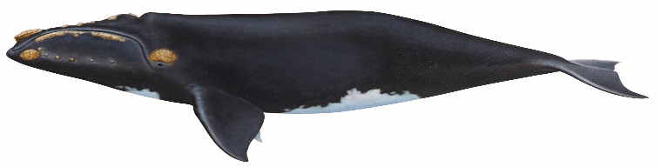

Figure 4. Southern Right Whale © B. Jarrett 2010

