Our Wildlife Fact Sheet
  - Little Penguin

The smallest of all penguins, the Little Penguin sure stands up to its name. Known also as the Fairy Penguin this fact sheet will give you some useful information about this unique species.

Scientific name
Eudyptula minor
Did you know?
Little Penguins secrete oily liquid from their tails which is rubbed over their feathers. This is to keep themselves waterproof so they can maintain a constant body temperature while at sea hunting for fish.
The Little Penguin can sleep at sea dozing on the water surface.
The Little Penguin can travel distances of over 1000 km in the first year of its life.
Description
The Little Penguin will stand 40 – 45 cm tall and weigh up to 1.2 kg. Compare this to the Emperor Penguin of Antarctica which can stand over 110 cm tall and weigh up to 30 kg!
The upper body and flippers are blue or blue grey in colour with the underbelly being white. This colouring provides camouflage for the Little Penguin while in water as predators can only see white from below and blue from above. Juveniles are generally brown in colour.
They have a black bill, pale pink webbed feet and large toes.
The male tends to be bigger than the female, with a deeper bill and larger head.
The Little Penguin will use its small wings as flippers to swim through the water at speeds of up to 6 km per hour.
The Little Penguin makes a variety of noises from a short bark to a growl when attracting a mate or in communication.

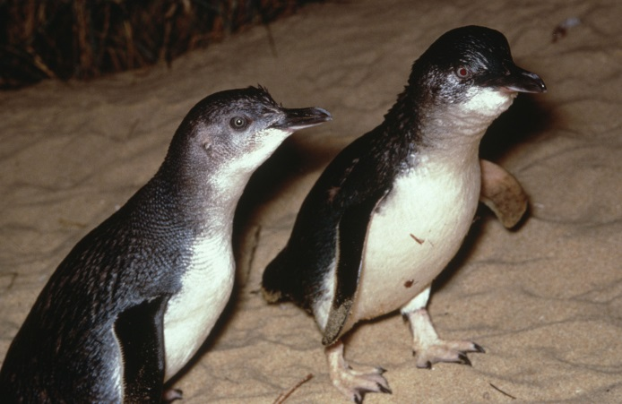
Figure 1. Little Penguin © I. McCann DSE 2009
Diet
The Little Penguin will consume the equivalent of its body weight in food every day. They feed on small fish, anchovies, pilchards, garfish and krill (shrimp like crustaceans).

They feed in shallow waters, hunting for small fish, as well as diving to the sea floor for squid and krill. Little Penguins swallow their catch whole. Little Penguins can dive up to 60 m.
Habitat
While they spend most of the day out at sea feeding, the Little Penguin comes ashore in coastal habitats to rest at night. They prefer sand dune vegetation for their nesting colonies yet can also be found among rocks and caves.

Every year the Little Penguin will return to its burrow to moult its old feathers and grow new ones. Moulting can take up to 2 weeks during which time they cannot return to sea to feed. Therefore, it is important that they fatten up before this period.

Distribution
The Little Penguin occurs only in Australia and New Zealand. They are found right along the southern edge of Australia and Tasmania. Most colonies exist on islands such as Kangaroo Island and Phillip Island.
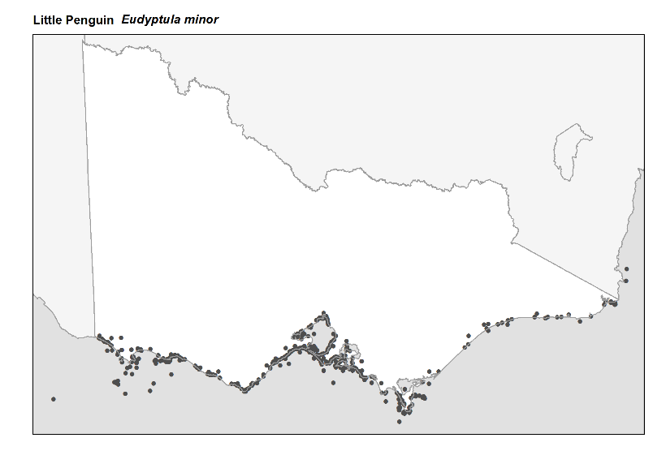
Figure 2. Recorded occurrences in Victoria
Source: Victorian Biodiversity Atlas (records post 1979), version 15/5/2017
Breeding
The breeding season runs from August to February. Between June and August, the male penguin returns to the colony to either renovate old burrows or dig new ones.
Males are quite noisy when courting the female and will try and impress her with his burrow. During courtship, both birds will stand erect with flippers spread, head bowed and walk in tight circles around the nest site.
The female will lay 1 to 2 white eggs in the burrow.
Little Penguins share the job of incubating the eggs usually in shifts of 1-2 days while the other returns to sea to feed. Hatching takes place within 33-37 days.
When hatched, chicks’ eyes open after one week. One parent hunts while the other stays with the young chicks. At 5 weeks old the chicks remain outside the burrows alone, waiting to be fed by both parents. The parents feed the young by regurgitating the food into their mouth. At 8 weeks of age, the young make their first trip out to sea.
Little Penguins have an average life span of 7 years.
What you can do to help!
Little Penguins are vulnerable to attacks by dogs, cats and foxes. They also suffer from habitat loss and destruction and pollution as a result of human activity, and can be impacted by the fishing industry depleting their food source.

Becoming aware of the wildlife in your surrounding area is a great way to help species such as the Little Penguin. If you see Little Penguins keep your distance and remain quiet as breeding sites can be easily disturbed. Never touch nests or eggs as human scent can cause the adults to abandon their breeding site. Never allow your dog to roam freely in known breeding areas.

Keep your coast clean! Rubbish affects all marine life including Little Penguins. If you see any rubbish lying about on your beach pick it up and dispose of it in a bin.

You can gain some great skills by joining a conservation group or friends group of the Little Penguin. Talk to Phillip Island Nature Park for more information.

Report any suspected illegal activity in regard to the Little Penguin to the DELWP Customer Contact Centre on 136 186.

All wildlife is protected in Victoria. Visit the DELWP website for more information regarding protected wildlife www.wildlife.vic.gov.au
Further reading
Simpson, K. and Day, N., (2010), Field guide to the birds of Australia, (8th ed), Penguin Books, Australia.
Morcombe, M., (2004), Field guide to Australian birds, Steve Parish Publishing, Australia.

