Our Wildlife Fact Sheet
  - Pobblebonk

Sounding something like a musical instrument, the Pobblebonk is one of Victoria’s most well-known frogs.

Scientific name
Limnodynastes dumerili

Did you know?

The Pobblebonk is a burrowing frog. With its powerful hind legs, it can dig backwards into the ground where it can remain until it rains.
Females use their legs to beat their egg clutches into a frothy mass that floats on the water surface.
The Pobblebonk is sometimes known as the Banjo Frog due to the banjo-like 'plonk' or 'bonk' sound it makes.

Description

Pobblebonks can grow up to 8.5 cm in length.

They vary in colour from grey, olive brown to dark brown with blackish patches and marbling, with a distinctive white cheek stripe.
Skin texture can vary from smooth to warty. The fingers and toes of the Pobblebonk are not webbed, but they have a shovel or spade-like structure on their hind toe that helps them dig.

Diet

The Pobblebonk follows the typical diet of most frogs, feeding on insects, worms and spiders.

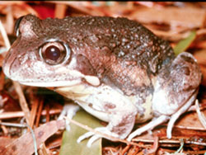Figure 1. Pobblebonk © DSE 2008

Habitat
Pobblebonks occupy wetlands, rivers, farms and dams.
They occur throughout Tasmania, Victoria and along the east coast of News South Wales.

Distribution

The Pobblebonk is found throughout most of Victoria as well as being widespread over the western and northern areas around Melbourne.
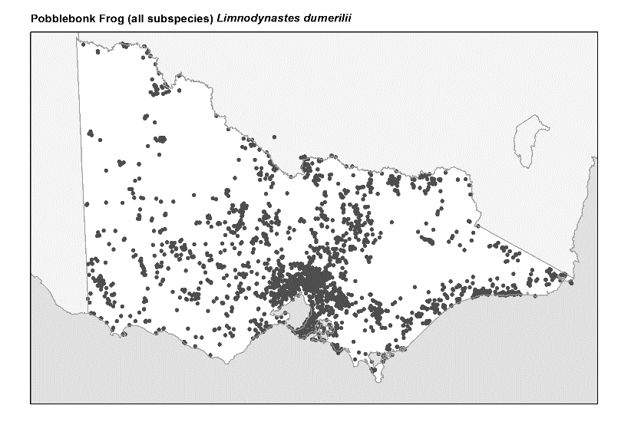
Figure 2. Recorded occurrences in Victoria
Source: Victorian Biodiversity Atlas (records post 1979), version 15/5/2017.

Breeding
Pobblebonk males compete with their calls to attract females emerging from burrows after rain.
Breeding occurs from August to April.
Females can lay a huge clutch containing up to 4000 eggs in a white floating foam raft.
Eggs and tadpoles occupy still water in swamps, streams, dams and lakes.

What you can do to help!

Sometimes humans can be a frog’s worst enemy!
Although the Pobblebonk remains abundant and widespread, loss of habitat due to clearing of land and development threatens some species of frogs. These particular species need your help.
Some frog species are susceptible to pollution. Keep waterways clean by not dumping waste and toxic liquids into your drains and creeks.
Frogs are also vulnerable to an infectious disease caused by the chytrid fungus, which can make them sick or kill them. Help protect Pobblebonks by not touching or moving them from one area to another.
Create a frog-friendly backyard by composting and avoid use of hard chemicals like herbicides.
When driving, watch out for Pobblebonks as they like to go road hopping on rainy nights.
Be careful when digging in the garden as the Pobblebonk will usually be found burrowed underground.
You can also join a frog group with your local council to give these special creatures a helping hand.

Further reading

Barker, J., Grigg, G. and Tyler, M. J. 1995. A Field Guide to Australian Frogs. Surrey Beatty & Sons, Sydney.

Cogger, H.G., (2000), Reptiles and amphibians of Australia (6th ed.), Reed New Holland, Sydney.

Hero, J-M., Littlejohn, M. and Marantelli, G. (1991). Frogwatch Field Guide to Victorian Frogs. Department of Conservation and Environment, Victoria.

Robinson, M. 2002. A Field Guide to Frogs of Australia. Australian Museum/Reed New Holland: Sydney.

Swan, G. 2001. Green Guide to Frogs of Australia. New Holland: Sydney.

Tyler, M. J. and Knight, F. (2009). Field Guide to the Frogs of Australia. CSIRO Publishing, Collingwood.
Frogs of Australia Website:
www.frogs.org.au

