Our Wildlife Factsheet
  - Chocolate Wattled Bat

The Chocolate Wattled Bat can be easily identified by its chocolate brown fur and pug nose.
Scientific name
Chalinolobus morio
Did you know?
The Chocolate Wattled Bat belongs to the Vesper Bat family meaning ‘evening bat’.
This is the most common family of bats, being found all over the world.
Bats are thought to have lived on earth for over 55 million years.
The Chocolate Wattled Bat has a clever way of ‘seeing’ while they fly around in the dark, to locate their prey and avoid obstacles.
They use echolocation, which is a series of high frequency sound pulses, generally outside the range of human hearing. We can hear up to 15 kHz while the Chocolate Wattled Bat calls at 50 kHz. The bat picks up the echoes as the pulses bounce off things. This way the bat can tell how far away the object is as well as its size, texture and if it is moving.
Contrary to the saying ‘blind as a bat’, bats actually have good eyesight, which they use to see big objects while using their echolocation to give them the fine detail.
Description
The Chocolate Wattled Bat is a microbat with a body length of only 60 mm and weighing a mere 9 grams.
Bats are the only mammals that can fly. They have the same bones in their wings as we do in our arms and hands, except the bones, especially the finger bones, are much longer and lighter. The skin is elastic and stretches over the forearm and fingers, attaching to the side of the bats body down to its ankle, forming a wing.
Because bats have bodies specifically designed to fly, they cannot stand on their hind legs. Instead they have special tendons in their feet that enable them to hang upside down without any effort.

Diet
The Chocolate Wattled Bat feeds on insects, mainly moths.
They are very agile and fast in flight, and are known to undertake a series of intricate twists and turns in order to catch their prey.
They can catch flying insects using their wings and they can eat over half of their own body weight in insects in a night.
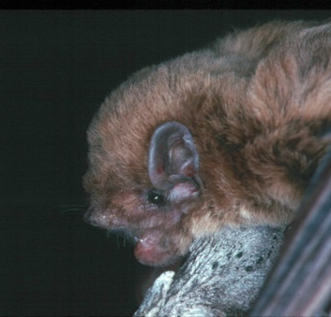
Figure 1. Chocolate Wattled Bat © L. Lumsden
Habitat
The Chocolate Wattled Bat will roost during the day in colonies of about 10 to 20, usually in tree hollows and buildings. They sleep during the day and come out at night to feed.
The Chocolate Wattled Bat has been recorded in Melbourne suburbs as well as throughout forests, woodlands and farmland areas.
Chocolate Wattled Bats living in the southern parts of Australia where the weather is cooler will hibernate during winter, dropping their body temperature to as low as 10º C. Their heart rate also slows down from an amazing 1000 beats a minute when they are flying, to about 10 beats a minute. This is a great way to save energy when there are not many insects around over winter to feed on.
Distribution
The Chocolate Wattled Bat is widespread across eastern and southern Australia, including Tasmania. They are also found in some parts of the Northern Territory. They are extremely common throughout Victoria.

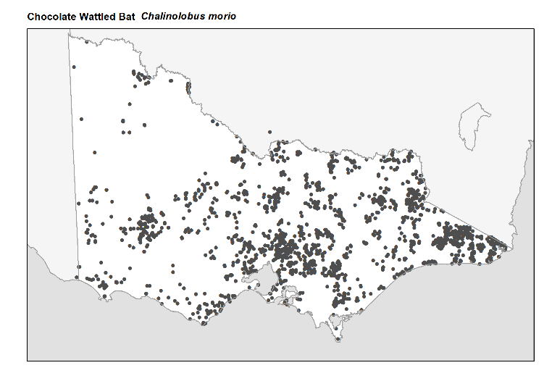
Figure 2. Recorded occurrences in Victoria
Source: Victorian Biodiversity Atlas (records post 1979), version 15/5/2017
Breeding
During breeding season female Chocolate Wattled Bats form larger maternity colonies.

Females give birth to one or two young each year, in late spring or early summer. The young are very large when born – up to 30 % of the mother’s body weight (that is like a woman giving birth to a 20 kg baby!). The young are born with very strong legs and will cling to the mother straight away. They are pink and furless with their eyes shut, but grow quickly to have fur within a few weeks. The mother suckles their young for 6 to 8 weeks, by which time they are almost adult size and ready to start flying.

The young are left in the roost at night while the mothers are out feeding. The Chocolate Wattled Bats use a crèche system where a few adults remain in the roost with the young while the other adults leave to forage.
What you can do to help!
The main threat to the Chocolate Wattled Bat and most other bat species is habitat loss. This is caused by land clearing and destruction of their roosting sites. Large old trees with hollows (both dead and alive) are especially important as roosting sites, including those in forests, rural or urban areas.

Chocolate Wattled Bats, like most microbats, are very timid and usually keep to themselves both during the day when in their roosts and when flying at night. They will not deliberately fly into you or get caught in your hair, contrary to old sayings. If you find a roost do not disturb them, as there may be breeding females with young.

Some bats can carry diseases such as Australian Bat Lyssavirus, while catching a disease from bats is very unlikely, bats should not be handled by members of the public.

See if there are any friends or conservation groups you can join in your local area that study microbats. This will give you the opportunity to learn about the many other species of bats and take part in the conservation and protection of these animals.

Report any suspected illegal activity relating to Chocolate Wattled Bats, or any other species of bats, to the DELWP Customer Contact Centre on 136 186.

All wildlife is protected in Victoria. Visit the DELWP website for more information regarding protected wildlife www.wildlife.vic.gov.au
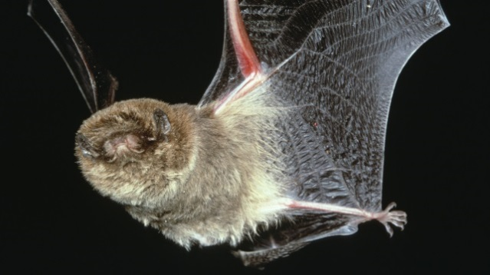
Figure 3. Chocolate Wattled Bat © I McCann DSE
Further reading
Menkhorst, P.W. (ed.), (1995), Mammals of Victoria, Oxford University Press, Melbourne.

Van Dyck, S., and Strahan, R. (2008). The Mammals of Australia. Third Edition., Reed New Holland, Sydney.

