Koalas at Cape Otway

Cape Otway Koala Management Actions – Autumn Program 2017

DEWLP to carry out another koala management program from 8 to 19 May 2017 at Cape Otway.

Wildlife officers and vets will return to Cape Otway from 8 to 19 May to carry out a two-week koala management program on private properties. The aim of this program is to conduct a fertility control, health check and translocation of koalas to north of Lorne within the Great Otway National Park.
The Autumn 2017 program aims to help the Manna Gum woodland continue to recover by reducing koala populations.
Areas with the highest koala densities and declining habitat will be targeted for translocation and fertility control of females that have not been previously caught. This will help reduce breeding rates in the future by maximising the percentage of fertility controlled female koalas within the population and minimising the percentage of the population that can breed.
This program is in line with the Cape Otway Koala Management Actions, 2015. Through these actions DELWP has implemented a range of measures aimed at achieving healthy habitats and a population of healthy koalas at Cape Otway.
Since May 2015 five management programs have been delivered within the framework of the Cape Otway Koala Management Actions. These include:
- Koala health assessment in May 2015,
- Koala welfare intervention and trial translocation in September 2015,
- Large scale translocation in November and December in 2015 and
- Fertility control and health check program in May 2016, and
- Fertility control, health check and translocation program in November/December 2016.

As a result of these programs, overall koala health and conditions at Cape Otway have improved, however, there are some areas of high koala densities still remaining, highlighting the need for further programs.
The Autumn Program will include:
- Targeting properties which have the highest koala density and declining canopy cover.
- Catching previously un-caught female koalas and implanting with fertility control implants.
- Translocating healthy koalas to reduce the koala population and assist the Manna Gum woodland to continue to recover.
- Assessing the health of all captured koalas.
- Euthanasing koalas assessed by the veterinarians as having a condition score < 3 (i.e. poor health) or significant health issues including genetic abnormalities.
- Re-homing any orphaned back young to approved zoos and wildlife shelters.

DELWP will continue to manage the koala population through ongoing fertility control, health checks and if required with translocation programs.
We would like to extend our sincere thanks to the Cape Otway community especially local landowners, businesses, the Conservation Ecology Centre and other research partners, for their cooperation during the fertility control, health check and translocation programs at Cape Otway.

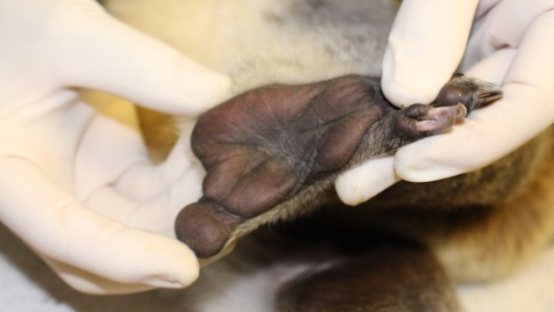
Vets assess the body condition and health of individual koalas.

