Our Wildlife Fact Sheet
  - Brolga

This fact sheet will provide you with useful information about the Brolga and its fantastic dancing rituals.
Scientific name
Grus rubicunda
Did you know?
The Brolga has featured on the Queensland coat of arms since 1977. They are known as ‘Native Companions’ because they are the only species of crane worldwide that is native to Australia.

The Brolga is the only crane species to have a gland in the corner of their eyes, which helps to pass excess salt.

Brolgas live in large flocks.
Description
The Brolga is one of Australia’s largest flying birds measuring from anywhere between 1 to 1.3 m in height. Their wing span ranges from 1.7 to 2.4 m. Males tend to be bigger than females.

The Brolga is a pale grey colour with an obvious red to orange patch on their head with a black dewlap (piece of skin) hanging underneath their chin.

Brolgas have very long legs, which are grey to black.
Diet
The Brolga is omnivorous meaning that they will feed on both plant and animal matter. They will eat a variety of wetland plants, insects and amphibians, and have also been known to eat mice.

Brolgas are quite skilled at foraging for food, and can even do so with their head completely submerged in water. They will use their heavy beak like a crow bar to wedge the ground open and turn it over in search of food.
In Northern Australia, Brolgas commonly feed on tubers, which they dig up from the ground using their pointed beaks.

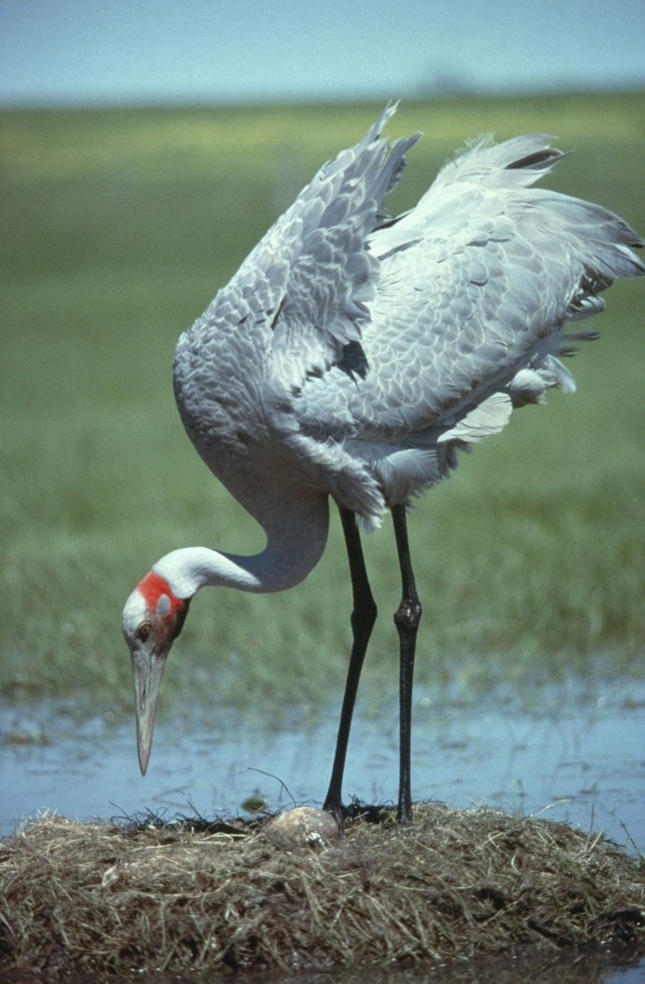
Figure 1. Brolga © I. McCann DSE 2009
Habitat
The Brolga is commonly found in open wetlands, grassy plains, well-watered farmland and sometimes coastal mudflats.

During the breeding season, they often inhabit shallow marshes where they build nests using grasses, sticks and mud.

Brolgas do not migrate, and have been known to use the same nesting site for up to 20 years.

Distribution
The Brolga is found across north and north-east Australia, north east Queensland and right through to Victoria.
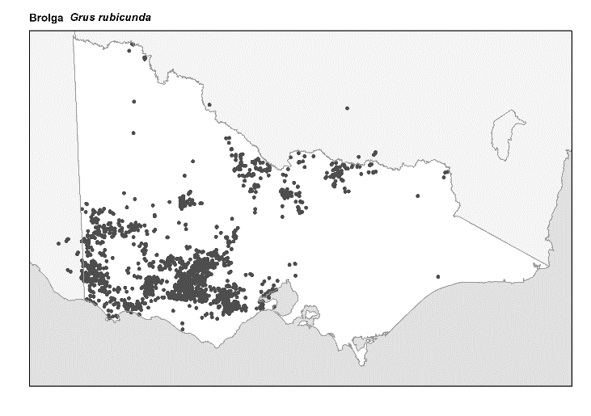
Figure 2. Recorded occurrences in Victoria
Source: Victorian Biodiversity Atlas (records post 1979), version 15/5/2017
Breeding
In southern parts of Australia, Brolgas breed between September to December. In the north, they typically breed a bit later in the year, between February and June.

The courtship ritual of Brolgas is an amazing display of dance. The dance involves jumping up to a metre in the air with outstretched wings as well as walking, bowing and bobbing their head. They also have a loud trumpet-like call which is used to attract a mate. They can dance in pairs or sometimes will dance in a group lined up opposite each other.

Brolgas are known to stay with the same partner for life. Usually two eggs are laid in their nest. The eggs are creamy coloured with reddish markings. Both the male and female incubate the eggs (sit on them to keep them warm) for about 28 - 32 days

When nesting, Brolgas are quite territorial with both the male and the female protecting the nest.
Once born, the chicks are able to fly within two weeks. The parents continue to raise the young for roughly 1 year after birth.

Conservation status
The Brolga is a threatened species. The most recent population estimate of Brolga’s in Victoria is 600 – 700 birds, with the population remaining at about the same level for the past decade.
One of the biggest threats to the Brolgas is the loss and degradation of their wetland habitats. Changes in vegetation type and structure caused by agriculture with excessive grazing and fencing is also a collision risk for Brolgas.

The Red Fox is a common predator for the Brolga, often eating eggs and young chicks.
What you can do to help!
Check with your local council or wildlife groups to see if you can join any programs aimed at wetland restoration or Brolga monitoring crews.

Report any illegal mistreatment of Brolgas to the DELWP Customer Contact Centre on 136 186.

All wildlife is protected in Victoria. Visit the DELWP website for more information regarding protected wildlife - www.wildlife.vic.gov.au
Further reading
Simpson, K. and Day, N., (2010), Field guide to the birds of Australia, (8th ed), Penguin Books, Australia.
Morcombe, M., (2004), Field guide to Australian birds, Steve Parish Publishing, Australia.

