Modelling the abundance of the Common Wombat across Victoria

G.W. Heard and D.S.L. Ramsey

February 2020

Arthur Rylah Institute for Environmental Research
Unpublished Client Report
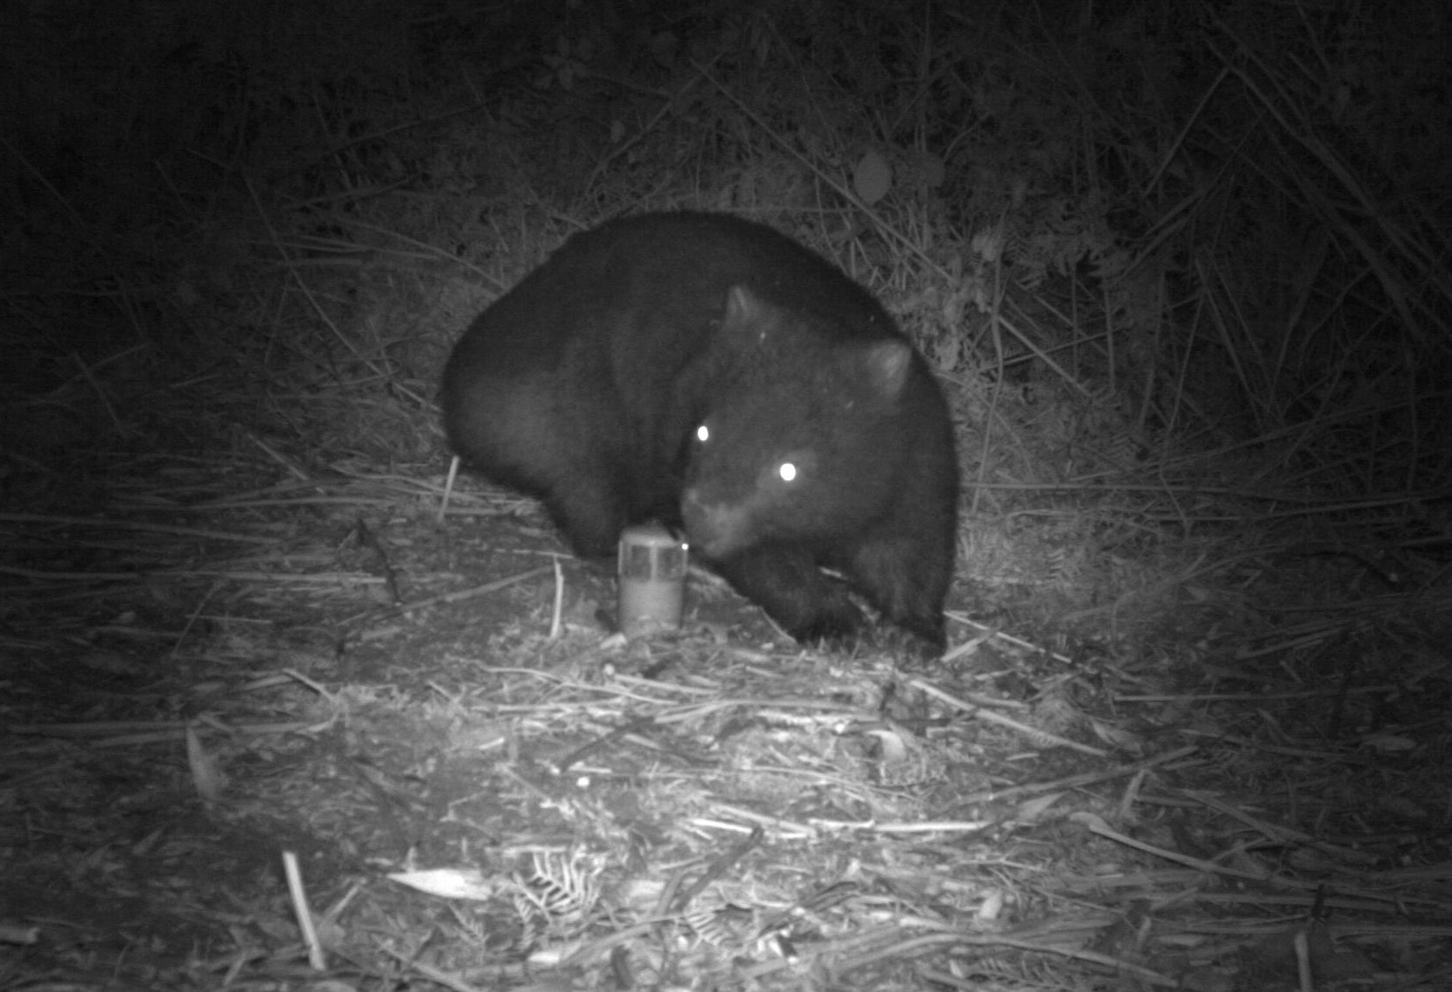
Arthur Rylah Institute for Environmental Research
Department of Environment, Land, Water and Planning
PO Box 137
Heidelberg, Victoria 3084
Phone (03) 9450 8600
Website: www.ari.vic.gov.au
Citation: Heard, G.W. and Ramsey, D.S.L. (2020). Modelling the abundance of the Common Wombat across Victoria. Unpublished Client Report for Biodiversity Division, Department of Environment, Land, Water and Planning. Arthur Rylah Institute for Environmental Research, Department of Environment, Land, Water and Planning, Heidelberg, Victoria.
Front cover photo: Common Wombat exploring a camera trap bait set for Southern Brown Bandicoots, Gippsland, Victoria. Photo courtesy of David Bryant.
© The State of Victoria Department of Environment, Land, Water and Planning 2020

Disclaimer
This publication may be of assistance to you but the State of Victoria and its employees do not guarantee that the publication is without flaw of any kind or is wholly appropriate for your particular purposes and therefore disclaims all liability for any error, loss or other consequence which may arise from you relying on any information in this publication.

Modelling the abundance of the Common Wombat across Victoria

Geoffrey W. Heard and David S.L. Ramsey

Arthur Rylah Institute for Environmental Research
Unpublished Client Report for Biodiversity Division,
Department of Environment, Land, Water and Planning

Acknowledgements
This report was commissioned by the Regulatory Strategy and Design Branch, Biodiversity Division, of the Department of Environment, Land, Water and Planning. Camera trapping data were sourced from various individuals and organisations across the State. We thank: (i) Nick Clemann (ARI) for images from the Bogong High Plains and Forlorn Hope Plain; (ii) Alan Robley (ARI) for extensive datasets from across Victoria; (iii) David Bryant and Matthew Bruce (ARI) for data from south Gippsland; (iv) Carlo Pacioni (ARI) for data from Gippsland and the Central Highlands; (v) Jemma Cripps and Luke Emerson (ARI) for data from the Central Highlands and Gippsland; (vi) Katie Howard and Lindy Lumsden (ARI) for extensive data from the north-eastern ranges; (vii) Katie Howard for data from Barmah National Park; (viii) Simon Watson (DELWP) for data from the Grampians, Pyrenees and Goldfields regions; (ix) Deirdre Lucas for data from the Bend of Isles region north-east of Melbourne, and; (x) Jamie Turner and Matthew Gill (Charles Sturt University) for images from the Mount Lawson State Park. For assistance in identifying potential data sources and fruitful discussions more generally, we thank Matthew Bruce, Jemma Cripps, Lindy Lumsden, Peter Menkhorst, Alan Robley and Michael Scroggie (all ARI). Graeme Newell and Matt White (ARI) kindly provided access to spatial layers of native tree cover across Victoria. Andrew Bennett provided constructive comments on an earlier version of this report. Lastly, we acknowledge the tremendous contribution of Deirdre Lucas to this project, who stoically reviewed many thousands of camera trap images under considerable time pressure.

Contents
Acknowledgements i
Summary 1
1 Introduction 3
2 Methods 4
2.1 Data collation 4
2.1.1 Atlas data 4
2.1.2 Camera trapping data 4
2.1.3 Environmental predictors 6
2.2 Modelling approach 6
2.2.1 Wombat distribution model 6
2.2.2 Wombat abundance model 7
2.2.3 Predicting State and regional abundance 8
2.2.4 Predicting the impact of Victorian wildfires 9
2.3 Assumptions and limitations 9
3 Results 10
3.1 Wombat distribution model 10
3.2 Wombat abundance model 11
3.3 State and regional abundance 14
3.4 Impact of Victorian wildfires 15
4 Discussion 17
4.1 Abundance model 17
4.2 Abundance estimates 18
4.3 Impact of Victorian wildfires 18
4.4 Conclusions and recommendations 18
References 20
Appendix 22

Summary

Context:
In Victoria and elsewhere, Common Wombats (or ‘wombats’) suffer from sarcoptic mange and are frequent victims of vehicle collisions. Similarly, they occur extensively through agricultural land – particularly that abutting forested areas or with riparian habitats – wherein they compete with livestock for food and are susceptible to land management practices that reduce habitat quality or population viability.
However, there are no overall or regional estimates of the abundance of wombats in Victoria. Similarly, there is a limited understanding of the drivers of abundance. In order to evaluate the status of Victoria’s wombat population, knowledge of the abundance of the species across the State is required.

Aims:
This project had an overall objective of improving knowledge of the distribution and abundance of the Common Wombat across Victoria, with four specific aims as follows:
- Review and collate existing data on the distribution and abundance of wombats across Victoria.
- Assess the suitability of these data for developing model-based estimates of wombat abundance across the State.
- Review environmental variables likely to be important determinants of wombat abundance, and identify and collate raster-based vegetation and biophysical variables that may be used as proxies for these variables.
- Develop a model of wombat abundance using existing data (if possible) and use the model to derive spatial estimates of wombat abundance across the state.
In response to the significant wildfires across Victoria during the preparation of this report, a further objective of providing a preliminary assessment of the impact of these fires on the species was also pursued.

Methods:
Camera trapping studies completed over the last 15 years provided a basis for building a statistical model of wombat abundance. Wombat detection data from 2,835 cameras deployed during 20 studies were compiled, totalling 24,485 individual images of the species. Detections were compiled as ‘time to detection’ histories and used to parameterise a time to event (TTE) model that uses the relationship between time to detection and abundance to estimate the latter. Twelve environmental covariates were included in the model to describe variation in wombat abundance. Relationships with these variables used to estimate wombat abundance across Victoria at a 1 km² resolution. Predictions were also derived for each of Victoria’s 87 Local Government Areas.
Estimates of the area of suitable habitat for wombats in Victoria and abundance across the State were overlaid with mapped fire extent (as of 21 January 2020) to estimate both the proportion of the species’ habitat affected, plus the proportion of the Victorian population affected.

Results:
Wombat abundance across the Victorian range of the species was estimated to span 0.5 - 166 per square kilometre, with the vast majority of areas predicted to have abundances between 1 and 21 per square kilometre. Non-linear relationships were evident between abundance and annual rainfall, rainfall and temperature seasonality, mean temperature of the warmest month, elevation, slope, distance to watercourse and native tree cover. Resulting predictions across Victoria suggest highest densities in the ranges to the north-east, east and south-east of Melbourne, with the highest abundances concentrated in Gippsland. The overall State-wide population estimate was 432,595, with 95% confidence interval of 405,559 – 461,388.
As of 21 January 2020, it is estimated that 21% of the suitable habitat for Wombats in Victoria has been affected by wildfires, with 19% of the Victorian population affected (roughly 83,000 individuals).

Conclusions and recommendations:
This study has produced the first statistical model of wombat abundance across the State, as well as predictions of wombat abundance at both State-wide and regional levels. The work suggests:
- Wombat abundance in Victoria is a function of annual rainfall, rainfall seasonality, temperature regimes, elevation, slope, distance to watercourse and native tree cover.
- The State-wide wombat population is predicted to be in the order of 433,000 individuals.
- Local Government Areas in Gippsland were predicted to support the largest wombat populations, including East Gippsland, Baw Baw, Wellington and South Gippsland (due to both the large size of these LGAs and the high habitat suitability therein). However, highest population densities are predicted in the ranges to the north-east, east and south-east of Melbourne.
- Some 21% of suitable habitat for wombats in Victoria has been affected by wildfires thus far during the 2019-2020 fire season, with 19% of the Victorian population affected.
Our project provides proof of concept for a model of wombat abundance in Victoria. Further work in the following areas would allow the model to be refined, with resulting increases in predictive reliability.
Improve the underlying dataset: State-wide or regional wombat surveys conducted using standardised camera trapping techniques would enable validation of the model developed here, and improve our ability to estimate population size and monitor trends. We advocate the use of distance-based protocols for camera trapping, following the approach outlined in Ramsey et al. (2019). These approaches enable distance-dependent detection functions to be explicitly incorporated into the model, allowing variation in the effective area sampled by camera traps to be accommodated. These surveys would be particularly useful in the wake of the significant wildfires of the 2019-2020 summer season, which have had an unknown impact on population size.
Improve the model: Further refinement of the model developed here could be pursued, including assessment of additional environmental covariates of abundance (for example, soil properties likely to influence burrowing) and testing of model goodness of fit and predictive capacity. Custom approaches to model testing may need to be developed for this purpose.
- Introduction
The Common Wombat (Vombatus ursinus, hereafter ‘wombat’) is widely distributed across south-eastern Australia, from the Border Ranges in far northern NSW south through higher elevations areas of the Great Dividing Range, to Victoria, Tasmania and south-eastern South Australia (Menkhorst and Knight 2001). The species is the most widely distributed of the three extant members of the genus Vombatus, and the only species to inhabit the mesic regions of the south-east of the continent. An obligate herbivore, the species consumes a wide variety of grasses, sedges and tubers, and shelters in burrows dug into moderately sloping terrain from which it emerges for nightly activity within a defined home-range (Menkhorst and Knight 2001, Skerratt et al. 2004).
In Victoria, wombats are primarily distributed through the State’s east, particularly in montane and foothill forests and coastal woodlands and heaths. Scattered populations occur through the west of the State, generally in more mesic regions including the Central Victorian Uplands and the far south-west. Despite apparently suitable habitat in the Otway Ranges, the species is almost entirely absent from this region, as are other forest adapted species such as the Superb Lyrebird (Menura novaehollandiae), Mountain Brushtail Possum (Trichosurus cunninghami) and Greater Glider (Petauroides volans). European persecution, particularly during the 19th and early 20th centuries, also significantly reduced the range of wombats in Victoria’s west.
In Victoria and elsewhere, wombats suffer from sarcoptic mange and are frequent victims of vehicle collisions. Similarly, they occur extensively through agricultural land – particularly that abutting forested areas or with riparian habitats – wherein they compete with livestock for food and are susceptible to land management practices that reduce habitat quality or population viability.
However, there are no overall or regional estimates of the abundance of wombats in Victoria. Similarly, there is a limited understanding of the drivers of abundance. In order to evaluate the status of Victoria’s wombat population, knowledge of the abundance of the species across the State is required.
Aims
This project had an overall objective of improving knowledge of the distribution and abundance of the Common Wombat across Victoria, with four specific aims as follows:
- Review and collate existing data on the distribution and abundance of wombats across Victoria.
- Assess the suitability of these data for developing model-based estimates of wombat abundance across the State.
- Review environmental variables likely to be important determinants of wombat abundance, and identify and collate raster-based vegetation and biophysical variables that may be used as proxies for these variables.
- Develop a model of wombat abundance using existing data (if possible) and use the model to derive spatial estimates of wombat abundance across the state.
In response to the significant wildfires across Victoria during the preparation of this report, a further objective of providing a preliminary assessment of the impact of these fires on the species was added. Specifically, we sought to estimate the proportion of the species’ habitat in Victoria that has been affected by these fires (as of 21 January 2020), plus the proportion of the Victorian population affected.
- Methods
  - Data collation
    - Atlas data
We began by collating all records of wombats within the Victorian Biodiversity Atlas (VBA), taking those from the last 15 years so as to match the camera trapping data collated for this project (see below). A total of 7,883 records of wombats with a spatial accuracy of ≤1 km were available from the VBA, of which 3,683 date from 2005 or later (Figure 1).

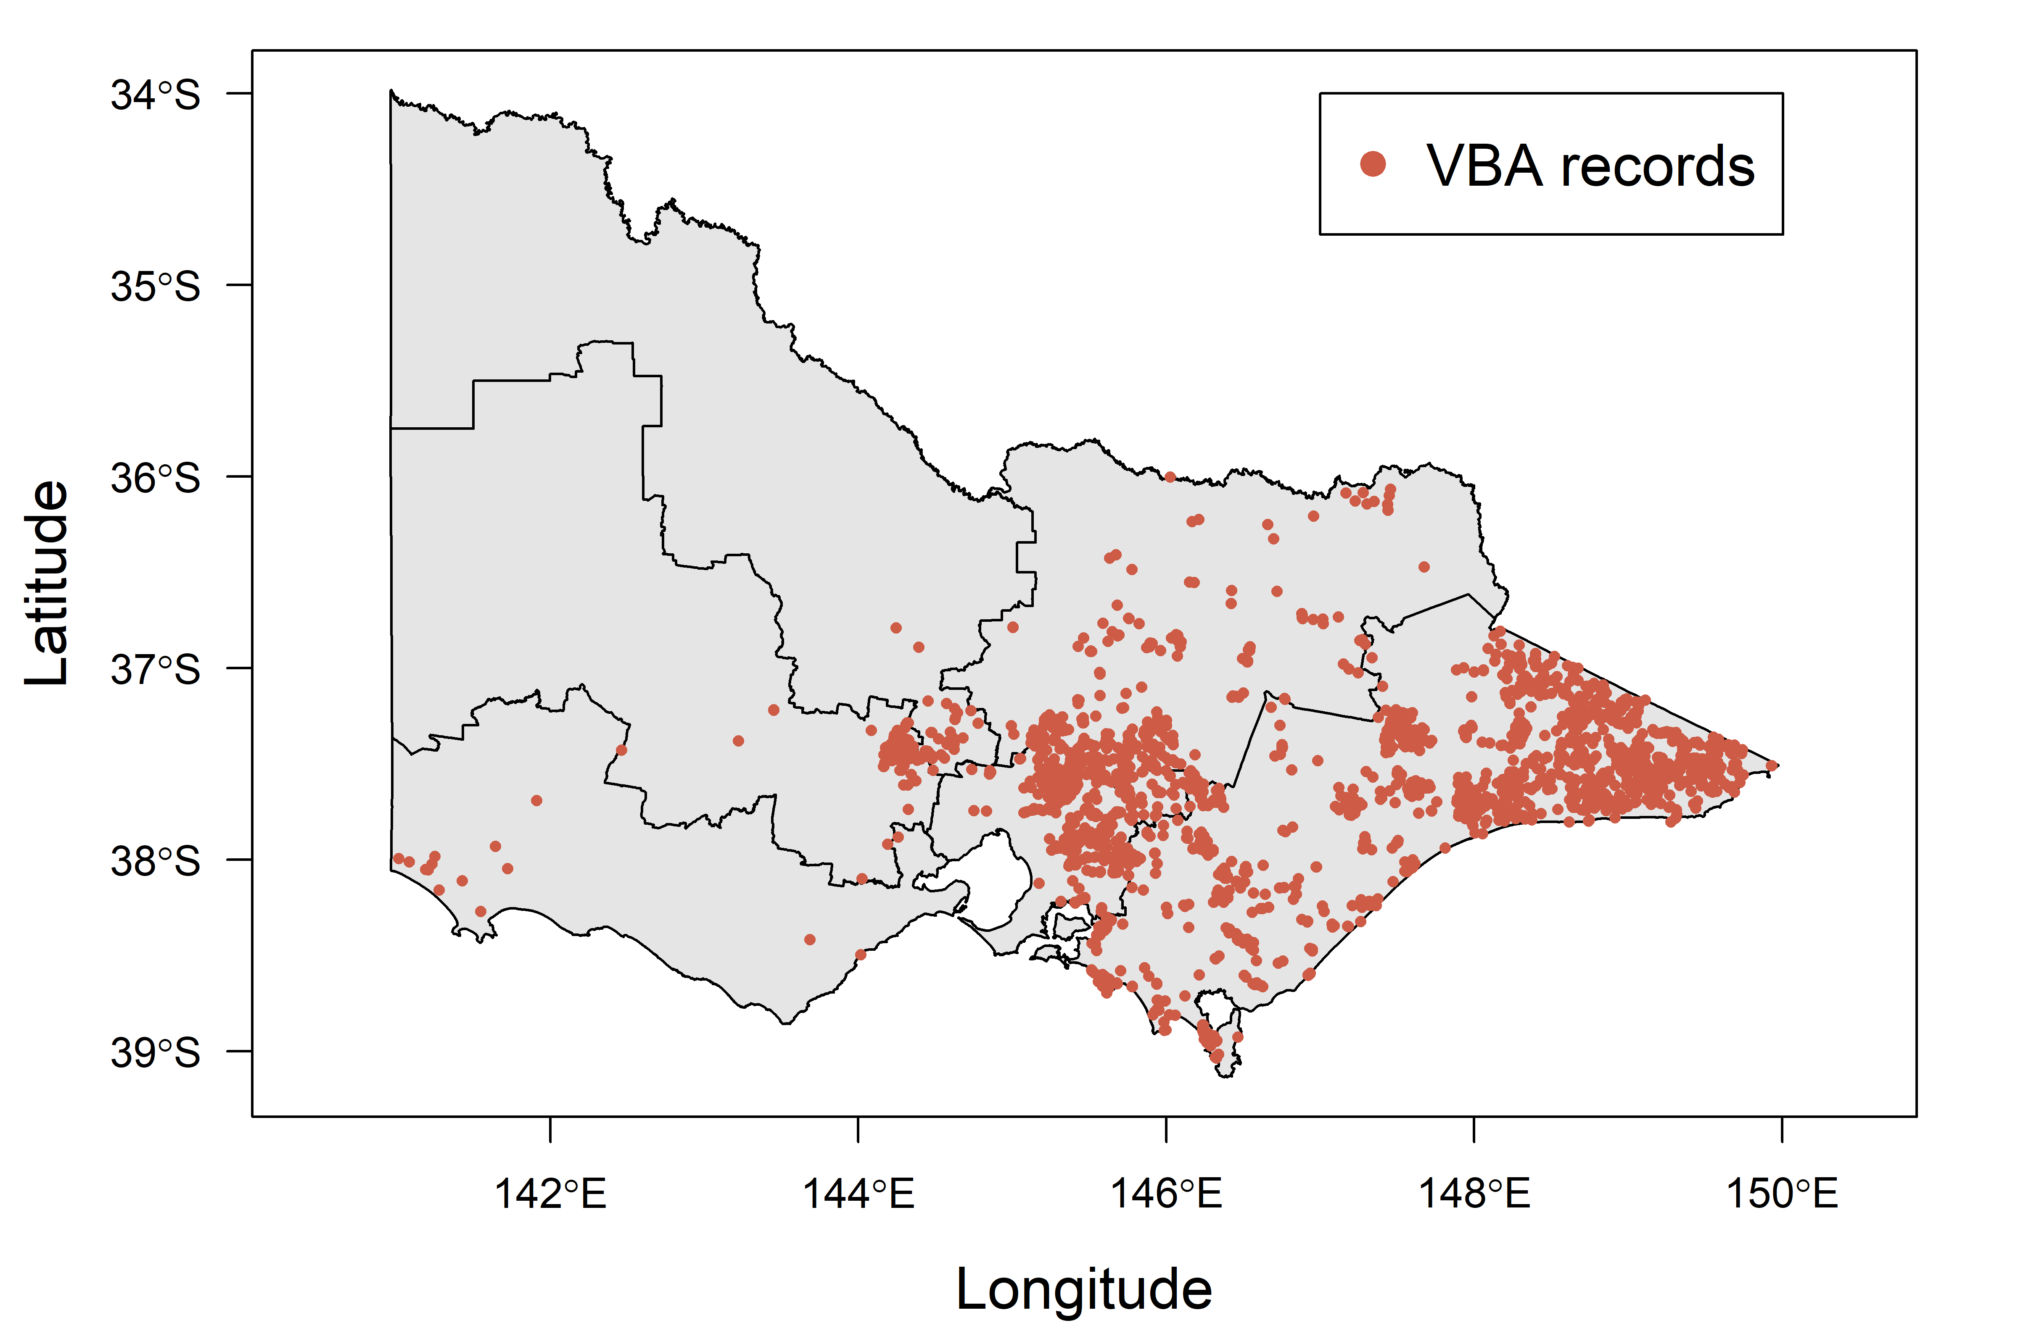
Figure 1. Records of the Common Wombat from the Victorian Biodiversity Atlas, collected between 2005 and 2019 and with a spatial accuracy of ≤ 1 km. Internal polygons show the DELWP regions.
    - Camera trapping data
The extensive camera trapping programs that have been conducted across Victoria over the past 15 years represented a significant resource for this project. While these projects have generally sought to establish regional occupancy patterns of fauna, often to test responses to particular disturbance or management regimes, the resulting data can be used to gain point estimates of abundance and to develop statistical models that link abundance to environmental covariates (as detailed in the next section). Landscape-scale predictions of abundance may then be produced from these models.
We targeted camera trapping exercises that have been undertaken across the State by Department of Environment, Land, Water and Planning (DELWP). Projects that provided a good spatial spread of sites were prioritised, to ensure gradients of wombat density and environmental variables were captured. This included sites beyond the range of wombats in Victoria, to ensure sites with zero density were represented. Projects for which image processing was already completed were targeted, given the limited capacity to process images during this project. However, dedicated image processing was completed for several high priority datasets to enable their integration into this project. These projects were conducted in areas of the State that were otherwise poorly represented, or not represented at all.
Camera trapping studies used for this project are listed in Table 1, with the spatial spread of camera trapping locations from these studies displayed in Figure 2. Data from 20 studies were compiled, with sites covering large sections of Gippsland, the north-east, Grampians, Goldfields, Central Victorian Uplands, Central Highlands, the Alps (Bogong High Plains and Forlorn Hope Plain), Otway Ranges and the far south-west, the Murray Valley and areas of the Mallee. Camera trap locations total 2,835 from these 20 studies.

For each camera deployed during each study, we compiled information on their exact location (easting and northing), year of deployment and operation period (set up date to either pick-up date or the date of the final image, if cameras were not operational on pick-up), and gave them a unique identifier. In most cases, images from these cameras had already been reviewed, either manually or using dedicated image-recognition software (ALFIE, Outofbox Solutions P/L). For the remainder, images were manually reviewed and those containing wombats extracted. We compiled the date and time (to the nearest second) for each wombat image taken by each camera. Duplicate images (those with exactly the same date and time stamp from the same camera) were discarded. We used package camtrapR version 1.2.1 (Niedballa et al. 2016) for R to extract the date and time stamp from wombat images reviewed and collated manually for this project, or those reviewed previously but for which these data had not been compiled.

Table 1. Camera trapping studies from which Common Wombat detections were collated.
Study | Region | Year/s | Camera locations
Long-footed Potoroo surveys across north-eastern Victoria | North-eastern ranges | 2006-2009 | 465
Fire ecosystem response surveys | Grampians, Goldfields and Central Victorian Uplands | 2018 | 213
Bandicoot surveys, Melbourne Strategic Assessment | West Gippsland | 2019 | 155
Guthega Skink predator surveys | Bogong High Plains | 2018-2019 | 20
Alpine Bog horse and deer impacts | Forlorn Hope Plain | 2018-2019 | 5
Hog Deer population assessment | Gippsland | 2018-2019 | 47
Sambar Deer surveys, farmland interface | Central Highlands and Gippsland | 2017-2018 | 43
Regional Forest Protection surveys | Central Highlands and Gippsland | 2018-2019 | 286
Mount Lawson State Park fauna survey | Mount Lawson State Park | 2019 | 5
Predatory surveys, Big Desert | Wyperfeld National Park | 2019 | 57
Central Highlands Ark | Central Highlands | 2014 | 89
Glenelg Ark | Public land across the far south-west | 2018 | 236
Glenelg fire and predator study | Public land across the far south-west | 2013 | 136
Grampians Fox surveys | Grampians National Park | 2011-2012 | 138
Hattah predator surveys | Hattah-Kulkyne National Park | 2014-2015 | 222
Otway Ark | Greater Otway National Park | 2018 | 335
Predator surveys, Wilson’s Promontory | Wilson’s Promontory National Park | 2019 | 95
Gippsland fire response project | East Gippsland | 2011-2012 | 219
Predator surveys, Barmah | Barmah National Park | 2015 | 39
Bend of Isles fauna survey | Bend of Isles, Yarra River | 2013 | 30

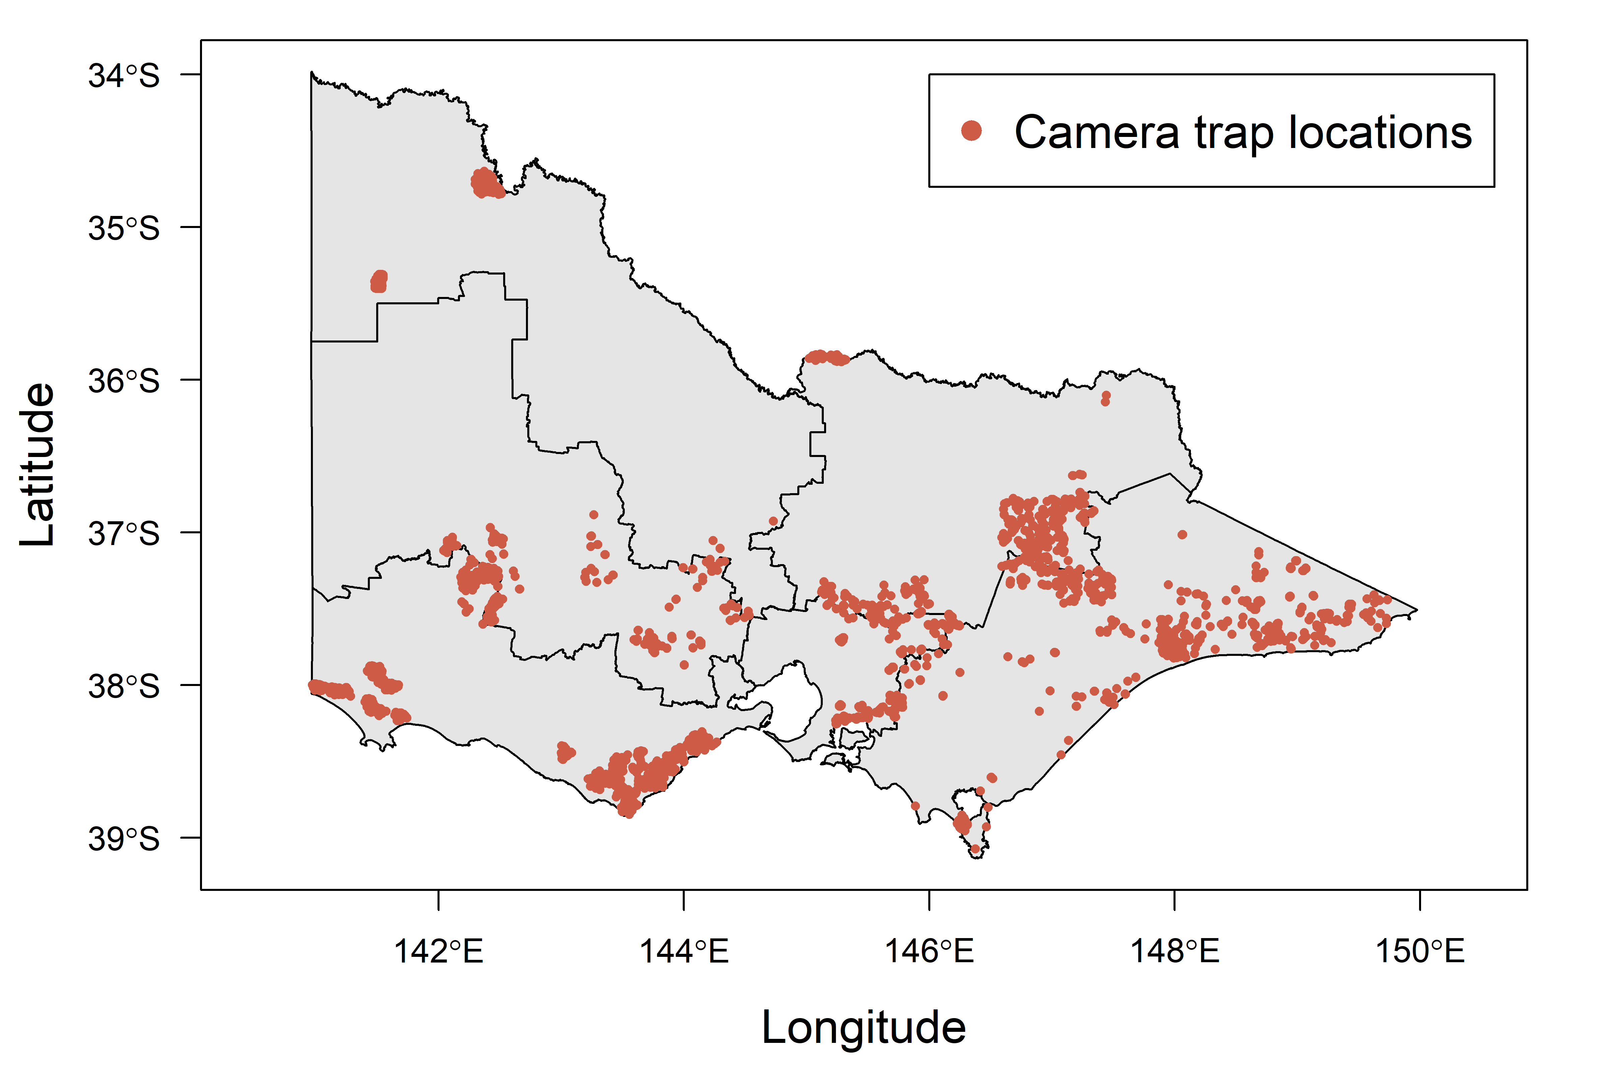
Figure 2. Camera trap locations across Victoria. Camera locations extend beyond the known range of the Common Wombat to ensure areas with zero abundance were included, ensuring relationships estimated between abundance and environmental covariates are representative of the full gradient.

    - Environmental predictors
We collated raster-based data for 12 topographic, climatic and vegetation variables considered likely to influence the distribution and abundance of wombats across Victoria, based on published studies of the species’ habitat affiliations or broader ecology (Lunney and O'Connell 1988, Catling and Burt 1995, Catling et al. 2000, Roger et al. 2007, Borchard et al. 2008, Roger and Ramp 2009, Borchard and Wright 2010, Matthews et al. 2010, Roger et al. 2012, Matthews and Spooner 2014). They were: (i) elevation (m asl); (ii) slope (degrees); (iii) topographic roughness; (iv) mean annual rainfall (mm); (v) rainfall seasonality; (vi) annual temperature range (°C); (vii) mean diurnal temperature range (°C), (viii) mean summer temperature (°C); (ix) mean temperature of the warmest month (°C); (x) temperature seasonality; (xi) native tree cover, and; (xii) distance to watercourse. Raster layers for each variable except slope, topographic roughness, native tree cover and distance to watercourse were downloaded from WorldClim version 2 (Fick and Hijmans 2017) at a 746 × 925 m grid cell resolution. Slope and topographic roughness were subsequently calculated from the elevation layer with the aid of the raster package (Hijmans and van Etten 2019) for R version 3.5.3 (R Core Team 2019). Each variable was then resampled to a 1 km² resolution.
Native tree cover was derived from a binary layer of this variable at a 75 m² grid cell resolution across Victoria, supplied by the Ecological Analysis and Synthesis Group, ARI. We resampled this layer to a 1 km² resolution by calculating the area, in hectares, of native tree cover represented by the count of 75 m² grid cells with native trees falling in each 1 km² cell (maximum of 100 ha covered by native trees per 1 km² cell). Distance to watercourse was calculated with the aid of a permanent stream layer available from the DELWP Spatial Datamart (https://services.land.vic.gov.au/SpatialDatamart/). For each 1 km² cell across the State, we estimated distance to watercourse as the straight-line distance between the cell centre and any feature (stream) on this layer. Calculations were completed with the raster package for R, as above.
  - Modelling approach
    - Wombat distribution model
We began by constructing a habitat distribution model (HDM) for wombats to delineate the species’ contemporary range across Victoria, using occurrence records from the VBA for this purpose. The Maxent algorithm (Phillips et al. 2006) was selected for model fitting, being readily applied to presence-only distribution data and displaying strong predictive performance relative to alternative methods (Elith et al. 2006). The Maxent algorithm compares presence locations with random ‘background’ points to identify environmental characteristics that differentiate occupied locations from the available environmental space.
A small set of candidate models was defined and sequentially fitted to the data. Two model sets were first defined, differentiated by their treatment of native vegetation cover. In the first model set, native vegetation cover was measured at the original 1 km² resolution. In the second model set, native vegetation cover was resampled to reflect the average cover in a focal grid cell and the surrounding eight grid cells (giving a measure of the neighbourhood cover of native forest and woodland for each 1 km² cell). Models were fitted using the ‘maxent’ function in the dismo package (Hijmans et al. 2019) in R, selecting hinge features only as they produce more biologically-realistic response curves, reduce the likelihood of over-ﬁtting and produce more robust predictions beyond the environmental space of the data (Elith et al. 2010). Background samples (n = 10,000) were drawn from the entire State.
Models were compared using Area Under the Curve (AUC; a measure of a model’s predictive accuracy) and Akaike’s Information Criterion (AIC; a measure of a model’s predictive capacity relative to other candidate models examined). The top ranked model was subsequently used to generate predictions of wombat habitat suitability across Victoria, using fitted relationships with the relevant climatic, topographic and tree cover layers.
    - Wombat abundance model
The majority of studies using camera traps for the purposes of estimating population density and/or abundance usually require at least some individually identifiable animals be present so that mark-recapture methods can be employed (e.g. Royle et al. 2009). However, wombats lack natural markings that would allow them to be identified in camera images and hence, techniques that can be applied to unmarked individuals must be employed. Unfortunately, the conventional method used to estimate abundance in unmarked populations (the N-mixture model; Royle 2004) is unsuitable for estimating population density from camera detections unless auxiliary data are collected. Hence, camera traps are often used to derive indices of animal density using the rate of camera detections. Unfortunately, the relationship between the rate of camera detections and true animal density will often be unknown.
One of the main issues with estimating animal density from camera traps is the requirement to address imperfect detection in front of the camera due to variation in the sensitivity of the camera’s infrared sensor, which is influenced by animal size, distance and angle of approach to the camera, as well as vegetation (Hofmeester et al. 2017, Moeller et al. 2018). Hence, knowledge of the effective detection distance (EDD) of the cameras is required to enable the estimation of animal density, by defining the effective area of detection (Hofmeester et al. 2017). We estimated the EDD for wombats from camera traps using a distance sampling approach employed during one of the studies compiled for this project. In that project (Ramsey et al. 2019), four plastic markers with reflective tape were placed along the midline of the field of view of each camera at 2.5, 5, 7.5, and 10 metres from the camera location, which were used to classify images of wombats into distance classes from the camera. These distances were then used to estimate a detection function, which models how detection probability declines with increasing distance from the camera (Buckland et al. 2006, Howe et al. 2017). We investigated two forms for the detection function (half-normal and hazard-rate), each with or without the addition of two cosine adjustment terms to improve fit, and compared these functions using AIC. The top ranked detection function was then integrated with respect to distance to give the marginal or ‘average’ probability of detection $\overline{p}$. The EDD was then calculated as:
$$EDD=w × \sqrt{\overline{p}}$$
where w was the truncation distance (10 m).
We analysed the detection rate of wombats in camera traps using time-to-event (TTE) models (Moeller et al. 2018). TTE models have been used extensively in ecological and medical settings for estimating the survival rate of individuals. For the present application, TTE models formalise the relationship between the camera detection rate and animal abundance by analysing the time to first detection of an individual in a camera. However, time to first detection is influenced not only by animal abundance, but also the rate of movement. Hence, a separate estimate of the movement rate of individuals is also required in order to estimate animal abundance. We use the TTE model of Moeller et al. (2018), which is summarised briefly below.
For each camera, we begin with a series of images of the target species, which are divided up into multiple sampling occasions (i.e. days), with each occasion then divided up into multiple sampling periods (e.g. hours). The number of individuals (N) occurring in the field of view of each camera i, on occasion j and period k is the modelled as:
$$N_{ijk} \sim Poisson(λ_{i})$$
where $λ_{i}$ is the mean number of individuals in the field of view for camera i. Under the TTE model, the parameter $λ_{i}$ is estimated using $T_{ij}$, the number of sampling periods until the target species is first detected in camera i during occasion j. If no individuals of the target species are seen in any period during an occasion, then $T_{ij}$ must be longer than the maximum number of periods observed and hence, is right censored at this time period. To account for movement rate, the length of each period k is set to the mean amount of time taken by the target species to cross the field of view of a camera. In our case, this was estimated by randomly sampling 50 image streams from 17 cameras and estimating the amount of time taken for each detected wombat to cross through the cameras field of view (following Moeller et al. 2018). For the images sampled, the mean estimate of the movement rate was approximately one minute. After accounting for movement rate using this method, the time to first detection was modelled as an exponential random variable:
$$T_{ij} \sim Exponential(λ_{i})$$
To account for spatial variation in the mean abundance parameter, we allowed $λ_{i}$ to vary according to potential explanatory variables measured at the location of camera i (where camera location was defined as the 1 km² grid cell to which it belonged):
$$\begin{aligned}λ_{i}= exp\left(α+ \sum_{m=1}^{n}{β_{m}}E_{im}\right)\end{aligned}$$
where α is the intercept and $β_{m}$ are regression coefficients for the $n$ respective environmental variables $E_{im}$. We used the 8 climatic, topographic and vegetation variables included in the top HDM as explanatory variables, allowing quadratic effects in each case. Variables were standardised by subtracting the mean and dividing by two standard deviations. Mean density (D) at each camera i, was then estimated using the effective detection area (a), which itself was a function of the EDD and the lens angle in degrees (which averages 40° for remote cameras used in wildlife surveys). Hence:
$$a= π×{EDD}^{2}×\frac{40}{360}$$
$$D_{i}= \frac{λ_{i}}{a}$$
    - Predicting State and regional abundance
To enable predictions of wombat abundance across the State, it was first necessary to define areas that are unlikely to be occupied. Predictions of habitat suitability may be used for this purpose, using a thresholding approach to convert continuous predictions of habitat suitability to binary predictions of ‘suitable’ or ‘unsuitable’ habitat (Liu et al. 2013). We applied such a threshold to the State-wide predictions of habitat suitability for wombats generated with the aid of Maxent (as above) to define the distribution of suitable and unsuitable habitat. While several approaches are available to identify the optimal threshold for delineating suitable and unsuitable habitat from continuous predictions (see Lui et al. 2013), these severely under-estimated the distribution of wombats across the State based on VBA records. An ad hoc approach was employed as a result, in which habitat maps resulting from decreasing threshold values of habitat suitability (≥0.9, ≥0.8, ≥0.7 etc) were iteratively compared with VBA records, with the aim of identifying a threshold that maximised the number of records captured by the resulting habitat map, while minimising over prediction into areas with no records. The selected threshold value was a predicted habitat suitability of ≥ 0.1.
In addition to the thresholding approach to defining the presence of suitable habitat, we defined offshore islands known to be unoccupied by the species as unsuitable habitat (French and Phillip Island primarily), and defined a significant portion of western Victoria as unsuitable on the basis of the distribution of recent records (2005 onwards) in the VBA, plus expert knowledge of the contemporary distribution of wombats in south-western Victoria (P. Menkhorst, ARI, pers. comm; Garry Peterson, DELWP, pers. comm). This area was bounded roughly by the Midland Highway from Geelong to Ballarat, the Ballarat-Maryborough Road, the Maryborough-Dunolly Road, the Dunolly-Moliagul Road, the Wimmera Highway to Natimuk and then an arc running south, west of the Black Range to Hamilton and then south-east to the coast at Port Fairy. As such, suitable habitat south and west of Ballarat was limited to the far south-west of the State, taking in the Lower Glenelg, Cobboboonee and Budj Bim National Parks and wooded land (both public and private) immediately north of the Princess Freeway. While a mask of this nature is ad hoc, it was necessary in this case as the distribution of wombats across south-western Victoria is extremely patchy (Figure 1), either for historical biogeographical reasons (such as absence from the Otway Ranges) or due to more recent persecution. Without application of a mask, population estimates in south western Victoria would be significant overestimates.
For each of the remaining 70,814 grid cells of suitable habitat across Victoria, the fitted relationships between wombat abundance ($λ_{i}$) and the climatic, topographic and native vegetation variables included in the final abundance model were used to predict wombat abundance therein. Cell-by-cell predictions were then aggregated to give an estimate across the entire State and for each of Victoria’s 87 LGAs.
    - Predicting the impact of Victorian wildfires
To provide a preliminary assessment of the impact of Victoria’s extensive recent wildfires on wombat populations, we estimated both the proportion of wombat habitat that has been affected by these fires, and the proportion of the population affected at both State and LGA resolutions. To do so, mapped fire extent (as of 21 January 2020) was used to calculate the area of wombat habitat that had been affected (based on the HDM described above), with predictions of abundance within this area produced using the abundance model and approach described in the section 2.2.3. The proportion of the population affected by wildfires, at both the State level and for each individual LGA, could then be estimated from these predictions.
  - Assumptions and limitations
This project collated existing camera trapping data from across Victoria for the purposes of building a statistical model of wombat abundance. Although extensive data were collated, with a good spatial spread across the species’ Victorian range (Figure 2), the dataset was nevertheless constructed from surveys that targeted other species, or sought to detect mammals in general. Likewise, these surveys varied in methodology and camera technology to some degree. For the purposes of this study, it was necessary to largely ignore these inconsistencies, such as some variation in camera height and angle, and the use of different bait types (or no bait at all). These inconsistencies may have led to variation in detection rates of wombats, which could not be integrated given missing information about these factors for most cameras.
In addition to variation in camera position and baiting, we have assumed (by necessity) that our estimates of effective detection distance and camera view angle are consistent across studies and cameras. Effective detection distance was calculated from a single dataset for which this was possible (Ramsey et al. 2019), based on the placement of distance markers along the camera view midline (allowing the distance of each wombat from the camera to be estimated). The generality of the resulting estimate of effective detection distance (5 m) cannot therefore be interrogated. It was possibly lower or greater for some camera arrangements. Likewise, we assumed a standard camera view shed of 40°. While the cameras used in the studies compiled for this project are likely to have been similar models (Reconyx Hyperfire models being now standard for such projects), we had only patchy information on the cameras deployed and could not therefore adjust view shed camera-by-camera.
The TTE modelling framework employed for this project is relatively novel (Moeller et al. 2018), and currently lacks standard means of assessing model goodness-of-fit and predictive capacity. As such, detailed interrogation of the goodness-of-fit and predictive capacity of the abundance model developed here was not possible in the time constraints of this project. While the density estimates and spatial predictions derived from the model appear reasonable (see ‘Discussion’ for further details), this represents a major limitation of the approach employed here.
Similarly, while we endeavoured to implement a rigorous approach to defining suitable habitat across Victoria for the purposes of abundance predictions, such delineations will always be imperfect. Some occupied areas will have been excluded, while other unoccupied areas have been retained. As above, the application of a mask to large tracts of south-western Victoria was suboptimal, but necessary given the very patchy distribution of the species in this region, driven largely by historical processes that cannot be modelled effectively. Given the very low densities of wombats in only a few pockets of the masked area, the State-wide and LGA abundance estimates will be largely unaffected, whereas failure to mask out habitat in this area would have produced abundance estimates inflated by many thousands of individuals.
Finally, we highlight that predictions into areas of largely cleared land may be inaccurate, as the majority of camera trapping data compiled for this study was obtained in wooded areas of the State, particularly public land. We had no data exclusively from cleared agricultural land, although one study from Gippsland sampled remnant vegetation in largely cleared landscapes, while another focussed on the forest-farmland interface. We discuss the ramifications of this bias to wooded areas later in the report (see ‘Discussion’).
For the reasons listed above, we caution that the abundance estimates produced for this project should be treated as interim, and advocate further, dedicated work to improve these estimates.

- Results
  - Wombat distribution model
Model selection statistics for the six Maxent models fit to the wombat occurrence data are shown in Table 2, with resulting predictions of habitat suitability across the State shown in Figure 3. The top ranked model included effects of annual rainfall, temperature and rainfall seasonality, elevation, slope and distance to stream, and differed from all others in including mean temperature of the warmest month and native tree cover measured at the 1 km² scale. AUC of this model was high (0.897), suggesting strong predictive capacity for wombat occurrence.
Resulting predictions of habitat suitability across the State (Figure 3, top panel) suggest large areas of highly suitable habitat throughout the eastern ranges, particularly on the southern fall of the Great Dividing Range from immediately north-east of Melbourne through to far-east Gippsland. Significant areas of habitat also occur through the Macedon Ranges to the north-west of Melbourne and the Wombat State Forest and neighbouring areas. Thresholded predictions of habitat suitability, with the mask for the State’s south-west, reduce the area of suitable habitat for the species to 70,814 square kilometres, concentrated across the ranges and foothills of eastern Victoria (Figure 3, bottom panel). The resulting map of suitable habitat aligns well with known records of wombats across Victoria since 2005 available from the VBA.
Table 2. Model selection statistics for the Maxent models fit to the distribution data for Common Wombat. Models were in two sets, with native tree cover measured either at the local (cell) scale or neighbourhood scale (average over surrounding eight cells). Within sets, models differed in the inclusion of temperature variables, either mean temperature of the warmest quarter (MTWQ), mean temperature of the warmest month (MTWM) or average diurnal temperature range (DTR). AIC, Akaike’s Information Criterion; ΔAIC, distance from the top model; AUC, Area under the Curve.
Model | Effective number of parameters | Log-likelihood | AIC | ΔAIC | AUC
Model 2: Global model, with MTWM and local tree cover | 123 | -18510.5 | 37266.95 | 0 | 0.897
Model 1: Global model, with MTWQ and local tree cover | 139 | -18517.1 | 37312.17 | 45.23 | 0.896
Model 3: Global model, with DTR and local tree cover | 131 | -18535.6 | 37333.25 | 66.30 | 0.896
Model 4: Global model, with MTWQ and neighbourhood tree cover | 119 | -18557.3 | 37352.54 | 85.59 | 0.900
Model 5: Global model, with MTWM and neighbourhood tree cover | 133 | -18553 | 37372.09 | 105.15 | 0.897
Model 6: Global model, with DTR and neighbourhood tree cover | 134 | -18571.3 | 37410.55 | 143.60 | 0.896

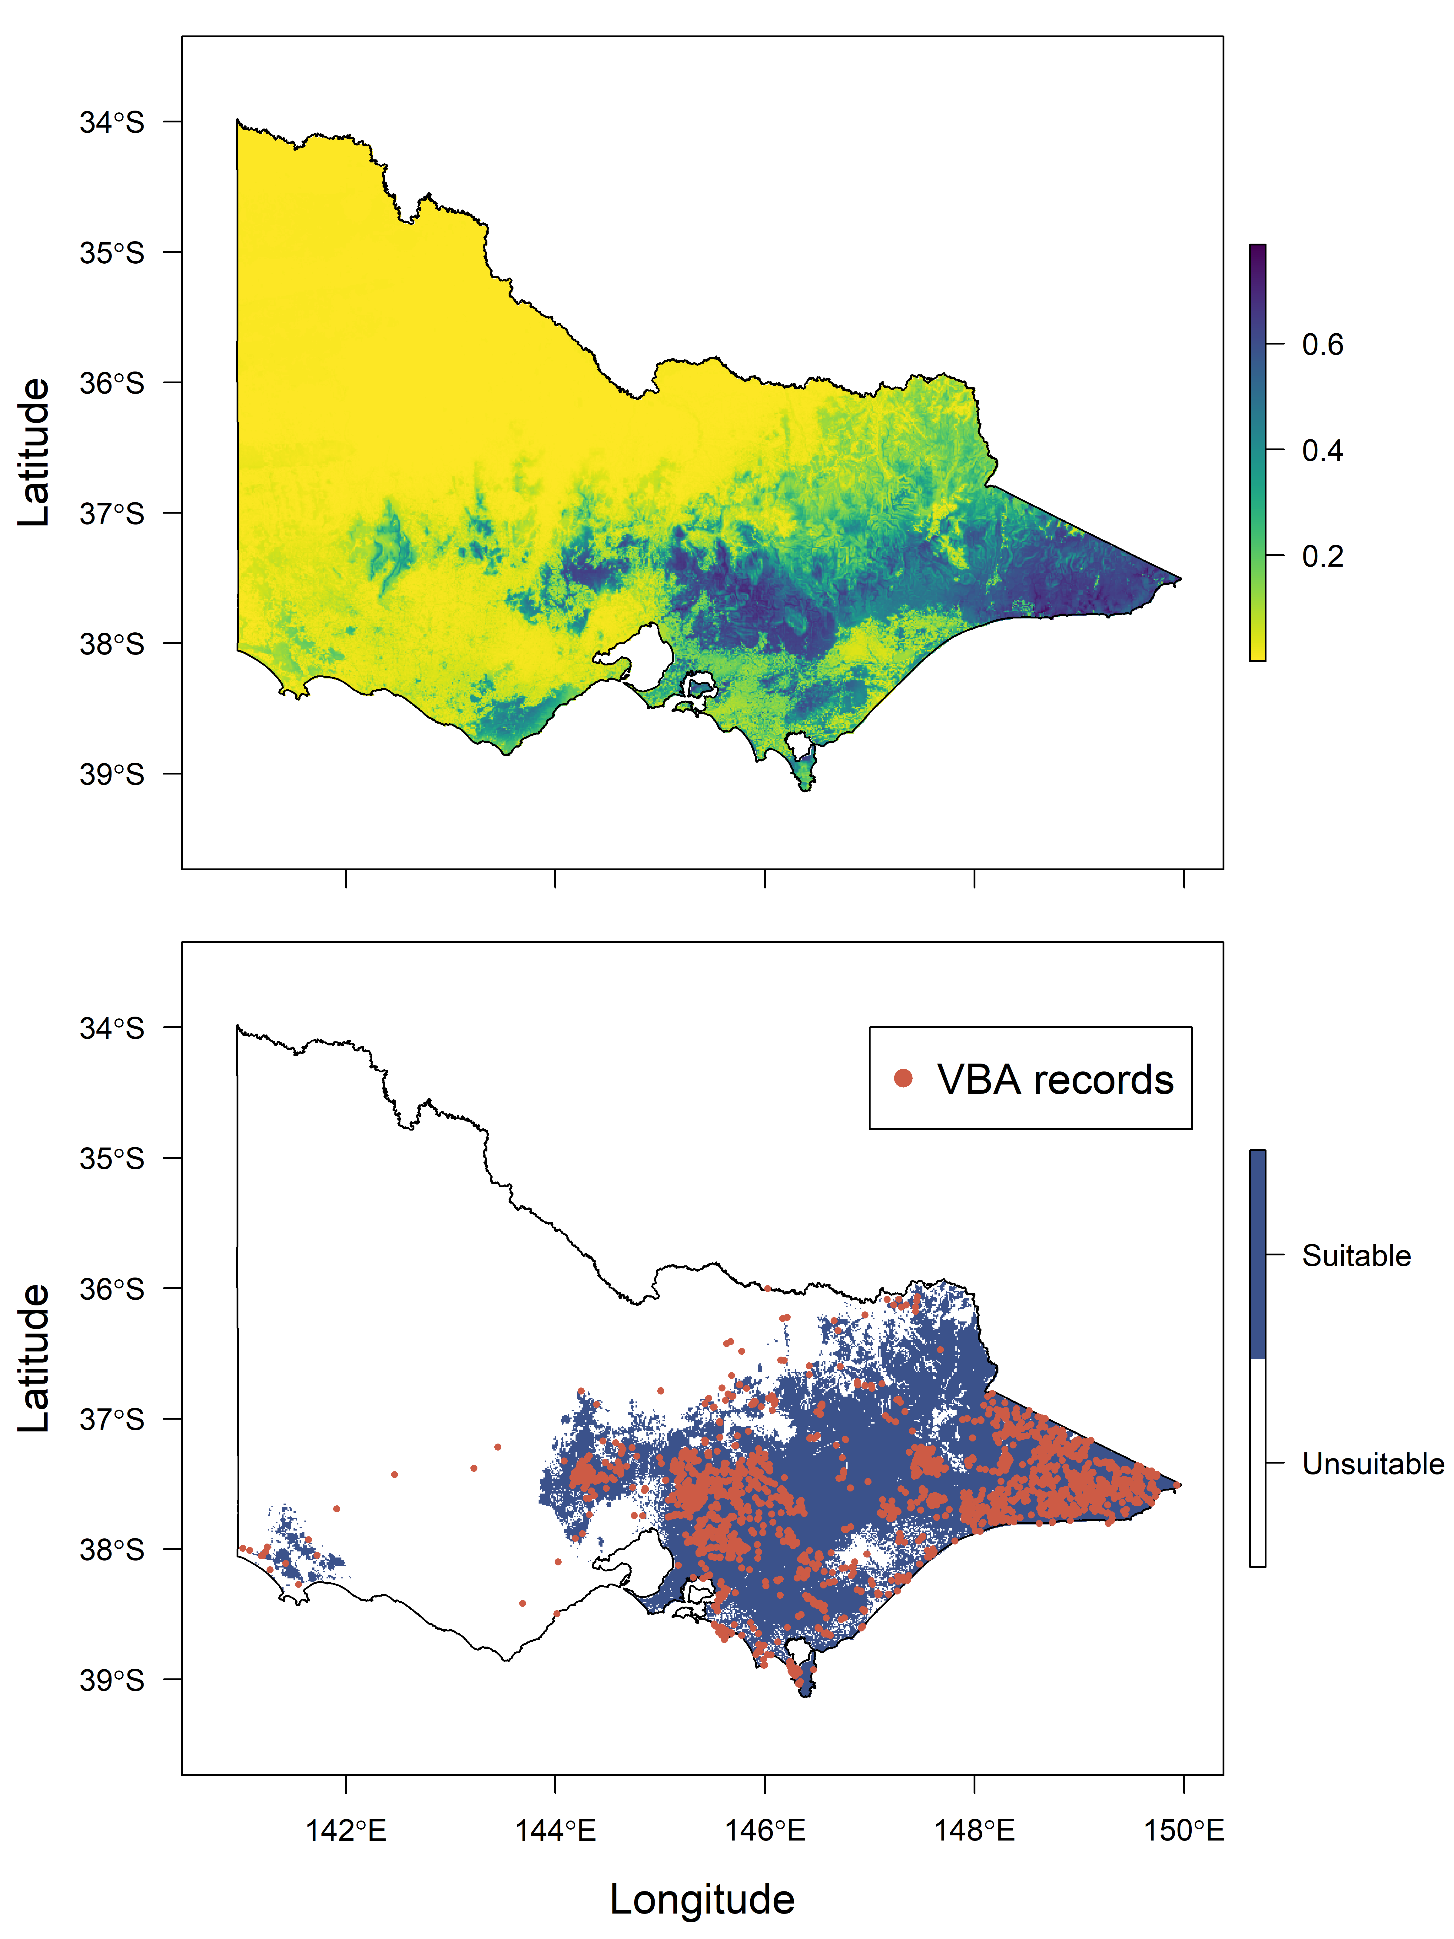

Figure 3. Predicted habitat suitability for the Common Wombat across Victoria (top panel, Maxent logistic output) and the mapped presence and absence of suitable habitat for the species across the State (bottom panel) based on thresholding of the suitability prediction and masking out largely unoccupied areas of south-western Victoria. Records from the Victorian Biodiversity Atlas from the last 15 years are provided for comparison.
  - Wombat abundance model
In total, 24,485 detections of wombats were obtained from 613 of the 2,835 camera locations across the State (Figure 4). Detections were overwhelmingly in the State’s east, with only five cameras west of Melbourne capturing wombat images. No wombats were detected on cameras deployed in the Central Victorian Uplands, the Grampians and almost all areas in the State’s south-west, with the exception of three cameras in the Lower Glenelg National Park. Detections per camera at sites where wombats were detected averaged 40, with a maximum of 1,571 detections for a single deployment.
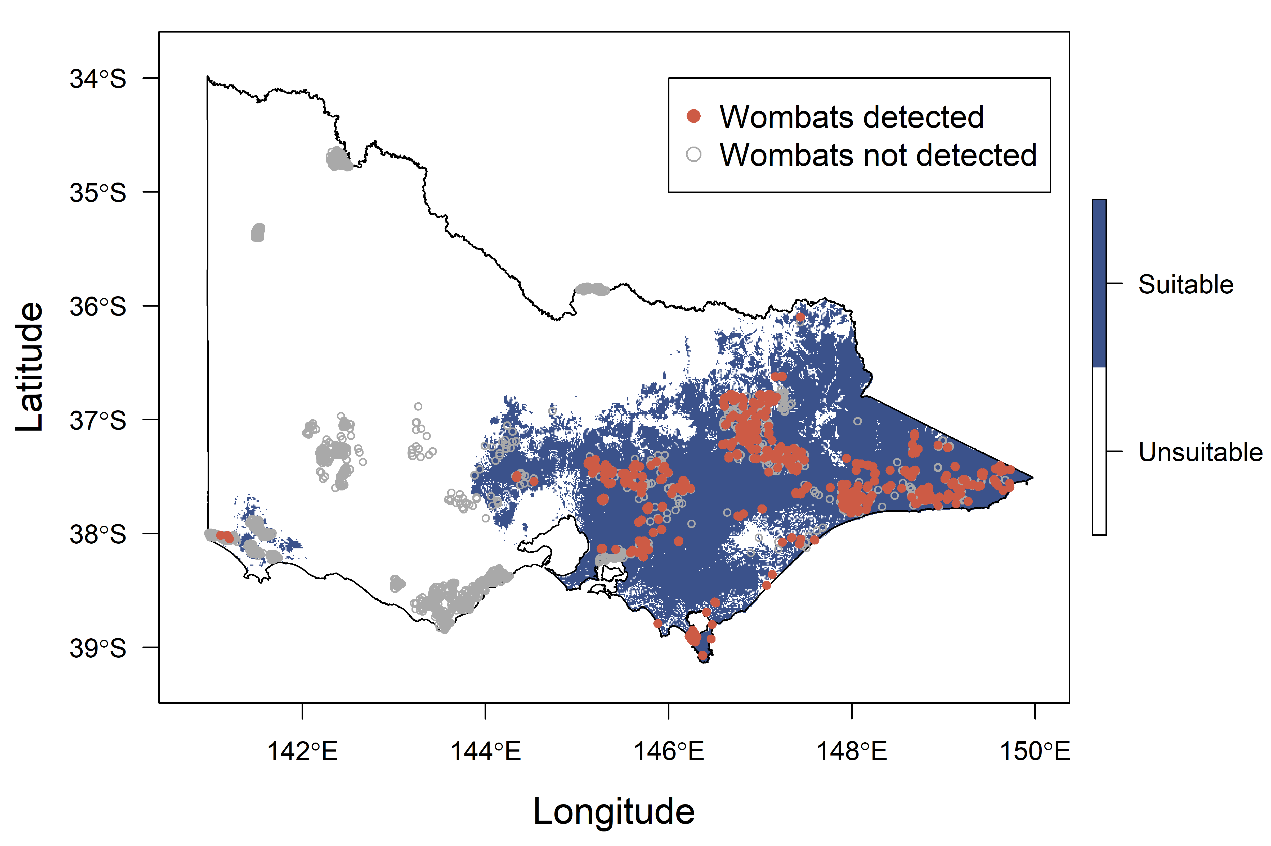
Figure 4. Detections of the Common Wombat across the 2,835 cameras from which data were collated for this project. The shaded area shows the mapped suitable habitat for the species, as per Figure 3.
Detection distances for wombats were obtained from 1,019 images from 22 cameras in south Gippsland. Detection distances peaked between 3-5 m from the camera, with detections beyond 5 m being rare (Figure 5). Model selection statistics for the half-normal and hazard-rate detection functions fit to the distance data are shown in Table 3. The hazard rate model without adjustment resulted in the lowest AIC value. The resulting detection function indicates a detection probability of wombats close to 1.0 within 5 m of the camera dropping very steeply thereafter to around zero beyond 8 m (Figure 5). The marginal (average) probability of detection within the cameras field of view out to the truncation distance of 10 m was 0.25 (SE, 0.009). The effective detection distance (EDD) was subsequently calculated to be 5 m.

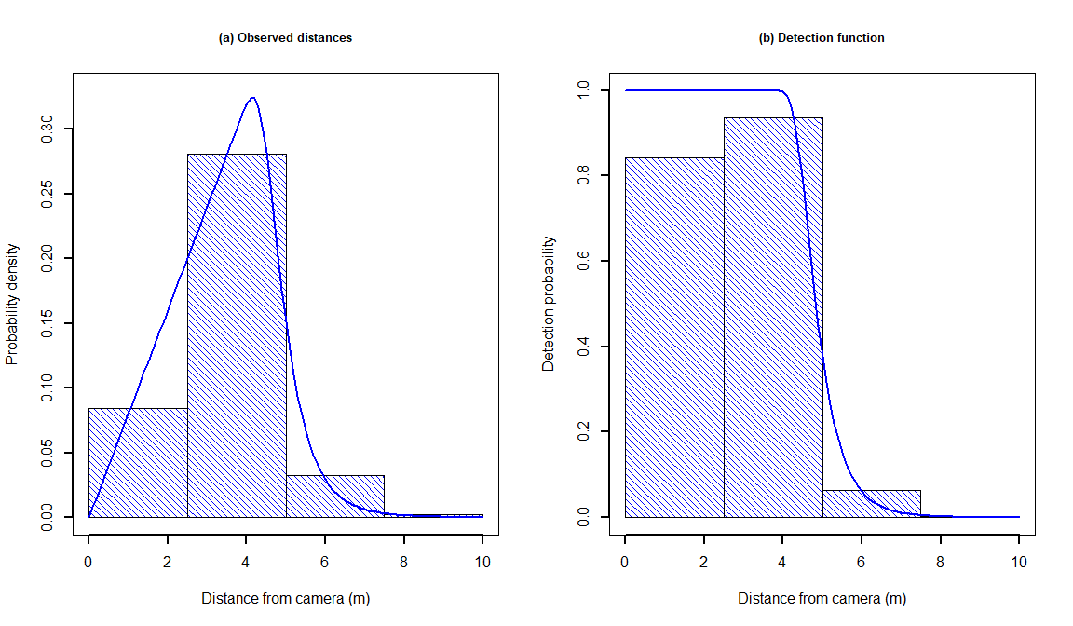
Figure 5. The probability density of observed distances (left) and the fitted hazard rate detection function (right) estimated from distances recorded between the camera and images of the Common Wombat.
Table 3. Model selection statistics for the detection functions fitted to the Common Wombat detection-distance data. AIC, Akaike’s Information Criterion, 𝚫AIC, distance from the top model.
Model | Adjustments | AIC | ΔAIC
Hazard-rate | None | 1668.35 | 0.00
Hazard-rate | 2nd and 3rd order cosine | 1672.35 | 4.00
Half-normal | 2nd and 3rd order cosine | 1746.53 | 78.17
Half-normal | None | 1872.46 | 204.11

Parameter estimates for the effects of environmental covariates on wombat abundance, derived from fitting the time-to-event (TTE) model to the full detection dataset, are shown in Table 4. With an effective detection distance (EDD) of 5 m and camera view angle of 40°, the detection area for application of the TTE model was set at 8.73 square metres. There were clear quadratic (non-linear) effects of most environmental covariates, including convex relationships between abundance and annual rainfall, rainfall seasonality, mean temperature of the warmest month, temperature seasonality, distance to stream and native tree cover. As such, wombat abundance is predicted to peak at intermediate values of these variables. In contrast, concave relationships between wombat abundance and both slope and elevation are suggested by the quadratic effects of these variables, suggesting abundance is lower at intermediate values and higher towards the extremities of these variables.

Table 4. Parameter estimates for the abundance model for the Common Wombat. Variables were standardised, meaning parameter estimates are directly comparable. SE, standard error.
Parameter / Variable | Estimate | SE | P-value
Intercept | -14.856 | 0.188 | <0.001
Annual rainfall | 7.309 | 0.630 | <0.001
Annual rainfall² | -4.234 | 0.486 | <0.001
Rain seasonality | 3.465 | 0.558 | <0.001
Rain seasonality² | -4.560 | 0.570 | <0.001
Elevation | -1.730 | 0.390 | <0.001
Elevation² | 1.379 | 0.197 | <0.001
Mean temperature of the warmest month | 33.158 | 3.085 | <0.001
Mean temperature of the warmest month² | -37.096 | 3.446 | <0.001
Temperature seasonality | 7.120 | 1.119 | <0.001
Temperature seasonality² | -6.447 | 1.284 | <0.001
Slope | -0.522 | 0.166 | 0.002
Slope² | 0.245 | 0.138 | 0.076
Distance to stream | -3.012 | 0.196 | <0.001
Distance to stream² | 4.743 | 0.269 | <0.001
Native tree cover | 2.559 | 0.307 | <0.001
Native tree cover² | -2.644 | 0.263 | <0.001

  - State and regional abundance
Estimates of wombat abundance across Victoria are depicted in Figures 6 and 7, with abundance estimates per LGA provided in the Appendix (Table A1). Excluding three grid cells with unrealistic density estimates (> 3 ha⁻¹), density estimates ranged up to 1.66 ha⁻¹ , but averaged just 0.06 ha⁻¹. As such, abundance estimates ranged up to 166 per square kilometre, with an average of just 6 per square kilometre. Abundances were predicted to be highest through the ranges to the north-east, east and south-east of Melbourne, with some areas of high abundance in far east Gippsland and the foothills of the Great Dividing Range in far north-eastern Victoria (Figure 6).
Resulting abundance estimates by LGA indicate the largest populations measured at this scale occur across Gippsland (particularly in far east Gippsland) and in the far north-east of the State (Figure 7, Table A1). Indeed, the predicted abundance for the East Gippsland LGA was significantly higher than any others, at 96,773 (95% CI: 87,150 – 107,458) individuals. The Baw Baw, Towong, Wellington and South Gippsland LGAs were all predicted to support wombat populations in excess of 30,000, with the Yarra Ranges, Murrundindi and Alpine LGAs predicted to support at least 20,000 wombats each. Populations of 10,000 or more were predicted for the Latrobe, Cardinia and Mansfield LGAs, with all others predicted to support less than this figure.
The resulting State-wide abundance estimate for wombats in Victoria was 432,595, with 95% CI of 405,559 –461,388.
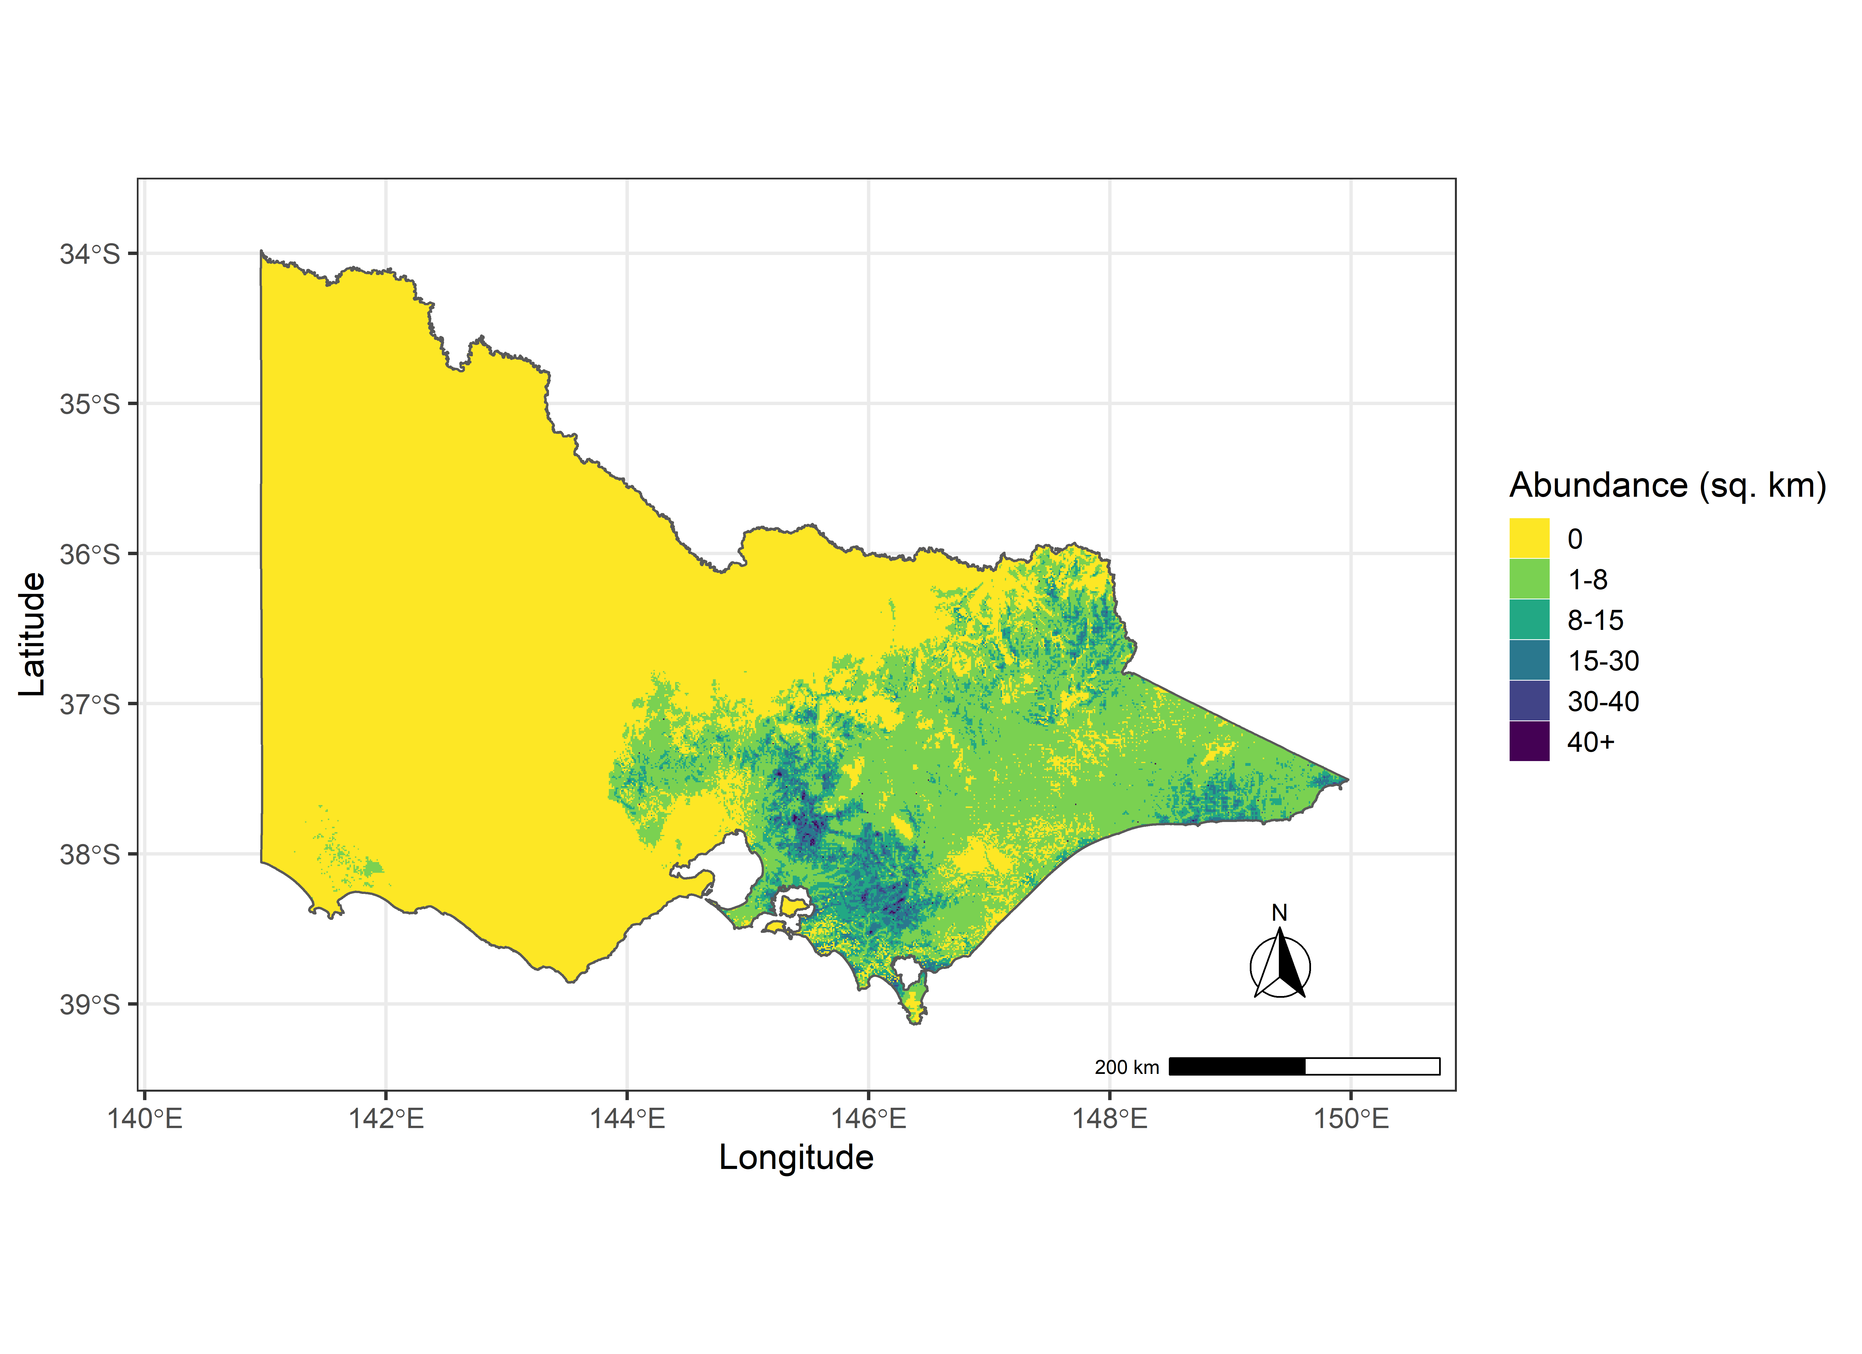
Figure 6. Predicted abundance of the Common Wombat (per square kilometre) across Victoria.

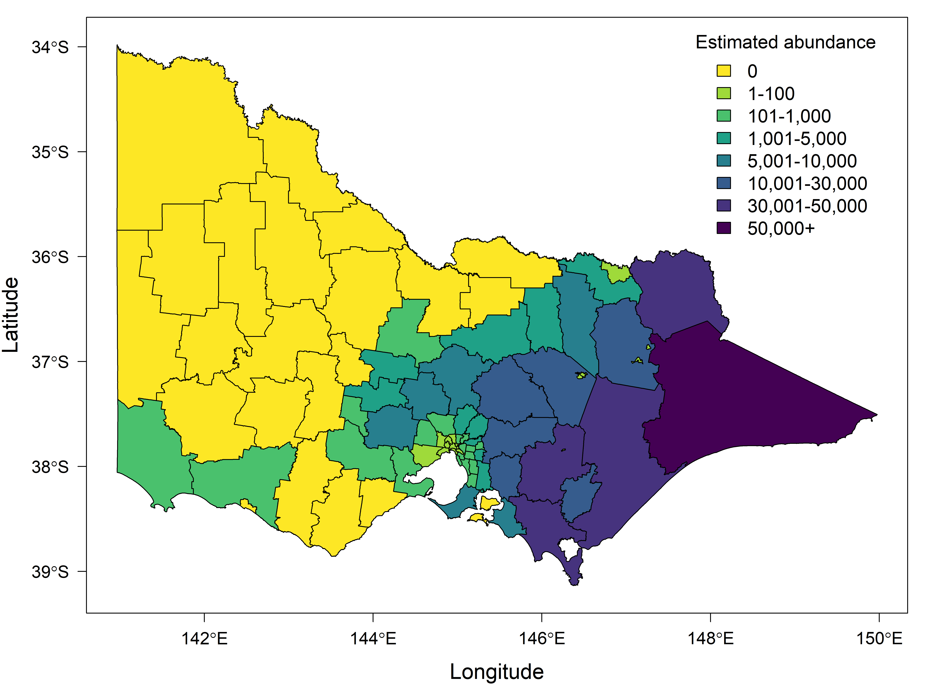
Figure 7. Predicted abundance of the Common Wombat across Victoria by Local Government Area.

  - Impact of Victorian wildfires
Figure 8 overlays the mapped extent of wildfires during the 2019-2020 season (as of 21 January 2020) on the predicted area of suitable habitat for wombats across Victoria (as per Figure 3) and abundance predictions across the State (as per Figure 6).
In total, 20.58% of suitable habitat for wombats in Victoria was predicted to have been impacted by these fires impacting 19.09% of the Victorian wombat population. The latter represents a prediction of 82,585 individuals within the current footprint of these fires (95% CI: 75,252 – 90,633).
The predicted numbers of wombats affected by wildfires for each LGA are provided in Table A2. By proportion of the population affected, largest impacts are for the Moyne (71%), East Gippsland (60%), Towong (46%) and Alpine (35%) LGAs. With the exception of the Moonee Valley LGA (which covers inner Melbourne), the proportion of the population affected is predicted to be under 10% for all other LGAs across the State.

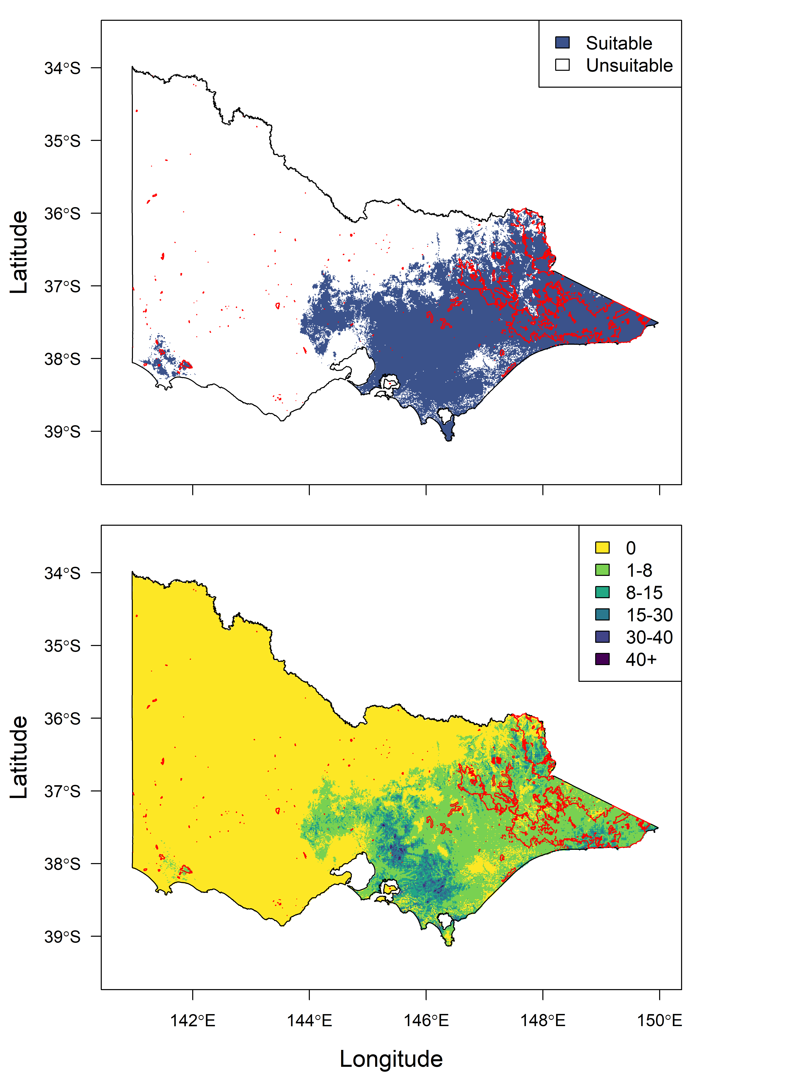

Figure 8. Comparison of the mapped extent of wildfires during the 2019-2020 fire season and both predicted wombat habitat across Victoria (top plot) and predicted wombat abundance (bottom plot). Red polygons show areas affected by wildfire as of 21 January 2020. Abundance in the bottom plot is the predicted number of individuals per square kilometre.

- Discussion
This study represents the first systematic attempt to estimate the abundance of the Common Wombat across Victoria. Below we discuss the ecological drivers of abundance identified during the modelling process and the strengths and weaknesses of the resulting model, before discussing the abundance estimates and spatial patterns therein. We close with recommendations about how future research, particularly a dedicated field program of surveys across the Victorian range of the Common Wombat, could refine our understanding of abundance and trends for the species.
  - Abundance model
Camera trapping data presents a significant challenge for estimating abundance when the individuals detected cannot be assigned a unique identifier (in which case, standard mark-recapture approaches to estimating abundance cannot be applied). We applied a relatively new technique (Moeller et al. 2018) that takes advantage of the relationship between time to detection and animal abundance to estimate the latter (after accounting for movement rate and detection distances from the camera), with density derived by dividing abundance by the area sampled by individual camera traps.
As a result of the novelty of this technique, standard means of assessing model goodness of fit and predictive capacity are not yet available, and are complicated by the nature of the observation process used (time to detection). As such, detailed testing of this model was not possible within the time constraints of this project. Nevertheless, the density estimates derived from this model align with those for wombats in the published literature, the relationships between abundance and environmental covariates are logical, and the spatial predictions of wombat abundance across the State are plausible.
Downes et al. (1997) estimated wombat density in areas of the Strathbogie Ranges in north-eastern Victoria from extensive field surveys. They estimated densities of 0.1 ha⁻¹ for forested landscapes, 0.19 ha⁻¹ for linear vegetation strips connected to forest and 0.03 ha⁻¹ for linear vegetation strips not connected to forest. Our model predicts densities within the occupied area of the Strathbogie Ranges to be between 0.01 ha⁻¹ to 0.16 ha⁻¹, very close to the range observed by Downes et al. (1997). Similarly, the finding of the highest densities in ‘edge’ environments with moderate tree cover (linear strips connected to forest) aligns with the quadratic effect of native tree cover indicated by our model, in which case density peaks at intermediate levels of tree cover. Skerratt et al. (2004) also report high wombat densities in such edge environments, recording a density of 1.9 adults ha⁻¹ within 30 ha of remnant vegetation and adjacent farmland near Glenburn, Victoria. Our models indicates relatively high densities through this area, but the estimates are significantly lower than those reported by Skerratt et al. (2004), with a maximum of 0.28 ha⁻¹. Such underprediction into riparian areas in farmland is not unexpected, given that the vast majority of data upon which our model was built were collected on forested public land. Nevertheless, it indicates that our model may underpredict densities in farmland in areas of high habitat suitability.
There are few other studies of wombat density with which our estimates can be compared. McIlroy (1977) trapped wombats in a study area west of Canberra, estimating density to range from 0.11 to 0.23 ha⁻¹ across the three sites on which he focussed. Evans (2008) completed intensive trapping of wombats across a 2 km² study area in the Riamukka State Forest on the New England Tableland in NSW, recording a density of 0.13 ha⁻¹. Our model predicts wombat densities ranging from 0.005 – 1.66 ha⁻¹ across Victoria, but 95% of predictions fall between 0.01 ha⁻¹ and 0.21 ha⁻¹. This accords well with the figures above, and with the general statement that ‘normal’ wombat densities range up to 0.3 ha⁻¹ (McIlroy et al. 2012).
Turning to the environmental drivers of wombat abundance, our model suggests convex quadratic (non-linear) relationships between wombat abundance and annual rainfall, rainfall seasonality, mean temperature of the warmest month, temperature seasonality, distance to stream and native tree cover, and concave relationships between wombat abundance and both elevation and slope (see Table 4). Few studies have examined the habitat preferences of wombats, and none have examined habitat affiliations at the scale of this study. However, some corroboration of these relationships exists in the literature, including convex relationships between occurrence, activity or density and vegetation cover (Catling et al. 2000, Roger et al. 2007, Borchard et al. 2008, Roger and Ramp 2009, Roger et al. 2012) and mean temperature of the warmest quarter (Roger et al. 2012). Effects of elevation and slope appear somewhat context dependent, with convex quadratic or negative effects of elevation and slope in higher elevation areas (Matthews et al. 2010, Matthews and Spooner 2014), and preferences for both gullies and ridges documented in foothill forest (Lunney and O'Connell 1988). Overall, our study suggest wombat abundances in Victoria are highest at areas with intermediate levels of rainfall, rainfall and temperature seasonality, mean temperature of the warmest month, distance to stream and native tree cover, with elevation and slope also being important determinants of density. The convex effect of native tree cover is of particular interest from a management perspective, indicating that densities are highest in areas with a mosaic of agricultural land (pasture) and forest or woodland. Wooded riparian zones and the ecotone between forest and pasture are likely to be areas of highest density.
  - Abundance estimates
Although our density estimates for wombats are generally low, the extensive range of the species (estimated to be in the order of 71,000 square kilometres) means large populations occur across the State. We estimated the State-wide population of the species to be in the order of ~433,000, with abundances up to 166 per square kilometre at the extreme upper end of predictions (although most lay in the bounds of 1 - 21 per square kilometre).
The largest populations are predicted to occur through the forested portions of eastern Victoria, particularly Gippsland. Of the five LGAs with the highest population estimates, four occur in Gippsland (Table A1, Figure 7). Nevertheless, densities are predicted to be highest through the ranges to the north-east, east and south-east of Melbourne (Figure 6), where LGAs are smaller on average than those across Gippsland (Figure 7). Populations across Victoria’s west and south-west are predicted to be relatively small, and limited primarily to the Wombat State Forest and surrounding areas north-west of Melbourne and to the Lower Glenelg and Cobboboonee National Parks and adjacent land in the far south-west. The population of wombats in the far south-west is predicted to be around 1000 individuals (Table A1, Figure 7).
Nevertheless, we reiterate that these estimates should be treated as interim estimates for further refinement. As per section 2.3, this project compiled data from camera trapping studies conducted for purposes other than modelling wombat abundance at large spatial scales, with resulting variation in techniques that could not always be accounted for in our modelling approach. Similarly, we caution that the goodness-of-fit and predictive capacity of the abundance model could not be interrogated to any great degree given time limitations, and that the underlying dataset was restricted largely to forested public land with few sites on the farmland interface or in heavily cleared areas. Predictions across agricultural land should therefore be treated with some caution.
  - Impact of Victorian wildfires
Wildfires across Victoria during the 2019-2020 summer season are predicted to have affected around 20% of wombat habitat in the State. Moreover, we predict that some 19% of the Victorian wombat population has been affected by these wildfires. Impacts are concentrated in four LGAs, being Moyne in the far south-west (as a result of a large fire in the Budj Bim National Park), East Gippsland, Towong and the Alpine LGA. In each of these LGAs, 35% or more of the population is predicted to have been affected.
Despite this, it is not possible at this stage to estimate impacts on population sizes, as mortality rates from fires are impossible to estimate, and likely vary considerably dependent on fire severity and terrain. Nevertheless, wombats are likely to have considerable resilience to wildfire, being closely affiliated with highly flammable vegetation communities (including heathlands and eucalypt forests and woodlands) and able to retreat to burrows to escape fire events.
  - Conclusions and recommendations
This study provides a basis for further refinement of our understanding of the Victorian wombat population. It has produced the first statistical model of wombat abundance across the State, as well as predictions of wombat abundance at both State-wide and regional levels. The work suggests:
- Wombat abundance in Victoria is a function of annual rainfall, rainfall seasonality, temperature regimes, elevation, slope, distance to watercourse and native tree cover (although exhaustive assessment of environmental drivers was not undertaken).
- The State-wide wombat population is predicted to be in the order of 433,000 individuals.
- Local Government Areas in Gippsland were predicted to support the largest wombat populations, including East Gippsland, Baw Baw, Wellington and South Gippsland (due to both the large size of these LGAs and the high habitat suitability therein). However, highest population densities are predicted in the ranges to the north-east, east and south-east of Melbourne.
- Some 21% of suitable habitat for wombats in Victoria has been affected by wildfires thus far during the 2019-2020 fire season, with 19% of the Victorian population affected.
Our project provides proof of concept for a model of wombat abundance in Victoria. Further work in the following areas would allow the model to be refined, with resulting increases in predictive reliability.
Improve the underlying dataset: State-wide or regional wombat surveys conducted using standardised camera trapping techniques would enable validation of the model developed here, and improve our ability to estimate the population and monitor trends. We advocate the use of distance-based protocols for camera trapping, following the approach outlined in Ramsey et al. (2019). These approaches enable distance-dependent detection functions to be explicitly incorporated into the model, allowing variation in the effective area sampled by camera traps to be accommodated. These surveys would be particularly useful in the wake of the significant wildfires of the 2019-2020 summer season, which have had an unknown impact on population size.
Improve the model: Further refinement of the model developed here could be pursued, including assessment of additional environmental covariates of abundance (for example, soil properties likely to influence burrowing) and testing of model goodness of fit and predictive capacity. Custom approaches to model testing may need to be developed for this purpose.

References
Borchard, P., McIlroy, J.C., and McArthur, C. (2008). Links between riparian characteristics and the abundance of common wombat (Vombatus ursinus) burrows in an agricultural landscape. Wildlife Research 35, 760-767.
Borchard, P., and Wright, I.A. (2010). Using camera-trap data to model habitat use by bare-nosed wombats (Vombatus ursinus) and cattle (Bos taurus) in a south-eastern Australian agricultural riparian ecosystem. Australian Mammalogy 32, 16-22.
Buckland, S.T., Summers, R.W., Borchers, D.L., and Thomas, L. (2006). Point transect sampling with traps or lures. Journal of Applied Ecology 43, 377-384.
Catling, P.C., and Burt, R.J. (1995). Studies of the ground-dwelling mammals of eucalypt forests in south-eastern New South Wales: the effect of habitat variables on distribution and abundance. Wildlife Research 22, 271-288.
Catling, P.C., Burt, R.J., and Forrester, R.I. (2000). Models of the distribution and abundance of ground-dwelling mammals in the eucalypt forests of north-eastern New South Wales in relation to habitat variables. Wildlife Research 27, 639-654.
Downes, S.J., Handasyde, K.A., and Elgar, M.A. (1997). The use of corridors by mammals in fragmented Australian eucalypt forests. Conservation Biology 11, 718-726.
Elith, J., Graham, C.H., Anderson, R.P., Dudík, M., Ferrier, S., Guisan, A., Hijmans, R.J., Huettmann, F., Leathwick, J.R., Lehmann, A., Li, J., Lohmann, L.G., Loiselle, B.A., Manion, G., Moritz, C., Nakamura, M., Nakazawa, Y., Overton, J.M., Peterson, A.T., Phillips, S.J., Richardson, K., Scachetti-Pereira, R., Schapire, R.E., Soberón, J., Williams, S.E., Wisz, M.S., and Zimmermann, N.E. (2006). Novel methods improve prediction of species’ distributions from occurrence data. Ecography 29, 129-151.
Elith, J., Kearney, M., and Phillips, S. (2010). The art of modelling range-shifting species. Methods in Ecology and Evolution 1, 330-342.
Evans, M.C. (2008). Home range, burrow-use and activity patterns in common wombats (Vombatus ursinus). Wildlife Research 35, 455-462.
Fick, S.E., and Hijmans, R.J. (2017). WorldClim 2: new 1-km spatial resolution climate surfaces for global land areas. International Journal of Climatology 37, 4302-4315.
Hijmans, R.J., Phillips, S., Leathwick, J., and Elith, J. (2019). dismo: Species distribution modeling. R package version 1.1-4. https://CRAN.R-project.org/package=dismo.
Hijmans, R.J., and van Etten, J. (2019). raster: Geographic analysis and modeling with raster data. R package version 2.9-23. http://CRAN.R-project.org/package=raster.
Hofmeester, T.R., Rowcliffe, J.M., and Jansen, P.A. (2017). A simple method for estimating the effective detection distance of camera traps. Remote Sensing in Ecology and Conservation 3, 81-89.
Howe, E.J., Buckland, S.T., Després-Einspenner, M.-L., and Kühl, H.S. (2017). Distance sampling with camera traps. Methods in Ecology and Evolution 8, 1558-1565.
Liu, C., White, M., and Newell, G. (2013). Selecting thresholds for the prediction of species occurrence with presence-only data. Journal of Biogeography 40, 778-789.
Lunney, D., and O'Connell, M. (1988). Habitat selection by the Swamp Wallaby, Wallabia bicolor, the Red-Necked Wallaby, Macropus rufogriseus, and the Common Wombat, Vombatus ursinus, in logged, burnt forest near Bega, New-South-Wales. Wildlife Research 15, 695-706.
Matthews, A., and Spooner, P.G. (2014). Using a resource selection approach to predict the suitability of alpine habitats for a common herbivore. Austral Ecology 39, 170-180.
Matthews, A., Spooner, P.G., Lunney, D., Green, K., and Klomp, N.I. (2010). The influences of snow cover, vegetation and topography on the upper range limit of common wombats Vombatus ursinus in the subalpine zone, Australia. Diversity and Distributions 16, 277-287.
McIlroy, J.C. (1977). Aspects of the ecology of the Common Wombat, Vombatus ursinus II. Methods for estimating population numbers. Wildlife Research 4, 223-228.
McIlroy, J.C., Collins, J., and Borchard, P. (2012). A revised method for estimating population densities of common wombats (Vombatus ursinus). Australian Mammalogy 34, 170-174.
Menkhorst, P.W., and Knight, F. (2001). Mammals of Australia. Oxford University Press, South Melbourne.
Moeller, A.K., Lukacs, P.M., and Horne, J.S. (2018). Three novel methods to estimate abundance of unmarked animals using remote cameras. Ecosphere 9, e02331.
Niedballa, J., Sollmann, R., Courtiol, A., and Wilting, A. (2016). camtrapR: an R package for efficient camera trap data management. Methods in Ecology and Evolution 7, 1457-1462.
Phillips, S.J., Anderson, R.P., and Schapire, R.E. (2006). Maximum entropy modeling of species geographic distributions. Ecological Modelling 190, 231-259.
R Core Team (2019). R: A language and environment for statistical computing. www.r-project.org.
Ramsey, D.S.L., Pacioni, C., and Hill, E. (2019). Abundance and population genetics of Hog Deer (Axis porcinus) in Victoria. Arthur Rylah Institute for Environmental Research Technical Report Series No. 303. Department of Environment, Land, Water and Planning, Heidelberg.
Roger, E., Bino, G., and Ramp, D. (2012). Linking habitat suitability and road mortalities across geographic ranges. Landscape Ecology 27, 1167-1181.
Roger, E., Laffan, S.W., and Ramp, D. (2007). Habitat selection by the common wombat (Vombatus ursinus) in disturbed environments: Implications for the conservation of a ‘common’ species. Biological Conservation 137, 437-449.
Roger, E., and Ramp, D. (2009). Incorporating habitat use in models of fauna fatalities on roads. Diversity and Distributions 15, 222-231.
Royle, J.A. (2004). N-mixture models for estimating population size from spatially replicated counts. Biometrics 60, 108-115.
Royle, J.A., Karanth, K.U., Gopalaswamy, A.M., and Kumar, N.S. (2009). Bayesian inference in camera trapping studies for a class of spatial capture–recapture models. Ecology 90, 3233-3244.
Skerratt, L.F., Skerratt, J.H.L., Banks, S., Martin, R., and Handasyde, K. (2004). Aspects of the ecology of common wombats (Vombatus ursinus) at high density on pastoral land in Victoria. Australian Journal of Zoology 52, 303-330.

Appendix
Table A1. Abundance estimates for the Common Wombat by Local Government Area (LGA). SE, standard error; LCL, lower confidence interval; UCL, upper confidence interval. LGAs are sorted by abundance estimates, from highest to lowest.
Local Government Area | Mean | LCI | UCI
EAST GIPPSLAND | 96773 | 87150 | 107458
BAW BAW | 44182 | 40304 | 48434
TOWONG | 33089 | 27628 | 39630
WELLINGTON | 32326 | 28969 | 36073
SOUTH GIPPSLAND | 32197 | 28117 | 36868
YARRA RANGES | 27574 | 24886 | 30552
MURRINDINDI | 27382 | 24450 | 30665
ALPINE | 20176 | 17655 | 23056
LATROBE | 16307 | 14725 | 18058
CARDINIA | 14853 | 13632 | 16183
MANSFIELD | 10957 | 9233 | 13003
MITCHELL | 8881 | 7772 | 10149
MACEDON RANGES | 7844 | 6698 | 9186
MOORABOOL | 7285 | 6208 | 8547
BASS COAST | 6651 | 5828 | 7589
WANGARATTA | 6340 | 5127 | 7839
MORNINGTON PENINSULA | 5018 | 4275 | 5890
HEPBURN | 4713 | 4009 | 5542
NILLUMBIK | 4519 | 4045 | 5047
CASEY | 3691 | 3224 | 4226
BENALLA | 2242 | 1810 | 2777
INDIGO | 2171 | 1665 | 2833
WHITTLESEA | 2002 | 1787 | 2244
STRATHBOGIE | 1954 | 1565 | 2440
MOUNT ALEXANDER | 1703 | 1379 | 2103
MANNINGHAM | 1366 | 1178 | 1585
KNOX | 1189 | 1043 | 1354
FRANKSTON | 937 | 811 | 1082
MAROONDAH | 901 | 795 | 1022
GLENELG | 852 | 686 | 1057
BALLARAT | 723 | 605 | 863

Table A1 (cont). Abundance estimates for the Common Wombat by Local Government Area (LGA).
Local Government Area | Mean | LCI | UCI
GREATER DANDENONG | 650 | 535 | 789
MONASH | 628 | 517 | 763
WHITEHORSE | 547 | 466 | 641
KINGSTON | 543 | 431 | 685
GREATER BENDIGO | 503 | 405 | 625
GOLDEN PLAINS | 436 | 367 | 518
HUME | 392 | 322 | 477
BANYULE | 347 | 285 | 421
GREATER GEELONG | 277 | 230 | 334
BOROONDARA | 239 | 194 | 294
MOYNE | 200 | 171 | 233
BAYSIDE | 172 | 120 | 246
GLEN EIRA | 152 | 114 | 202
DAREBIN | 129 | 107 | 154
MELTON | 123 | 103 | 146
WODONGA | 62 | 45 | 87
STONNINGTON | 55 | 44 | 68
MORELAND | 35 | 29 | 43
MOUNT HOTHAM ALPINE RESORT | 35 | 25 | 49
PORT PHILLIP | 30 | 22 | 41
MELBOURNE | 30 | 25 | 36
YARRA | 26 | 22 | 32
BRIMBANK | 25 | 19 | 32
FALLS CREEK ALPINE RESORT | 20 | 14 | 29
MOUNT STIRLING ALPINE RESORT | 18 | 14 | 23
HOBSONS BAY | 13 | 10 | 16
MOUNT BULLER ALPINE RESORT | 12 | 10 | 15
MOONEE VALLEY | 10 | 8 | 13
WYNDHAM | 7 | 6 | 9
MOUNT BAW BAW ALPINE RESORT | 4 | 2 | 7
MARIBYRNONG | 2 | 2 | 3
LAKE MOUNTAIN ALPINE RESORT | 1 | 1 | 2
GABO ISLAND | 0 | 0 | 0
WARRNAMBOOL | 0 | 0 | 0
COLAC OTWAY | 0 | 0 | 0

Table A1 (cont). Abundance estimates for the Common Wombat by Local Government Area (LGA).
Local Government Area | Mean | LCI | UCI
SURF COAST | 0 | 0 | 0
MILDURA | 0 | 0 | 0
SWAN HILL | 0 | 0 | 0
GANNAWARRA | 0 | 0 | 0
PYRENEES | 0 | 0 | 0
MOIRA | 0 | 0 | 0
CAMPASPE | 0 | 0 | 0
GREATER SHEPPARTON | 0 | 0 | 0
QUEENSCLIFFE | 0 | 0 | 0
FRENCH-ELIZABETH-SANDSTONE ISLANDS | 0 | 0 | 0
QUEENSCLIFF | 0 | 0 | 0
CENTRAL GOLDFIELDS | 0 | 0 | 0
YARRIAMBIACK | 0 | 0 | 0
HORSHAM | 0 | 0 | 0
HINDMARSH | 0 | 0 | 0
SOUTHERN GRAMPIANS | 0 | 0 | 0
WEST WIMMERA | 0 | 0 | 0
BULOKE | 0 | 0 | 0
LODDON | 0 | 0 | 0
NORTHERN GRAMPIANS | 0 | 0 | 0
ARARAT | 0 | 0 | 0
CORANGAMITE | 0 | 0 | 0

Table A2. Predicted impact of recent wildfires on the populations of Common Wombat in each of Victoria’s Local Government Areas (LGA). The ‘pre-fire’ population estimate is provided for each LGA, along with the population predicted to be affected by fire and the proportion of the population predicted to be affected. LGAs are sorted by proportion of the population affected, from highest to lowest.
Local Government Area | Population estimate | Population affected | Proportion affected
MOYNE | 200 | 142 | 0.71
EAST GIPPSLAND | 96773 | 57984 | 0.60
TOWONG | 33089 | 15378 | 0.46
ALPINE | 20176 | 7161 | 0.35
MOONEE VALLEY | 10 | 1 | 0.12
WANGARATTA | 6340 | 596 | 0.09
GLENELG | 852 | 58 | 0.07
MANSFIELD | 10957 | 549 | 0.05
WELLINGTON | 32326 | 520 | 0.02
HUME | 392 | 4 | 0.01
INDIGO | 2171 | 10 | 0.00
MOORABOOL | 7285 | 8 | 0.00
NILLUMBIK | 4519 | 4 | 0.00
BALLARAT | 723 | 0 | 0.00
BANYULE | 347 | 0 | 0.00
BASS COAST | 6651 | 0 | 0.00
BAW BAW | 44182 | 0 | 0.00
BAYSIDE | 172 | 0 | 0.00
BENALLA | 2242 | 0 | 0.00
BOROONDARA | 239 | 0 | 0.00
BRIMBANK | 25 | 0 | 0.00
CARDINIA | 14853 | 0 | 0.00
CASEY | 3691 | 0 | 0.00
DAREBIN | 129 | 0 | 0.00
FALLS CREEK ALPINE RESORT | 20 | 0 | 0.00
FRANKSTON | 937 | 0 | 0.00
GABO ISLAND | 64 | 0 | 0.00
GLEN EIRA | 152 | 0 | 0.00
GOLDEN PLAINS | 436 | 0 | 0.00
GREATER BENDIGO | 503 | 0 | 0.00
GREATER DANDENONG | 650 | 0 | 0.00
GREATER GEELONG | 277 | 0 | 0.00

Table A2 (cont). Predicted impact of recent wildfires on the populations of Common Wombat by Local Government Area (LGA).
Local Government Area | Population estimate | Population affected | Proportion affected
HEPBURN | 4713 | 0 | 0.00
HOBSONS BAY | 13 | 0 | 0.00
KINGSTON | 543 | 0 | 0.00
KNOX | 1189 | 0 | 0.00
LAKE MOUNTAIN ALPINE RESORT | 1 | 0 | 0.00
LATROBE | 16307 | 0 | 0.00
MACEDON RANGES | 7844 | 0 | 0.00
MANNINGHAM | 1366 | 0 | 0.00
MARIBYRNONG | 2 | 0 | 0.00
MAROONDAH | 901 | 0 | 0.00
MELBOURNE | 30 | 0 | 0.00
MELTON | 123 | 0 | 0.00
MITCHELL | 8881 | 0 | 0.00
MONASH | 628 | 0 | 0.00
MORELAND | 35 | 0 | 0.00
MORNINGTON PENINSULA | 5018 | 0 | 0.00
MOUNT ALEXANDER | 1703 | 0 | 0.00
MOUNT BAW BAW ALPINE RESORT | 4 | 0 | 0.00
MOUNT BULLER ALPINE RESORT | 12 | 0 | 0.00
MOUNT HOTHAM ALPINE RESORT | 35 | 0 | 0.00
MOUNT STIRLING ALPINE RESORT | 18 | 0 | 0.00
MURRINDINDI | 27382 | 0 | 0.00
PORT PHILLIP | 30 | 0 | 0.00
SOUTH GIPPSLAND | 32197 | 0 | 0.00
STONNINGTON | 55 | 0 | 0.00
STRATHBOGIE | 1954 | 0 | 0.00
WHITEHORSE | 547 | 0 | 0.00
WHITTLESEA | 2002 | 0 | 0.00
WODONGA | 62 | 0 | 0.00
WYNDHAM | 7 | 0 | 0.00
YARRA | 26 | 0 | 0.00
YARRA RANGES | 27574 | 0 | 0.00
ARARAT | 0 | 0 | NA
BULOKE | 0 | 0 | NA

Table A2 (cont). Predicted impact of recent wildfires on the populations of Common Wombat by Local Government Area (LGA).
Local Government Area | Population estimate | Population affected | Proportion affected
CAMPASPE | 0 | 0 | NA
CENTRAL GOLDFIELDS | 0 | 0 | NA
COLAC OTWAY | 0 | 0 | NA
CORANGAMITE | 0 | 0 | NA
FRENCH-ELIZABETH-SANDSTONE ISLANDS | 0 | 0 | NA
GANNAWARRA | 0 | 0 | NA
GREATER SHEPPARTON | 0 | 0 | NA
HINDMARSH | 0 | 0 | NA
HORSHAM | 0 | 0 | NA
LODDON | 0 | 0 | NA
MILDURA | 0 | 0 | NA
MOIRA | 0 | 0 | NA
NORTHERN GRAMPIANS | 0 | 0 | NA
PYRENEES | 0 | 0 | NA
QUEENSCLIFFE | 0 | 0 | NA
SOUTHERN GRAMPIANS | 0 | 0 | NA
SURF COAST | 0 | 0 | NA
SWAN HILL | 0 | 0 | NA
WARRNAMBOOL | 0 | 0 | NA
WEST WIMMERA | 0 | 0 | NA
YARRIAMBIACK | 0 | 0 | NA

www.delwp.vic.gov.au

www.ari.vic.gov.au

