DELWP Grants Online Information Sheet
for Community Users

The Wildlife Rehabilitator Grants 2021-22 program uses the DELWP Grants Online portal to accept applications.
This portal is used across all DELWP grant programs.

Starting a new application
The ‘Create a new application’ button is available at wildlife.vic.gov.au/grants/wildlife-rehabilitator-grants.

Registration and login
If you will be creating and submitting grant applications on behalf of your group or organisation, it is highly recommended that you register an account with an organisational generic email address, so that account login details can be shared across the organisation.

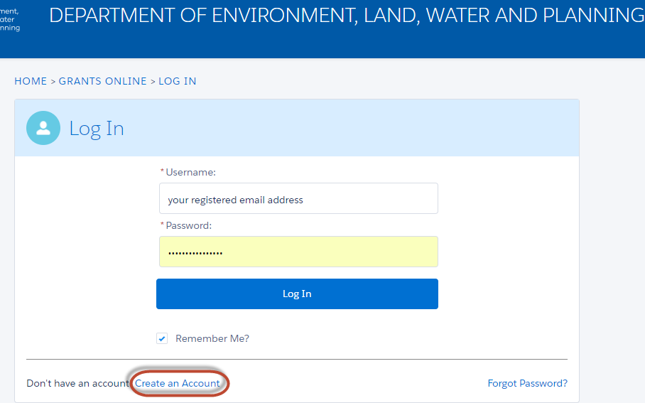

Accessing existing draft and submitted applications
A unique application reference number is generated by the system when your application is saved as draft, the application number starts with “GA-F” and looks like “GA-F12345-1234”.

It is important that you include your application reference number in any communication with this grant program.

There are three ways to access existing draft and submitted applications:

- Login to https://delwp1.force.com/GrantsPortalLogin to access all your draft and submitted applications.
- Using the link provided on the program page under the “Apply” section.
- Using the link provided in the notification email you received after creating a new draft.

Site navigation
- The side navigation bar helps you to quickly navigate to the page you have worked on. The navigation bar colour changes from grey to green once the page is completed. You can only jump to a page that is in green colour.
- When you click on the Save as Draft button, your application form is saved.
- When you click on the View as PDF button, you can view the entire application form before start filling.
- When you click on the Next Page button, the previous page content is saved automatically.

