Our Wildlife Fact Sheet
  - Sulphur – crested Cockatoo

Australia is home to an incredibly diverse group of birds, of which one of the most cheeky and intelligent is the Sulphur-crested Cockatoo.
Scientific name
Cacatua galerita
Did you know?
Cockatoos are a popular pet right across the world.
Cockatoos use a natural alarm system to alert other cockatoos of predators when feeding on the ground. At least one cockatoo will sit in a tree and watch over other cockatoos. If the watcher senses there is danger present they will screech loudly to alert feeding birds until the flock flies to safety.
Sulphur-crested Cockatoos are extremely intelligent. In captivity, people have been able to teach them to talk.
Sulphur-crested Cockatoos line their nest with rotting wood and wood shavings.
The beaks of Sulphur-crested Cockatoos continuously grow, which is why they need to chew on objects to maintain good beak condition.
Description
Sulphur-crested Cockatoos are large parrots, ranging between 44 – 51 cm in length, with a wingspan of up to 103 cm.
The feathers on their neck and head are white with concealed pale yellow. There are also yellow markings underneath their wings which can be seen when flying.
Sulphur-crested Cockatoos have a distinctive yellow crest on the back of their head which sticks up when alarmed. They also have a dark black beak.
Male and female birds are similar in appearance.
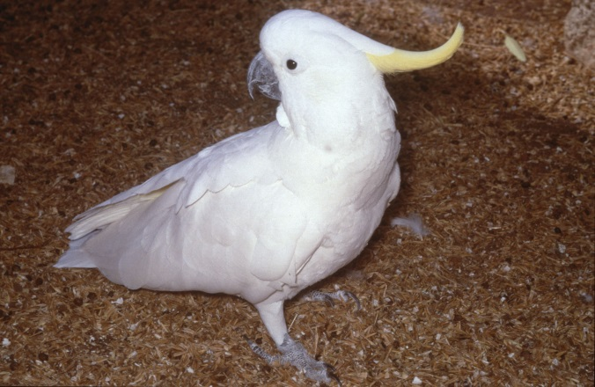
Figure 1. Sulphur- crested Cockatoo © Ian Temby DSE 2009
Diet
The Sulphur-crested Cockatoo’s diet includes grass seeds, plants, nuts and insects.
Feeding normally takes place in small to large groups, in the mornings and evenings.
When they are not feeding Sulphur-crested Cockatoos will bite off smaller branches and leaves from trees. This pruning and clipping keeps their beak trimmed and in good condition.
Habitat
Sulphur-crested Cockatoos are found in a wide variety of habitats with trees, often near water.
The birds do not migrate and usually stay around the same area year-round.
They have adapted well to living on farms and in cities.
Distribution
Sulphur-crested Cockatoos are widespread throughout north, east and south-east Australia.
They are widespread throughout Victoria, though generally less common in the Mallee, some parts of the Western District, High Country and far East Gippsland.
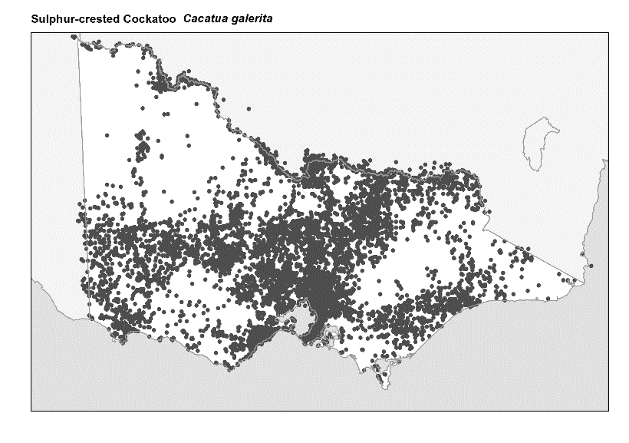
Figure 2. Recorded occurrences in Victoria
Source: Victorian Biodiversity Atlas (records post 1979), version 15/5/2017
Breeding
Sulphur-crested Cockatoos usually nest in tree hollows of dead or mature trees.
The females lay between one and four eggs which are incubated (kept warm) by both the male and female.
The chicks emerge covered in a pale yellow down with their eyes closed. The chicks remain with the parents, and family groups often stay together.
Each flock has its own roosting (sleeping and resting) site which is rarely deserted. In fact, individuals and small groups can come together in groups of up to several thousand birds.
They are most vocal at roosts in the early morning and late afternoon.
What you can do to help!
To help protect the habitat of Sulphur-crested Cockatoos, you can retain old trees around your property, as only the old trees develop the hollows which are required for nesting.
You can also plant trees that are native to your area. This will ensure that Cockatoos and other wildlife have suitable habitat in the future. Contact your local nursery for a list of plants native to your area.

Cockatoos may be considered a pest in some areas due to the damage they can cause when maintaining their beaks. If you are having problems with cockatoos in your area, please visit the DELWP website at www.wildlife.vic.gov.au for information on how to live with these fascinating animals.

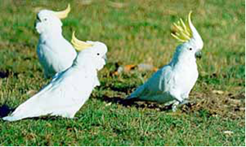
Figure 3. Sulphur- crested Cockatoo © I. McCann DSE
Further reading
Simpson, K. and Day, N., (2010), Field guide to the birds of Australia, (8th ed), Penguin Books, Australia.

Morcombe, M., (2004), Field guide to Australian birds, Steve Parish Publishing, Australia.

