Our Wildlife Factsheet
  - Common Brushtail Possum

The Common Brushtail Possum is the most abundant and familiar of the Australian possums.
Scientific name
Trichosurus vulpecula
Did you know?
A nocturnal animal, it spends the day in a den in a hollow branch, tree-trunk, fallen log, rock cavity or even a hollow termite mound.

Brushtail Possums prefer to live by themselves, not with other possums.

The Brushtail Possum moves rapidly among trees and will leap from one branch to another.

Brushtail Possums use a range of sounds including screams, hissing and growling which are frequent, particularly in mating season.

Studies of the behaviour of Brushtail Possums have shown that about 16 per cent of their time is spent feeding, 30 per cent travelling, 44 per cent sleeping or sheltering, and 10 per cent grooming.

In New Zealand, where it was introduced, the Brushtail Possum is a pest, however people use its fur for a wide range of products including socks and jumpers.
Description
The Brushtail Possum’s head and body length is 35 -55 cm and its tail is from 25 - 40 cm long. It weighs between 1.2 - 4.5 kg.

The Brushtail Possum is a medium-sized marsupial that lives in trees. It has grey fur on its head, back and sides. Black fur is seen around the eyes, nose and sometimes along centre of forehead. Its belly is pale grey to yellowish or white.

Brushtail Possums have black oval shaped ears with white tips. Their tail is black and bushy, but sparsely furred or even naked underneath and at the tip.
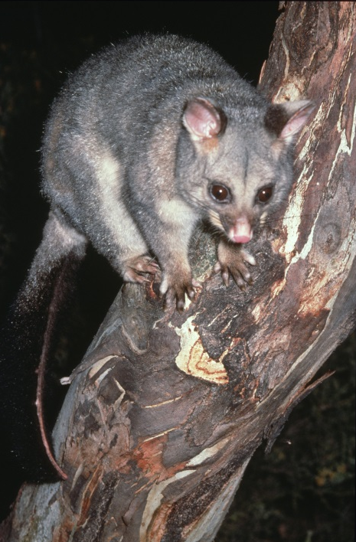 Figure 1. Common Brushtail Possum © I. McCann DSE 2008
Diet
Brushtail Possums eat plant material, supplemented with bird eggs, baby birds and some insects. They mainly eat leaves of eucalypts but also some shrubs (mainly wattles), herbs, flowers and fruit. They forage in the canopy, in lower levels of the forest and on the ground. In urban areas, the Common Brushtail Possum will eat a variety of food including fruit and bread.
The Brushtail Possum’s liver cannot cope with an abundance of toxins in eucalypt leaves so they need to have a varied diet.
Brushtail Possums prefer eucalyptus leaves with a high nutrient content. They can distinguish between high and low nutrient quality leaves, even when the foliage of these plants is intermingled.
Habitat
Brushtail Possums can be found in a wide range of forests and woodlands across the state. They are generally absent from the driest areas.

Brushtail Possums are very common in urban parks and gardens. In cities, possums often seek shelter, warmth and protection in the dark holes in buildings. A favoured spot is between the ceiling and the roof, and this can be a problem to some people.

Distribution
Brushtail Possums are found right across Victoria. Its conservation status is secure in Victoria as it is widespread.
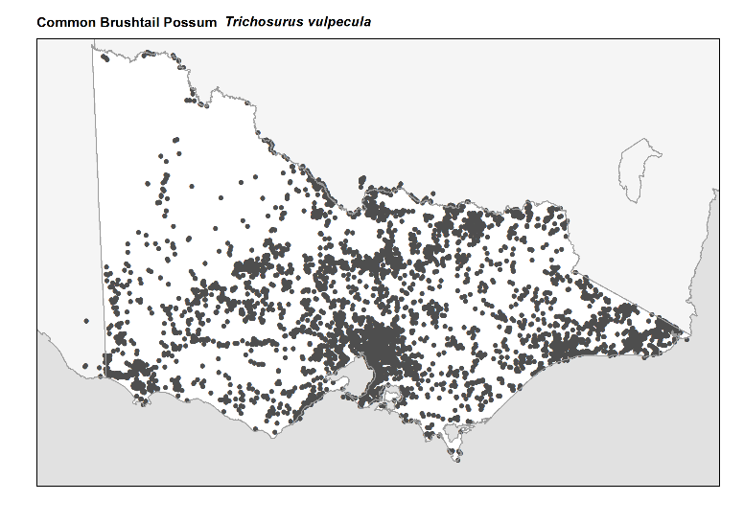
Figure 2. Recorded occurences in Victoria
Source: Victorian Biodiversity Atlas (records post 1979), version 15/5/2017

Breeding
Females give birth to a single young (mostly March-May), which is carried in the pouch for up to 5 months. When it is too big to fit in the pouch, the young generally rides on its mother’s back. This usually occurs up to the age of about 9 months when it can feed itself. Females usually breed after their first year, and may raise young each year thereafter.
Few young die in the pouch, but between 6 and 18 months of age, a considerable number die when they are moving from the area of their birth in an attempt to establish home ranges. Males particularly suffer due to territorial fighting, and as a result make up only one-third of the adult population.

What you can do to help!
In the past possums were often trapped and released into other areas when causing problems in roofs. Recent research has shown that possums can't cope in a new environment, and die within a few days of release. Removing a possum from your property will also just make room for another one to move in.
The only solution to possums in your roof is to get them out and stop them getting back in. First check that your roof resident is a possum. Rats make similar noises and often get into roofs.
Possums can gain access to the roof space through loose tiles, loose roofing iron, broken eaves and holes in timber or brickwork. Make sure these are covered up and there are no branches leading to your roof.
Buy or make a nest box and install it in your garden as an alternative den site. Possums are territorial, if one adopts the nest box it is likely to keep others away from your roof and garden.
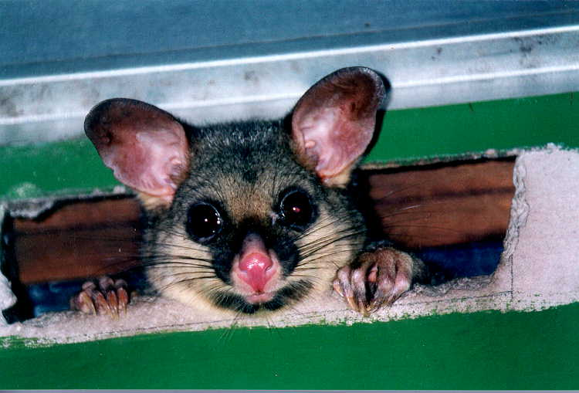 Figure 3. Brushtail possum © I. Temby DSE 2008
Further information
For further information on how to live in harmony with possums, please visit the Managing Wildlife (Possums) section of the Department of Environment, Land, Water and Planning website at: www.wildlife.vic.gov.au

Further Reading
Menkhorst, P.W. (ed.), (1995), Mammals of Victoria, Oxford University Press, Melbourne.
Temby, I.D. (2005), Wild Neighbours: the humane approach to living with wildlife. Citrus Press, Broadway, NSW.

