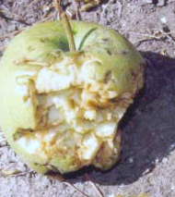
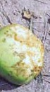
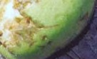
➤
BIRD AND FLYING-FOX BAT DAMAGE TO ORCHARD FRUIT
A GUIDE

BIRD AND FLYING-FOX BAT DAMAGE TO ORCHARD FRUIT

WHAT IS THE GUIDE?
This Department of Natural Resources and Environment (NRE) guide is designed to help you identify what animal or bird is damaging your fruit, and what to do about it. The guide has been developed as part of a Flying-fox management strategy that includes creation of an alternative camp site at Banyule for the Flying-foxes currently resident in the
Melbourne Royal Botanic Gardens.

There is a range of animals that may cause damage to developing or ripening stone and pome fruits. These include several kinds of parrots, lorikeets, honeyeaters and other birds, the Grey-headed Flying-fox, possums and rarely rats. Each of these animals usually attacks fruit in a particular w ay and it is often possible to identify what has caused the damage if you know what signs to look for.

WHY IS THIS GUIDE HELPFUL?
It is important to know what animal is causing the damage, so you know how to reduce their negative impacts. It is ineffectual patrolling at night for Flying-foxes (or shooting them) if the damage is being caused during the day by birds. Of course, it is possible that you may have more than one kind of animal causing damage.

HOW MUCH DAMAGE?
The first step before starting to scare or shoot animals in your orchard, is to estimate the amount, location and cause of damage. This is to determine whether you need to take any action. Sometimes, damage is restricted to one or two row s of trees and it may be better to accept losses in that part in order to protect the rest of the orchard.
Scaring animals from those rows already damaged may cause them to land elsewhere in the orchard and spread the damage, perhaps to more valuable fruit varieties.

HOW TO USE THE GUIDE
Images of typical kinds of damage caused by parrots, by other birds and by Flying-foxes provide the basis for identification of the cause of damage. Simply compare your damaged fruit and other indicators w ith the images in this guide. This should provide you w ith assistance as to what is likely to be causing the damage. It is alw ays useful to notice the birds in and near your orchard in order that you are aw are of potential crop feeders that are present. The presence of these birds does not necessarily mean that damage will occur, as the birds may be using other food in the area.

MINIMISING DAMAGE
Methods that may assist with minimising damage caused by wildlife to your crops range from non-lethal scaring and exclusion (netting) to limited destruction of wildlife under an NRE permit. Many kinds of birds may be encouraged to feed elsewhere by persistent scaring, aided by techniques such as lethal shooting (with permit only), to emphasise that there is real danger associated with the scaring activities.
An effective scaring program may include strategic use of scare guns (gas guns) and possibly scarecrows that are moved daily to different positions, patrolling and taped alarm or distress calls. Species such as lorikeets and Flying-foxes appear to be undeterred by the use of these techniques and effective damage control may require the installation of nets. All native mammals and birds are protected and must not be harmed w ithout obtaining an Authority to Control Wildlife.
Applications may be obtained from NRE’s Customer Service Centre on 136 186.

FOR FURTHER INFORMATION
If you would like further information on Flying-foxes, on the alternative camp site project at Banyule, on problems caused by Flying-foxes or birds in orchards, check the NRE website at: www.nre.vic.gov.au in the Plants and Animals section, or contact the
NRE Customer Service Centre on 136 186 for information and assistance.

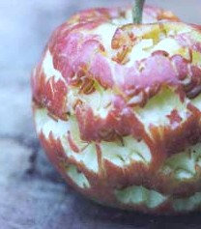
Look for horseshoe-shaped marks made by the lower part of the beak
Lorikeets often damage numerous fruits on a tree

Apple damaged by Musk Lorikeet
Below left: Musk Lorikeet Below right: Rainbow Lorikeet

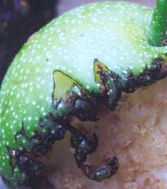
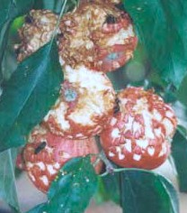
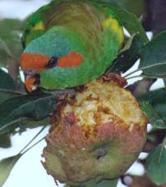
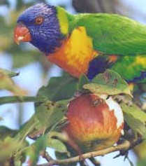
Look for triangular marks made by the upper part of the beak

Nashi w ith typical triangular beak marks made by Musk Lorikeet

Sulphur-crested Cockatoos, Galahs and Long-billed Corellas may also attack some fruit crops, often going for the seeds or kernels in pome and stone fruits.
Many non-parrot birds tend to partially hollow out fruits. Often, their beak marks are seen.

Some honeyeaters may leave numerous fibres protruding from the fruit, as they are more interested in the juice. Other birds take pieces of flesh. Species include: (however not limited to) Common Blackbird, Common (Indian) Myna, Noisy Miner, Red Wattlebird, Satin Bowerbird, Common Starling, Silvereye and Yellow-faced Honeyeater. The species of birds involved will vary from year to year, depending upon bird movements and availability of other food sources in your area.
Some of these birds may make single or multiple punctures in the skin of the fruit, perhaps testing for taste. This may falsely appear to look like Flying-fox damage (see below).

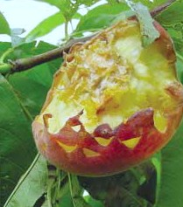
Peach damaged by Eastern Rosellas, showing typical lower beak marks.

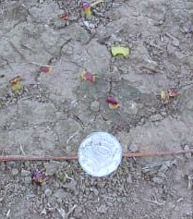
Plum fragments on the ground after a
rosella feeding on fruit. Note size of fragments.
Similar or smaller fragments are also common beneath lorikeet feeding sites.

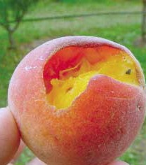
Peach partly hollowed by non-parrot birds, most likely a Noisy Miner in this case. Note absence of parrot beak marks.

Look for large, compressed pieces of skin and flesh on the ground under the tree. These are formed when Flying- foxes bite off a piece of a fruit, compress the fruit between tongue and hard palate to extract the juice, then spit out the remains. These fragments, known as “spats”, are about the size of a ten cent piece and are a clear sign of Flying-fox feeding. With pome fruits, the whole fruit may be consumed, therefore the only evidence may be spats under trees where the upper branches should have fruit present.
Look for broken leaders (new season’s shoots) at the top of the tree.
Look for tooth marks on fruit or under the tree.
Look under tall trees within approximately 100 metres of your fruit trees particularly for spats. Also, stones from peaches, nectarines and plums and partially-eaten fruit may
be present on the ground directly below trees.
Flying-foxes may knock fruit to the ground when moving about the tree. This fruit will not necessarily have any sign of damage.
NB: If you cannot find spats under your fruit trees or under nearby shelter or ornamental trees, then it is unlikely that Flying-foxes are feeding on your fruit.

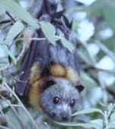
Grey-headed Flying-fox (bat), these are large animals with a wing span up to 1 metre.

Below left: Flying-fox bites on plum. Two separate bites are indicated by the white lines.
Below right: Spats (some circled) and plum stones. (some arrowed) Note size of spats.

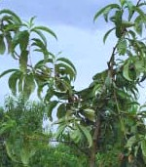
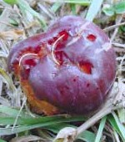
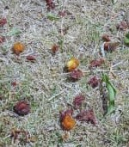
Peach tree with several leaders broken by Flying-foxes, reducing next year’s crop

Peach stones dropped below Flying-fox feeding perches.

Usually, many spats and sometimes nearly whole fruit are found below perches. This fruit will usually show tooth marks, as Flying foxes carry them in their mouths.
Typical fresh spat made by a Flying-fox feeding on apple.
Note the fragments of skin and fruit pulp compressed together. This is characteristic of spats and distinguishes them from remnants of fruit that may
have been dropped by birds. The size is generally consistent. Fresh spats are obvious under feeding sites. Older, dried spats may be brown and slightly shrivelled, however may still be identified as spats. These should not be confused with fallen fruit or fragments left by birds.

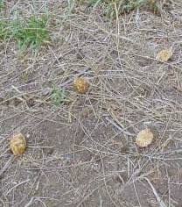
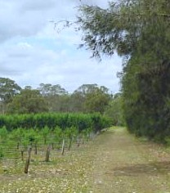
Trees used as feeding roosts by Flying-foxes. Arrow show s w here peach stones found.

Peach stones dropped below Flying-fox feeding perches. Usually, many spats and sometimes nearly whole fruits are found
below such perches.
Part-eaten apples and spats left below feeding roost by Flying-foxes.

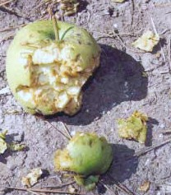
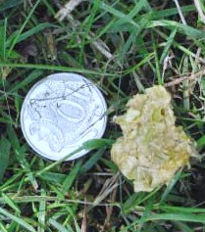
Typical fresh spat made by Flying-fox feeding on apple. Note the fragments of skin and fruit pulp compressed together.

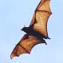
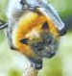
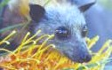
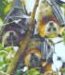
BIRD AND FLYING-FOX BAT DAMAGE
TO ORCHARD FRUIT: AN IDENTIFICATION GUIDE
Department of Natural Resources and Environment, Melbourne.
ISBN 1 74106 088 5

The State of Victoria, Department of Natural Resources and Environment, 2002.

This publication is copyright. Apart from any fair dealing for the purposes of private study, research, criticism or review as permitted under the Copyright Act 1968, no part may be reproduced, copied, transmitted in any form or by any means (electronic, mechanical or graphic) without the prior written permission of the State of Victoria, Department of Natural Resources and Environment. To obtain permission, please contact the Copyright Officer, NRE, Customer Service Centre on 136 186.
Disclaimer This publication may be of assistance to you but the State of Victoria and its employees do not guarantee that the publication is without flaw of any kind or is w holly appropriate for your particular purposes and therefore disclaims all liability for any error, loss or other consequence which may arise from you relying on any information in this publication.
Photographs Back cover, Vivien Jones. Bat image courtesy Healesville Sanctuary©. All others Ian Temby.
Cover photo Apples partly eaten by Flying-foxes.

Designed by Sue Palmer Design
Printed by Braemar Graphic Reproductions

