Marine Mammals of Victoria
Identification Guide

Victorian waters are home to an amazing diversity of marine mammal
species, including whales, dolphins and seals.

This guide provides information on some of the various species of whales, dolphins and seals that can be seen in Victorian waters or on beaches.

Whales
Whales and dolphins belong to the order Cetacea, of which there are two different types, the baleen whales (Mysticeti) and toothed whales (Odontoceti). Baleen is a fibrous, bristle like substance used to sieve small prey from the water.

Identification features
The following shows the features of whales and dolphins that are used for identification. These features are referred to in the descriptions overleaf.

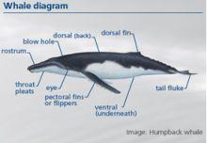

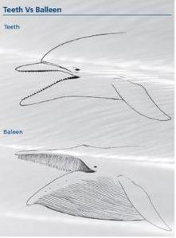

Seals
There are two types of seals within Australian waters: the ‘eared’ (Otariidae) and the ‘true seals’ (Phocidae).

The following diagrams show the features of seals used for identification and their differences in size. These features are referred to in the descriptions below.

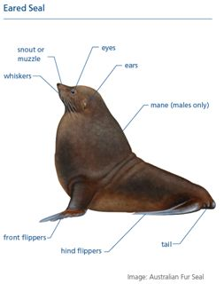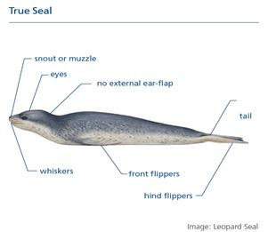

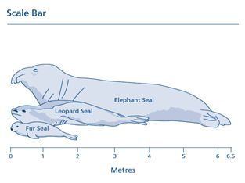

Eared Seals

Australian Fur Seal (Arctocephalus pusillus doriferus)

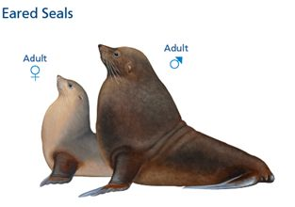

Distinguishing features: Larger than other fur seals and similar character to
sea lions. Males are heavy chested with thick dark mane.

Length: Adult male: 2.5m; Adult female: 1.5m; Juvenile: 1.2m, Pup: 0.7m.

Weight: Adult male: 100kg; Adult female: 50kg; Juvenile: 25kg, Pup: 10kg.

Colour: Adult male: Greyish brown with paler chest and dark brown belly.
Adult female: Pale fawn to greyish brown with pale chest and brown belly.
Juvenile: Similar to the female, coat pale when dry.
Pup: Black with variable grey-brown underneath (Dec – Feb), same colouration as female (after Feb).

Coat: Short thick underfur concealed by long outer fur. Older males have light coloured mane.

Flippers: Front flippers rounded and thicker where they join body. Hind flippers rotate beneath body, enabling them to walk on land.

Family: Otariidae

Mating season: 6-10 days after birth of a pup, with delayed fertilisation to allow for birthing from spring to summer.

Pupping season: Oct – Dec

No. of pups: 1

Conservation status: Protected in Victoria.

Distribution: Can be seen along entire coastline, with substantial breeding
colonies at Phillip Island, Lady Julia Percy Island, Cape Bridgewater, The Skerries at Croajingalong National Park, Rag Island and Kanowna Island off Wilson’s Promontory.
Sub-Antarctic Fur Seal (Arctocephalus tropicalis)

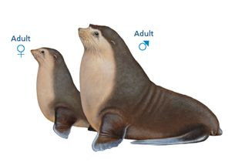

Distinguishing features: Smallest of the seals found in Victoria. Unique pale yellow
colour underside. Colour around eyes contrasts with darker upperparts. Males have distinctive ‘mo-hawk’ crest.

Length: Adult male: 2m; Adult female: 1.5m; Juvenile: 1m; Pup: 0.7m.

Weight: Adult male: 100kg; Adult female: 35kg; Juvenile: 20kg; Pup: 7kg.

Colour: Adult male: Dark grey with contrasting whitish-yellow face and chest.
Adult female: Dark grey with contrasting whitish-yellow face and chest.
Juvenile: Uniform dark olive-brown, occasionally with whitish-yellow face and chest.
Pup: Glossy-black with dark chocolate brown belly.

Coat: Dense short underfur concealed by long outer fur. Adult males have prominent black crest on forehead and thick mane.

Flippers: Front flippers short and broad in relation to body size. Fleshy extensions of hind flippers are shorter compared with Antarctic fur seal. Hind flippers rotate beneath body, enabling them to walk on land.

Family: Otariidae

Mating season: 7-12 days after birth of a pup, with delayed fertilisation to allow for birthing from spring to summer.

Pupping season: Nov – Feb

No. of pups: 1

Conservation status: Protected in Victoria, “Vulnerable nationally”.

Distribution: Occasional visitors to Victoria’s coastline

New Zealand Fur Seal (Arctocephalus forsteri)

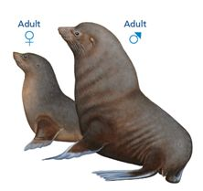

Distinguishing features: Smaller than the Australian fur seal and darker in
colouration. Sharply pointed snout.

Length: Adult male: 2m; Adult female: 1.5m; Juvenile: 1m; Pup: 0.6m.

Weight: Adult male: 100kg; Adult female: 35kg; Juvenile: 20kg; Pup: 7kg.

Colour: Male: Grey to brown.
Adult female: Grey to brown and lighter underneath.
Juvenile: Similar to female.
Pup: Black, but become grey to brown after first moult (4mths).

Coat: Long outer fur conceals short thick underfur. Older males have mane.

Flippers: Front flippers are long with straight sides, with little or no thickening where it joins body. Hind flippers rotate beneath body, enabling them to walk on land.

Family: Otariidae

Mating season: 7-8 days after birth of a pup, with delayed fertilisation to allow for birthing from spring to summer.

Pupping season: Nov – Jan

No. of pups: 1

Conservation status: Protected and considered vulnerable in Victoria*.

Distribution: Can be seen along entire coastline.

*Advisory List of Threatened Vertebrate Fauna in Victoria 2007

Australian Sea Lion (Neophoca cinerea)

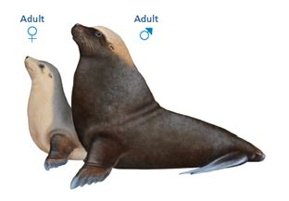

Distinguishing features: Bulky, black nose with white ring around eyes. Males have
a large head and yellow crown.

Length: Adult male: 2.5m; Adult female: 1.8m; Juvenile: 1.2m; Pup: 0.7m.

Weight: Adult male: 100kg; Adult female: 60kg; Juvenile: 25kg; Pup: 10kg.

Colour: Adult male: Chocolate brown, yellow crown with dark muzzle. Greyer back with dusky abdomen and flippers.
Adult female: Dark back and top of head, with creamy yellow under-body and sides of head.
Juvenile: Similar to female.
Pup: Dark brown with paler crown and dark facial mask.

Coat: Short hair with lack of dense underfur. Males have a mane.

Flippers: Outermost digits of hind limbs are longer than middle digits. Hind flippers rotate under body enabling them to walk on land.

Family: Otariidae

Mating season: 7-10 days after birth of a pup, with delayed fertilisation to allow for birthing from spring to summer.

Calving season: Jan – Oct

No. of pups: 1

Conservation status: Protected in Victoria.

Distribution: Occasional visitors to Victoria’s coastline.

True Seals

Leopard Seal (Hydrurga leptonyx)

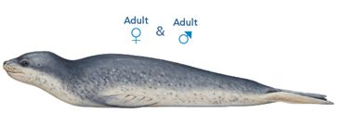

Distinguishing features: Serpent-like appearance, with long neck and large, flat reptilian head. Powerful jaws and broad mouth gape. Sharp teeth.

Length: Adult male: 4m; Adult female: 4.5m; Juvenile: 2m ; Pup: 1.2m.

Weight: Adult male: 350kg; Adult female: 400kg; Juvenile: 120kg; Pup: 30kg.

Colour: Adult male and female: Silver to dark blue-grey, with pale silver underneath. Dark areas variably spotted darker grey and black.
Juvenile: Similar to adult, but demarcation between dark above and pale underneath more obvious.
Pup: Same as adult.

Coat: Hair short and dense.

Flippers: Front flippers long and broad, near the centre of the body. Hind flippers small and used for locomotion in the water.

Family: Phocidae

Mating season: Nov – Jan

Pupping season: Sept - Jan

No. of pups: 1

Conservation status: Protected in Victoria.

Distribution: Occasional visitors to Victoria’s coastline.

Southern Elephant Seal (Mirounga leonina)

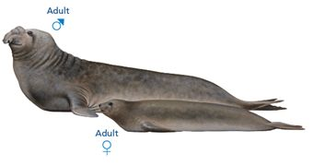

Distinguishing features: Long body and heavy build. Adult male is noticeably larger than female, with conspicuous proboscis (nose) during the breeding season.

Length: Adult male: 6.5m; Adult female: 4m; Juvenile: 3m; Pup: 1.5m.

Weight: Adult male: 4,000kg; Adult female: 500kg; Juvenile: 400kg; Pup: 100kg.

Colour: Adult male: Dark brown with lighter brown underneath.
Adult female: Darker than males.
Juvenile: Greyish coat, slightly paler below.
Pup: Black to very dark brown.

Coat: Hair short and stiff.

Flippers: Front flippers small in relation to body size. Hind flippers cannot rotate under body, so unable to walk on land.

Family: Phocidae

Mating season: 18 days after birth of a pup, with delayed fertilisation to allow for birthing in summer.

Pupping season: Sept – Nov

No. of pups: 1

Conservation status: Protected in Victoria, “Vulnerable” nationally.

Distribution: Occasional visitors to Victoria’s coastline.

Note: all lengths and weights are averages for an animal in healthy condition, but may vary.
= Female, = Male

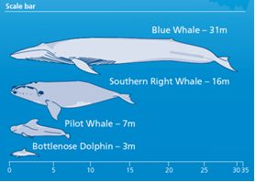

Baleen whales

Humpback Whale (Megaptera novaeangliae)

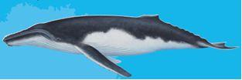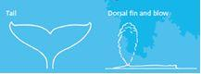

Distinguishing Features: Long pectoral fins (1/3 body length) and reduced dorsal fin situated two-thirds of the way along the back. Prominent double blow holes. Head, pectoral fins and tail fluke often covered with rounded knobs. Throat pleats present. Renowned for leaping out of the water and rolling in the air (breaching).

Length: Adult male: 14m; Adult female: 16m; Calf: 4.5m

Weight: Adult male: 40 tonnes; Adult female: 40 tonnes; Calf: 2 tonnes

Colour: Upper body black or bluish-grey. Pattern of white varying on the underside of body and throat pleats. Pattern on underside of tail fluke unique on each individual. Cruising speed: 7km/hr

Blow pattern: Small and bushy, up to 5m.

Mating season: June - October

Calving season: June - October

No. of Calves: 1

Calving interval: 2 - 3 years

Conservation status: Vulnerable nationally and in Victoria.

Distribution: Humpback Whales are usually seen migrating through Victorian waters between autumn and spring, from their feeding grounds in Antarctica to calving grounds in southern Queensland.

Southern Right Whale (Eubalaena australis)

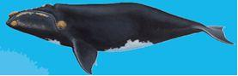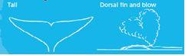

Distinguishing Features: Large head with strongly arched mouth line. Distinctive V-shaped blow. Wide pectoral fins and lack of a dorsal fin. Callosities form rough white markings on head, enabling identification of individual animals.

Length: Adult male: 16m; Adult female: 18m; Calf: 6m

Weight: Adult male: 80 tonnes; Adult female: 80 tonnes; Calf: 1.5 tonne

Colour: Black body, many have irregular white blotches underneath. Callosities form distinctive white markings on head.

Cruising speed: 3km/hr

Blow pattern: V-shaped blow up to 5m from two blow holes.

Mating season: May - September

Calving season: June - August

No. of Calves: 1

Calving interval: 3 years

Conservation status: Endangered nationally, Critically Endangered in Victoria.

Distribution: Can be seen in small numbers during winter along the whole of Victori’s coastline where they breed annually, with a known nursery aggregation area at Logan’s Beach, Warrnambool.

Blue Whale (Balaenoptera musculus)

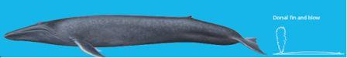

Distinguishing Features: Very large, slender, streamlined whale. Single ridge on the top of head leads back to a prominent blowhole. Small dorsal fin set well back on the body gives the impression of a very long back. The throat contains large pleats that expand to allow the mouth to hold water while feeding. Largest whale in the world. Also commonly seen in Victorian waters is the Pygmy Blue Whale, which is similar in size to a sub-adult Blue Whale.

Length: Adult male: 31m; Adult female: 33.5m; Calf: 7m

Weight: Adult male: 150 tonnes; Adult female: 180 tonnes; Calf: 4 tonnes

Colour: Silver-grey to grey-black with mottled patterns used to identify individuals. Appears pale blue when submerged.

Cruising speed: 20 km/hr

Blow pattern: blow is powerful, tall and straight, may reach up to 15m and be heard 3 - 5km away.

Mating season: June - August

Calving season: June - August

No. of Calves: 1

Calving interval: 2 - 3 years

Conservation status: Endangered nationally, Critically Endangered in Victoria.

Distribution: Occur between November and May along the whole of Victoria’s continental shelf, but are most common wets of Cape Otway due to cold water upwelling, which sustains abundant krill. Migrates north in winter.

Sei Whale (Balaenoptera borealis)

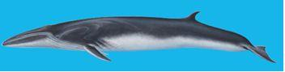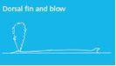

Distinguishing Features: Long slender body with a tall dorsal fin. A V-shaped head with a single central ridge. Small triangular tail flukes and short narrow flippers.

Length: Adult male: 17m; Adult female: 20m; Calf: 5m

Weight: Adult male: 25 tonnes; Adult female: 30 tonnes; Calf: 0.6 ton

Colour: Head and body a dark bluish-grey with white underneath.

Cruising speed: 20 km/hr

Blow pattern: Diffuse blow up to 3m high.

Mating season: June - August

Calving season: June

No. of Calves: 1

Calving interval: 2 - 3 years

Conservation status: Vulnerable nationally. Protected in Victoria.

Distribution: Rarely seen in Victoria’s offshore waters

Dwarf Minke Whale (Balaenoptera acutorostrata)

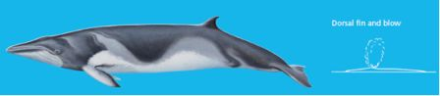

Distinguishing Features: Small and sleek with an elongated body. A tall, sickle-shaped dorsal fin two-thirds of the way along its back. Double blow hole.

Length: Adult male: 8m; Adult female: 7m; Calf: 3m

Weight: Adult male: 6 tonnes; Adult female: 6 tonnes; Calf: Unknown

Colour: Upper side uniform dark grey-brown, Greyish white underneath. White area on flippers, which extends upwards towards the head.

Cruising speed: 16km/hr

Blow pattern: Vertical, but often hard to see. Less
than 2m high.

Mating season: December - June

Calving season: December - June

No. of Calves: 1

Calving interval: 1 - 2 years

Conservation status: Protected in Victoria.

Distribution: Rarely seen in Victoria’s offshore waters.

Toothed whales

Sperm Whale (Physeter macrocephalus)

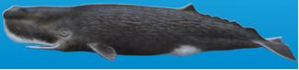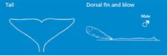

Distinguishing Features: Long, log-like and usually finless body, distinct spinal ridges (or ‘knuckles’) along the back. Broad, triangular tail flukes, and a huge box-like head with a blunt snout. Single slit-like blowhole on the left side.

Length: Adult male: 18m; Adult female: 11m; Calf: 4.5m

Weight: Adult male: 55 tonnes; Adult female: 20 tonnes; Calf: 1 ton

Colour: Dusky grey-brown

Cruising speed: 8 km/hr

Blow pattern: Bushy, always directed at a low angle to the left.

Mating season: February – April

Calving season: February – April

No. of Calves: 1

Calving interval: 3 – 6 years

Conservation status: Protected in Victoria.

Distribution: Can occasionally be seen in waters off Victoria’s coastline.

Strap-toothed Whale (Mesoplodon layardii)

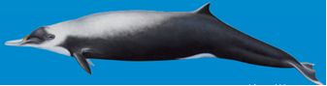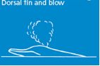

Distinguishing Features: Medium-sized beaked whale with distinctive black mask around face and underside from flipper to tail fluke. Adult male has 2 strap-like tusks that protrude up and sometimes around the upper jaw. Low dorsal fin set far back on body.

Length: Adult male: 6m; Adult female: 6m; Calf: 2.5m

Weight: Adult male: 3.5 tonnes; Adult female: 3.5 tonnes; Calf: Unknown

Colour: Back and neck whitish-grey. Beak is long and mostly pale whitish-grey.

Cruising speed: Unknown

Blow pattern: Inconspicuous

Mating season: Unknown

Calving season: September –February

No. of Calves: 1

Calving interval: Unknown

Conservation status: Protected in Victoria.

Distribution: Known in Victoria from occasional strandings only.

Short-beaked Common Dolphin (Delphinus delphis)

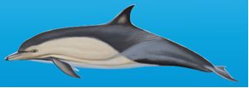

Distinguishing Features: Small. Round head, with a short and stocky beak. Black
on top, with a large yellowish panel on the chest bordered by white flanks. Single blow hole. Dorsal fin triangular and pointed.

Length: Adult male: 2m; Adult female: 2m; Calf: 1m

Weight: Adult male: 110kg; Adult female: 110kg; Calf: 10kg

Colour: Dark colouring on top in a cape-like shape. Distinctive and large yellowish panel on the chest bordered by whiter flanks. Black eye spot.

Cruising speed: 7km/hr

Mating season: June - September

No. of Calves: 1

Calving season: June - September

Calving interval: 2-3 years

Conservation status: Protected in Victoria.

Distribution: Can be seen along the whole of Victoria’s coastline, including in Port Phillip Bay.

Risso’s Dolphin (Grampus griseus)

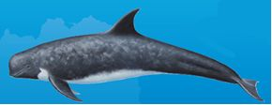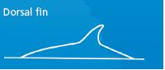

Distinguishing Features: Broad, pale body with bulbous head. Lacks an obvious beak. Very tall curved dorsal fin in the middle of the back. Long, pointed flippers.

Length: Adult male: 4m; Adult female: 4m; Calf: 1.5m

Weight: Adult male: 500kg; Adult female: 500kg; Calf: 20kg

Colour: Uniformly coloured, usually bluish-grey body colour. Dark when young, becoming more white with age due to scarring.

Cruising speed: 9km/hr

Mating season: Unknown

No. of Calves: 1

Calving season: Poorly known.

Calving interval: Unknown

Conservation status: Protected in Victoria.

Distribution: Can occasionally be seen along the whole of Victoria’s coastline.

Killer Whale (or Orca) (Orcinus orca)

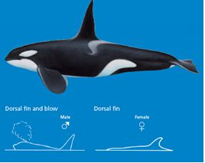

Distinguishing Features: Round-bodied with a huge head and blunt nose. Black upper body contrasts starkly with the white underparts and eye patch. Rounded flippers. Tall dorsal fin in the males and single blow hole.

Length: Adult male: 10m; Adult female: 8.5m; Calf: 2.5m

Weight: Adult male: 5.5 tonnes; Adult female: 5.5 tonnes; Calf: 0.2 tonnes

Colour: Mainly black, with contrasting white throat to abdomen and rear flanks. Grey-which patch (saddle) behind the dorsal fin.

Cruising speed: 10km/hr

Blow pattern: Tall but bushy.

Mating season: Unknown

Calving season: May - September

No. of Calves: 1

Calving interval: 3- 8 years

Conservation status: Protected in Victoria.

Distribution: Can be seen along the whole of Victoria’s coastline.

False Killer Whale (Pseudorca crassidens)

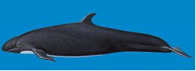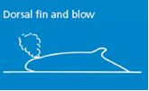

Distinguishing Features: Long dark body with no beak but characteristic elbow-shaped flippers. A tall and curved dorsal fin with a rounded tip. Blunt shaped head with an upper jaw that slightly overhangs the lower jaw.

Length: Adult male: 6m; Adult female: 5m; Calf: 2m

Weight: Adult male: 2 tonnes; Adult female: 2 tonnes; Calf: 0.08 tonnes

Colour: Uniformly blackish-grey.

Cruising speed: 9 km/hr

Blow pattern: Conspicuous and bushy.

Mating season: Year round.

Calving season: Unknown

No. of Calves: 1

Calving interval: 7 years

Conservation status: Protected in Victoria.

Distribution: Can occasionally be seen along the whole of Victoria’s coastline.

Pilot Whale (Globicephala sp)

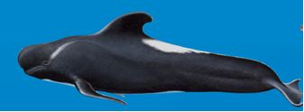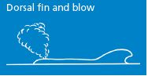

Distinguishing Features: Beakless with a round, bulbous head. Dorsal fin is broad at the base and curved back towards the tail. Very long pectoral flippers set well forward on the body.

Length: Adult male: 7m; Adult female: 5.5m; Calf: 2m

Weight: Adult male: 2 - 4 tonnes; Adult female: 2 - 4 tonnes; Calf: 0.08 tonnes

Colour: Almost totally black, except for a white diagonal stripe that slopes down towards the eyes, a white saddle behind the dorsal fin and an ‘anchor-shaped’ patch underneath.

Cruising speed: 4 km/hr

Blow pattern: Low and bushy.

Mating season: Unknown

Calving season: October - April

No. of Calves: 1

Calving interval: 3 – 5 years

Conservation status: Protected in Victoria.

Distribution: Can be seen in Victoria’s offshore waters.

Bottlenose Dolphin (Tursiops sp)

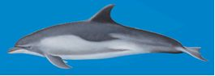

Distinguishing Features: Prominent curved-back dorsal fin. Stubby beak, distinctly
set off from the robust head by a crease. Often has a white-tipped lower jaw. Single blow hole.

Length: Adult male: 3m; Adult female: 3m; Calf: 1m

Weight: Adult male: 650kg; Adult female: 650kg; Calf: 30kg

Colour: The sides of the head and body are a dark bluish grey, which shades gradually into an off-white or pinkish underbelly.

Cruising speed: 10km/hr

Mating season: December - February

No. of Calves: 1

Calving season: December - February

Calving interval: 2 – 6 years

Conservation status: Endangered in Victoria.

Distribution: Can be seen along the whole of Victoria’s coastline, including within Port Phillip Bay, Western Port Bay and Gippsland Lakes.

Note: all lengths and weights are averages for an animal in healthy condition but may vary

Keep your distance
If you come across a whale, dolphin or seal in Victoria, it is important that you act responsibly by admiring them from a distance. This is for your own safety, as well as to minimise our impact on these animals.

State Regulations are in place to protect marine mammals. For further information on these Regulations, and what you can and can’t do around whales, dolphins and seals, visit the DSE website at www.dse.vic.gov.au.

Reporting injured or distressed marine mammals
Stranded, entangled, sick or injured whales or dolphins should be reported to the Whale and Dolphin Emergency Hotline on 1300 136 017. Do not report seal issues to this number. Stranded, entangled sick or injured seals should be reported to the DSE Customer Service Centre on 136 186.

Reporting infringements
Illegal interactions with whales, dolphins and seals should be reported to the DSE Customer Service Centre on 136 186. If in doubt, report it!

Published by the Victorian Government Department of Sustainability and Environment Melbourne, September 2010
© The State of Victoria Department of Sustainability and Environment 2010

This publication is copyright. No part may be reproduced by any process except in accordance with the provisions of the Copyright Act 1968

Authorised by the Victorian Government, 8 Nicholson Street, East Melbourne

Printed by Stream Solutions
Printed on recycled paper
ISBN 978-1-74242-609-9 (print)
ISBN 978-1-74242-610-5 (online)

For more information contact the DSE Customer Service Centre 136 186

Disclaimer
This publication may be of assistance to you but the State of Victoria and its employees do not guarantee that the publication is without flaw of any kind or is wholly appropriate for your particular purposes and therefore disclaims all liability for any error, loss or other consequence which may arise from you relying on any information in this publication.

Photography
Cover image by David Donnelly (Dolphin Research Institute), John Gibbens
and Glenn Sharp (DSE). Illustrations by Brett Jarrett.

This document is also available in PDF format on the Internet at www.dse.vic.gov.au

