|  |
| --- |
| Kangaroo Pet Food Trial |
| Information for shooters |

The Department of Environment, Land, Water and Planning (DELWP) issues Authorities to Control Wildlife (ATCWs) under section 28A of the *Wildlife Act 1975* for the control of kangaroos that are damaging pasture, crops or other property or impacting on biodiversity values.

Landholders who are issued with an ATCW may arrange for shooters to control wildlife on their behalf.

DELWP is conducting a trial, extended to September 2019, to facilitate the processing for the production of pet food of Eastern Grey Kangaroos (*Macropus giganteus*) and Western Grey Kangaroos (*Macropus fuliginosus*) controlled under ATCWs.

It is important to remember that the purpose of the trial is not to control kangaroo population numbers, nor is it to supply a commercial harvesting industry. Instead, landholders are required to demonstrate that kangaroos are causing damage in order to be issued with an ATCW. Therefore the number of kangaroos able to be controlled and processed, is not predictable.

The extension of the trial is intended to provide continuity to current participants of the KPFT while a new, ongoing kangaroo pet food program is developed. Further information about this program will be provided as its development progresses.

For more information about the operation of the current trial see the “Overview”, “Information for landholders” and “Information for pet meat processing facilities” factsheets.

## How can I participate in the trial?

Shooters must be named as a preferred supplier in a food safety plan (also known as a Quality Assurance Program) of a licensed pet meat processing facility which also holds a wildlife processor licence issued by DELWP. Please note that as a condition of their licence, the licensed pet meat processing facility must provide DELWP with a list of the preferred suppliers listed under their food safety plan, which will include your name, address and contact number.

Shooters must hold a current firearms licence. Please contact Licensing & Regulation Division of Victoria Police to determine if you have the appropriate reason(s) on your firearm license. Shooters must also be appropriately trained to ensure that they meet the requirements of the *National code of practice for the humane shooting of kangaroos and wallabies for commercial purposes* and the *Australian standard for the hygienic production of pet meat*. The pet meat processing facility will arrange training.

Landholders who have been issued with a Kangaroo Pet Food Trial (KPFT) ATCW will contact a participating pet meat processing facility to arrange for a shooter to control kangaroos on their property. If a landholder already knows of a preferred shooter who is listed in the food safety plan of a pet meat processing facility, they can request that the processor make arrangements for their preferred shooter to undertake the control work on their property.

Shooters cannot apply for a KPFT ATCW on behalf of a landowner or land manager.

It is important the shooters and landholders meet to discuss the details of the control. It is up to the landholder to decide on the number of kangaroos that they would like controlled under their KPFT ATCW at any one time, and when that control can take place on their property.

Shooters are required to control kangaroos in accordance with the conditions of the KPFT ATCW. They must obtain a copy of the KPFT ATCW from the landholder and carry it while shooting/transporting kangaroos.

Landholders will also provide shooters with DELWP-issued coloured plastic tags for the number and species of kangaroos agreed to be controlled on the property. Tags must remain on the property for which they have been issued to, or in the possession of the landholder, until attached to a kangaroo.

Shooters must tag each kangaroo controlled with a provided coloured plastic tag and complete a record sheet which records the number of each species of kangaroos controlled and the tag numbers used. Blue tags must be attached to Eastern Grey Kangaroos controlled under the ATCW, and white tags must be attached to all Western Grey Kangaroos. The completed record sheet must be returned to the landholder, along with any unused tags, at the end of the control work.

Once a tag is attached to a kangaroo, it must not be tampered with or removed until required for processing.

Tags are registered against the landholder’s KPFT ATCW and therefore all tags, whether used or unused, must be accounted

for in order to comply with the conditions of the ATCW. Any lost or stolen tags must be reported to the landholder as soon as possible (within 24hours).

Non-compliance with the conditions of the ATCW may result in an investigation and/or compliance action taken by DELWP.

Shooters must follow the requirements of the pet meat processing facility’s food safety plan when controlling, treating and transporting kangaroos to meet hygiene requirements.

## Steps for shooters:

Contact a pet meat processing facility to discuss becoming a preferred supplier

Undertake the required training (contact Primesafe for more information)

*Pet meat processing facility lists you as preferred supplier in its food safety plan*

Control kangaroos in accordance with the ATCW and the pet meat processing facility’s food safety plan

*If there is sufficient demand, a pet meat processing facility will contact you to arrange control of kangaroos on landholder’s property*

Provide pet meat processing facility with details of the KPFT ATCW and the number of kangaroos controlled

Tag each kangaroo with the appropriate coloured tag and complete the record sheet. Provide any unused tags and the completed record sheet back to the landholder.

Meet with the landholder to obtain instructions on the agreed number of kangaroos to be controlled, where to control them, and to obtain a copy of the ATCW, the plastic kangaroo tags and the record sheet

Arrange for the kangaroos to be transported to the pet meat processing facility.

## Frequently Asked Questions

***When will the trial run?***

The trial will run from 31 March 2014 to 30 September 2019.

***In what area is the trial running?***

The trial is open for landowners in the following local government areas: Ararat, Benalla, Glenelg, Greater Bendigo, Horsham, Loddon, Mansfield, Mitchell, Murrindindi, Northern Grampians, Pyrenees, Southern Grampians, Strathbogie, Wangaratta, West Wimmera and Yarriambiack.

Please see figure 1 for a map of the trial areas.

***Can a pet meat processing facility accept kangaroos from Victoria that have been controlled outside the trial area?***

No. Only kangaroos that have been controlled within the trial area under a KPFT ATCW are able to be processed. It is an offence against the *Wildlife Act 1975* to destroy kangaroos without an ATCW.

***Do I have to be nominated in the food safety plan of a pet meat processing facility to participate in the trial?***

Yes. A pet meat processing facility cannot receive kangaroos from anyone who is not listed as a preferred supplier in its food safety plan.

***Can a pet meat processing facility accept kangaroos that have been controlled on land where there is no ATCW?***

No. Only kangaroos that have been controlled in accordance with a KPFT ATCW can be processed.

***Who will run the training and how do I book in?***

Training will be run by the pet meat processing facility – please contact them directly for more information.

***Where do I get the kangaroo tags from?***

Tags will be provided to you by the landholder for the agreed number and species of kangaroos to be controlled, along with a record sheet and a copy of the ATCW. You must arrange to collect the tags, the record sheet and a copy of the ATCW from the landholder. Tags must remain on the property for which they have been issued to, or in the possession of the landholder, until attached to a kangaroo.

Blue tags must be attached to all Eastern Grey Kangaroos controlled under the ATCW, and white tags must be attached to all Western Grey Kangaroos.

***What do I do with any unused tags provided by the landholder?***

Unused DELWP-issued tags must be returned to the landholder at the completion of the control work, along with the completed record sheet.

DELWP-issued tags are registered against the landholders ATCW and therefore all tags, whether used or unused, must be accounted for in order to comply with the conditions of the ATCW.

***What do I do with the record sheet?***

The record sheet must be returned to the landholder at the completion of the control work.

***How will the new kangaroo pet food program be different from the trial?***

Unlike the KPFT, the new framework will operate independently of the ATCW system. Landholders will still be able to apply for ATCWs to control kangaroos on their own property, however these carcasses will not be processed under the new system.

The new regulatory framework and Kangaroo Management Plan will establish kangaroo harvesting zones and set appropriate annual quotas for each zone, based on information gained from recent statewide kangaroo population surveys, to ensure Victoria’s kangaroo population is managed sustainably under the pet food program.

The new framework will include safe guards to ensure that harvesting is sustainable, animal welfare requirements are met and stronger compliance and enforcement requirements are in place.

Figure 1 Map of existing and extended trial area. Four additional local government areas were added in 2016 after local government and key stakeholder consultation.

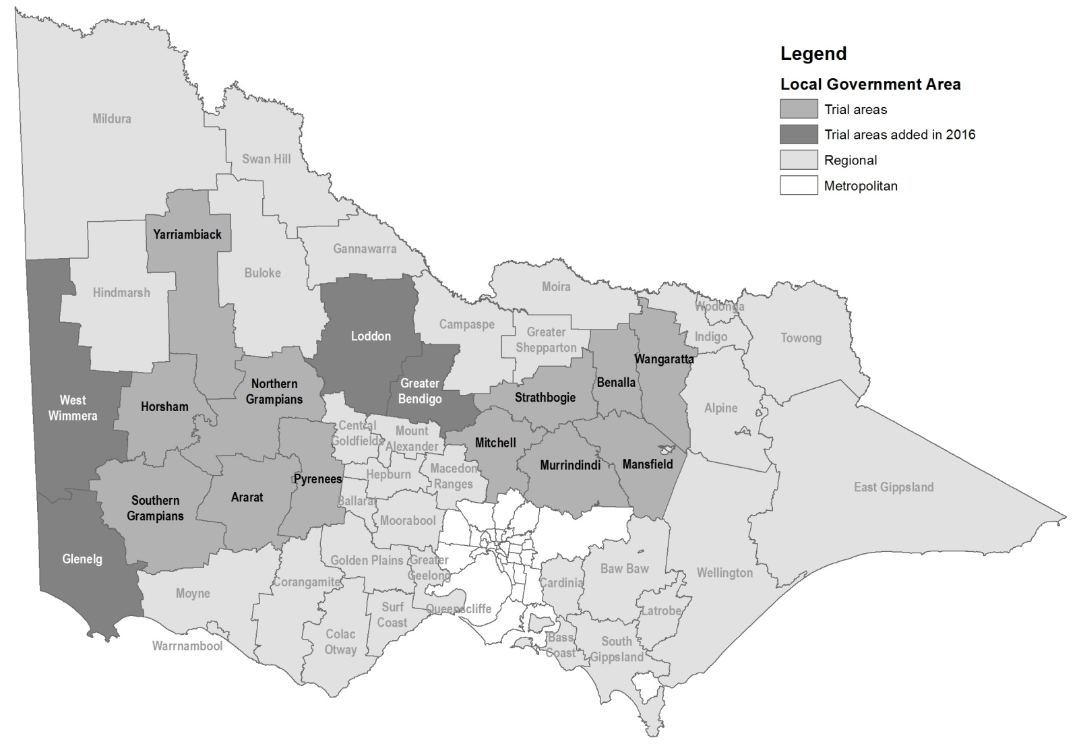

|  |  |
| --- | --- |
| © The State of Victoria Department of Environment, Land, Water and Planning 2019  LogoThis work is licensed under a Creative Commons Attribution 4.0 International licence. You are free to re-use the work under that licence, on the condition that you credit the State of Victoria as author. The licence does not apply to any images, photographs or branding, including the Victorian Coat of Arms, the Victorian Government logo and the Department of Environment, Land, Water and Planning (DELWP) logo. To view a copy of this licence, visit http://creativecommons.org/licenses/by/4.0/.  [ISBN 978-1-74326-821-6](https://www.wildlife.vic.gov.au/__data/assets/pdf_file/0026/28277/Kangaroo-Pet-Food-Trial-Information-for-shooters-update-15-September.pdf) (Online) Disclaimer  This publication may be of assistance to you but the State of Victoria and its employees do not guarantee that the publication is without flaw of any kind or is wholly appropriate for your particular purposes and therefore disclaims all liability for any error, loss or other consequence which may arise from you relying on any information in this publication. | Accessibility  If you would like to receive this publication in an alternative format, please telephone the DELWP Customer Service Centre on 136186, email [customer.service@delwp.vic.gov.au](mailto:customer.service@delwp.vic.gov.au), or via the National Relay Service on 133 677 [www.relayservice.com.au](http://www.relayservice.com.au). This document is also available on the internet at [www.delwp.vic.gov.au](http://www.delwp.vic.gov.au). |