Our Wildlife Fact Sheet
  - Blue Whale

The Blue Whale is the largest known animal on earth! This fact sheet will provide some useful information on this majestic species.
Scientific name
Balaenoptera musculus
Did you know?
The heart of a Blue Whale is as big as a car.

One Blue Whale can consume as much as 4 tonnes of krill (shrimp-like crustaceans) per day.

Blue Whales don’t have teeth; instead they eat by sifting seawater through their mouth to catch krill. The seawater is filtered through hundreds of giant sieves in their mouth called baleen plates.

Blue Whales can live for up to 90 years and carry lice that live and feed on loose skin.
Description
Blue Whales can grow up to 33 metres long and weigh as much as 180 tonnes. Their tongues alone can weigh as much as an elephant. Females are generally bigger than males.

Blue Whales are silver-grey to dark grey in colour, with light grey spots across the skin which appears bright blue underwater.

They have a small dorsal fin on their back and throat pleats (grooves) from the lower jaw to the belly.

Blue Whales breathe air from their blow hole near the top of the head in a powerful burst. They can blow water up to 9 metres into the air and be heard 3 -5 km away.
Diet
The main diet of the Blue Whale is krill but they also consume some small fish and squid.

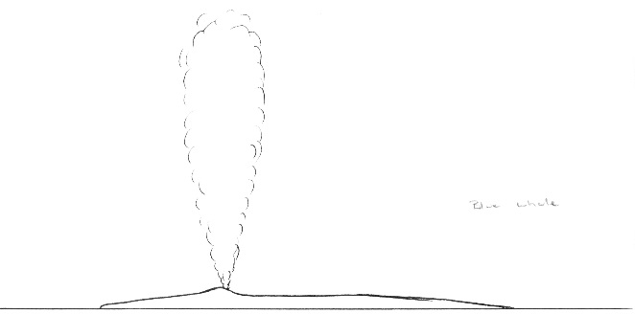
Figure 1. Blue Whale blow pattern © B. Jarrett 2010

They generally feed in the summer months in sub-Antarctic and Antarctic waters but can be seen feeding off the western Victorian coast near Portland.

To eat, they take large gulps of water containing krill, discarding the water through the baleen plates.
Habitat
Blue Whales are found throughout the world’s oceans.

In the summer months, they tend to reside in sub-Antarctic and Antarctic waters. In the winter months, they migrate to breeding grounds in warmer tropical waters.

Distribution
Blue Whales are often sighted along the south west coast of Victoria during Summer.
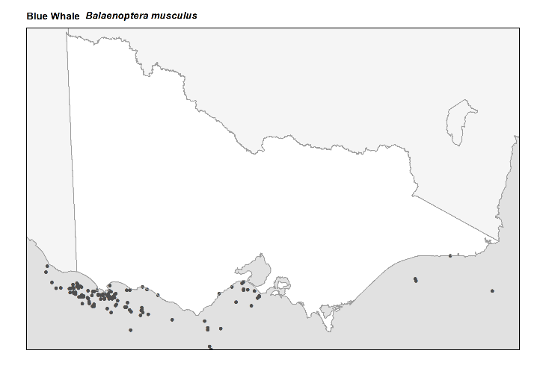
Figure 2. Recorded occurrences in Victoria
Source: Victorian Biodiversity Atlas (records post 1979), version 15/5/2017

Breeding
Blue Whales reach sexual maturity at around 7-10 years of age although observations of Blue Whales in the act of mating are rare.

Males are known to compete for mates and use very loud, high frequency sounds to attract females.

Females give birth to a single calf after a gestation period of 11 months. Females are capable of giving birth every 2-3 years.

Calves can weigh up to 4 tonnes and are 6-7 metres long. The newborn will immediately swim to the surface for its first breath with the mother aiding it with her flippers. Calves can swim unaided within half an hour of being born.

Calves are fed milk for approximately 7-8 months before being weaned. During the nursing period, the calf can drink up to 400 litres of milk per day.

Conservation status
Blue Whales were nearly hunted to extinction during the early 1900s.

Numbers have increased in recent times but not significantly. The current total world population of Blue Whales is estimated at between 2,000 and 5,000 individuals.

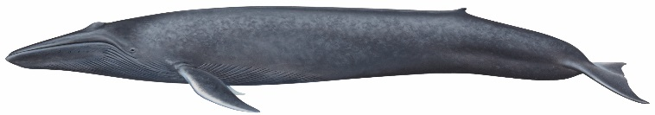

Figure 3. Blue Whale © B. Jarrett 2010

Many countries around the world, including Australia, have listed the Blue Whale as an endangered species.
What you can do to help!
It’s important not to get too close to whales. They need space to move, feed and take care of their young.

Boating can disturb these behaviours and threaten their well being. If you are out on the ocean and see a whale, make sure you stay at least 200 metres away! When riding a jetski then you need to stay at least 300 metres away.

If you are flying a drone, remember that you must not allow the drone to get closer than 500 metres above or around the whale.

Don’t drop litter! The litter you discard on the street ends up in the oceans and can be harmful to all marine life.

Don’t discard fishing line into the ocean. It can harm marine life, including whales, for many years to come

If you see a whale entangled in fishing gear or stranded on a beach, call the Whale and Dolphin Emergency Hotline on 1300 136 017.

Further reading
Menkhorst, P.W. (ed.), (1995), Mammals of Victoria, Oxford University Press, Melbourne.

