|  |
| --- |
| Our Wildlife Fact Sheet |
| Southern Brown Tree Frog |

Southern Brown Tree Frogs are one of Victoria’s common frog species.

Scientific name

*Litoria ewingi*

Did you know?

The Southern Brown Tree Frog is an agile hunter. It can leap to catch insects in mid flight.

Their large sticky toes make them great climbers.

Female Southern Brown Tree Frogs can lay up to 600 eggs at a time.

It takes between 12 and 26 weeks for Southern Brown tadpoles to turn into frogs.

Description

Southern Brown Tree Frogs grow up to about 50 mm in length.

Their colour is true to their name as they are brown on their backs. The backs of their thighs are yellowish to bright orange, and they have a white grainy belly. They also have a distinctive white stripe from the eye to their fore-leg. Their skin is smooth with small lumps. They have webbing on their feet that goes half way up their toes while their fingers have no webbing at all.

Breeding males have a light brown vocal sac.

Diet

Southern Brown Tree Frogs feed mainly on flying insects such as mosquitoes, moths and flies.

**Habitat**

Southern Brown Tree Frogs can be found in wetlands, cool temperate open grasslands, heathlands, forest and farmland.

They can also be found in suburban gardens and parks.

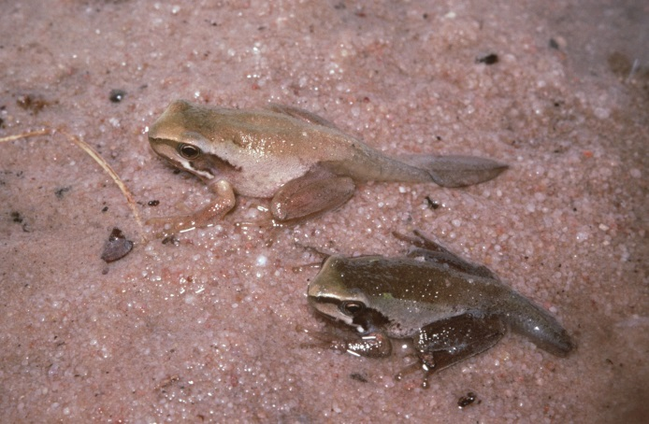**Figure 1. Southern Brown Tree Frog metamorphs © A. Houston DSE 2008**

**Distribution**

Southern Brown Tree Frogs occur in southern Victoria, Tasmania and along the south coast of New South Wales.

They are found across most of southern, central and north-eastern Victoria, but do not occur in the north-west corner of the state. In north-central Victoria and in parts of the state’s north-east they are replaced by the closely-related Plains Brown Tree Frog (*Litoria paraewingi)*.

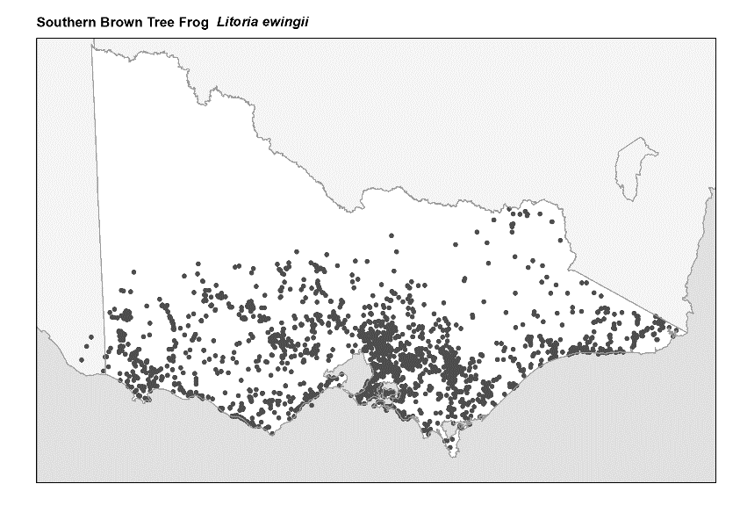**Figure 2. Recorded occurrences in Victoria**

***Source: Victorian Biodiversity Atlas (records post 1979), version 15/5/2017****.*

**Breeding**

Southern Brown Tree Frogs breed all year round, peaking in late winter and early spring.

Males call from the edge of the water among vegetation or on land.

Males call using a series of rising “*crees*” that are repeated between 5 and 15 times, with the first note being held the longest (“*creeeeeee creee creee*”).

Females lay up to 600 eggs in clumps of about 10-15 eggs.

The eggs are attached to vegetation near the surface of the water.

Tadpoles hatch after 4 to 6 days and take between 12 and 26 weeks to turn into frogs.

**What you can do to help!**

Sometimes humans can be a frog’s worst enemy!

Although the Southern Brown Tree Frog remains abundant and widespread, loss of habitat due to clearing of land and development threatens some species of frogs. These species need your help.

Some frog species are prone to pollution so keep waterways clean by not dumping waste and toxic liquids into your drains and creeks.

Frogs are also vulnerable to an infectious disease caused by the chytrid fungus, which can make them sick or kill them. Help protect Southern Brown Tree Frogs by not touching or moving them from one area to another.

Create a frog-friendly backyard by composting and avoid use of hard chemicals like herbicides.

The Southern Brown Tree Frog relies upon vegetation in the water to lay its eggs. There are many water plants including ones you can eat that can be put into a pond in your garden to provide habitat for frogs.

Figure 3. Southern Brown Tree Frog © Nick Clemann

**Further reading**

Barker, J., Grigg, G. and Tyler, M. J. 1995. A Field Guide to Australian Frogs. Surrey Beatty & Sons, Sydney.

Cogger, H.G., (2000), *Reptiles and amphibians of Australia (6th ed.)*, Reed New Holland, Sydney.

Hero, J-M., Littlejohn, M. and Marantelli, G. (1991). *Frogwatch Field Guide to Victorian Frogs.* Department of Conservation and Environment, Victoria.

Robinson, M. 2002. A Field Guide to Frogs of Australia. Australian Museum/Reed New Holland: Sydney.

Swan, G. 2001. Green Guide to Frogs of Australia. New Holland: Sydney.

Tyler, M. J. and Knight, F. (2009). *Field Guide to the Frogs of Australia.*  CSIRO Publishing, Collingwood.

Frogs of Australia Website: [www.frogs.org.au](http://www.frogs.org.au)