Electrocuted Grey-headed Flying-fox
  - What to do when you find an
  - electrocuted Grey-headed Flying-fox

Grey-Headed Flying-fox

The Grey-headed Flying-fox (GHFF) is a large Australian ‘fruit-bat’. It has a dark grey body with a light grey head and a reddish-brown neck collar of fur. The wing membranes are black and the wingspan can be up to one metre. GHFF are relatively long-lived mammals, often reaching an age of between six to ten years.

The GHFF is endemic to Australia, occurring along the east coast from Bundaberg in Queensland to Melbourne, Victoria and more recently to Adelaide, South Australia. It feeds on a wide variety of trees and shrubs. Native figs and palms, eucalypt blossoms, banksias and angophoras are particular favourites of the GHFF. Flying-foxes are important pollinators and seed dispersers of over 100 native tree species.

Conservation Status

The GHFF is listed as a ‘vulnerable species’ on the Department of Environment, Land, Water and Planning (DELWP) advisory list of threatened vertebrate fauna in Victoria 2013. It is also listed as threatened under the Flora and Fauna Guarantee Act 1988; and listed as a ‘vulnerable species’ under the Commonwealth Environment Protection and Biodiversity Conservation Act 1999.

Threats

Grey-headed Flying-foxes are threatened primarily by the large-scale loss of habitat and food resources as well as disturbance of roosting sites. Illegal shooting, entanglement in backyard fruit tree or netting and electrocution on powerlines can also contribute.

Electrocution on powerlines

DELWP sometimes receives reports about multiple fatalities of GHFF as a result of contact with powerlines.

After feeding, flying-foxes may rest on nearby powerlines. As they spread their wings to take flight the wings can make contact with live wires, resulting in electrocution. In most cases, the flying-foxes die.

Occasionally animals survive electrocution, but badly injured flying-foxes will not be able to fly and will be on the ground. Unattended injured animals can suffer, and may also pose a health risk to the public from bites or scratches. A small number of flying-foxes carry Australian Bat Lyssavirus. This is only transmissible via a bite or scratch.

The most important thing to remember is your own safety:

• Do not assume a flying-fox is dead – treat the situation carefully. If the flying-fox is on the ground, use a shovel to gently move the animal

• Never attempt to touch a live flying-fox (unless you are trained and/or inoculated)

• Never try to rescue or touch an animal caught in powerlines

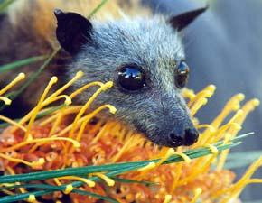

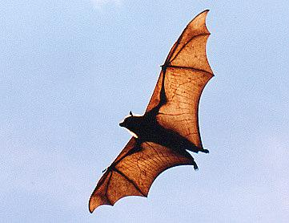

Your help is needed

If you see a lifeless electrocuted flying-fox on your property, on, or below, power lines, or on an adjacent nature strip - do not touch the animal.

Check the animal is dead by turning it over with a shovel. Using the shovel and gloves place the animal in a double plastic bag. All carcasses should be disposed of in accordance with local government by-laws. Contact the relevant electricity distributor to report the incident.

If you find an electrocuted flying-fox alive on the ground - do not touch the animal (a small percentage of flying-foxes carry diseases including Australian Bat Lyssavirus and Hendra virus).

Cover the flying-fox with a towel, cardboard box or washing basket and contact a Wildlife Carer or vet to collect the animal.

Contacts

Call the DELWP Customer Contact Centre on 136 186, who can also provide you contact details for wildlife rehabilitation organisations.

The contact details for wildlife rehabilitation organisations can also be found on this website: https://www.wildlife.vic.gov.au/sick-injured-or-orphaned-wildlife/sick-injured-or-orphaned-wildlife

The contact details for Victoria five electricity distributors are:

- Citi Power: Melbourne CBD and inner suburbs 1300 301 101
- Jemena: Melbourne’s northern and north-western suburbs 1300 131 871
- Powercor: Melbourne’s outer western suburbs and regional and rural centres in the central and western areas of Vicoria 13 22 06
- SP Ausnet: Eastern Victoria 1300 360 795
- United Energy: Melbourne’s south-eastern and eastern suburbs and Mornington peninsula 132 099
