|  |
| --- |
| Kangaroo Pet Food Trial |
| Information for pet meat processing facilities |

The Department of Environment, Land, Water and Planning (DELWP) issues Authorities to Control Wildlife (ATCWs) under section 28A of the *Wildlife Act 1975* for the control of kangaroos that are damaging pasture, crops or other property or impacting on biodiversity values.

Landholders who are issued with an ATCW may arrange for shooters to control wildlife on their behalf.

DELWP is conducting a trial to facilitate the processing of kangaroos controlled under ATCWs for the production of pet food in the domestic market. The trial does not allow kangaroo meat to be used for human consumption.

The trial will not change the requirement for a landholder applying for an ATCW to demonstrate that kangaroos are causing property damage.

The Kangaroo Pet Food Trial (KPFT) was initially a two-year trial that has been extended twice to test its sustainability over a longer period and to see whether changes to compliance, monitoring and education would address issues that arose. It will now operate until 30 September 2019, after which an ongoing kangaroo pet food program will commence.

The extension of the trial is intended to provide continuity to current participants of the KPFT while the new program is developed. Further information about this program will be provided as its development progresses.

For more information about the operation of the current trial see the *“Overview”*, *“Information for landholders”* and *“Information for shooters”* factsheets.

## Who can process kangaroos for pet food?

Pet meat processing facilities may process kangaroos controlled under the trial provided they:

* meet the outcomes of the Australian Standard for the Hygienic Production of Pet Meat
* ensure they have a pet meat processing plant licence from PrimeSafe
* ensure they have an approved food safety plan (also known as a Quality Assurance Program) that provides for kangaroos as a meat source
* obtain a wildlife processor licence from DELWP.

## How can I participate in the trial?

Firstly, you should contact PrimeSafe to discuss your food safety plan and licence requirements.

You will be required to list preferred suppliers of kangaroos in your food safety plan. These suppliers are the shooters who will control kangaroos on behalf of landholders issued with ATCWs in the trial area.

You must ensure your preferred suppliers (i.e. professional shooters) are appropriately trained in humane killing procedures, consistent with the National Code of Practice for the Humane Shooting of Kangaroos and Wallabies for Commercial Purposes, and hygienic handling of kangaroos for pet food. The preferred suppliers are required to comply with the conditions of the KPFT ATCW and your food safety plan.

You are also required to obtain a wildlife processor licence from DELWP. You should contact DELWP for information on how to apply for this licence. Under the wildlife processor licence, you are required to provide DELWP with the list of preferred suppliers under your food safety plan.

DELWP will provide landholders who have been issued with KPFT ATCWs with the contact details of all participating meat processing facilities. The landholder can then contact the meat processing facility of their choice to arrange the control of the kangaroos.

For more information see the *“Overview”*, *“Information for landholders”* and *“Information for shooters”* factsheets.

## Record keeping requirements

Holders of a wildlife processor licence have prescribed record keeping requirements where all wildlife transactions must be recorded in record books provided by DELWP. PrimeSafe also have prescribed record keeping requirements that must be adhered to.

Pet meat processing facilities participating in the trial are also required to record, in a template provided by DELWP, the following information for kangaroos received under the trial for the purposes of traceability of carcasses:

* the relevant KPFT ATCW number
* the number and species of kangaroos received and the corresponding tag numbers and colour
* the name of the shooter who supplied the carcasses, and
* the date they were received.

A copy of these records must be provided to DELWP by the 5th day of each month.

Records must be sent to:

Biodiversity Regulation, DELWP

PO Box 500

East Melbourne VIC 8002

Or email: [biodiversity.regulation@delwp.vic.gov.au](mailto:biodiversity.regulation@delwp.vic.gov.au)

## Steps for pet meat processing facilities:

Contact PrimeSafe to discuss licensing requirements

Organise training for your preferred suppliers

Apply to DELWP for a wildlife processor licence

*Landholder in the trial area applies to DELWP for a Kangaroo Pet Food Trial ATCW*

*Landholder contacts a pet meat processing facility to arrange for a shooter to control an agreed number of kangaroos on their property on an agreed date*

*Shooter tags the kangaroos and arranges for the kangaroos to be transported to your pet meat processing facility*

*Shooter controls kangaroos in accordance with ATCW conditions and your food safety plan*

Process kangaroos for pet food

Record details of kangaroo transactions in record books supplied by PrimeSafe and DELWP

*PrimeSafe and DELWP issue licences*

Apply for licence from PrimeSafe and ensure your food safety plan is compliant

*DELWP provides landholders holding Kangaroo Pet Food Trial ATCWs with contact details of pet meat processing facilities*

Submit returns to DELWP every 3 months

## Frequently Asked Questions

***When will the trial run?***

The trial will run from 31 March 2014 to 30 September 2019.

***In what area is the trial running?***

The trial is open for landowners in the following local government areas: Ararat, Benalla, Glenelg, Greater Bendigo, Horsham, Loddon, Mansfield, Mitchell, Murrindindi, Northern Grampians, Pyrenees, Southern Grampians, Strathbogie, Wangaratta, West Wimmera and Yarriambiack.

Please see figure 1 for a map of the trial areas.

***Can a pet meat processing facility accept kangaroos that have been controlled outside the trial area?***

No. Only kangaroos controlled in the trial area under a KPFT ATCW are able to be processed.

***Can a pet meat processing facility accept kangaroos from shooters who are not listed in its food safety plan?***

No. A pet meat processing facility can only receive kangaroos that have been controlled in a trial area by shooters (acting on behalf of landholders) who are listed as preferred suppliers in its food safety plan.

***Can a pet meat processing facility accept kangaroos that have been controlled on land where there is no ATCW?***

Only kangaroos that have been controlled under KPFT ATCW are able to be processed. The only exception is where the kangaroos have been imported from another state or territory in accordance with an import licence issued under the *Wildlife Act 1975*.

***Can kangaroos be processed for human consumption?***

No. That is outside the scope of the trial and would be subject to different licensing regimes.

***Can kangaroos be used for non-meat products?***

Yes. Please contact DELWP for more information.

***Can kangaroo skins be exported overseas?***

On the 1st February 2018, the Federal Minister for the Environment and Energy approved DELWP’s Kangaroo Pet Food Trial Developmental Wildlife Trade Operation Plan as a developmental wildlife trade operation and as an existing stocks wildlife trade operation under the *Environment Protection and Biodiversity Conservation Act 1999*. These approvals enable participating pet meat processors to export kangaroo skins collected under the trial overseas.

The current approval expires on 31 March 2019. Processors may continue to export skins of kangaroos that were controlled on or prior to 31 March 2019. Skins from kangaroos controlled from 1 April 2019 cannot be exported during the extension period.

Arrangements for the export of skins under the new program will be considered during the development of the program.

***Do I need to provide tags to shooters?***

No. Landholders will be provided with DELWP-issued plastic tags which they then provide to the shooter. Shooters must tag each kangaroo controlled with a provided plastic tag and complete a record sheet which records the number of kangaroos controlled and the tag numbers used. Blue tags must be attached to Eastern Grey Kangaroos controlled under the ATCW, and white tags must be attached to all Western Grey Kangaroos The completed record sheet must be returned to the landholder, along with any unused tags, at the end of the control work.

***What records do I need to keep?***

Processors need to keep records in the record books or form specified by DELWP and PrimeSafe in accordance with your licence conditions.

For the purpose of carcass traceability, processors also need to keep records in the template provided by DELWP, of the following information:

* the relevant KPFT ATCW number
* the number and species of kangaroos received and the corresponding tag numbers and colour
* the name of the shooter who supplied the carcasses
* the date they were received.

It is important that you record every single tag number against the relevant KPFT ATCW, so that each one is accounted for.

A copy of these records must be provided to DELWP by the 5th day of each month.

Records must be sent to:

Biodiversity Regulation, DELWP

PO Box 500

East Melbourne VIC 8002

Or email: [biodiversity.regulation@delwp.vic.gov.au](mailto:biodiversity.regulation@delwp.vic.gov.au)

|  |  |
| --- | --- |
| © The State of Victoria Department of Environment, Land, Water and Planning 2019  LogoThis work is licensed under a Creative Commons Attribution 4.0 International licence. You are free to re-use the work under that licence, on the condition that you credit the State of Victoria as author. The licence does not apply to any images, photographs or branding, including the Victorian Coat of Arms, the Victorian Government logo and the Department of Environment, Land, Water and Planning (DELWP) logo. To view a copy of this licence, visit http://creativecommons.org/licenses/by/4.0/  ISBN 978-1-74326-823-0 (Online)  Disclaimer  This publication may be of assistance to you but the State of Victoria and its employees do not guarantee that the publication is without flaw of any kind or is wholly appropriate for your particular purposes and therefore disclaims all liability for any error, loss or other consequence which may arise from you relying on any information in this publication. | Accessibility  If you would like to receive this publication in an alternative format, please telephone the DELWP Customer Service Centre on 136186, email [customer.service@delwp.vic.gov.au](mailto:customer.service@delwp.vic.gov.au), or via the National Relay Service on 133 677 [www.relayservice.com.au](http://www.relayservice.com.au). This document is also available on the internet at [www.delwp.vic.gov.au](http://www.delwp.vic.gov.au). |

Figure 1 Map of existing and extended trial area. Four additional local government areas were added in 2016 after local government and key stakeholder consultation.

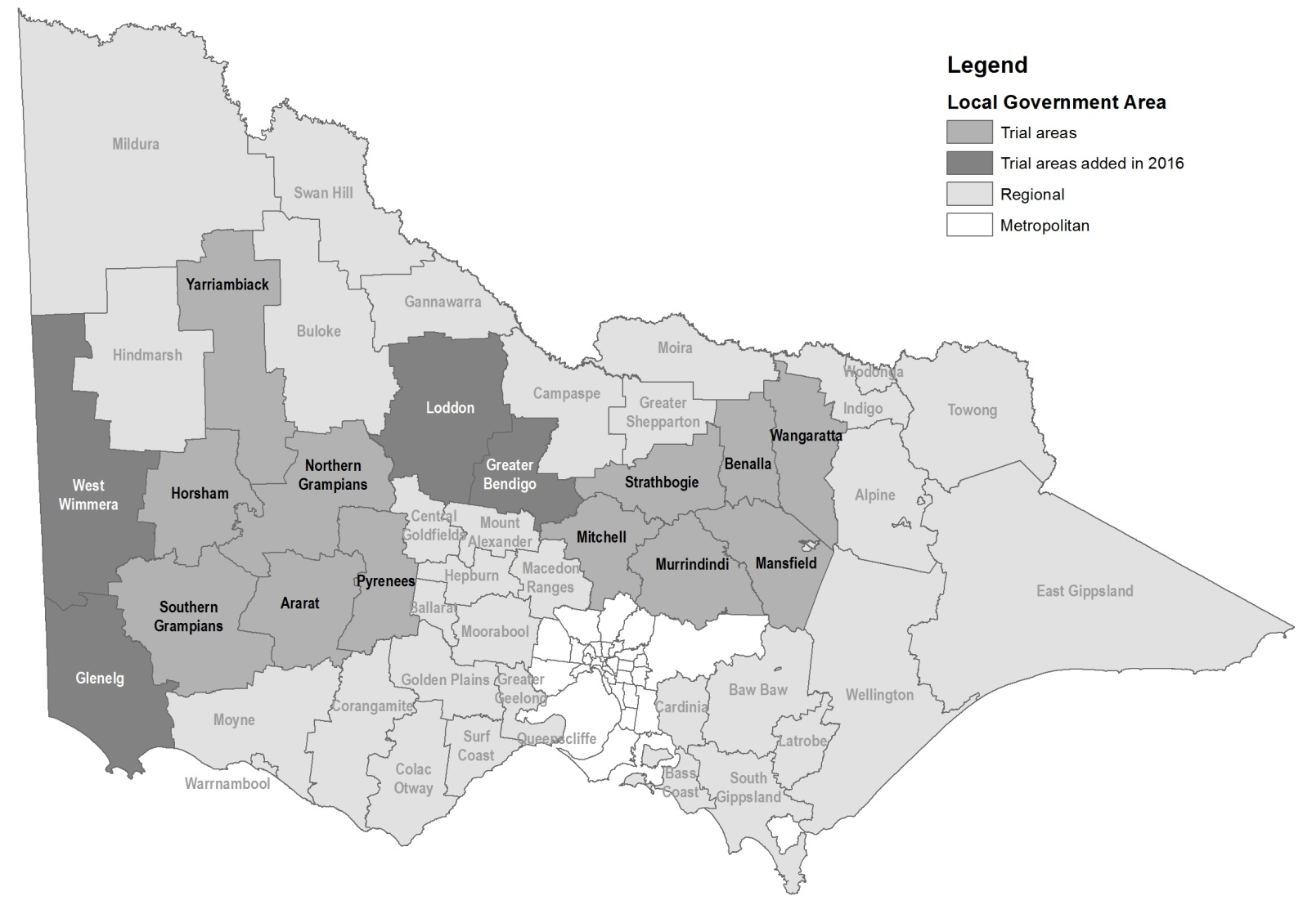

Keep all content above this instruction text line. Delete only when document formatting is complete.