Our Wildlife Fact Sheet
  - Emu

One of the most interesting and recognisable birds found in the Victorian bush is the Emu. With its long reptilian legs, bushy looking feathers and sheer size, it’s unmistakable.
Scientific name
Dromaius novaehollandiae
Did you know?
The Emu is Australia’s tallest native bird.
Emus can’t fly!
Australia is the only country in the world where you will find an Emu in the wild.
The nest of an Emu can be up to 1.5 metres wide.
An Emu egg can weigh up to 680 grams, which is the equivalent of about 12 chicken eggs.
Emus can run at speeds of up to 48 km per hour.
Emus swallow large pebbles to help their stomach grind up food.
The Emu and Kangaroo are on Australia’s Coat of Arms. It is thought they were chosen as they are the only two Australian animals that can’t move backwards. The Coat of Arms therefore symbolises a nation moving forward.
Description
The Emu is a large bird, standing up to 2 m tall and weighing up to 55 kg.
It is covered in primitive feathers that are dusky brown to grey-brown with black tips.
The Emu’s neck is bluish black and mostly free of feathers. Their eyes are yellowish brown to black and their beak is brown to black.

The Emu has greatly reduced wings, but long and powerful reptilian-like legs with large feet and sharp claws.
Their feet have three toes that all face forward, which enables them to run fast.

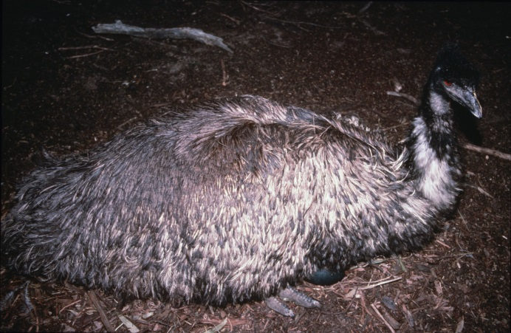Figure 1. Emu © I. McCann DSE 2009
Diet
Emus are omnivorous, which means they eat a variety of plants and animals.
Their food choice depends on what is available; it can include leaves, grasses, fruits, native plants and insects.
Emus seek out the most nutritious part of the plant to eat in order to help maintain their huge body weight.
Habitat
Emus live in a variety of habitats from open arid plains to tropical woodlands. They avoid thickly forested areas.
Distribution
Emus occur in all Australian states except Tasmania.
They are found across most of Victoria, although they avoid densely populated areas and are generally absent from the central district.
They move around their home range according to climatic conditions, although will stay in one area if food and water are readily available.
They can move large distances, travelling at rates of 15 – 25 km per day.
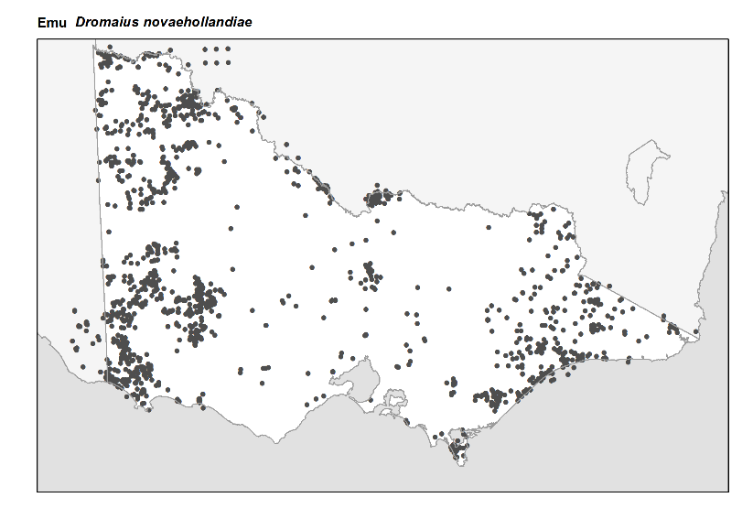
Figure 2. Recorded occurrences in Victoria
Source: Victorian Biodiversity Atlas (records post 1979), version 15/5/2017
Breeding
Emus usually pair up in summer and autumn, and mate in winter. Pairs remain together for about five months.
Their nest is a scraped area on the ground lined with grass or leaves.
The female lays between five and fifteen eggs. The eggs are about the length of a human hand and are dark bluish-green when first laid.
Once the eggs are laid, the female leaves the nest and the male takes over the incubation process, by sitting on the eggs to keep them warm.
For eight weeks, the male sits continuously on the eggs. The male rarely eats during this time and as a result can lose a lot of weight.
Newly hatched Emu chicks weigh just over 500 g. They are cream-coloured with dark brown stripes. The colouration helps to camouflage them from predators.
Wild Emus can live for 5 to 10 years.

What you can do to help!
Join a local conservation group. Many groups work on improving habitat for Emus.
For more information on how you can improve native habitat on your property, visit the Department of Environment, Land, Water and Planning website at: www.wildlife.vic.gov.au.
Be aware of road signs indicating Emus are in an area and slow down when driving. Take caution particularly at dawn and dusk, when Emus are most active.
If you do see wildlife when you are driving, be careful and give them plenty of time and space to move off the road.
Control your dog, dogs can harass and injure Emus and other wildlife.

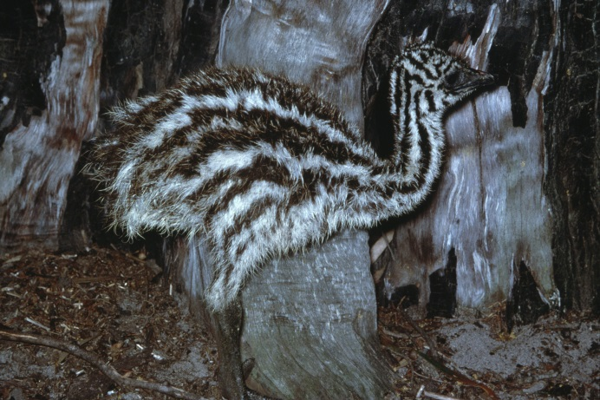Figure 3. Emu chick. © I. McCann DSE 2009
Further reading
Simpson, K. and Day, N., (2010), Field guide to the birds of Australia, (8th ed), Penguin Books, Australia.
Morcombe, M., (2004), Field guide to Australian birds, Steve Parish Publishing, Australia.

