Our Wildlife Fact Sheet
  - Superb Lyrebird

Only two species of Lyrebird are found in Australia; Albert’s Lyrebird and the Superb Lyrebird.
Scientific name
Menura novaehollandiae
Did you know?
The Superb Lyrebird features on the Australian 10c coin.
The Superb Lyrebird is an expert mimic. Able to copy both natural and mechanical sounds, the Suberp Lyrebird composes these sounds into an inspiring song. Sounds can include anything heard in the bird’s surroundings, such as other birds, chainsaws, car engines and even a dog barking!
Each song can last up to 20 minutes.
The Superb Lyrebird has received its name from its tail feathers which look similar to a lyre (an ancient Greek musical instrument).
Description
The Superb Lyrebird size can range from 80-100 cm tall including the tail.
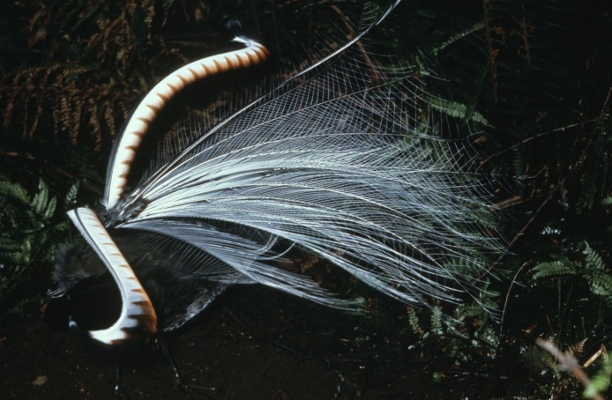
Figure 1. Superb Lyrebird © I. McCann DSE 2009
Both male and female are similar in colour with brown feathers on the upper part of the body, and lighter brown and red throat markings. The tail feathers are dark brown above and silver grey below. Their beak, legs and feet are black.

The male has a larger tail that forms the shape of the lyre while the females and the juveniles have plain tails.
Young male Superb Lyrebirds will not grow their lyre tails until they are 3 – 4 years old.
The Superb Lyrebird can fly, although it often won’t unless escaping from immediate danger.
Diet
The Superb Lyrebird feeds on seeds, insects, spiders, worms, frogs, and smaller invertebrates.
They find food by scratching with their long and sharp claws under leaf litter. They tend to forage alone unless with young.
Habitat
The Superb Lyrebird’s preferred habitat is moist forests and woodlands.
They generally roost in trees at night and forage on the ground during the day.
Lyrebirds rarely move long distances, tending to stay within a 10 km radius of their preferred habitat.
Distribution
The Superb Lyrebird can be found in south eastern Australia and southern Tasmania. In Victoria, they exist almost exclusively in the east of the state. 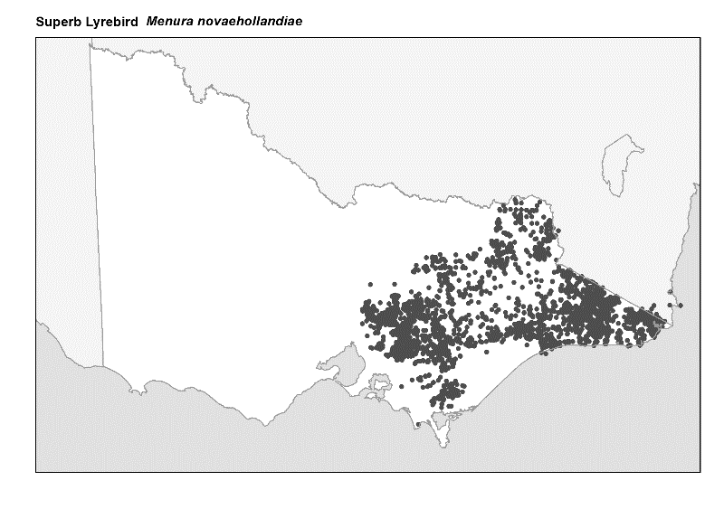
Figure 2. Recorded occurrences in Victoria
Source: Victorian Biodiversity Atlas (records post 1979), version 15/5/2017

Breeding
The Superb Lyrebird breeds from June through to October.

The male will make quite a presentation to the female by building one or two small mounds of dirt to use as a podium. He then raises his tail above his head and sings his intricate song made up of sounds from his surroundings while dancing for the female. Males generally mate with several females.

Females build the nest either on the ground or on rocks, tree stumps or in caves. The nest is delicately constructed of sticks with a soft lining of fern, roots and feathers. Females lay a single egg that is brown to purple in colour. The egg hatches after 50 days, with the young Superb Lyrebird remaining in the nest for a further 6 weeks.

The female Superb Lyrebird is in sole charge of nest building, incubating and rearing the young.

The young will forage together in groups with the adults, until the young males leave to stake their own territory.

Superb Lyrebirds can live up to 20 years of age.
What you can do to help!
The Superb Lyrebird was driven almost to extinction due to habitat clearing and hunting for their stunning tail feathers. Protection methods have helped stabilise its population sizes yet both the Superb Lyrebird and Albert’s Lyrebird remain under threat from feral cats and foxes, as well as human urban development.

You can learn a lot about the Superb Lyrebird as well as protecting their population by joining a friends group in your local area.

If you are fortunate enough to have the Superb Lyrebird grace your backyard you will be rewarded by their wonderful mimicry. Be careful to protect your garden as they will rake up seedlings and rummage through the compost bin.

Report any suspected illegal activity relating to the Lyrebird to the DELWP Customer Contact Centre on 136 186.

All wildlife is protected in Victoria. Visit the DELWP website for more information regarding protected wildlife www.wildlife.vic.gov.au.

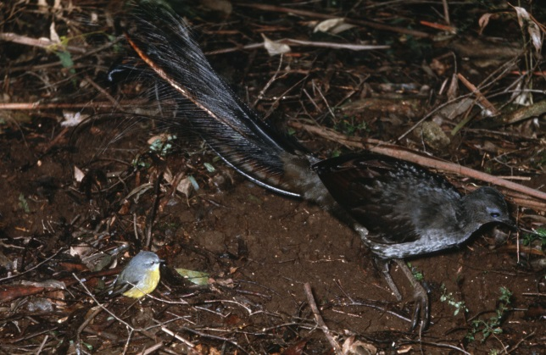Figure 3. Superb Lyrebird © I McCann DSE
Further reading
Simpson, K. and Day, N., (2010), Field guide to the birds of Australia, (8th ed), Penguin Books, Australia.
Morcombe, M., (2004), Field guide to Australian birds, Steve Parish Publishing, Australia.

