Our Wildlife Fact Sheet
  - Koala

The koala is one of the most recognisable animals in Australia. People from all over the world come here to visit this slow moving, supposedly bear-like mammal.
Scientific name
Phascolarctos cinereus
Did you know?
The Koala’s closest relative is the wombat.
This tree dwelling species spends over 20 hours a day sleeping. They can also swim!
An adult koala eats from 0.5 kg – 1 kg of eucalypt (gum) leaves per day.
Koalas have many adaptations for life in the trees. They have long, sharp claws and strong muscles in their limbs. They also have two ‘thumbs’ and three fingers on each foot. The two thumbs enable them to grip evenly on either side of branches.
Koalas use their hind toes to groom their fur.
Koalas are Australia’s only tree-dwelling species without a tail.
Description
Koalas are tree dwelling marsupials. They are covered in fine woolly fur which varies from grey to brown. Koalas have white patches on their chin, chest and forelimbs.
Their broad head with large hairy ears, a flattened nose and small eyes are what gives them the cute appearance that so many love.
Koalas have a short and stocky body. They can range up to 82 cm in length and weigh up to 14 kg.
Koalas in Victoria are generally larger than those in Queensland, and their fur is thicker.
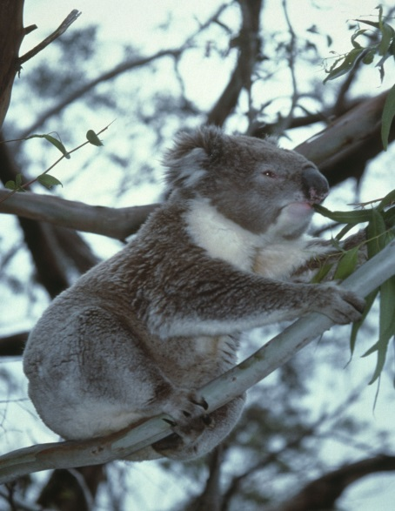
Figure 1. Koala © I. McCann DSE 2008
Diet
The koala’s diet consists of eucalypt leaves. The species of eucalyptus trees that koalas eat is dependent on the area and the preferences of the individual animal. Koalas are very selective in the types of leaves they eat; it is thought they are able to smell the chemical composition of leaves to ensure they are suitable before eating them.
Eucalyptus leaves are low in nutrients, so koalas conserve energy by sleeping for most of the day and looking for food in the evenings.
Koalas rarely need to drink water, except in times of drought, as usually they obtain their moisture from the leaves they eat and any dew that may be on them.
Habitat
Koalas are widespread throughout eucalypt woodlands and forests in lowland Victoria. They are rare or absent from wetter forests. Koalas spend most of their time up trees but will climb down to move between trees. Feeding, mating and travelling occur mainly at night. Grooming is a daytime activity.
Distribution
The koala has a patchy distribution throughout eastern Australia from northeast Queensland to the Eyre Peninsula in South Australia.
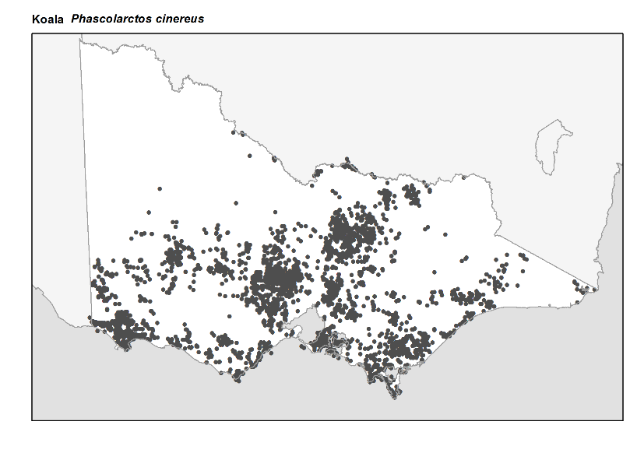
Figure 2. Recorded occurrences in Victoria
Source: Victorian Biodiversity Atlas (records post 1979), version 15/5/2017
Breeding
Koalas are marsupials which means they belong to a group of mammals with pouches that have young born at an early stage of development.
Koalas mate in late spring. Their joeys when born are only 2 cm long. The young joey spends the next 7 months in the pouch growing. The koala’s pouch is rear facing, and is lined with strong muscles that keep the joey from falling out.
After 7 months, the joey moves out of the pouch and rides on its mothers back until it is 1 year old.
During this time, joeys feed on small quantities of their mother’s ‘pap’ which is excreted in their faeces. This pap helps prepare the joey’s digestive system for the tough diet of an adult koala; eucalyptus leaves.
Young female koalas spend the next year close to their mother. Young male koalas generally move away from their mother’s area to find new territory.
Females are able to reproduce from 2 years of age, whereas males take longer to reach sexual maturity at 3–4 years. The territorial calls of male koalas are loud pig-like growls and grunts.
Male koalas have a dark scent gland in the centre of their chest which they rub on the bark of trees to mark their territory. They also communicate their presence to other males in the area by calling.
What you can do to help!
You can help koalas by improving the habitat on your property. Koalas need many healthy mature trees for food and shelter.
Be aware of road signs indicating koalas are in the area and slow down. Koalas may be moving along the road. Be especially careful at dawn and dusk when visibility is poor and koalas are likely to be moving between trees.
If you do see koalas or other wildlife when you are driving, be careful and give them plenty of time to move off the road.
Take care with your dog. Unrestrained dogs can harass and injure wildlife.
Join a local conservation group! Many groups work on increasing and improving habitats for koalas. Koalas and other wildlife need continuous habitat to live and breed successfully.

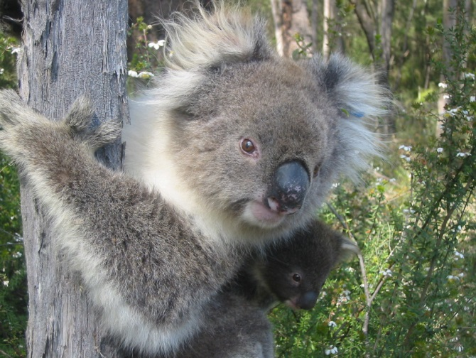
Figure. 3 Koala © I. Temby DSE 2010
Further reading
Menkhorst, P.W. (ed.), (1995), Mammals of Victoria, Oxford University Press, Melbourne.

