Possum Repellents Fact Sheet

Possum repellents may work through two chemical senses: smell and taste. In addition, some repellents are designed to repel because of their texture ('mouth feel').

Many substances have been used in the hope that they will stop possums eating garden plants. DELWP is not aware of any definitively successful, universal repellent that will consistently deter possums from eating plants.
Some people believe that certain products or mixtures work and it may be that, in some circumstances, they do. Others claim that they have 'tried everything' and that nothing stops their plants being eaten.

Possum repellents
Listed below are several compounds that have been reported to deter possums from their plants.
The effectiveness of any of these compounds is not proven, however they are listed below in case people wish to test them to see if they offer any level of protection for their gardens.
Animal cruelty is an offence under the Prevention of Cruelty to Animals Act 1986, it is important to remember that any methods used to repel or control possums must be lawful.
This list includes those products tested in a Deakin University study (outlined below). The letters (S), (T) or (F) after the products indicate whether they are intended to repel by smell (S), taste (T) or feel (F). Directions for use are given where we have this information.
Note: compounds that dissolve in water are likely to be removed by rain and should be reapplied after rain. It is wise to test any of these products on a small part of a plant, to see whether it causes any damage to the plant, before applying it more generally.
- Charlie Carp® (S) (fish-based fertiliser): spray/paint on plant stems or other parts to be protected.
- Skunk-off® (S) (proprietary repellent product): follow label instructions.
- Tea-based deterrent (T): boil two litres of water; add four heaped tablespoons of Lapsang Souchong tea; leave to cool, strain off liquid and apply from plastic spray bottle directly onto affected plants. Reapply every two weeks and always after rain. Make a fresh brew every time.
- Indonesian fish sauce (T): place one tablespoon of sauce in one litre of water and spray on foliage.
- Garlicspray (S, T): place two tablespoons freshly crushed garlic (a variation is to add two tablespoons of freshly crushed hot chilli) in one litre of hot water. Allow to stand overnight. Spray on foliage.
- Quassia chips (T) (Chips of bark from a South American tree): add 100 g chips to 2 litres water and heat for one hour before straining. Add one tablespoon detergent. Dilute at rate of 1 part of solution to four parts water and apply as a spray.
- Blood & Bone (S) (Animal-derived fertiliser): sprinkle around the base of plants to be protected.
- D-ter® (S, T) (proprietary repellent product): follow label instructions.
- Keep Off® (S) (proprietary repellent product): follow label instructions.
- Stay Off® (S) (proprietary repellent product): follow label instructions.
- Scat® (S) (proprietary repellent product): follow label instructions.
- Tabasco Sauce® (T): use full strength as paint or spray.
All of these products may be bought from your local supermarket or from a plant nursery.
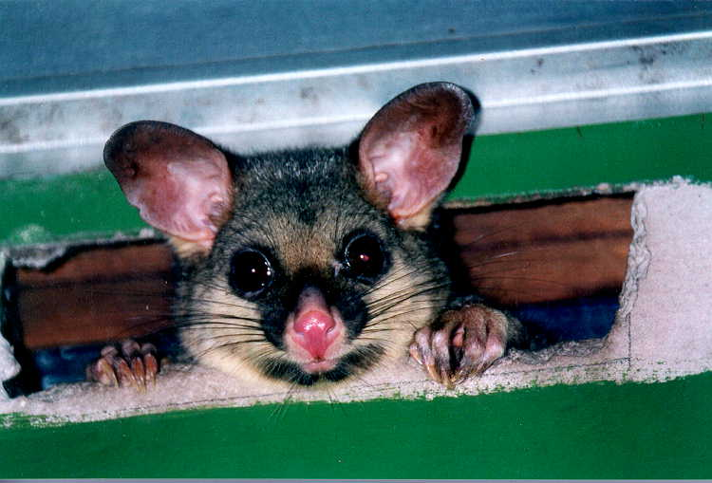
Figure 1. Brushtail possum © I. Temby DSE 2008

Possum repellent study
A study by Deakin University in Melbourne set out to test the repellency of 14 products most of which are commonly used to deter possums. The following is a summary of this study and does not represent DELWP's view or endorsement of any of the products listed.
It should be noted that these trials were undertaken on one population of possums at one site. Products tested included:
garlic spray Tabasco sauce®
hot English mustard Indonesian fish sauce
White King® camphor
naphthalene flakes quassia chips
Blood and Bone Keep Off®
Stay Off® D-Ter®
Scat® Bitrex®.
These products are readily available either at the supermarket or at a plant nursery with the exception of Bitrex. Bitrex is a bittering agent commonly added to make certain products unpalatable and is an ingredient in some proprietary repellent products, such as D-Ter®.
Products were organised in categories according to their supposed method of repellency, either by taste (gustatory repellents) or odour (olfactory repellents). Different tests were devised for each category. Two of the products were tested in both categories because they could conceivably repel by both taste and odour (garlic spray and D-Ter®).
Gustatory repellents were tested on piles of apple pieces laid out in a grid pattern, with untreated apple and three different repellent treatments tested in each trial of two hours during which wild possums had free access to the food.
The behaviour of the possums and the amount of food in each treatment remaining at the end of the trial period were recorded.

Results
The results showed that when possums were hungry, none of the repellents prevented them from eating all the apples provided. The products tested in this series of trials included: Tabasco sauce®, hot English mustard, Indonesian fish sauce, Bitrex®, garlic spray and D-Ter®.
Olfactory repellents were tested by placing treated and untreated chopped apple in a cage suspended above the ground. A counter recorded the number of times a possum attempted to gain access to the contents of the cage. Many attempts to get the untreated apple, compared with few attempts to get at the treated apple would be taken as an indication of successful repellency. The results suggested that some of the tested compounds may show some degree of repellency, for instance Keep Off® and Scat®.
The other products tested in the olfactory trials were: D-Ter®, Stay Off®, Blood and Bone, Garlic and Quassia chips.
The results do not necessarily indicate that similar responses will be displayed by possums elsewhere, or that other kinds of tests would yield similar results.
Reference: Cooney, Janine 1998. An evaluation of commonly used deterrents for urban common brushtail possums, Trichosurus vulpecula (Kerr, 1792). BSc (Hons) thesis, School of Ecology and Environment, Deakin University.

