Netting is commonly used to protect fruit trees. Unfortunately, many of these net types are the leading cause of flying fox injury and death.

To test if your netting is wildlife-safe, see if you can fit a finger through the netting holes. If you can, don’t put the net on your trees, and help keep wildlife safe!

Wildlife-safe netting tips

* Use only small aperture white netting, 5mm x 5mm or less. If single strand, 2mm x 2mm or less.
* Remove netting from trees once fruit has been harvested or is over-ripe.
* While using netting, check your trees daily to ensure no wildlife are entangled.
* Pick fruit early and leave your tree un-netted.
* Never throw netting loosely over trees – fix tightly to branches or tie onto trunk.
* Thirty percent blockout shadecloth can also be used. It’s wildlife-safe and will not stop fruit from ripening. You can also re-use it the following year.
* Never use netting if fingers can be pushed through holes.
* Consider netting selected branches only rather than the entire tree (see image below).

**Fruit tree netting and wildlife**

|  |  |
| --- | --- |
| © The State of Victoria Department of Environment, Land, Water and Planning 2017  LogoThis work is licensed under a Creative Commons Attribution 4.0 International licence. You are free to re-use the work under that licence, on the condition that you credit the State of Victoria as author. The licence does not apply to any images, photographs or branding, including the Victorian Coat of Arms, the Victorian Government logo and the Department of Environment, Land, Water and Planning (DELWP) logo. To view a copy of this licence, visit http://creativecommons.org/licenses/by/4.0/  Disclaimer  This publication may be of assistance to you but the State of Victoria and its employees do not guarantee that the publication is without flaw of any kind or is wholly appropriate for your particular purposes and therefore disclaims all liability for any error, loss or other consequence which may arise from you relying on any information in this publication. | Accessibility  If you would like to receive this publication in an alternative format, please telephone the DELWP Customer Service Centre on 136186, email [customer.service@delwp.vic.gov.au](mailto:customer.service@delwp.vic.gov.au), or via the National Relay Service on 133 677 [www.relayservice.com.au](http://www.relayservice.com.au). This document is also available on the internet at [www.delwp.vic.gov.au](http://www.delwp.vic.gov.au). |



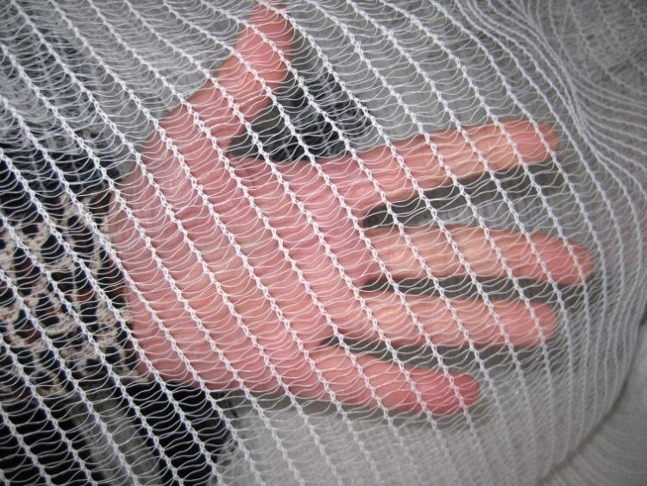

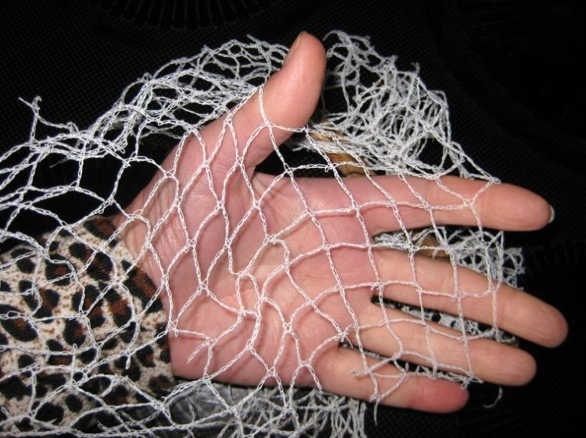Photos: Denise Wade

**For injured wildlife, contact your local rescue organisation:** https://www.wildlife.vic.gov.au/sick-injured-or-orphaned-wildlife

