|  |
| --- |
| Kangaroo Pet Food Trial |
| Information for landholders |

The Department of Environment, Land, Water and Planning (DELWP) issues Authorities to Control Wildlife (ATCWs) under section 28A of the *Wildlife Act 1975* for the control of kangaroos that are damaging pasture, crops or other property or impacting on biodiversity values.

DELWP is conducting a trial, extended until September 2019, to facilitate the processing of kangaroos controlled under ATCWs for the production of pet food. The trial will not change the requirement for a landholder applying for an ATCW to demonstrate that kangaroos are causing property damage.

The trial focuses on the use of Eastern Grey Kangaroos (*Macropus giganteus*) and Western Grey Kangaroos (*Macropus fuliginosus*) controlled under ATCWs for the production of pet food. The trial does not allow kangaroo meat to be used for human consumption.

During the extension period, the Victorian Government will develop a regulatory framework, including a Kangaroo Management Plan, to support the sustainable operation of an ongoing kangaroo pet food program in Victoria. The new program will operate from 1 October 2019.

## Application process

Landholders who wish to participate in the trial should complete the Kangaroo Pet Food Trial (KPFT) ATCW application form. The application form requires the landholder to describe the property damage and to specify the number of kangaroos causing the damage.

Landholders must note their Property Identification Code (PIC) on the KPFT ATCW application form. The PIC is used for pet food safety purposes. If you do not already have a PIC you should contact DELWP and enquire about this process.

DELWP will assess the application and issue a KPFT ATCW to the landholder, if satisfied that it is necessary to manage the kangaroos.

If approved, DELWP will provide the landholder with:

* the KPFT ATCW
* contact details for the pet meat processing facilities participating in the trial
* individually numbered blue and white plastic tags for the number and species of kangaroos authorised for control
* a record sheet to record the number and species of kangaroos controlled.

Professional shooters cannot apply for an ATCW on behalf of a landholder.

## Arranging the control of the kangaroos

For kangaroos controlled under a KPFT ATCW to be able to be processed for pet food, they must be shot by a person (i.e. a professional shooter) who is listed in the food safety plan (also known as a Quality Assurance Program) of a licensed pet meat processing facility. Kangaroos shot by any other person, including the landholder, cannot be used for commercial pet food.

To arrange for a professional shooter to control kangaroos under a KPFT ATCW, landholders should contact one of the participating pet meat processing facilities. Each facility may have different policies and procedures for their shooters. DELWP recommends that landholders confirm with the facility what the policies and procedures are prior to engaging a shooter to undertake the control work. DELWP will provide these contact details when the ATCW is issued.

If the landholder already has a preferred shooter who is listed in the food safety plan of a pet meat processing facility and is participating in the trial, they can request the processor make arrangements for their preferred shooter to undertake the control work on their property.

A copy of the KPFT ATCW and conditions must be given to any professional shooters that are controlling kangaroos on behalf of the landholder under that ATCW. The shooters must keep this copy with them at all times while shooting and transporting kangaroos.

The landholder is responsible for any shooting that is undertaken on their property. It is therefore important that the landholder only allows shooters access to the property if they have arranged for them to undertake the control work. Any unauthorised shooting or trespass should be reported to Victoria Police.

If a landholder is concerned with the actions of a shooter who has attended their property, they should report their concerns to DELWP and the pet meat processing facility that the shooter is working with. Landholders may engage a different pet meat processing facility at any time if they are not satisfied with the service being provided.

It is important to remember that the landholder is the ATCW holder and it is their right to decide the number of kangaroos to be controlled under the ATCW (up to the maximum allocated by the ATCW), and when they are controlled, at any one time. To achieve the most effective damage mitigation under the ATCW, it is recommended that the control be undertaken periodically, to scare other kangaroos from the property over time. Shooting the full allocation of kangaroos under an ATCW at one time is not likely to deal with the problem of kangaroo damage on the property.

## Tagging and record keeping

DELWP will provide the landholder with individually numbered plastic tags for each kangaroo authorised for control and a record sheet. Tags are either blue or white, depending on the species authorised for control (blue tags for Eastern Grey Kangaroos and white tags for Western Grey Kangaroos).

The landholder, after determining the number of kangaroos of each species to be controlled, is required to provide the equivalent number of coloured tags to the shooter along with a record sheet.

The tags are required to be attached to the kangaroo carcasses by the professional shooter so that the carcasses can be traced back to the KPFT ATCW they were controlled under. The shooter is also required to complete the record sheet upon completion of shooting on the landholder’s property, and must provide this back to the landholder with any unused tags. This tagging and record keeping process provides the landholder with confirmation of the number of kangaroos controlled under the ATCW.

Tags must remain on the property for which they have been issued to, or in the possession of the landholder, until attached to a kangaroo. Once a tag is attached to a kangaroo, it must not be tampered with or removed until required for processing.

Within two weeks of the expiry of the authorisation, unused tags and completed record sheets must be sent back to DELWP.

As the ATCW holder, it is the landholder’s responsibility to report any lost or stolen tags to DELWP within 24 hours of becoming aware of the theft or loss.

**If a shooter is unable to service the property**

A KPFT ATCW does not guarantee that a professional shooter will attend a landholder’s property. The availability of shooters will depend on the distance of the property from a processing facility, the terrain, the surrounding land use, weather, and number of kangaroos for control.

If no KPFT shooters are able to attend the property, the landholder or their agent may undertake the control of the kangaroos themselves, however none of the carcasses may be used by the pet meat processors. Instead they may be used for the landholders own personal use, buried or left on site to decompose naturally.

In this scenario, the landholder or agent must complete the record sheet provided with the ATCW. Kangaroos that are not controlled by professional shooters for the purposes of pet food do not need to be tagged, however, the corresponding number of tags must be set aside and not reused. These unused tags must be provided back to DELWP at the end of the authorisation period, along with the completed record sheets.

For more information see the “Overview”, “Information for shooters” and “Information for pet meat processing facilities” factsheets.

## Steps for landholders:

Submit a Kangaroo Pet Food Trial ATCW application form to DELWP

*DELWP assesses your application and issues or refuses the ATCW*

Contact the pet meat processor of your choice to arrange for a professional shooter to come to your property on an agreed date.

Provide the shooter with a copy of the ATCW, plastic tags for the number and species of kangaroos you want them to control and the record sheet.

*Shooter controls kangaroos and arranges for them to be transported to the pet meat processing facility. Shooter provides you with the completed record sheet and any unused tags.*

*If successful, DELWP provides you with your ATCW and contact details of participating pet meat processing facilities, numbered kangaroo tags and record sheets.*

Within two weeks of the expiry of the authorisation, send completed record sheets and unused tags back to DELWP.

## Frequently Asked Questions

***When will the trial run?***

The trial will run from 31 March 2014 to 30 September 2019.

***Can all landholders participate in the trial?***

Landholders can participate in the trial if:

* kangaroos are causing property damage and all non-lethal means of control have been exhausted
* the property is located in the trial area (see Figure 1).
* the landholder is issued with a KPFT ATCW to control kangaroos on their property.

The person who shoots the kangaroos must be trained and listed as a preferred supplier in the food safety plan of a licensed pet meat processing facility.

***I am outside the trial area, can I participate?***

No. Only kangaroos controlled in the trial area (See Figure 1) may be used for pet food.

***Where can I obtain a Kangaroo Pet Food Trial ATCW application form?***

You can download the form from the DELWP website or contact the DELWP Customer Service Centre on 136 186 to have the form sent out to you.

***What if I don’t have a Property Identification Code (PIC)?***

All landholders will need to provide a PIC on the KPFT ATCW application form. To obtain a PIC, please contact DELWP Customer Service Centre on 136 186.

***Where is the trial running?***

The trial is open for landowners in the following local government areas (Figure 1):

Ararat, Benalla, Glenelg, Greater Bendigo Horsham, Loddon, Mansfield, Mitchell, Murrindindi, Northern Grampians, Pyrenees, Southern Grampians, Strathbogie, Wangaratta, West Wimmera and Yarriambiack.

***What if I don’t want to participate in the trial?***

If you live in the trial areas you do not have to participate in the trial. You may apply for an ATCW using the standard form and follow the normal process.

***What if I was already participating in the original trial?***

Existing KPFT ATCWs will be valid until their expiration date. Landholder can apply for a new authorisation as part of the extended trial when their existing ATCW expires.

***Can I control the kangaroos myself and take them to a pet meat processing facility?***

No. Kangaroos must be controlled by a professional shooter who is listed in the food safety plan of a licensed pet meat processing facility.

Any kangaroos controlled by landholders must be left on the property or kept for personal use only.

***How many pet meat processing facilities are participating in the trial?***

As of February 2016, three pet meat processing facilities have the relevant approvals and are processing kangaroos as part of the trial.

***How do I arrange for a shooter to control the kangaroos?***

If an ATCW application is successful, DELWP will provide the contact details of the pet meat processors participating in the trial. Landholders may then contact the processor of their choice to arrange for a shooter to visit their property at an agreed time to control the kangaroos.

If the landholder has a preferred shooter who is listed in the food safety plan of a pet meat processing facility and is participating in the trial, they can request that the processor make arrangements for that shooter to undertake the control work on their property.

***I have some concerns about the shooter who controlled the kangaroos on my property, what do I do?***

All concerns should be reported to the local DELWP office and the pet meat processing facility that the shooter is working with.

Non-compliance with the conditions of the KPFT ATCW may result in an investigation and compliance action taken by DELWP.

***Where do I get the tags from?***

The tags will be provided to you by DELWP with your KPFT ATCW.

***Do I have to give the shooter all of the tags?***

No. You only need to give the shooter tags for as many kangaroos as you want them to control at any one time. It is recommended to arrange with the shooter to spread the control of the kangaroos over several weeks or months to allow for more effective control of the population.

If all of the kangaroos authorised for control are controlled at once, then kangaroos from other areas may move onto your property once the control work has ceased. It is often more effective to control the kangaroos over time to keep pressure on the population.

***What do I do with unused tags?***

Unused tags must be returned to DELWP within two weeks of the expiry of your KPFT ATCW. Tags must be returned to:

Biodiversity Regulation, DELWP

PO Box 500

East Melbourne VIC 8002

***If I control the kangaroos myself do I have to tag them?***

No. However, you must set aside tags for the same number and species of kangaroo that you control and return these to DELWP when your KPFT ATCW expires, along with the completed record sheet.

***Can I give or sell the tags to someone else with a KPFT ATCW?***

No. The tags are individually numbered and registered to your KPFT ATCW. Any unused tags must be returned to DELWP when your KPFT ATCW expires.

***My tags were lost or stolen, what do I do?***

You must notify DELWP within 24hrs of becoming aware of the loss or theft of the tags by emailing [biodiversity.regulation@delwp.vic.gov.au](mailto:biodiversity.regulation@delwp.vic.gov.au).

***What do I do with the record sheet?***

The record sheet must be filled in by the person undertaking the control of the kangaroos. If you have arranged for a professional shooter to undertake the control then you must provide them with the record sheet to complete. Once they have completed the control work they will give the completed record sheet back to you.

If you undertake the control of the kangaroos yourself then you must complete the record sheet.

Completed record sheets must be submitted to DELWP when your KPFT ATCW expires. Ensure that you keep a copy for your own records. Record sheets can be returned to:

Biodiversity Regulation, DELWP

PO Box 500

East Melbourne VIC 8002

Or scanned and emailed to: [biodiversity.regulation@delwp.vic.gov.au](mailto:biodiversity.regulation@delwp.vic.gov.au)

***What happens if a professional shooter will not come to my property?***

If a professional shooter cannot attend your property, you can control the number of kangaroos specified in the DELWP-issued KPFT ATCW, but the meat cannot be processed for commercial pet food.

If you are unable to control the kangaroos yourself, you can engage a suitably licensed and equipped shooter to conduct the control on your behalf providing they comply with the conditions of your ATCW. There is no requirement under the KPFT ATCW to have these agents listed on your permit.

***Will the pet meat processing facility pay me?***

No, landholders must not receive any money for kangaroos controlled on their properties.

***How will the new kangaroo pet food program be different from the trial?***

Unlike the KPFT, the new framework will operate independently of the ATCW system. Landholders will still be able to apply for ATCWs to control kangaroos on their own property, however these carcasses will not be processed under the new system.

The new regulatory framework and Kangaroo Management Plan will establish kangaroo harvesting zones and set appropriate annual quotas for each zone, based on information gained from recent statewide kangaroo population surveys, to ensure Victoria’s kangaroo population is managed sustainably under the pet food program.

The new framework will include safe guards to ensure that harvesting is sustainable, animal welfare requirements are met and stronger compliance and enforcement requirements are in place.

Figure 1 Map of existing and extended trial area. Four additional local government areas were added in 2016 after local government and key stakeholder consultation.

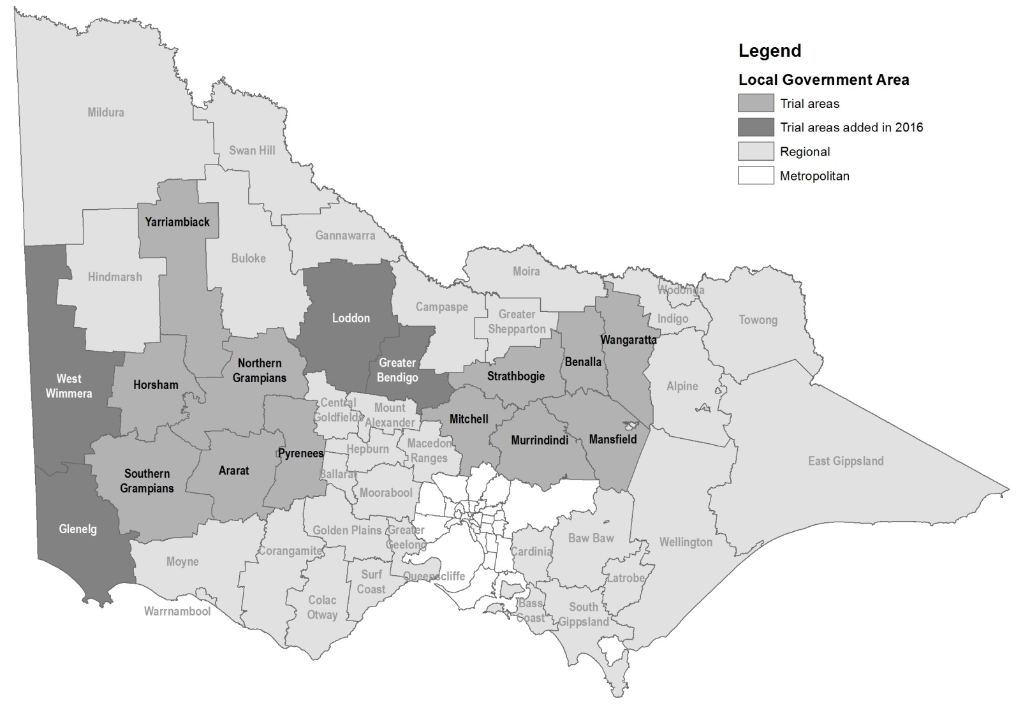

Figure 1:

Credit:

Source:

Keep all content above this instruction text line. Delete only when document formatting is complete.

|  |  |
| --- | --- |
| © The State of Victoria Department of Environment, Land, Water and Planning 2019  LogoThis work is licensed under a Creative Commons Attribution 4.0 International licence. You are free to re-use the work under that licence, on the condition that you credit the State of Victoria as author. The licence does not apply to any images, photographs or branding, including the Victorian Coat of Arms, the Victorian Government logo and the Department of Environment, Land, Water and Planning (DELWP) logo. To view a copy of this licence, visit http://creativecommons.org/licenses/by/4.0/.  [ISBN 978-1-74326-819-3](https://www.wildlife.vic.gov.au/__data/assets/pdf_file/0028/28288/Kangaroo-Pet-Food-Trial-Landholders-update-15-September-2016.pdf) (Online)  Disclaimer  This publication may be of assistance to you but the State of Victoria and its employees do not guarantee that the publication is without flaw of any kind or is wholly appropriate for your particular purposes and therefore disclaims all liability for any error, loss or other consequence which may arise from you relying on any information in this publication. | Accessibility  If you would like to receive this publication in an alternative format, please telephone the DELWP Customer Service Centre on 136186, email [customer.service@delwp.vic.gov.au](mailto:customer.service@delwp.vic.gov.au), or via the National Relay Service on 133 677 [www.relayservice.com.au](http://www.relayservice.com.au). This document is also available on the internet at [www.delwp.vic.gov.au](http://www.delwp.vic.gov.au). |