Our Wildlife Fact Sheet
  - Bottlenose Dolphin

Bottlenose Dolphins are actually small whales, and belong to the group known as 'toothed whales'.
They are air breathing mammals, so even though they have adapted to the marine environment, they still have to come to the surface to breathe through the blowhole on top of their heads.

The Bottlenose Dolphin is the ever-smiling species that most people have come to know and love due to the TV show "Flipper".
Scientific name
Tursiops truncatus
Did you know?
Bottlenose Dolphins can live to over 30 years of age, with some studies confirming age at death as 50 years old.
Dolphins are conscious breathers and are required to be awake or semi-conscious to breathe or else they will drown. While semi-conscious they rest one side of their brain at a time.
Bottlenose Dolphins can swim at speeds around 37 km/hour.
Studies have shown that Bottlenose Dolphins are smart, highly social animals that can even recognise themselves in a mirror.
Description
The Bottlenose Dolphin is commonly seen in groups or pods, containing anything from two or three individuals to more than a thousand.
The Bottlenose Dolphin has a short rounded, bottle shaped snout, hence the origin of their name. Their lower jaw is typically white tipped.
The large dorsal fin is slightly hooked and set half way along the body (see diagram).
Overall, the body of a Bottlenose Dolphin is dark bluish to grey tones with an indistinct paler grey wash on the flanks fading into an off-white belly.
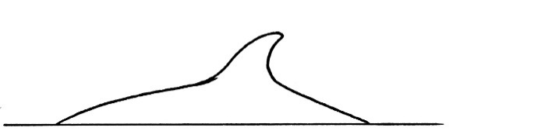

Figure 1. Shape of a Bottlenose Dolphin dorsal fin © B. Jarrett 2010
Diet
Their diet and hunting behaviour varies greatly as they adapt to local prey availability and conditions.
Coastal dolphins eat a variety of fish species, squid, octopus and krill. Their diet generally consists of 4 or 5 local prey species. Bottlenose Dolphins eat around 15 kg of food per day.
Dolphins use echo-location for hunting and navigating. The clicking sounds they make travels through the water hitting objects up to 200 metres in front of them, echoing back to the dolphin. This movement of sound allows them to work out the size, shape, speed, distance and direction of their prey.
Habitat
Bottlenose Dolphins are found throughout tropical and temperate oceans.
Along the Victorian coast Bottlenose Dolphins can be seen across all the bays, estuaries and coastal lakes, occasionally entering the tidal reaches of large and small rivers e.g. Bass, Yarra and Maribyrnong.
Distribution
Within Australia, the Bottlenose Dolphin is found in all states and the Northern Territory, and Norfolk Island.

There is thought to be two species of Bottlenose, the inshore and the offshore.

In Victoria, populations of Bottlenose Dolphins can be seen along the whole of the coastline, including within Port Phillip Bay, Western Port and Gippsland Lakes. It is thought that the Port Phillip Bay population is genetically different from the other offshore dolphin populations.

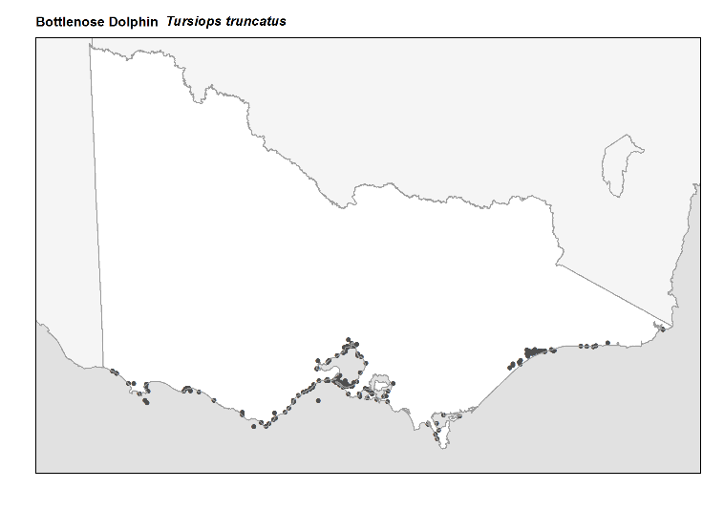
Figure 2. Recorded occurrences in Victoria
Source: Victorian Biodiversity Atlas (records post 1979), version 15/5/2017
Breeding
Bottlenose Dolphins have many partners over a lifetime and mate all year round. Calves are born throughout the year, although most are born in spring and summer after a gestation period of 12 months.

Females generally give birth to a single calf, every 2 - 6 years.
Calves suckle for up to 18 months, although they begin eating fish at about 6 months of age. Their teeth begin to come through at about 5 weeks of age.
Calves are born tail first so that they do not drown and are quickly pushed up to the surface for their first breath.
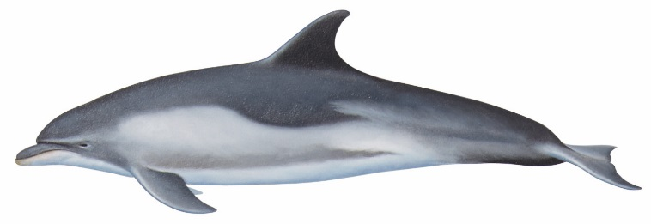
Bottlenose Dolphins can be quite aggressive (particularly the males) towards each other. Males have been known to fight so violently that they have killed each other; they will also attack other species of dolphins and porpoises.

Figure 3. Bottlenose Dolphin
© B. Jarrett 2010

What you can do to help!
It’s important not to get too close to dolphins. They need space to move, feed and take care of their young.

Boating can disturb these behaviours and threaten their well being. If you are out on the ocean and see dolphins, make sure you stay at least 100 metres away! When riding a jetski then you need to stay at least 300 metres away.

If you are flying a drone, remember that you must not allow the drone to get closer than 500 metres above or around the whale.
You can care for dolphins by helping to keep their environment clean. Take your rubbish home, and if you find any floating at sea or on the coast, please pick it up. Don’t drop litter! The litter you drop on the street ends up in the oceans and can be very harmful to all marine life.
Also, don’t discard fishing line into the ocean. It can still harm marine life, including dolphins, many years later.
Bottlenose Dolphins often strand, either singly or in small groups. If you find a stranded or entangled dolphin report it immediately to DELWP. While you are waiting for help to arrive, keep it wet and cool, and keep it shaded so it doesn't get sunburnt, but remember not to obstruct the blowhole, so the dolphin can breathe.
If you see a dolphin entangled in fishing gear or stranded on a beach, call the Whale and Dolphin Emergency Hotline on 1300 136 017.
Further reading
Menkhorst, P.W. (ed.), (1995), Mammals of Victoria, Oxford University Press, Melbourne.

